I use frdm-k64 and led demo to show you how to allocate the data at the specified the address.

Open the project and build it(You must build it). Then open the project properties. Cancel the click. Apply and close.

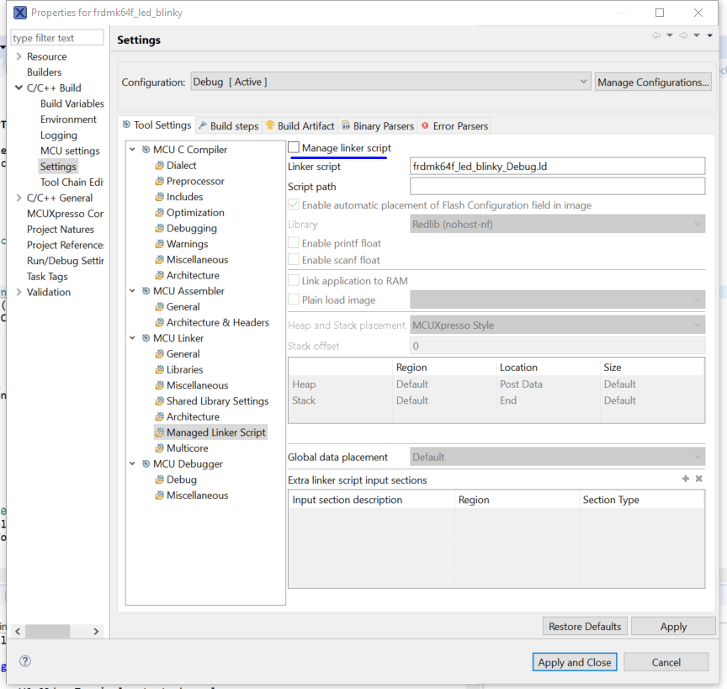

Open startup_mk64f12.c. Create a structure—FlashT. And place it at section “.FlashT”

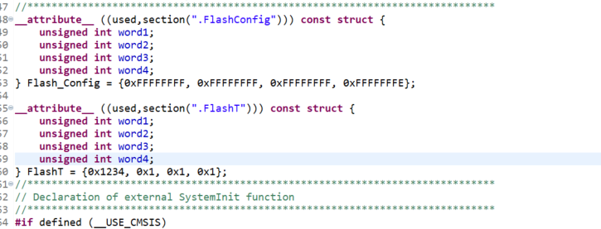

Open frdmk64f_led_blinky_Debug.ld. Insert the code

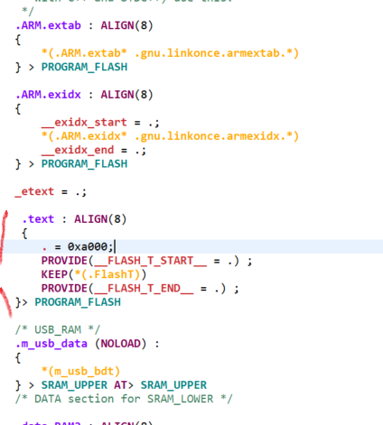

Then my structure will locate at 0xa000. You can see the value 0x1234 at address 0xa000.

