OTA的RAM flash更新

K32w061

定义函数擦写函数在ram里，



函数实现时候要避免使用任何库的函数，即使是memcpy都不可以，必须自己手动用for循环实现，在ram擦写flash时候，不能依赖任何库，否则擦写会失败

这是我在k32w061上实现的两个函数，参考了sdk的flash烧写，然后修改成没有任何调用的函数

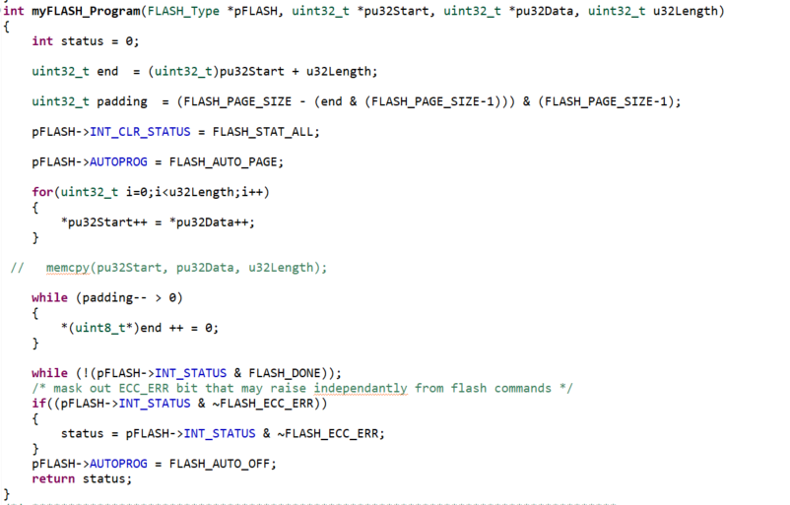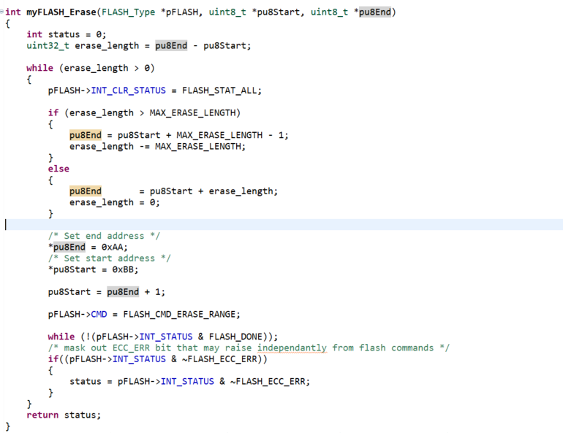

然后写应用函数，我要将ota获得的镜像（在0x48000），烧写到0x0位置

**#define** FLASH_START_ADDRESS 0

**#define** FLASH_APP_START_ADDRESS 0x48000

**#define** FLASH_OTA_START_PAGE (FLASH_START_ADDRESS / FLASH_PAGE_SIZE) //0

**#define** FLASH_OTA_PAGE_NUM (0x48000 / FLASH_PAGE_SIZE) //0x48000 / 512 = 576

**#define** FLASH_APP_START_PAGE (FLASH_OTA_PAGE_NUM) //576

**#define** FLASH_APP_PAGE_NUM (0x0004dfff / FLASH_PAGE_SIZE) //0x0004dfff/512 = 623

**void** **myFunc**(uint32_t *imageSize)

{

uint8_t tempMem[FLASH_PAGE_SIZE] = {0};

uint32_t *pu32Start = (uint32_t *)(FLASH_PAGE_SIZE * 0);

uint8_t *appEraseStartAddress = (uint8_t *)(FLASH_APP_START_ADDRESS);

uint8_t *appEraseEndAddress = appEraseStartAddress + FLASH_PAGE_SIZE * FLASH_APP_PAGE_NUM - 1;

uint8_t boolTag = 0;

// uint8_t wrongValue = 0;

uint32_t imagePage = *imageSize / FLASH_PAGE_SIZE;

uint8_t *pu8Start;

uint8_t *pu8End;

uint8_t *pageCount2address;

**if**(imagePage*FLASH_PAGE_SIZE < (*imageSize))

{

imagePage++;

}

FLASH_Init(FLASH);

__ASM **volatile** ("cpsid i" : : : "memory");

**for**(uint32_t i=0; i<imagePage; i++)

{

pu8Start = (uint8_t *)(FLASH_START_ADDRESS + FLASH_PAGE_SIZE*i);

pu8End = (pu8Start + FLASH_PAGE_SIZE * 1) - 1;

pageCount2address = (uint8_t*)((FLASH_APP_START_PAGE+i)*FLASH_PAGE_SIZE);

flashAgain:

myFLASH_Erase(FLASH,pu8Start,pu8End);

**for**(uint16_t index=0;index<FLASH_PAGE_SIZE;index++)

{

tempMem[index] = *(pageCount2address+index);

}

pu32Start = (uint32_t *)(FLASH_START_ADDRESS + i*FLASH_PAGE_SIZE);

myFLASH_Program(FLASH,pu32Start , (uint32_t*)tempMem, FLASH_PAGE_SIZE);

**for**(uint16_t index=0;index<FLASH_PAGE_SIZE;index++)

{

boolTag = (tempMem[index] == *((uint8_t*)pu32Start+index))? 1:0;

**if**(boolTag == 0)

{

**goto** flashAgain;

}

}

}

myFLASH_Erase(FLASH,appEraseStartAddress,appEraseEndAddress);

**void** (*p_Chip_LOWPOWER_ChipSoftwareReset)(**void**);

p_Chip_LOWPOWER_ChipSoftwareReset = (**void** (*)(**void**))0x03003fa1U;

p_Chip_LOWPOWER_ChipSoftwareReset();

}

最后找到OTA_SetNewImageFlag和ResetMCU

都注释掉，改成调用myFunc即可