1. Prepare a JLink Lite FSL or LPC link.Install Jlink on your computer.Link：[www.segger.com](http://www.segger.com)

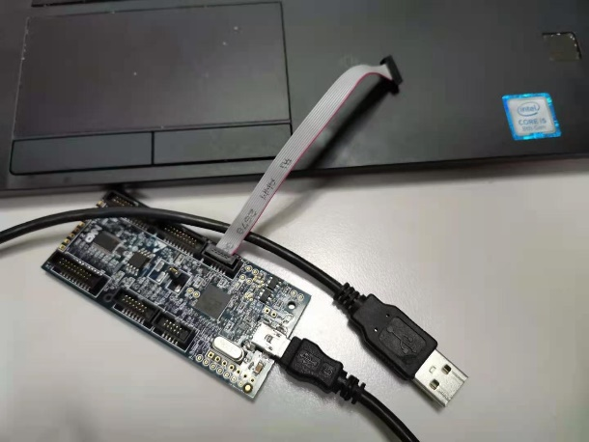

1. Visit [www.nxp.com/opensda](http://www.nxp.com/opensda).

Select board.

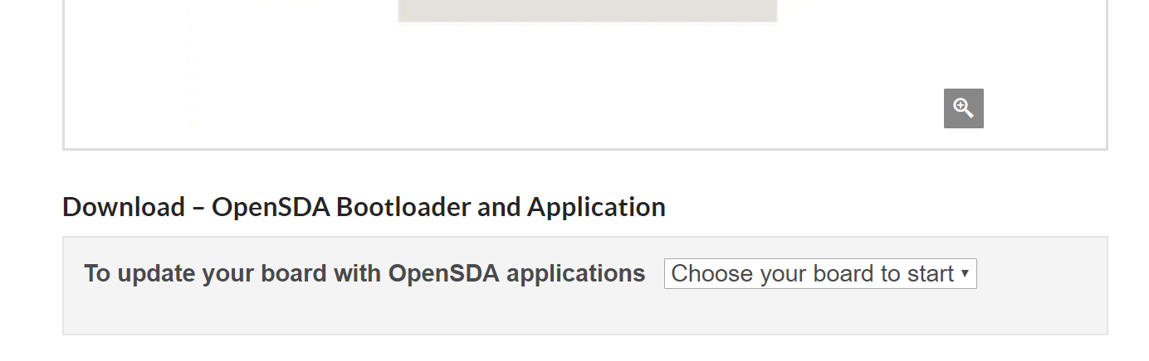

When you choose the board you need ,you will find the content like this.

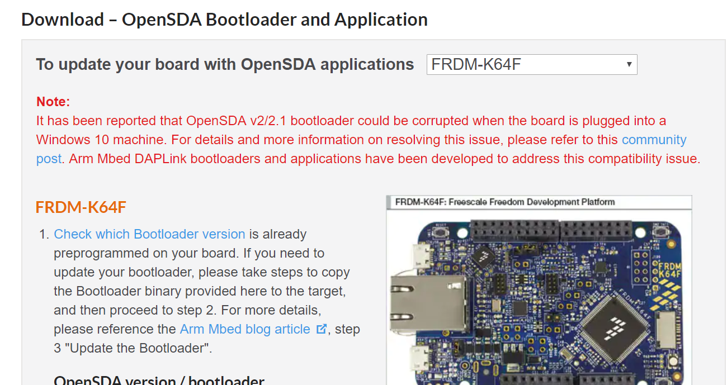

1. Then,you should download bootloader binary.

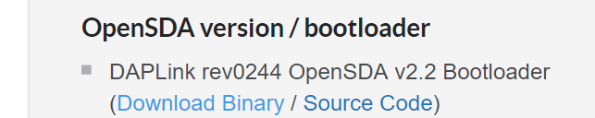

1. Put the binary in your Jlink’s installation path.

I install the Jlink in “C:\Program Files (x86)\SEGGER\”

So I put the binary in “C:\Program Files (x86)\SEGGER\JLink_V648a”

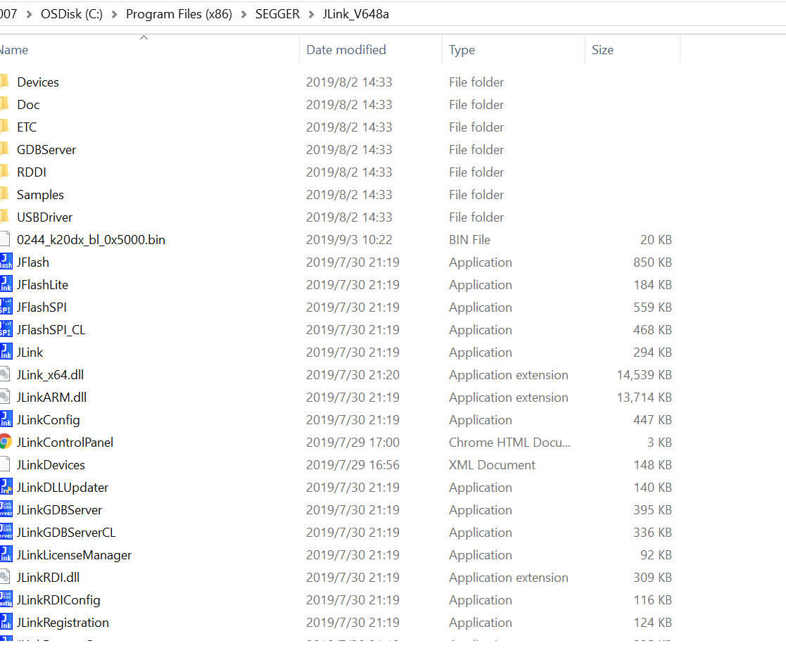

1. Now, you need connect Jlink to your board and your PC.

Then you connect the board’s usb to your PC.

Don't make the wrong order.

1. The path you put binary has the application “JLink”.Open it.And you should enter “connect” . Then review your schematic. Find your debugger mcu. For k64, it is ‘mk20dx128’. Then “device MK20”,Then “s”,“40000” at last. All commands is end with pressing button ”enter”.

It will appear a window “Target device settings”.

Input “mk20dx128xxx5” and choose it.

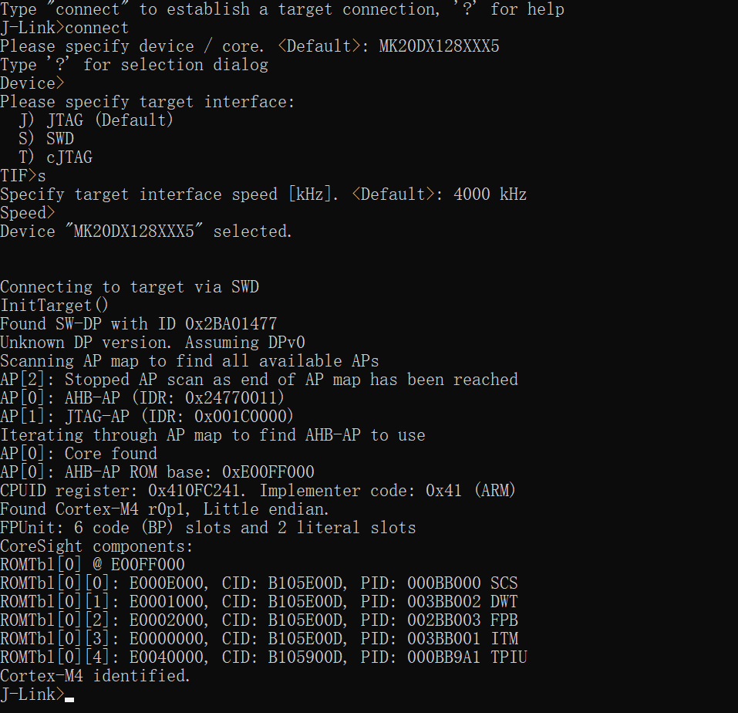

1. Input “erase”
2. Input “loadfile 0244_k20dx_bl_0x5000.bin”Then you can close this application.
3. Visit <https://www.nxp.com/design/microcontrollers-developer-resources/ides-for-kinetis-mcus/opensda-serial-and-debug-adapter:OPENSDA#FRDM-K64F>

Select the board you need.

Download firmware application’s binary.



10、Disconnect the Jlink and usb.

Press the “reset” button without releasing,then connect the usb to your board and PC.

At the same time check the content like this.

If the “MANTENANCE” appears,copy the firmware application’s binary into it.

Then reboot.

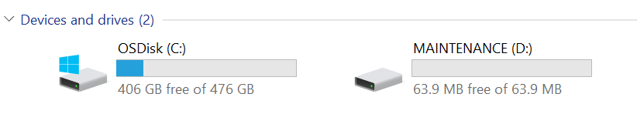

You will find content like this.

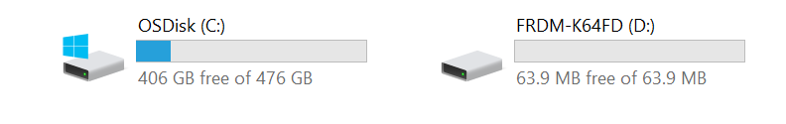

12、Finally,you should download CMSIS-DAP driver in this link

<https://os.mbed.com/handbook/Windows-serial-configuration>

Then you can use the mcuxpress ,IAR or keil to download program.