**Hands on 1**

**Create a Spring Web Project using Maven** 

Code:

package com.cognizant.spring_learn;

import org.slf4j.Logger;

import org.slf4j.LoggerFactory;

import org.springframework.boot.SpringApplication;

import org.springframework.boot.autoconfigure.SpringBootApplication;

*@SpringBootApplication*

public class SpringLearnApplication {

private static final Logger ***LOGGER*** = LoggerFactory.*getLogger*(SpringLearnApplication.class);

public static void main(String[] args) {

SpringApplication.*run*(SpringLearnApplication.class, args);

***LOGGER***.info("Inside main");

}

}

application.properties

spring.application.name=spring-learn

logging.level.org.springframework=info

logging.level.com.cognizant=debug

logging.pattern.console=%d{dd-MM-yy} %d{HH:mm:ss.SSS} %-20.20thread %5p %-25.25logger{25} %25M %4L %m%n

server.port=2032

Output:

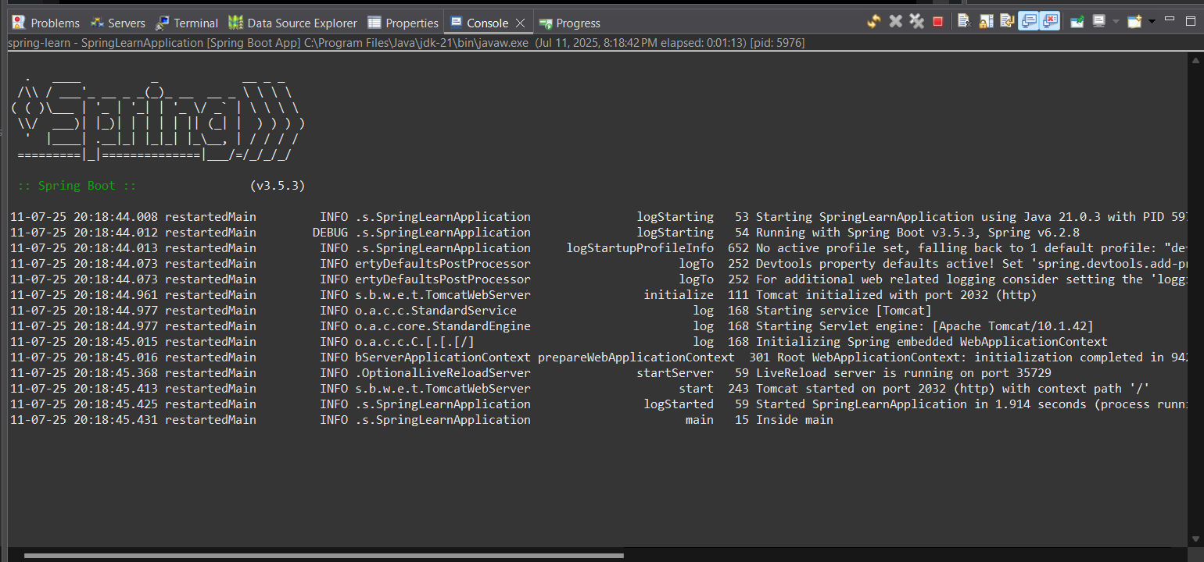

**Hands on 2**

**Spring Core – Load SimpleDateFormat from Spring Configuration XML** 

Code:

package com.cognizant.spring_learn;

import java.text.ParseException;

import java.text.SimpleDateFormat;

import java.util.Date;

import org.slf4j.Logger;

import org.slf4j.LoggerFactory;

import org.springframework.boot.SpringApplication;

import org.springframework.boot.autoconfigure.SpringBootApplication;

import org.springframework.context.ApplicationContext;

import org.springframework.context.support.ClassPathXmlApplicationContext;

*@SpringBootApplication*

public class SpringLearnApplication {

private static final Logger ***LOGGER*** = LoggerFactory.*getLogger*(SpringLearnApplication.class);

public static void main(String[] args) {

SpringApplication.*run*(SpringLearnApplication.class, args);

***LOGGER***.info("Inside main");

*displayDate*();

}

public static void displayDate() {

ApplicationContext context = new ClassPathXmlApplicationContext("date-format.xml");

SimpleDateFormat format = context.getBean("dateFormat", SimpleDateFormat.class);

try {

Date date = format.parse("31/12/2018");

System.***out***.println("Parsed Date: " + date);

} catch (ParseException e) {

e.printStackTrace();

}

}

}

date-format.xml:

<?**xml** version=*"1.0"* encoding=*"UTF-8"*?>

<**beans** xmlns=*"http://www.springframework.org/schema/beans"*

xmlns:xsi=*"http://www.w3.org/2001/XMLSchema-instance"*

xsi:schemaLocation=*"http://www.springframework.org/schema/beans*

*https://www.springframework.org/schema/beans/spring-beans.xsd"*>

<**bean** id=*"dateFormat"* class=*"java.text.SimpleDateFormat"*>

<**constructor-arg** value=*"dd/MM/yyyy"* />

</**bean**>

</**beans**>

Output:

**Hello World RESTful Web Service** 

Code:

package com.cognizant.spring_learn;

import java.text.ParseException;

import java.text.SimpleDateFormat;

import java.util.Date;

import org.slf4j.Logger;

import org.slf4j.LoggerFactory;

import org.springframework.boot.SpringApplication;

import org.springframework.boot.autoconfigure.SpringBootApplication;

import org.springframework.context.ApplicationContext;

import org.springframework.context.support.ClassPathXmlApplicationContext;

*@SpringBootApplication*

public class SpringLearnApplication {

private static final Logger ***LOGGER*** = LoggerFactory.*getLogger*(SpringLearnApplication.class);

public static void main(String[] args) {

SpringApplication.*run*(SpringLearnApplication.class, args);

***LOGGER***.info("Inside main");

*displayDate*();

}

public static void displayDate() {

ApplicationContext context = new ClassPathXmlApplicationContext("date-format.xml");

SimpleDateFormat format = context.getBean("dateFormat", SimpleDateFormat.class);

try {

Date date = format.parse("31/12/2018");

System.***out***.println("Parsed Date: " + date);

} catch (ParseException e) {

e.printStackTrace();

}

}

}

application.properties:

spring.application.name=spring-learn

logging.level.org.springframework=info

logging.level.com.cognizant=debug

logging.pattern.console=%d{dd-MM-yy} %d{HH:mm:ss.SSS} %-20.20thread %5p %-25.25logger{25} %25M %4L %m%n

server.port=8083

HelloController.java:

package com.cognizant.spring_learn.controller;

import org.slf4j.Logger;

import org.slf4j.LoggerFactory;

import org.springframework.web.bind.annotation.GetMapping;

import org.springframework.web.bind.annotation.RestController;

*@RestController*

public class HelloController {

private static final Logger ***LOGGER*** = LoggerFactory.*getLogger*(HelloController.class);

*@GetMapping*("/hello")

public String sayHello() {

***LOGGER***.info("START - sayHello()");

String message = "Hello World!!";

***LOGGER***.info("END - sayHello()");

return message;

}

}

Output:

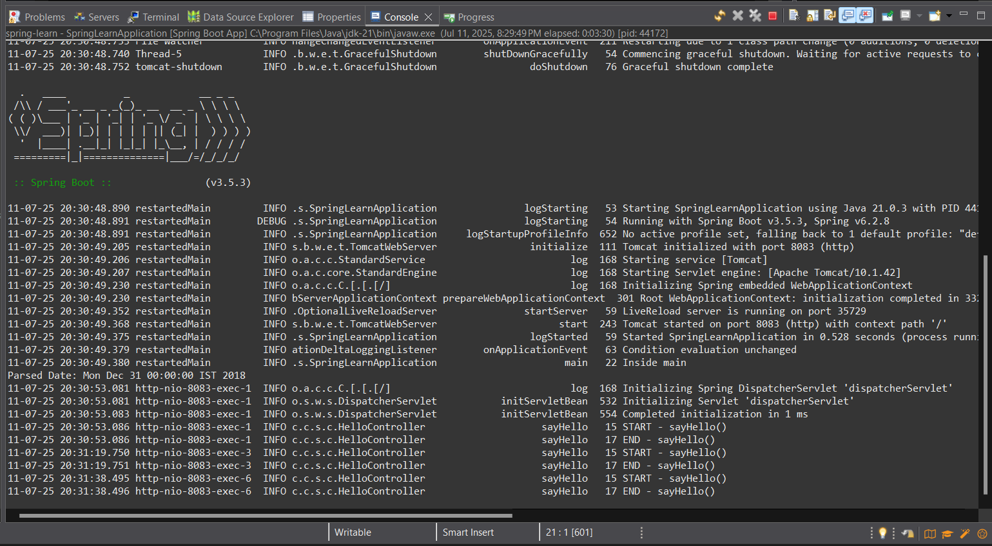

**REST - Country Web Service** 

Country.java:

package com.cognizant.spring_learn.model;

public class Country {

private String code;

private String name;

public Country() {

}

public Country(String code, String name) {

this.code = code;

this.name = name;

}

public String getCode() {

return code;

}

public void setCode(String code) {

this.code = code;

}

public String getName() {

return name;

}

public void setName(String name) {

this.name = name;

}

}

country.xml:

<?**xml** version=*"1.0"* encoding=*"UTF-8"*?>

<**beans** xmlns=*"http://www.springframework.org/schema/beans"*

xmlns:xsi=*"http://www.w3.org/2001/XMLSchema-instance"*

xsi:schemaLocation=*"http://www.springframework.org/schema/beans*

*https://www.springframework.org/schema/beans/spring-beans.xsd"*>

<**bean** id=*"in"* class=*"com.cognizant.spring_learn.model.Country"*>

<**property** name=*"code"* value=*"IN"*/>

<**property** name=*"name"* value=*"India"*/>

</**bean**>

</**beans**>

CountryController.java:

package com.cognizant.spring_learn.controller;

import com.cognizant.spring_learn.model.Country;

import org.slf4j.Logger;

import org.slf4j.LoggerFactory;

import org.springframework.context.ApplicationContext;

import org.springframework.context.support.ClassPathXmlApplicationContext;

import org.springframework.web.bind.annotation.RequestMapping;

import org.springframework.web.bind.annotation.RestController;

*@RestController*

public class CountryController {

private static final Logger ***LOGGER*** = LoggerFactory.*getLogger*(CountryController.class);

*@SuppressWarnings*("resource")

*@RequestMapping*("/country")

public Country getCountryIndia() {

***LOGGER***.info("START - getCountryIndia()");

ApplicationContext context = new ClassPathXmlApplicationContext("country.xml");

Country country = context.getBean("in", Country.class);

***LOGGER***.info("END - getCountryIndia()");

return country;

}

}

Output:

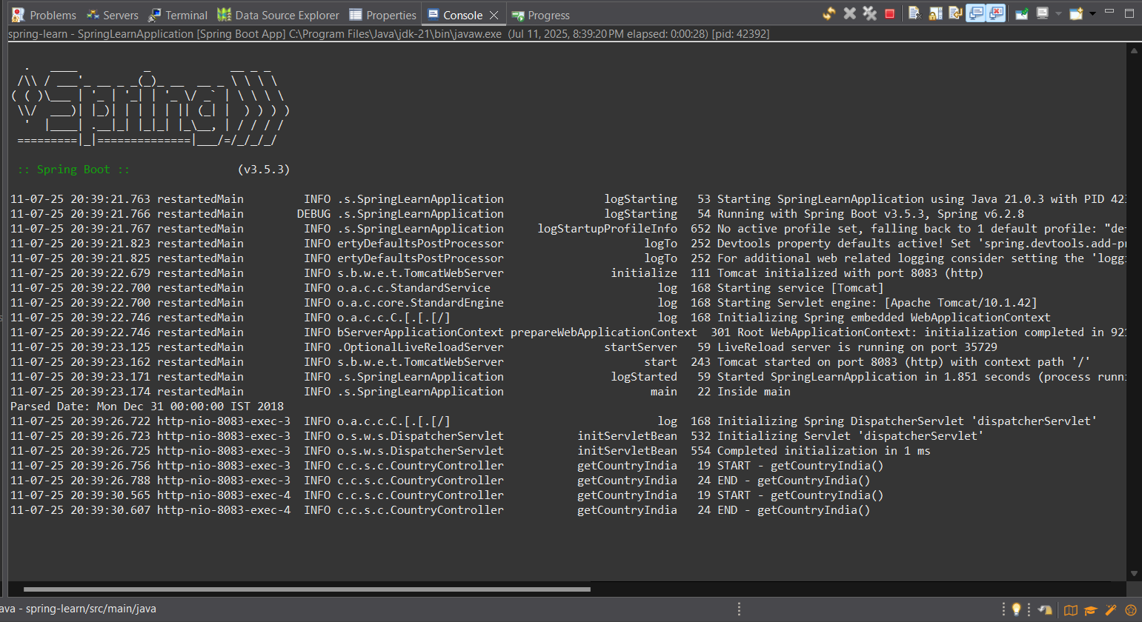

**REST - Get country based on country code** 

Code:

package com.cognizant.spring_learn.model;

public class Country {

private String code;

private String name;

public Country() {

}

public Country(String code, String name) {

this.code = code;

this.name = name;

}

public String getCode() {

return code;

}

public void setCode(String code) {

this.code = code;

}

public String getName() {

return name;

}

public void setName(String name) {

this.name = name;

}

}

country.xml:

<?**xml** version=*"1.0"* encoding=*"UTF-8"*?>

<**beans** xmlns=*"http://www.springframework.org/schema/beans"*

xmlns:xsi=*"http://www.w3.org/2001/XMLSchema-instance"*

xsi:schemaLocation=*"http://www.springframework.org/schema/beans*

*https://www.springframework.org/schema/beans/spring-beans.xsd"*>

<**bean** id=*"countryList"* class=*"java.util.ArrayList"*>

<**constructor-arg**>

<**list**>

<**bean** class=*"com.cognizant.spring_learn.model.Country"*>

<**property** name=*"code"* value=*"IN"*/>

<**property** name=*"name"* value=*"India"*/>

</**bean**>

<**bean** class=*"com.cognizant.spring_learn.model.Country"*>

<**property** name=*"code"* value=*"US"*/>

<**property** name=*"name"* value=*"United States"*/>

</**bean**>

<**bean** class=*"com.cognizant.spring_learn.model.Country"*>

<**property** name=*"code"* value=*"CN"*/>

<**property** name=*"name"* value=*"China"*/>

</**bean**>

</**list**>

</**constructor-arg**>

</**bean**>

</**beans**>

CountryService.java:

package com.cognizant.spring_learn.service;

import com.cognizant.spring_learn.model.Country;

import org.springframework.context.ApplicationContext;

import org.springframework.context.support.ClassPathXmlApplicationContext;

import org.springframework.stereotype.Service;

import java.util.List;

*@Service*

public class CountryService {

public Country getCountry(String code) {

ApplicationContext context = new ClassPathXmlApplicationContext("country.xml");

List<Country> countryList = (List<Country>) context.getBean("countryList");

return countryList.stream()

.filter(country -> country.getCode().equalsIgnoreCase(code))

.findFirst()

.orElse(null);

}

}

CountryController.java:

package com.cognizant.spring_learn.controller;

import com.cognizant.spring_learn.model.Country;

import com.cognizant.spring_learn.service.CountryService;

import org.slf4j.Logger;

import org.slf4j.LoggerFactory;

import org.springframework.beans.factory.annotation.Autowired;

import org.springframework.web.bind.annotation.*;

*@RestController*

public class CountryController {

private static final Logger ***LOGGER*** = LoggerFactory.*getLogger*(CountryController.class);

*@Autowired*

private CountryService countryService;

*@GetMapping*("/countries/{code}")

public Country getCountry(*@PathVariable* String code) {

***LOGGER***.info("START - getCountry()");

Country country = countryService.getCountry(code);

***LOGGER***.info("END - getCountry()");

return country;

}

}

Output:

**Create authentication service that returns JWT**   
  
Code:

SecurityConfig.java:

package com.cognizant.spring_learn.security;

import org.springframework.context.annotation.Bean;

import org.springframework.context.annotation.Configuration;

import org.springframework.security.config.annotation.web.configuration.EnableWebSecurity;

import org.springframework.security.web.SecurityFilterChain;

import org.springframework.security.config.annotation.web.builders.HttpSecurity;

*@Configuration*

*@EnableWebSecurity*

public class SecurityConfig {

*@Bean*

public SecurityFilterChain filterChain(HttpSecurity http) throws Exception {

http

.csrf(csrf -> csrf.disable())

.authorizeHttpRequests(auth -> auth

.requestMatchers("/authenticate").permitAll()

.anyRequest().authenticated()

);

return http.build();

}

}

JwtUtil.java:

package com.cognizant.spring_learn.security;

import io.jsonwebtoken.Jwts;

import io.jsonwebtoken.SignatureAlgorithm;

import io.jsonwebtoken.security.Keys;

import org.springframework.stereotype.Component;

import java.security.Key;

import java.util.Date;

*@Component*

public class JwtUtil {

private final Key key = Keys.*secretKeyFor*(*SignatureAlgorithm*.***HS256***);

private final long EXPIRATION_TIME = 10 * 60 * 1000;

public String generateToken(String username) {

return Jwts.*builder*()

.setSubject(username)

.setIssuedAt(new Date())

.setExpiration(new Date(System.*currentTimeMillis*() + EXPIRATION_TIME))

.signWith(key)

.compact();

}

}

AuthenticationController.java:

package com.cognizant.spring_learn.controller;

import com.cognizant.spring_learn.security.JwtUtil;

import org.springframework.beans.factory.annotation.Autowired;

import org.springframework.http.ResponseEntity;

import org.springframework.web.bind.annotation.*;

import java.util.Base64;

import jakarta.servlet.http.HttpServletRequest;

*@RestController*

public class AuthenticationController {

*@Autowired*

private JwtUtil jwtUtil;

*@GetMapping*("/authenticate")

public ResponseEntity<?> authenticate(HttpServletRequest request) {

String header = request.getHeader("Authorization");

if (header == null || !header.startsWith("Basic ")) {

return ResponseEntity.*status*(401).body("Missing or invalid Authorization header");

}

String base64Credentials = header.substring("Basic ".length());

byte[] decodedBytes = Base64.*getDecoder*().decode(base64Credentials);

String decodedCredentials = new String(decodedBytes);

String[] credentials = decodedCredentials.split(":", 2);

String username = credentials[0];

String password = credentials[1];

if ("user".equals(username) && "pwd".equals(password)) {

String token = jwtUtil.generateToken(username);

return ResponseEntity.*ok*().body("{\"token\":\"" + token + "\"}");

} else {

return ResponseEntity.*status*(401).body("Invalid credentials");

}

}

}

pom.xml:

<?xml version="1.0" encoding="UTF-8"?>

<project xmlns="http://maven.apache.org/POM/4.0.0" xmlns:xsi="http://www.w3.org/2001/XMLSchema-instance"

xsi:schemaLocation="http://maven.apache.org/POM/4.0.0 https://maven.apache.org/xsd/maven-4.0.0.xsd">

<modelVersion>4.0.0</modelVersion>

<parent>

<groupId>org.springframework.boot</groupId>

<artifactId>spring-boot-starter-parent</artifactId>

<version>3.5.3</version>

<relativePath/> <!-- lookup parent from repository -->

</parent>

<groupId>com.cognizant</groupId>

<artifactId>spring-learn</artifactId>

<version>0.0.1-SNAPSHOT</version>

<name>spring-learn</name>

<description>Demo project for Spring Boot</description>

<url/>

<licenses>

<license/>

</licenses>

<developers>

<developer/>

</developers>

<scm>

<connection/>

<developerConnection/>

<tag/>

<url/>

</scm>

<properties>

<java.version>21</java.version>

</properties>

<dependencies>

<dependency>

<groupId>org.springframework.boot</groupId>

<artifactId>spring-boot-starter-web</artifactId>

</dependency>

<dependency>

<groupId>org.springframework.boot</groupId>

<artifactId>spring-boot-devtools</artifactId>

<scope>runtime</scope>

<optional>true</optional>

</dependency>

<dependency>

<groupId>org.springframework.boot</groupId>

<artifactId>spring-boot-starter-test</artifactId>

<scope>test</scope>

</dependency>

<dependency>

<groupId>org.springframework.boot</groupId>

<artifactId>spring-boot-starter-security</artifactId>

</dependency>

<dependency>

<groupId>org.springframework.security</groupId>

<artifactId>spring-security-test</artifactId>

<scope>test</scope>

</dependency>

<dependency>

<groupId>io.jsonwebtoken</groupId>

<artifactId>jjwt-api</artifactId>

<version>0.11.5</version>

</dependency>

<dependency>

<groupId>io.jsonwebtoken</groupId>

<artifactId>jjwt-impl</artifactId>

<version>0.11.5</version>

<scope>runtime</scope>

</dependency>

<dependency>

<groupId>io.jsonwebtoken</groupId>

<artifactId>jjwt-jackson</artifactId>

<version>0.11.5</version>

<scope>runtime</scope>

</dependency>

</dependencies>

<build>

<plugins>

<plugin>

<groupId>org.springframework.boot</groupId>

<artifactId>spring-boot-maven-plugin</artifactId>

</plugin>

</plugins>

</build>

</project>

Output:

