1. ReactJS-HOL

Code:

import './App.css';

function App() {

  return (

    <h1>Welcome to first session of React</h1>

  );

}

export default App;

Output:

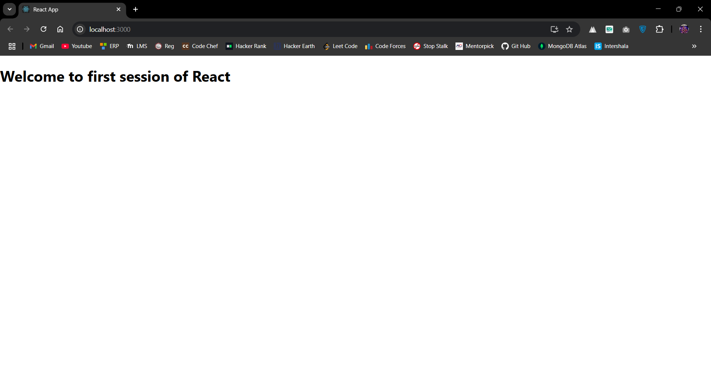

1. ReactJS-HOL

Code:

import React,{Component} from 'react';

class Home extends Component{

    render() {

        return (

            <div>

                <h3>Welcome to Home Page of Studnet Management Portal</h3>

            </div>

        );

    }

}

export default Home;

import React,{Component} from 'react';

class About extends Component{

    render() {

        return (

            <div>

                <h3>Welcome to About Page of Studnet Management Portal</h3>

            </div>

        );

    }

}

export default About;

import React,{Component} from 'react';

class Contact extends Component{

    render() {

        return (

            <div>

                <h3>Welcome to Contact Page of Studnet Management Portal</h3>

            </div>

        );

    }

}

export default Contact;

import About from './Components/About';

import Home from './Components/Home';

import Contact from './Components/Contact';

function App() {

  return (

    <div className="container">

      <Home/>

      <About/>

      <Contact/>

    </div>

  );

}

export default App;

Output:

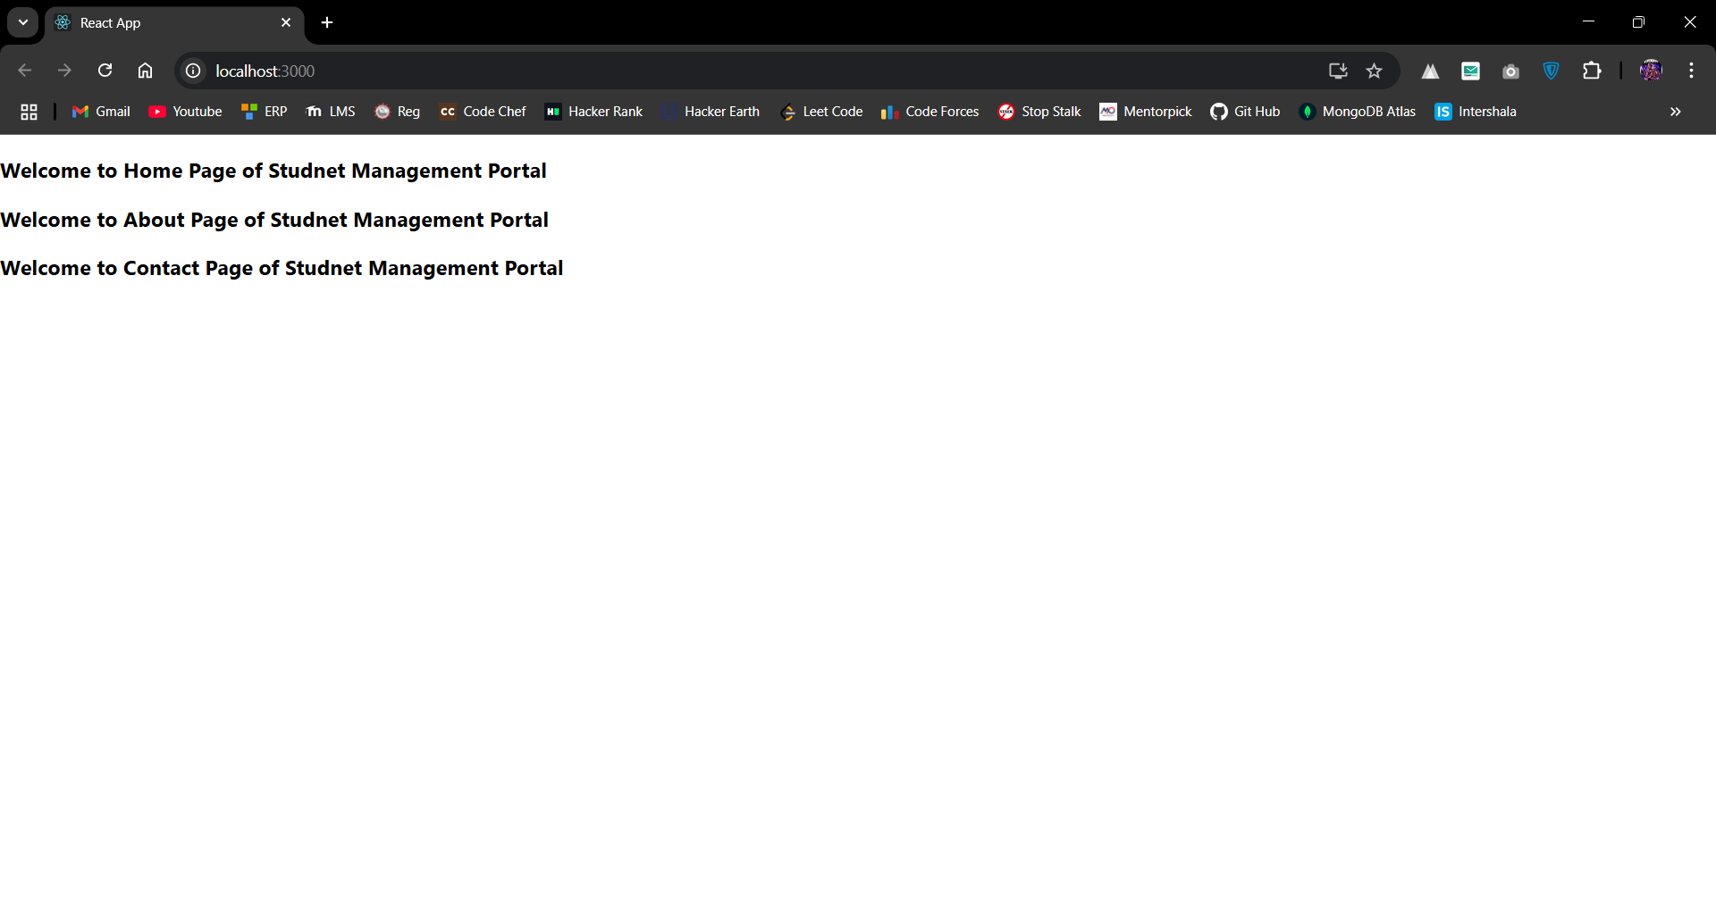

1. ReactJS-HOL

Code:

import '../Stylesheets/mystyle.css';

const percentToDecimal = (decimal) => {

    return (decimal.toFixed(2) + '%');

};

const calcScore = (total, goal) => {

    return percentToDecimal((total / goal) \* 100);

};

export const CalculateScore = ({ Name, School, total, goal }) => (

    <div className="formatstyle">

        <h1><font color="Brown">Student Details</font></h1>

        <div className="Name">

            <b><span> Name: </span></b>

            <span>{Name}</span>

        </div>

        <div className="School">

            <b><span> School: </span></b>

            <span>{School}</span>

        </div>

        <div className="Total">

            <b><span> Total:</span></b>

            <span>{total}</span>

            <span> Marks</span>

        </div>

        <div className="Score">

            <b> Score:</b>

            <span>

                {calcScore(total, goal)}

            </span>

        </div>

    </div>

);

.Name {

    font-weight: 300;

    color: blue;

}

.School {

    color: crimson;

}

.Total {

    color: darkmagenta;

}

.formatstyle {

    text-align: center;

    font-size: large;

}

.Score {

    color: forestgreen;

}

import { CalculateScore } from './Components/CalculateScore.js';

function App() {

    return (

        <div>

            <CalculateScore

                Name={"Steve"}

                School={"DNV Public School"}

                total={284}

                goal={300}

            />

        </div>

    );

}

export default App;

Output:

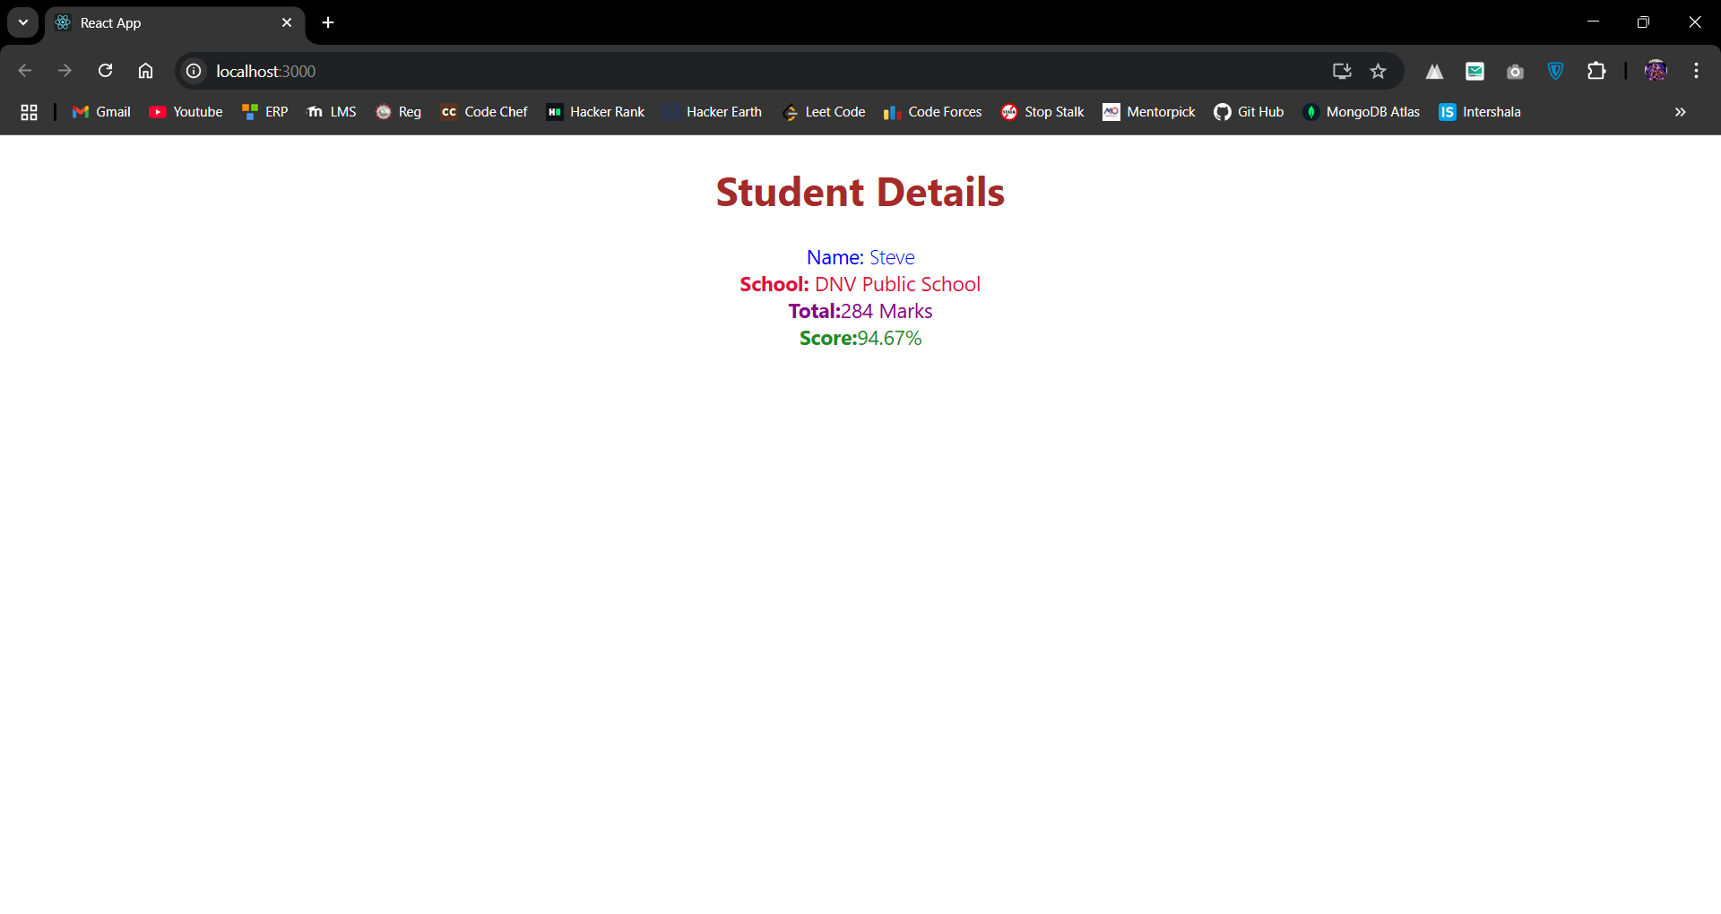

1. ReactJS-HOL

Code:

class Post{

    constructor(id,title,body){

        this.id = id;

        this.title = title;

        this.body = body;

    }

}

export default Post;

import React from 'react';

class Posts extends React.Component {

    constructor(props) {

        super(props);

        this.state = {

            posts: []

        };

    }

    componentDidMount() {

        this.loadPosts();

    }

    loadPosts() {

        fetch('https://jsonplaceholder.typicode.com/posts')

            .then(response => response.json())

            .then(data => {

                this.setState({ posts: data });

            })

            .catch(error => {

                console.error('Error fetching posts:', error);

            });

    }

    render() {

        return (

            <div>

                {this.state.posts.map(post => (

                    <div key={post.id}>

                        <h2>{post.title}</h2>

                        <p>{post.body}</p>

                    </div>

                ))}

            </div>

        );

    }

    componentDidCatch(error, info) {

        alert('An error occurred: ' + error.toString());

        console.error('Error caught in Posts component:', error, info);

    }

}

export default Posts;

import './App.css';

import Posts from './Posts';

function App() {

  return (

    <Posts/>

  );

}

export default App;

Output:

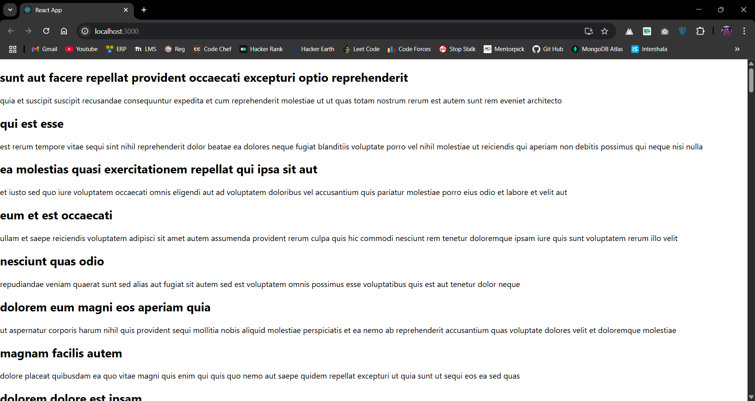

1. ReactJS-HOL

Code:

class Cohort {

    constructor(cohortCode,

        startDate,

        technology,

        trainerName,

        coachName,

        currentStatus) {

        this.cohortCode = cohortCode;

        this.coachName = coachName;

        this.trainerName = trainerName;

        this.technology = technology;

        this.startDate = startDate;

        this.currentStatus = currentStatus;

    }

}

const CohortsData =[

    new Cohort('INTADMDF10','22-Feb-2022', '.NET FSD', 'Jojo Jose','Aathma', 'Scheduled'),

    new Cohort('ADM21JF014','10-Sep-2021', 'Java FSD', 'Elisa Smith','Apoorv', 'Ongoing'),

    new Cohort('CDBJF21025','24-Dec-2021', 'Java FSD', 'John Doe','Aathma', 'Ongoing'),

    new Cohort('INTADMJF12','22-Feb-2022', 'Java FSD', 'To Be Assigned','Ibrahim', 'Scheduled'),

    new Cohort('CDE22JF011','24-Dec-2021', 'Java FSD', 'Emma Swan','Apoorv', 'Ongoing'),

    new Cohort('INTADMDF09','22-Feb-2022', 'Dataware Housing', 'Babjee Rao','Aathma', 'Scheduled'),

    new Cohort('ADM22DF001','10-Sep-2021', '.NET FSD', 'Marie Curie','Ibrahim', 'Ongoing'),

];

export {Cohort, CohortsData};

import styles from './CohortDetails.module.css';

function CohortDetails(props) {

    const statusClass = props.cohort.currentStatus.toLowerCase() === 'ongoing'

        ? styles.ongoing

        : styles.other;

    return (

        <div className={styles.box}>

            <h3 className={statusClass}>

                {props.cohort.cohortCode} -

                <span> {props.cohort.technology}</span>

            </h3>

            <dl>

                <dt>Started On</dt>

                <dd>{props.cohort.startDate}</dd>

                <dt>Current Status</dt>

                <dd>{props.cohort.currentStatus}</dd>

                <dt>Coach</dt>

                <dd>{props.cohort.coachName}</dd>

                <dt>Trainer</dt>

                <dd>{props.cohort.trainerName}</dd>

            </dl>

        </div>

    );

}

export default CohortDetails;

.box {

    width: 300px;

    display: inline-block;

    margin: 10px;

    padding: 10px 20px;

    border: 1px solid black;

    border-radius: 10px;

}

dt {

    font-weight: 500;

}

.ongoing {

    color: green;

}

.other {

    color: blue;

}

import './App.css';

import { CohortsData} from './Cohort'

import CohortDetails from './CohortDetails';

function App() {

  return (

  <div>

    <h1>Cohorts Details</h1>

    {CohortsData.map(cohort => <CohortDetails cohort={cohort}/>)}

  </div>

  );

}

export default App;

Output:

