9. ReactJS – HOL:

import React from 'react';

const ListofPlayers = () => {

  const players = [

    { name: 'Virat', score: 90 },

    { name: 'Rohit', score: 45 },

    { name: 'Dhoni', score: 75 },

    { name: 'Raina', score: 66 },

    { name: 'Ashwin', score: 30 },

    { name: 'Jadeja', score: 85 },

    { name: 'Shami', score: 50 },

    { name: 'Kohli', score: 77 },

    { name: 'Pandya', score: 62 },

    { name: 'Gill', score: 88 },

    { name: 'Kishan', score: 40 }

  ];

  const below70 = players.filter(player => player.score < 70);

  return (

    <div>

      <h2>All Players</h2>

      <ul>

        {players.map((player, index) => (

          <li key={index}>{player.name} - {player.score}</li>

        ))}

      </ul>

      <h3>Players with score below 70</h3>

      <ul>

        {below70.map((player, index) => (

          <li key={index}>{player.name} - {player.score}</li>

        ))}

      </ul>

    </div>

  );

};

export default ListofPlayers;

import React from 'react';

const IndianPlayers = () => {

  const allPlayers = ['Virat', 'Rohit', 'Dhoni', 'Raina', 'Ashwin', 'Jadeja'];

  const oddTeam = allPlayers.filter((_, index) => index % 2 === 0);

  const evenTeam = allPlayers.filter((_, index) => index % 2 !== 0);

  const T20Players = ['Surya', 'Hardik', 'Gill'];

  const RanjiTrophyPlayers = ['Pujara', 'Rahane'];

  const mergedPlayers = [...T20Players, ...RanjiTrophyPlayers];

  return (

    <div>

      <h2>Odd Team Players</h2>

      <ul>

        {oddTeam.map((player, index) => (

          <li key={index}>{player}</li>

        ))}

      </ul>

      <h2>Even Team Players</h2>

      <ul>

        {evenTeam.map((player, index) => (

          <li key={index}>{player}</li>

        ))}

      </ul>

      <h2>Merged Players (T20 + Ranji)</h2>

      <ul>

        {mergedPlayers.map((player, index) => (

          <li key={index}>{player}</li>

        ))}

      </ul>

    </div>

  );

};

export default IndianPlayers;

import React from 'react';

import ListofPlayers from './components/ListofPlayers';

import IndianPlayers from './components/IndianPlayers';

function App() {

  const flag = true;

  return (

    <div className="App">

      <h1>🏏 Cricket App</h1>

      {flag ? <ListofPlayers /> : <IndianPlayers />}

    </div>

  );

}

export default App;

Output:

10. ReactJS – HOL

import React from 'react';

function App() {

  // Single office object

  const singleOffice = {

    name: "Tech Tower",

    rent: 55000,

    address: "MG Road, Bangalore"

  };

  // List of office spaces

  const officeList = [

    { name: "Startup Hub", rent: 45000, address: "Koramangala, Bangalore" },

    { name: "BizNest", rent: 70000, address: "Hitech City, Hyderabad" },

    { name: "CodeSpace", rent: 62000, address: "Cyber Park, Noida" },

    { name: "InnoSpace", rent: 58000, address: "T-Nagar, Chennai" }

  ];

  // Style function for rent

  const rentStyle = (rent) => ({

    color: rent > 60000 ? 'green' : 'red',

    fontWeight: 'bold'

  });

  return (

    <div className="App">

      {/* Heading element */}

      <h1>Office Space Rental Portal</h1>

      {/* Image element */}

      <img

        src="https://images.unsplash.com/photo-1586262611739-1fbe8b248e16"

        alt="Office Space"

        width="500px"

      />

      {/* Single office details */}

      <h2>Featured Office:</h2>

      <p><strong>Name:</strong> {singleOffice.name}</p>

      <p style={rentStyle(singleOffice.rent)}>

        <strong>Rent:</strong> ₹{singleOffice.rent}

      </p>

      <p><strong>Address:</strong> {singleOffice.address}</p>

      {/* Looping through office list */}

      <h2>Available Spaces:</h2>

      <ul>

        {officeList.map((office, index) => (

          <li key={index}>

            <p><strong>Name:</strong> {office.name}</p>

            <p style={rentStyle(office.rent)}><strong>Rent:</strong> ₹{office.rent}</p>

            <p><strong>Address:</strong> {office.address}</p>

          </li>

        ))}

      </ul>

    </div>

  );

}

export default App;

Output:

11. ReactJS – HOL:

import React, { Component } from 'react';

class EventHandlers extends Component {

  constructor(props) {

    super(props);

    this.state = {

      count: 0,

      message: ''

    };

    this.increment = this.increment.bind(this);

    this.sayHello = this.sayHello.bind(this);

    this.handleWelcome = this.handleWelcome.bind(this);

  }

  increment() {

    this.setState(prev => ({ count: prev.count + 1 }));

    this.sayHello();

  }

  decrement = () => {

    this.setState(prev => ({ count: prev.count - 1 }));

  };

  sayHello() {

    this.setState({ message: 'Hello! Count has been updated.' });

  }

  handleWelcome(msg) {

    this.setState({ message: `Welcome Message: ${msg}` });

  }

  handleSyntheticEvent = (e) => {

    e.preventDefault(); // Synthetic event

    this.setState({ message: 'I was clicked' });

  };

  render() {

    return (

      <div>

        <h2>React Event Handling</h2>

        <p>Count: {this.state.count}</p>

        <button onClick={this.increment}>Increment</button>

        <button onClick={this.decrement}>Decrement</button>

        <br /><br />

        <button onClick={() => this.handleWelcome('Welcome to React!')}>Say Welcome</button>

        <br /><br />

        <button onClick={this.handleSyntheticEvent}>Click Me (Synthetic Event)</button>

        <br /><br />

        <p>{this.state.message}</p>

      </div>

    );

  }

}

export default EventHandlers;

import React, { useState } from 'react';

const CurrencyConvertor = () => {

  const [rupees, setRupees] = useState('');

  const [euro, setEuro] = useState('');

  const handleSubmit = (e) => {

    e.preventDefault(); // synthetic event

    const rupeeValue = parseFloat(rupees);

    if (!isNaN(rupeeValue)) {

      setEuro((rupeeValue / 89.5).toFixed(2)); // Assume 1 Euro = 89.5 INR

    }

  };

  return (

    <div>

      <h2>Currency Convertor</h2>

      <form onSubmit={handleSubmit}>

        <label>Enter amount in INR:</label><br />

        <input

          type="number"

          value={rupees}

          onChange={(e) => setRupees(e.target.value)}

        /><br /><br />

        <button type="submit">Convert</button>

      </form>

      {euro && (

        <p>Converted to Euros: €{euro}</p>

      )}

    </div>

  );

};

export default CurrencyConvertor;

// src/App.js

import React from 'react';

import EventHandlers from './EventHandlers';

import CurrencyConvertor from './CurrencyConvertor';

function App() {

  return (

    <div className="App">

      <EventHandlers />

      <hr />

      <CurrencyConvertor />

    </div>

  );

}

export default App;

Output:

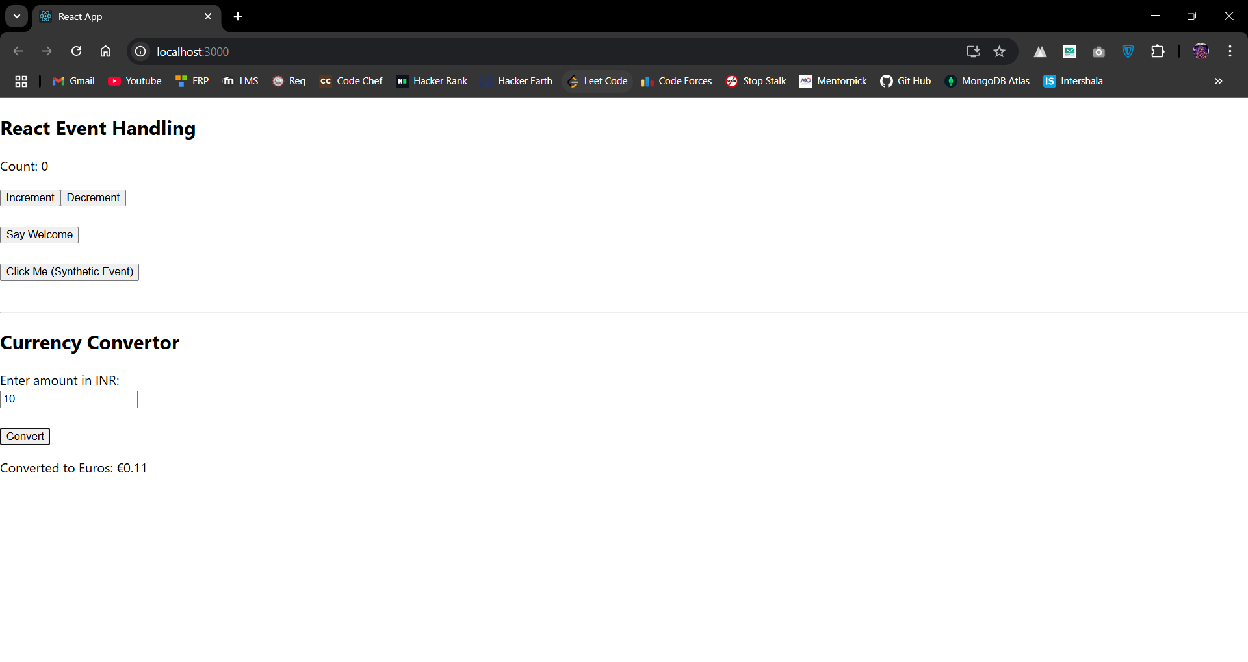

12. ReactJS – HOL:

import React from 'react';

const GuestPage = () => {

  return (

    <div>

      <h2>Welcome Guest!</h2>

      <p>You can browse available flights below:</p>

      <ul>

        <li>Flight A - 10:00 AM</li>

        <li>Flight B - 01:00 PM</li>

        <li>Flight C - 06:30 PM</li>

      </ul>

    </div>

  );

};

export default GuestPage;

import React from 'react';

const UserPage = () => {

  return (

    <div>

      <h2>Welcome Back!</h2>

      <p>You can now book tickets:</p>

      <ul>

        <li>Book Flight A</li>

        <li>Book Flight B</li>

        <li>Book Flight C</li>

      </ul>

    </div>

  );

};

export default UserPage;

import React, { useState } from 'react';

import GuestPage from './GuestPage';

import UserPage from './UserPage';

function App() {

  const [isLoggedIn, setIsLoggedIn] = useState(false);

  const handleLoginToggle = () => {

    setIsLoggedIn(prev => !prev);

  };

  let pageContent;

  if (isLoggedIn) {

    pageContent = <UserPage />;

  } else {

    pageContent = <GuestPage />;

  }

  return (

    <div className="App">

      <h1>✈️ Ticket Booking App</h1>

      <button onClick={handleLoginToggle}>

        {isLoggedIn ? 'Logout' : 'Login'}

      </button>

      {pageContent}

    </div>

  );

}

export default App;

Output:

13. ReactJS – HOL:

import React from 'react';

const BookDetails = ({ books }) => {

  return (

    <div>

      <h2>📚 Book List</h2>

      {books.length === 0 ? (

        <p>No books available.</p>

      ) : (

        <ul>

          {books.map((book, index) => (

            <li key={index}>

              <strong>{book.title}</strong> by {book.author}

            </li>

          ))}

        </ul>

      )}

    </div>

  );

};

export default BookDetails;

import React from 'react';

const BlogDetails = ({ blogs }) => {

  return (

    <div>

      <h2>📝 Blog Posts</h2>

      {blogs.length > 0 &&

        blogs.map((blog, idx) => (

          <div key={idx}>

            <h4>{blog.title}</h4>

            <p>{blog.content}</p>

          </div>

        ))}

    </div>

  );

};

export default BlogDetails;

import React from 'react';

const CourseDetails = ({ courses }) => {

  if (!courses || courses.length === 0) return null;

  return (

    <div>

      <h2>🎓 Available Courses</h2>

      <ul>

        {courses.map((course) => (

          <li key={course.id}>

            {course.name} - {course.duration} months

          </li>

        ))}

      </ul>

    </div>

  );

};

export default CourseDetails;

import React, { useState } from 'react';

import BookDetails from './BookDetails';

import BlogDetails from './BlogDetails';

import CourseDetails from './CourseDetails';

function App() {

  const [showBooks, setShowBooks] = useState(true);

  const [showBlogs, setShowBlogs] = useState(true);

  const [showCourses, setShowCourses] = useState(true);

  const books = [

    { title: "React Mastery", author: "Dan Abramov" },

    { title: "JavaScript Deep Dive", author: "Kyle Simpson" },

  ];

  const blogs = [

    { title: "Why React?", content: "React is a JavaScript library..." },

    { title: "JSX Tips", content: "JSX lets you write HTML in JS..." },

  ];

  const courses = [

    { id: 1, name: "React Basics", duration: 3 },

    { id: 2, name: "Advanced JS", duration: 2 },

  ];

  return (

    <div className="App">

      <h1>🧑‍💻 BloggerApp</h1>

      <button onClick={() => setShowBooks(!showBooks)}>

        Toggle Books

      </button>

      <button onClick={() => setShowBlogs(!showBlogs)}>

        Toggle Blogs

      </button>

      <button onClick={() => setShowCourses(!showCourses)}>

        Toggle Courses

      </button>

      <hr />

      {showBooks ? <BookDetails books={books} /> : <p>Books section hidden.</p>}

      {showBlogs && <BlogDetails blogs={blogs} />}

      <CourseDetails courses={showCourses ? courses : []} />

    </div>

  );

}

export default App;

