**10. Understanding Import Sets in ServiceNow**

The Import Set [sys_import_set] Table

In order to keep the imported records in our Staging table organized, ServiceNow provides an out-of-box table named Import Set [sys_import_set]. Each time an import run is executed, the platform adds a record to the Import Set table. That record represents the import run, or the set of data. As the imported rows are added to the Staging table, each record is marked with a reference to the Import Set record. The Set attribute is used to store that reference. This allows us to organize and identify that our 40 staged records are distributed between 2 Import Sets.

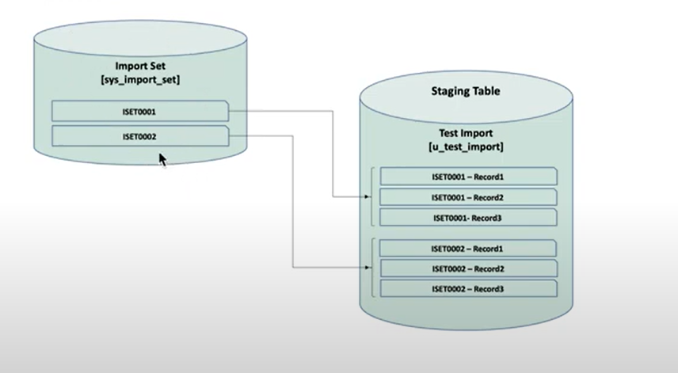

To create an import set we need to navigate to Data source > Administration > System Import Sets. Which will give the already existing data records.

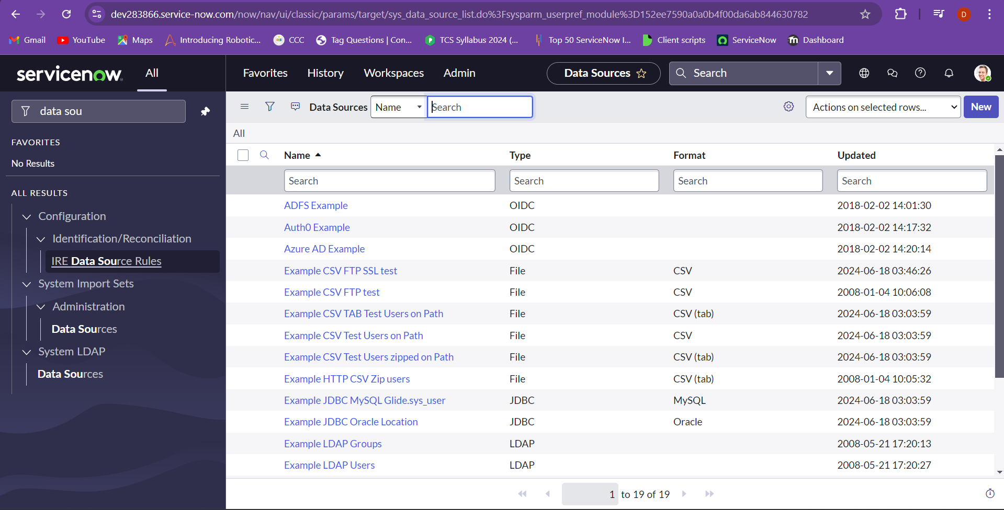

Select the new to create the new import set.

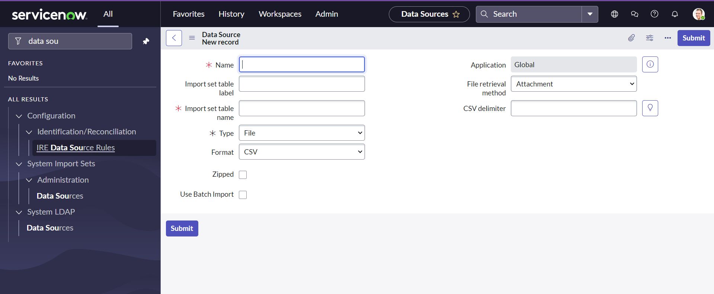

Now we enter the details and the import set table name will be automatically filled and choose the format of file that needs to be attached and we choose the excel format and application is set to global by default. File retrieval method is choosen to attached.

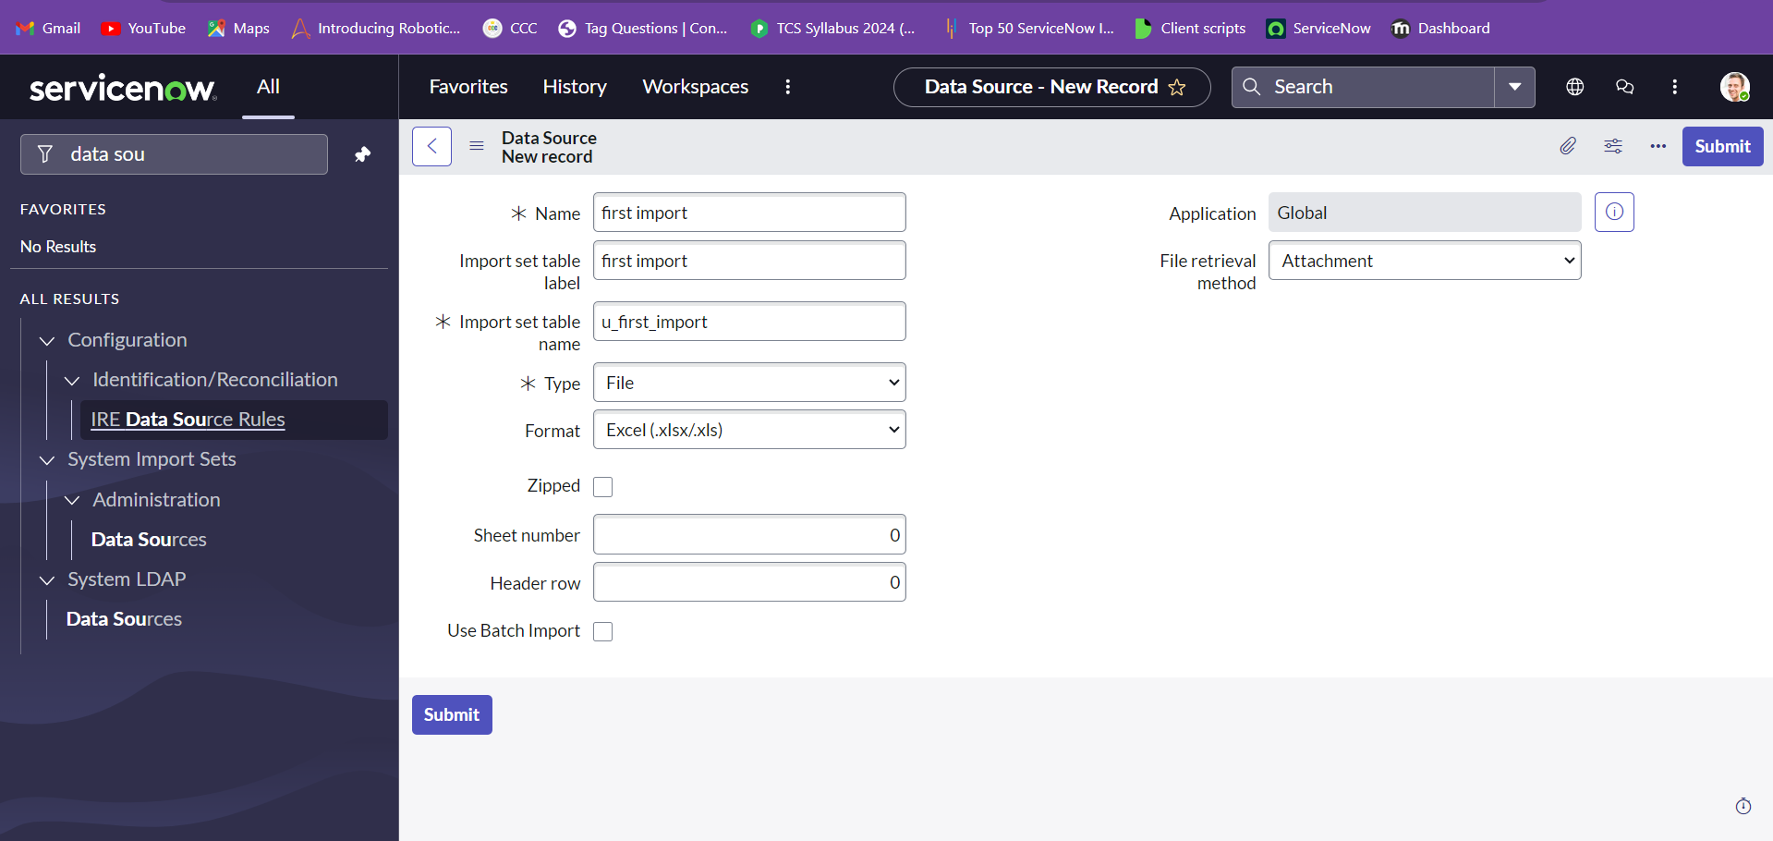

Search for the table created after submitting.

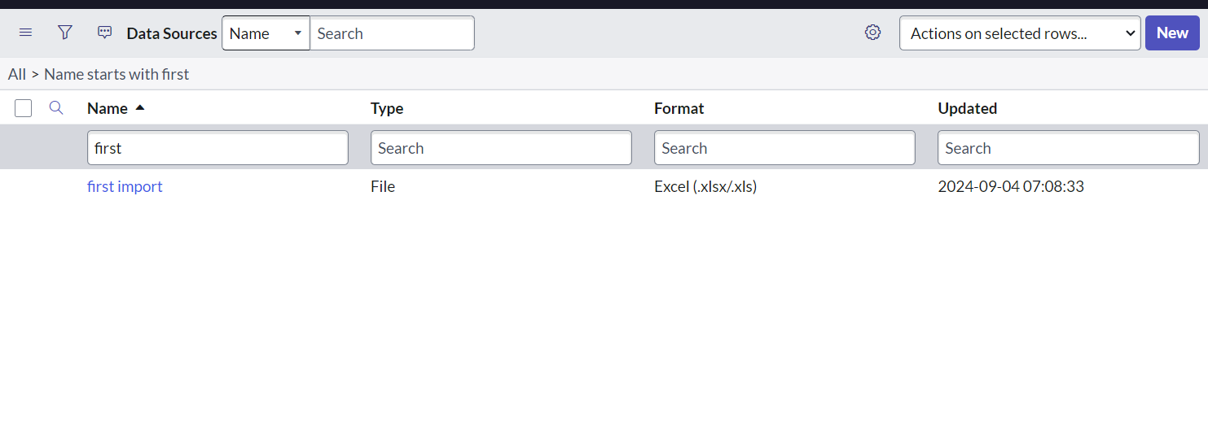

Now we can attach the file with the format mentioned previously.

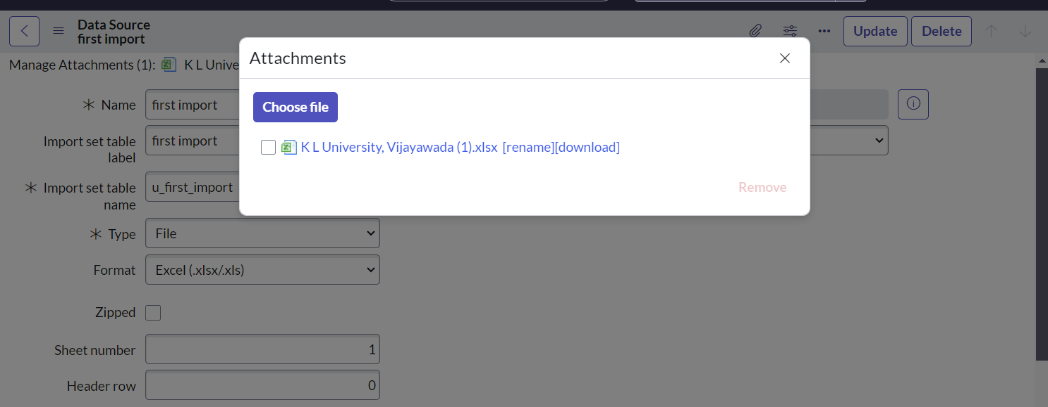

After giving the excel, choose upload. Now we go to the end of the form and choose the load all records.

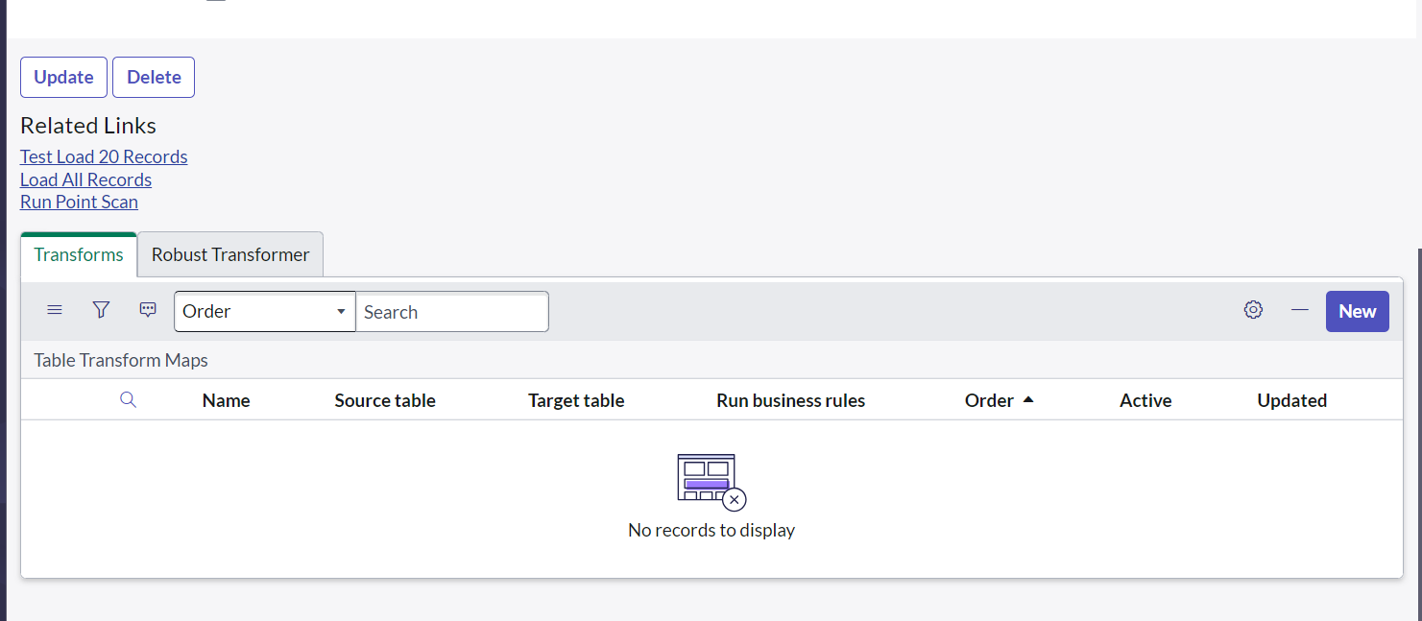

If the excel is successfully uploaded we can see the state and completion code of the excel.

