**11.ServiceNow Transform Maps & Field Maps**

Field maps: defining how data flows from the staging table to the Target is done on a field by field basis. 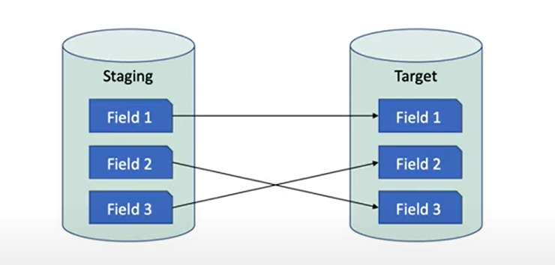

Type the list name sys_transform_entry.list in the navigation to get the list

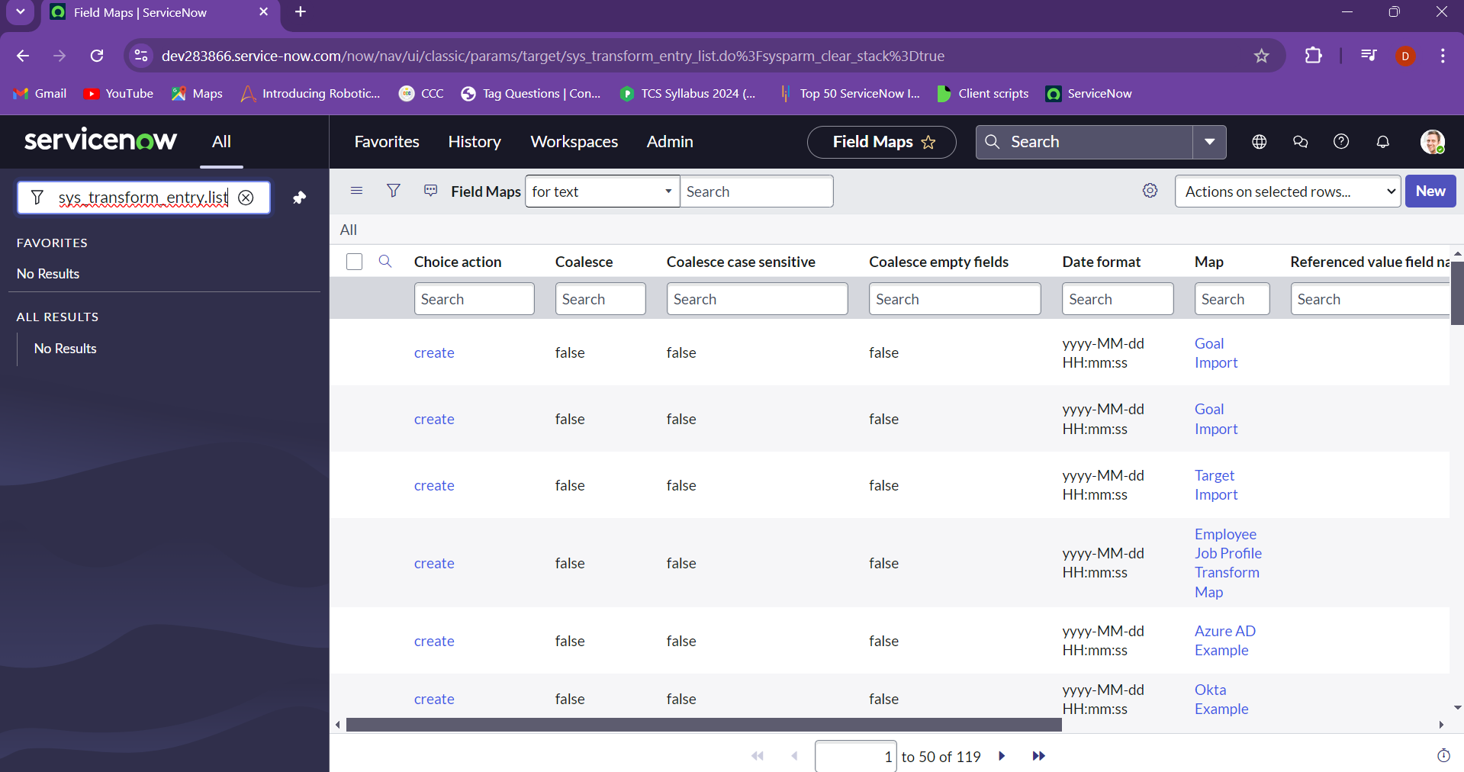

Transform maps: the grouping tool used to group fields is called as transform maps

Type sys_transform_map.list in the navigation bar to get the list

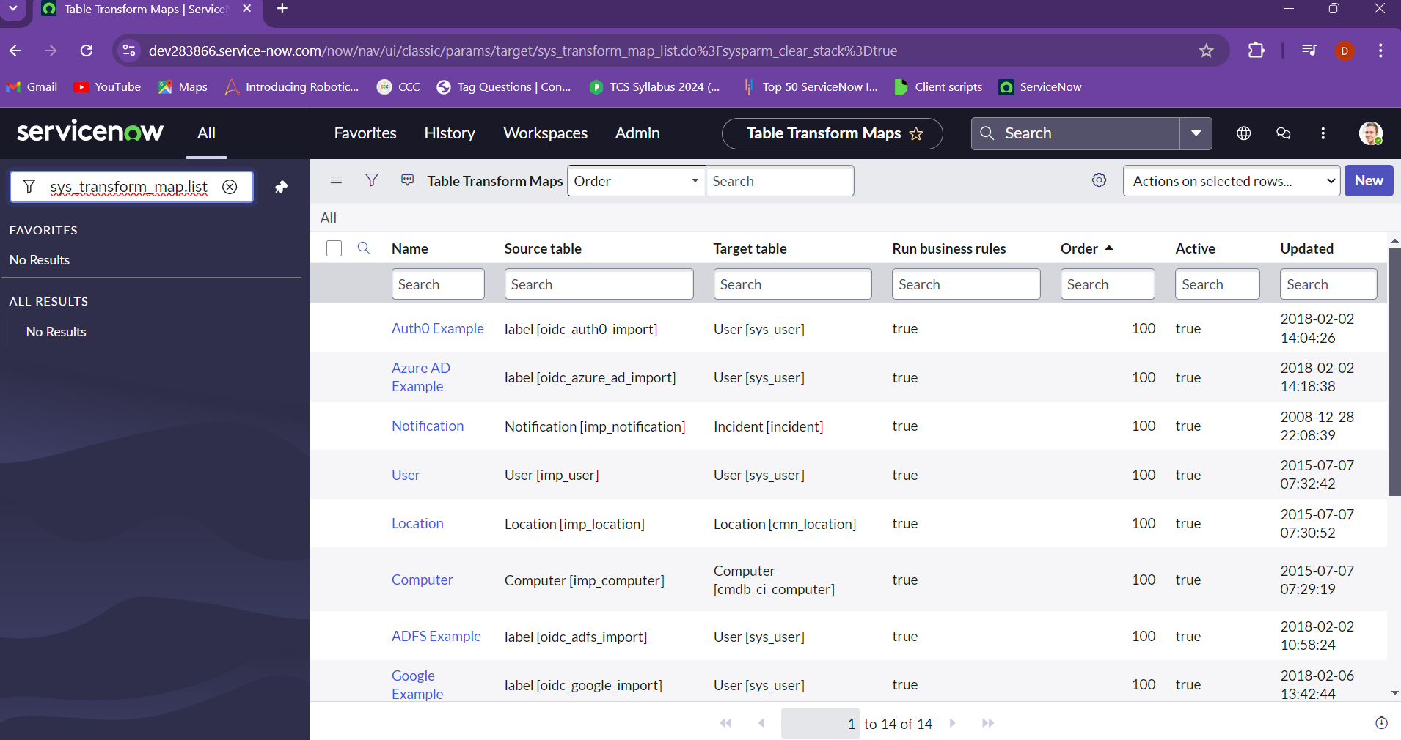

It would be more suggestable to create the transform map before as we create the group and then add the fields that are needed.

For the above we need to create a table, as we go to tables click on new and then give a name “my table” and save it

Now create the transform map by giving the name as “test transform map” and set the source table to “user[imp_user]” and set the target table as “my table” and click on submit.

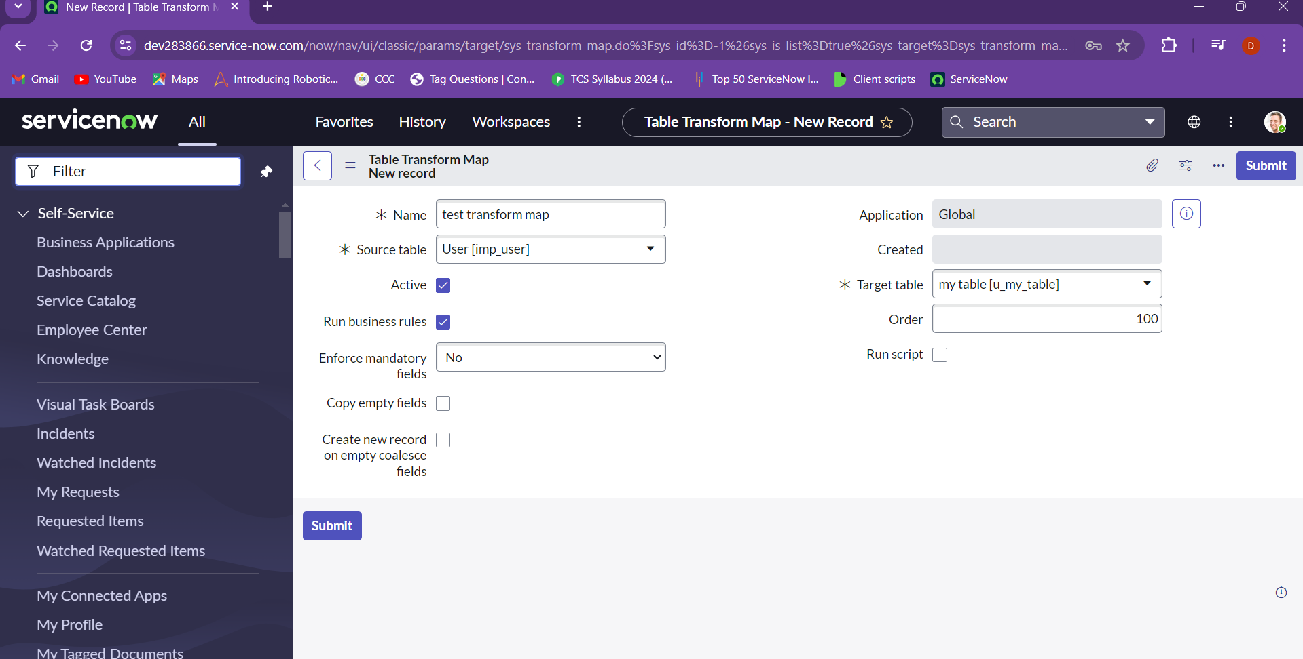

Now you will be getting the choice to add the fields into your transform without actually creating it separately.

Choose the mapping assist for easy acess.

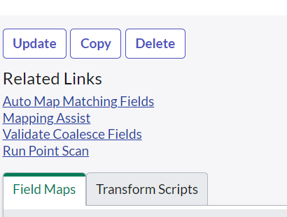

Add the fields from the source table and the target table and save.

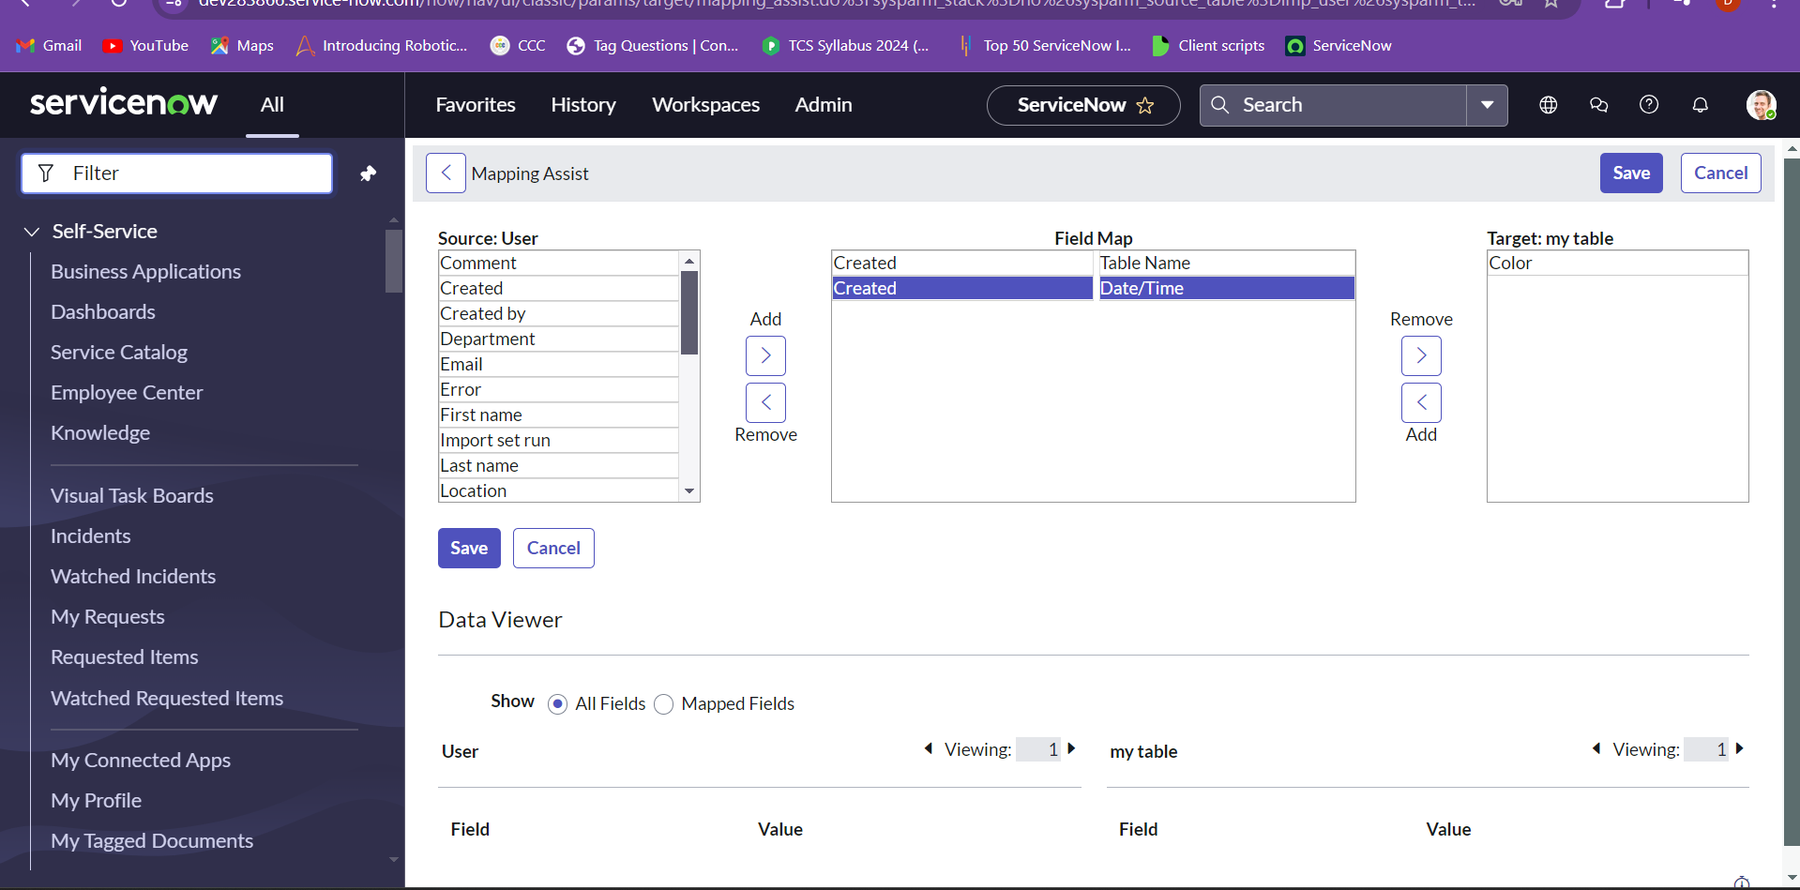

The fields have been added to the transform map and the coalesce is marked false by default. We can change the coalesce by clicked and checking the check box.

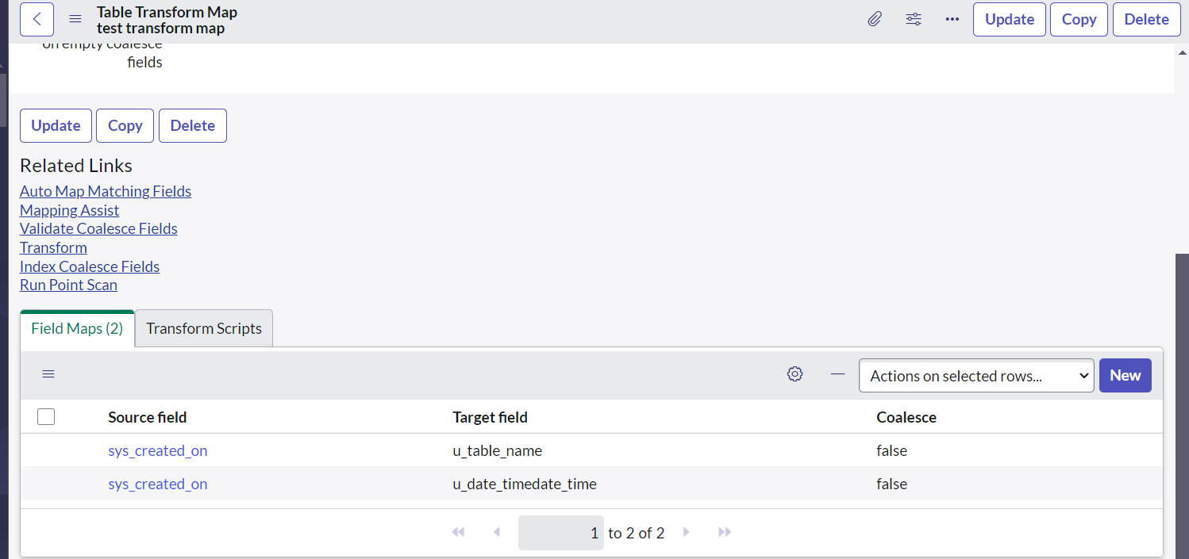

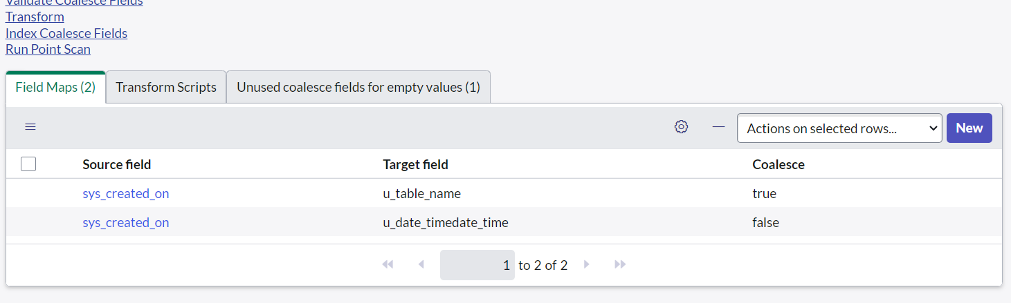

And now we can see the changed coalesce field. To check if the fields were added we can navigate to sys_transform_entry.list to check the fields. 