**12.ServiceNow Incident Management Tutorial and Task Administration**

Task: a task is some item of work that needs to get done. In servicenow, each Task is represented by a record in a database table named Task[task].

There are different attributes that define each record data and they are common to all types of tasks.

To get to tasks we need to enter task.list in the navigation bar.

The task table contains three sub groups which are:

* change request
* incident
* problem

These sub division have the inherited attributes from the task table along with their own attributes. We don’t directly create the task table, we create the sub group mentioned above and these get into the task table. There are many other types or divisions based on the type of task we want to mention but we would learn about these three.

Task Management

* Defining and managing tasks in ServiceNow allow you to take common work that needs to be done and build repeatable processes to efficiently get it done
* Assignment Rules auto assign tasks to users or groups, making sure they are handled by the most appropriate team members
* Approvals can be created for a list of approvers (manually or automatically) according to approval rules
* Service Level Agreements track the amount of time a task has been open to ensure they are completed within an allotted time
* Inactivity Monitors ensure that tasks don't fall through the cracks by notifying when tasks are untouched for a predefined period

Task assignment:

Tasks can be assigned to an individual user or a group of users(or both). Which means the issue is given to a particular group or a single member of that group to solve and user can be in any number of groups but a group should contain only one.

The task needs to be assigned to only one user or one group. Task assignment is done using assignment rules.

All>System Policy>Rules>Assignment

Go to the assignment rules in the system policy.

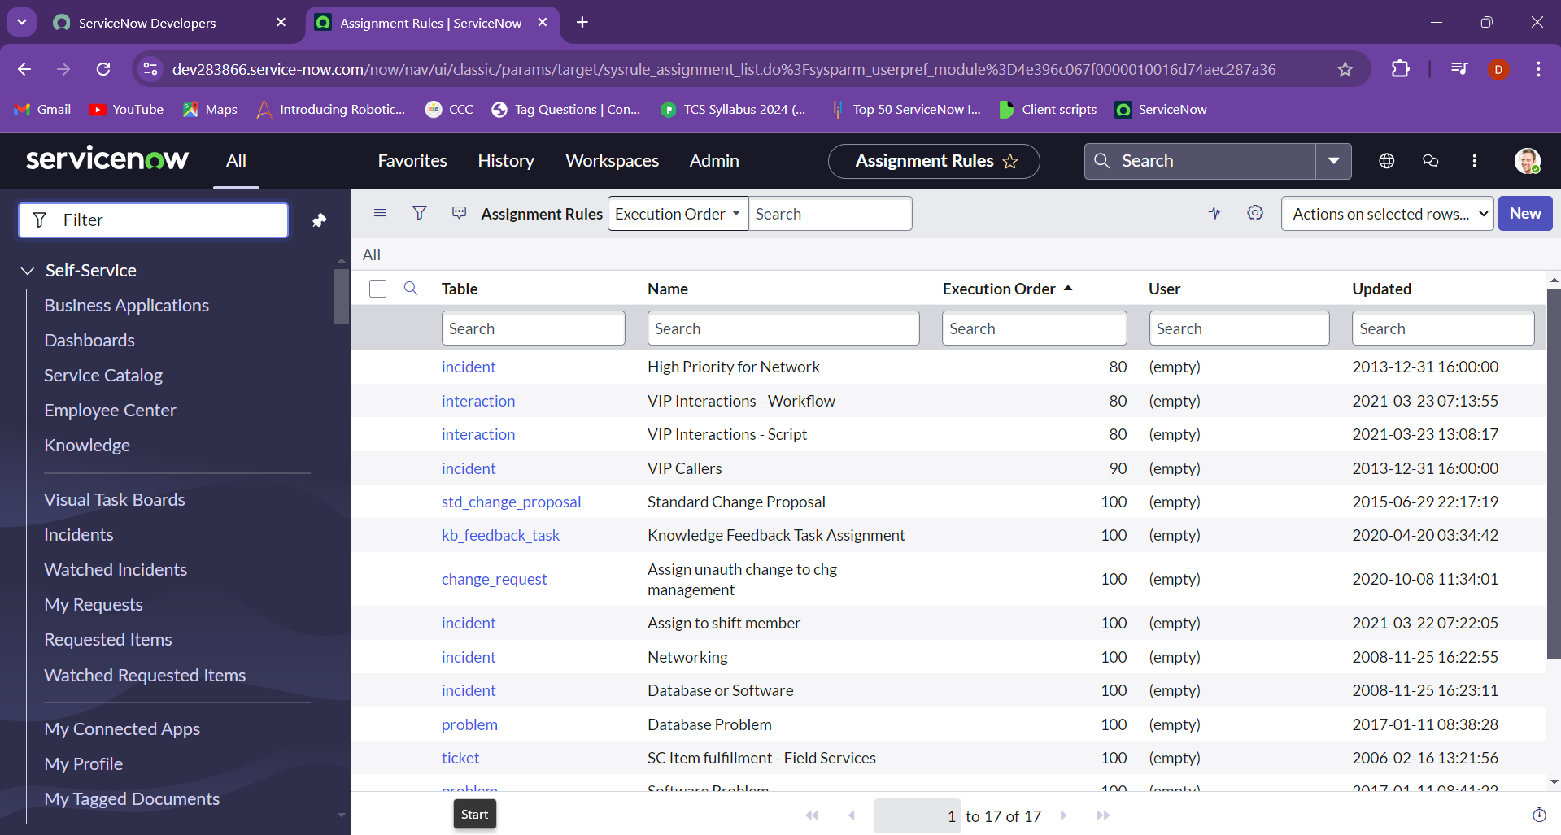

Type the table name as incident and you will get a list of incident named tables and set the execution order from low to high. Lowest number gets executed first.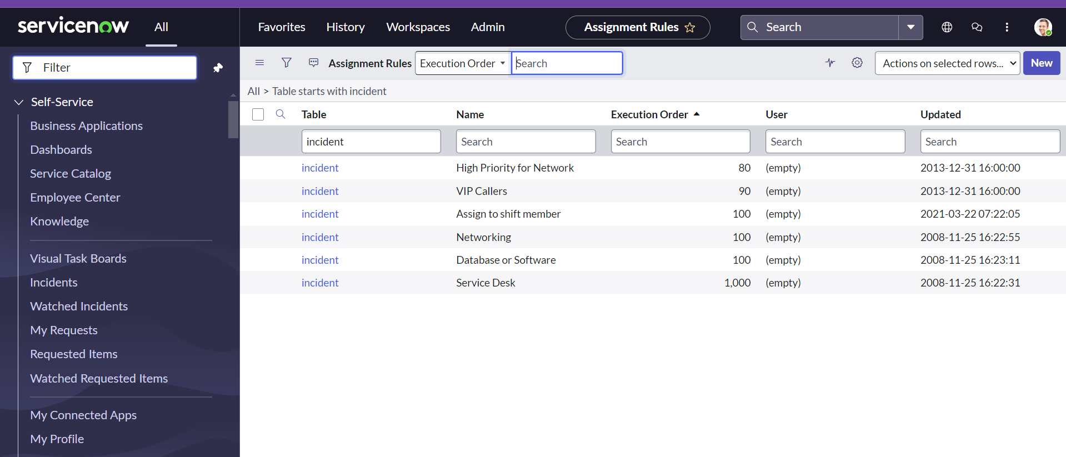

Click on new and add the name as Hardware Incidents and choose the condition based on your requirement as I choose the category is Hardware. 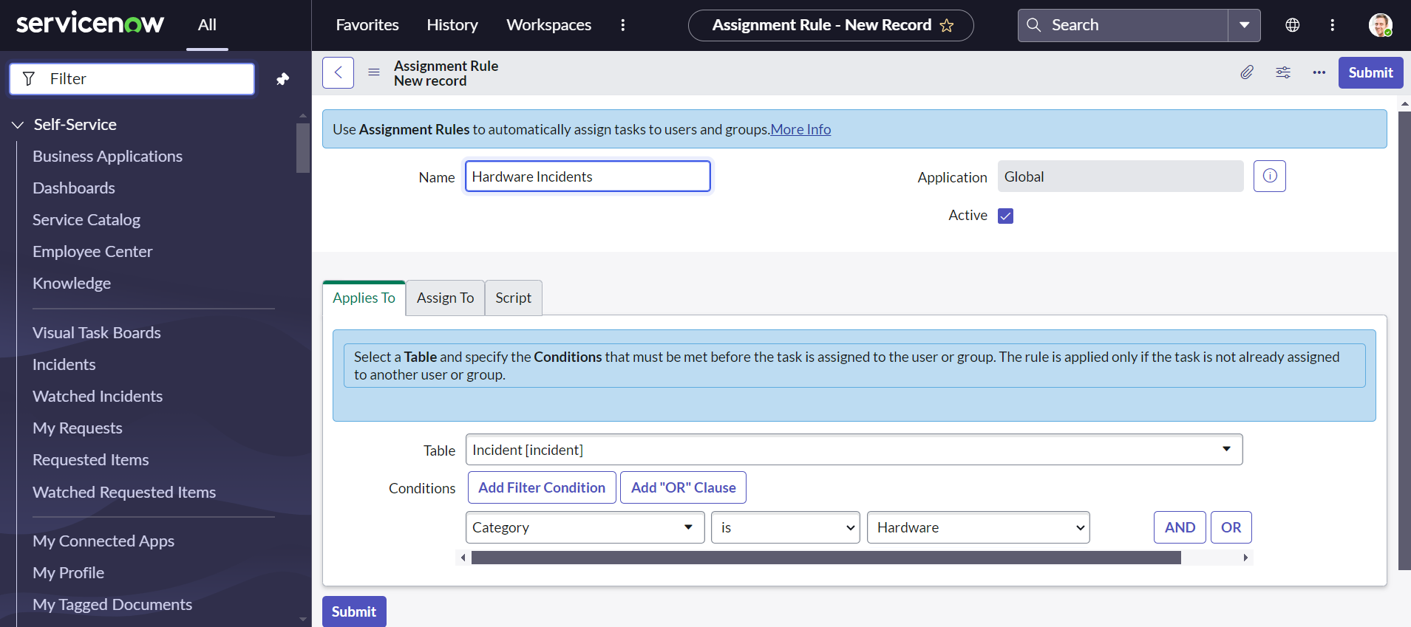

Choose the assign to as follows and submit: 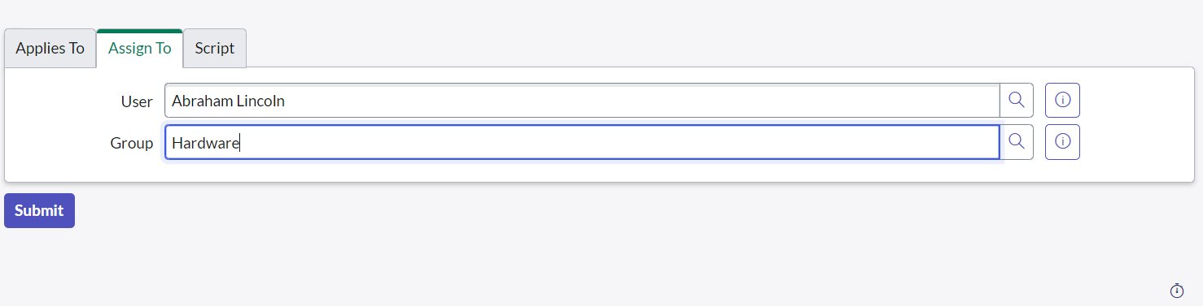

Now we change the execution order to any lowest and create an icident to check the assignment rule and give the caller category and short description as needed.

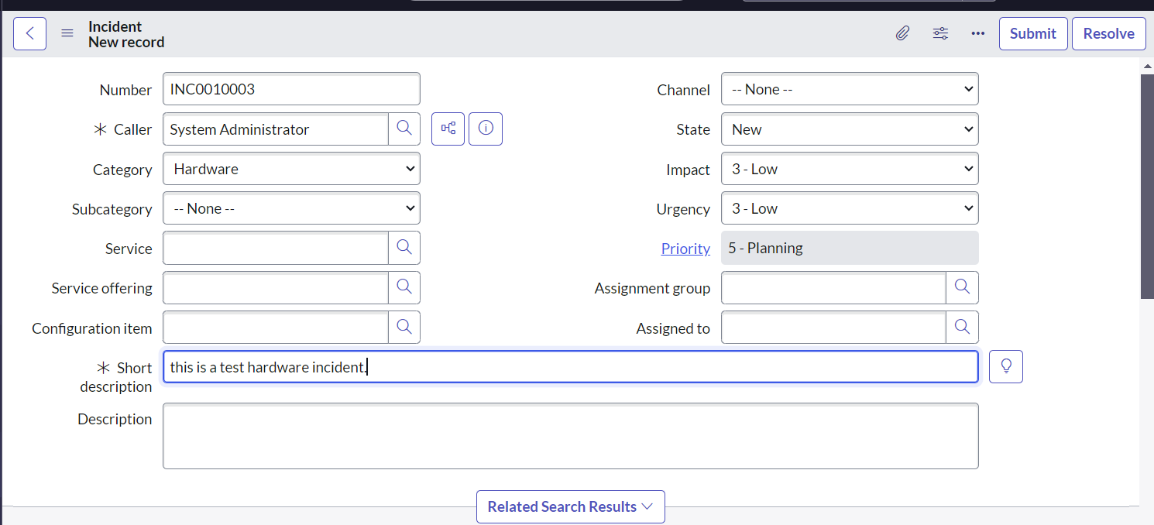

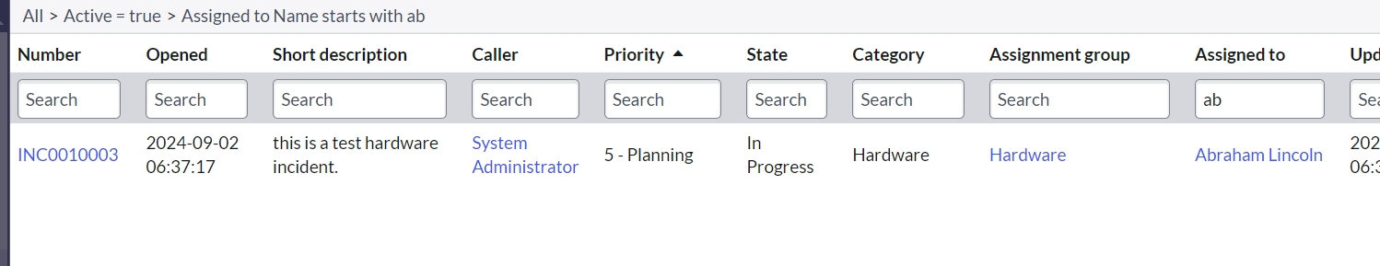as we can see it is assigned to Abraham Lincoln.

Now coming to assigning tasks to work we can go to service desk and choose my work or my group work inorder to see the assigned work status.

Task Collaboration- user presence allows multiple stakeholders to view and update a record simultaneously.

The Active Viewers Icon will display on the header bar when another user is viewing the record at the same time.

The Real-time Editing (Pulse) Icon will display beside a field that has been changed by another user.

The changes that are made in any one user or the administrator will be immediately reflected to the other users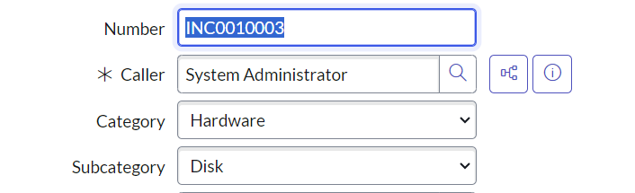

When we click the activity stream we will be going to the notes where we can give notes and will be viewed by larger group of people.

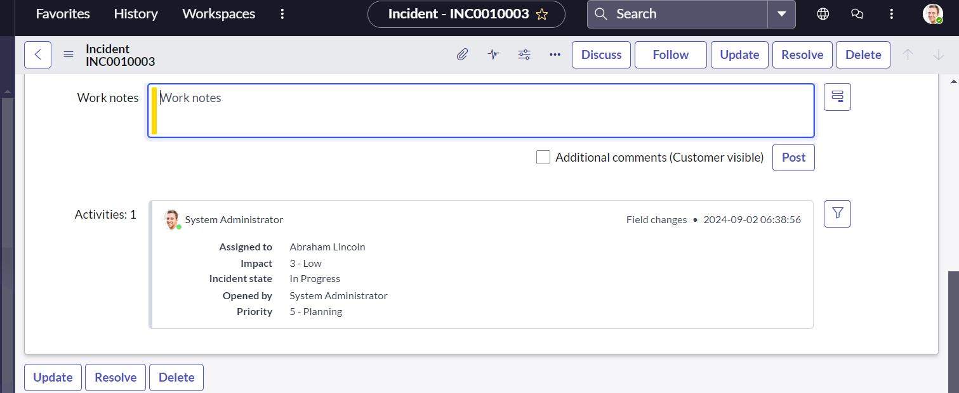

Visual task board: graphical presentation of tasks using the drag and drop model.

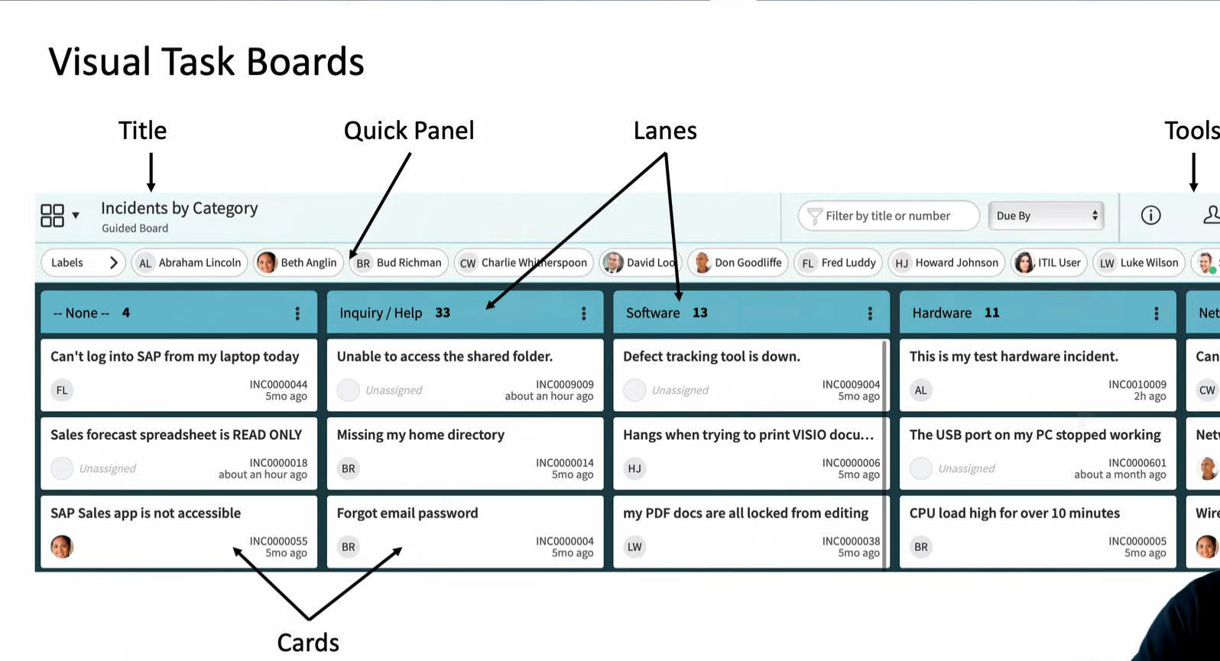

To go to the visual task board we can type the visual task board and choose the table or create a board. 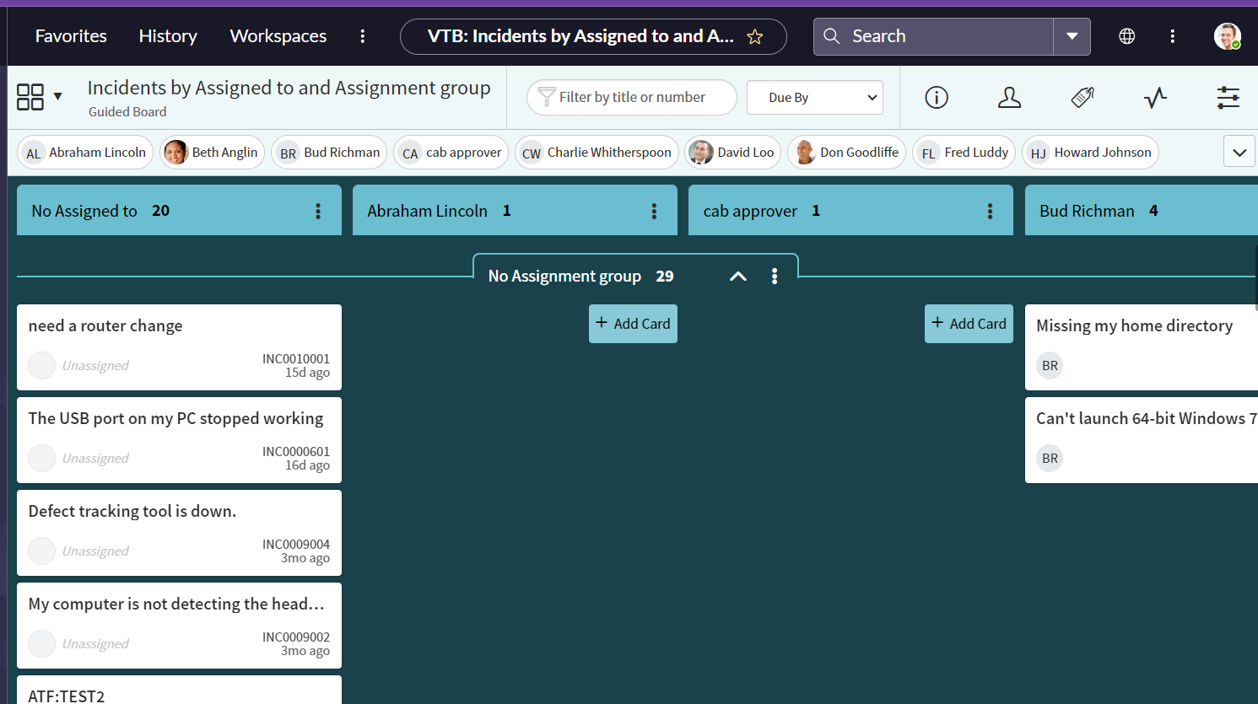

We can move the incidents from “no assigned to” to “assigned to” and the info gives the information of the table, Label shows the labeling of the incident, profile shows who the task is assingned to and activity shows the description and etc.

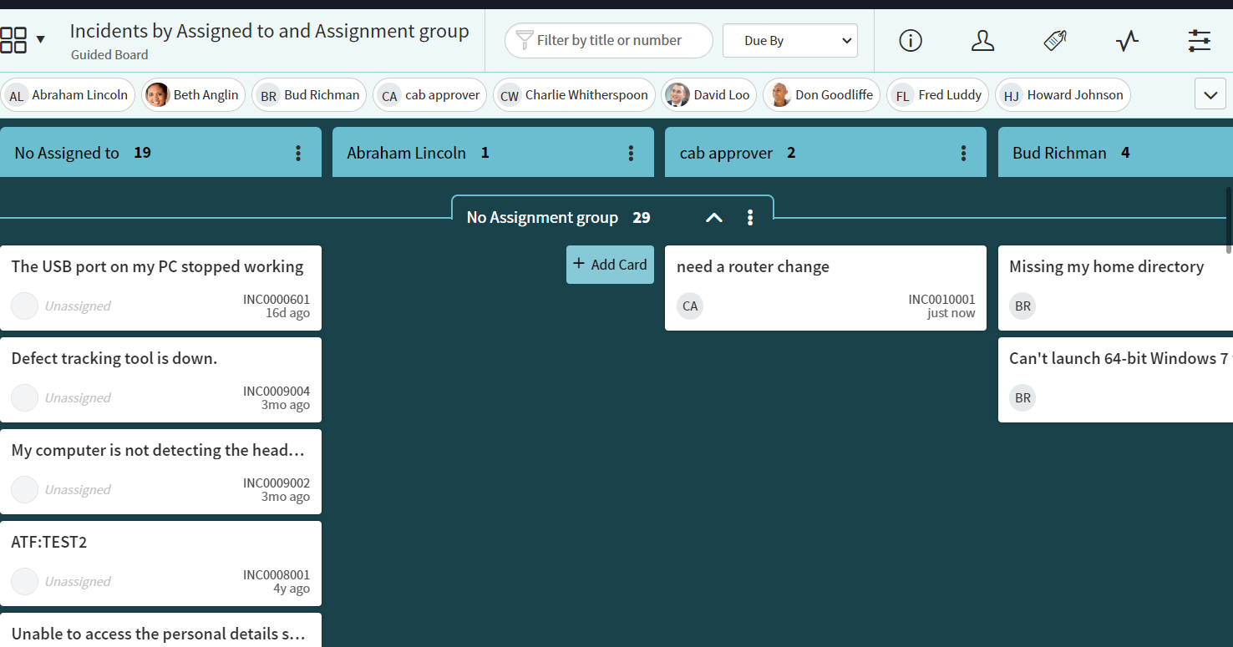

Visual Task Board Types

Guided

* Normally created from a list using an attribute that has a pre-defined set of values as lanes
* Task values are changed when cards are moved between lanes

Flexible

* Normally created from a list using an attribute that does not have a pre-defined set of values as lanes
* Tasks values are not changed when cards are moved between lanes

Freeform

* Not created from a list
* Used for personalized work management via Private tasks

**13.ServiceNow Reporting Tutorial**

ServiceNow provides a comprehensive reporting and analytics platform for monitoring and managing IT services and operations.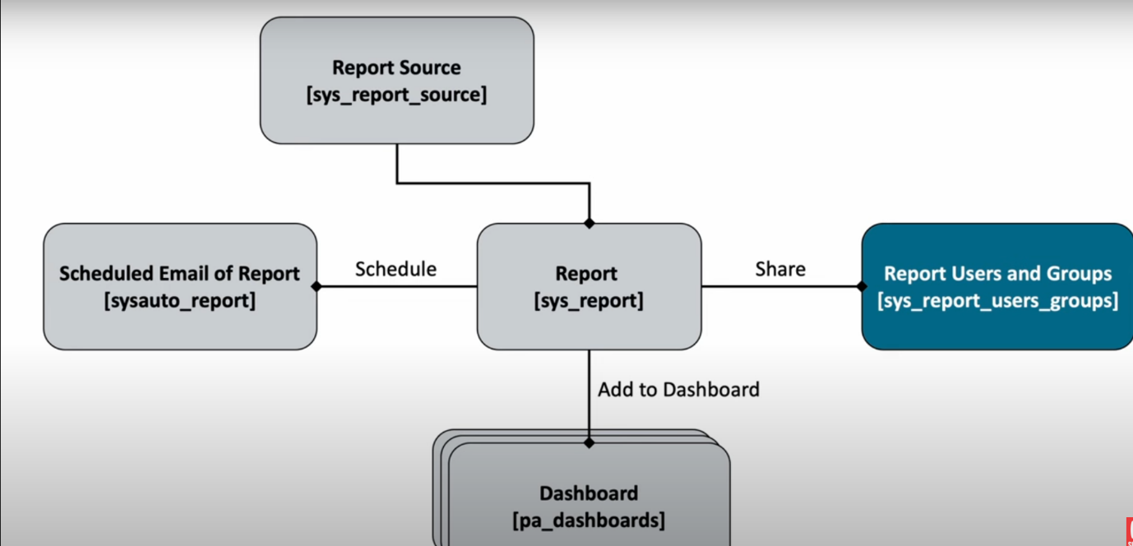

To create reports: Go to Reports > View / Create.

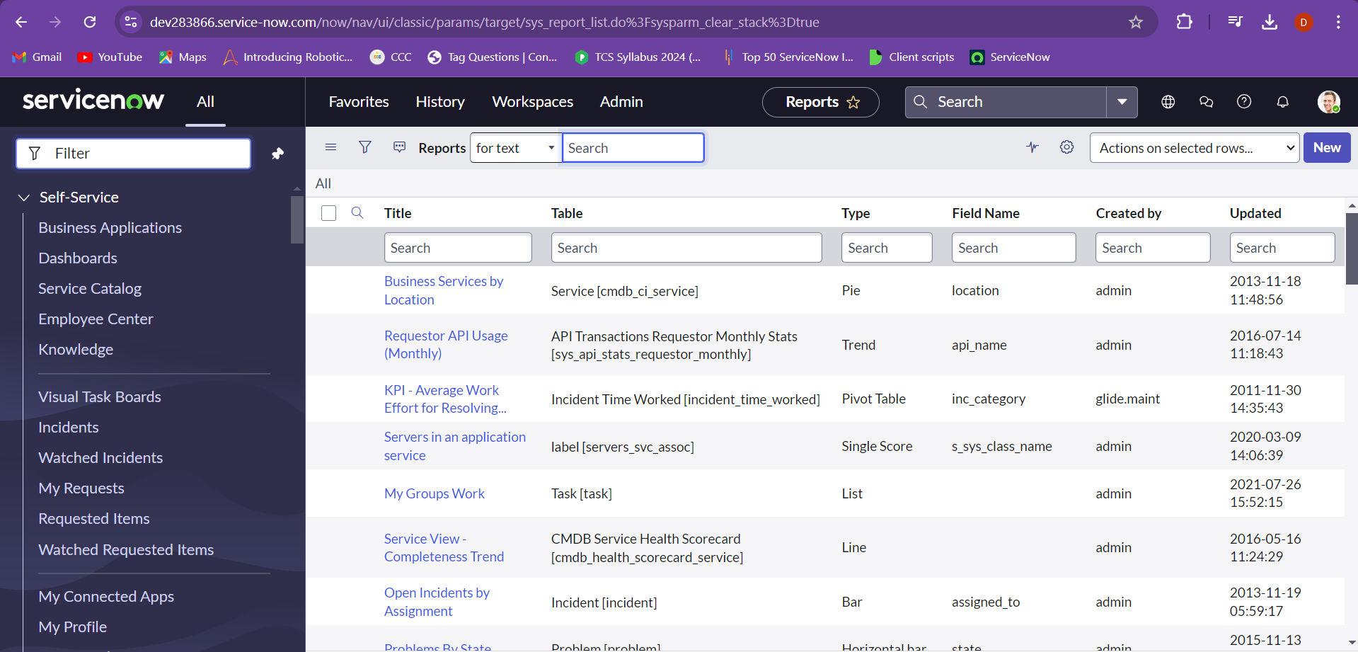

The personalisation list helps in adding or removing attributes or fields into the table.

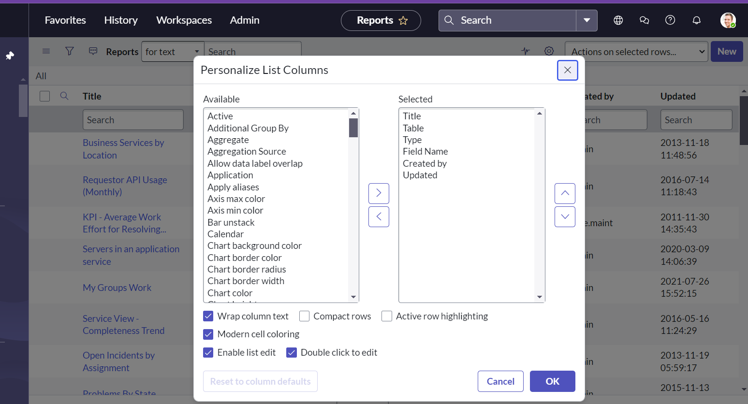

Go to configure on the title field and then choose the table.

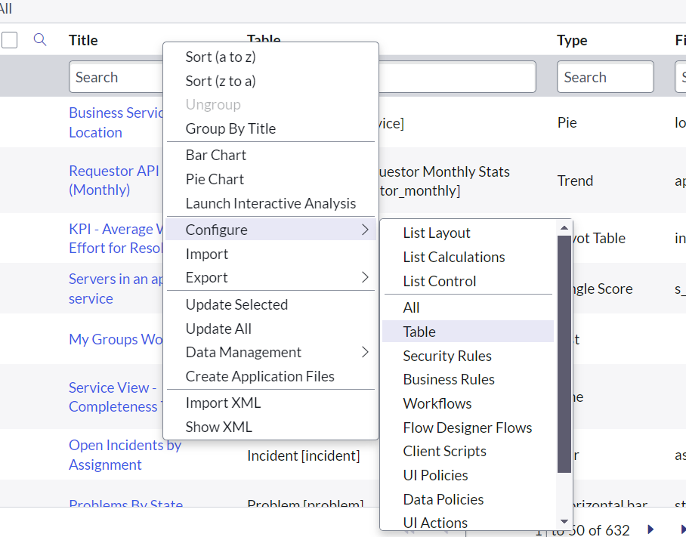

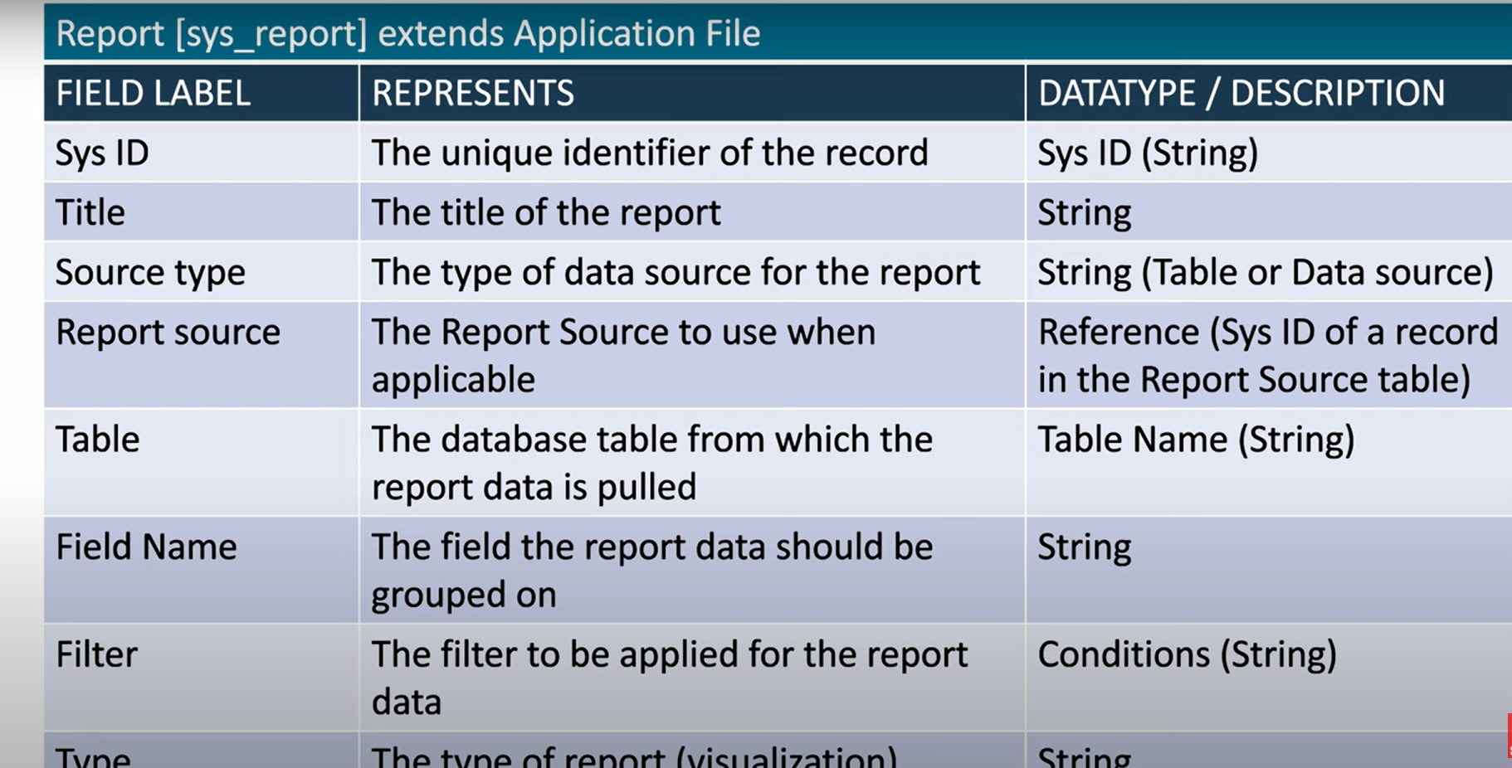

Types of reports:

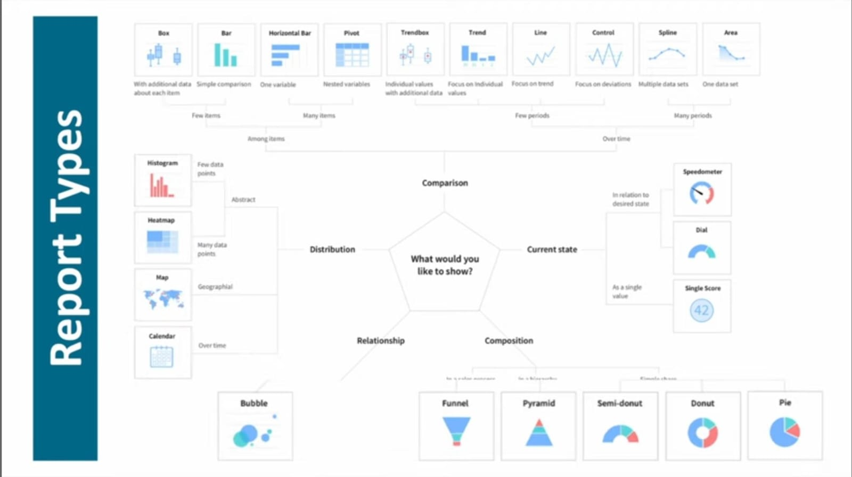

Go to the reports using navigation and create new, give the information mentioned below

On the type tab we can see the type of charts for the visualization.

Configuration is the grouping of the types of data.

Style is used to change the colours accordingly for the requirements.

