**3.ServiceNow User Interface Overview**

The below image shows the main screen elements

Banner frame: the list of elements that are shown on the top bar is known as the banner frame elements like the banner image, navigation, favourites, scope, search, profile.

Application navigator: The Application Navigator helps in the searching of any tables, lists, forms or incidents.

Content frame: the work place is known as the content frame of the instance.

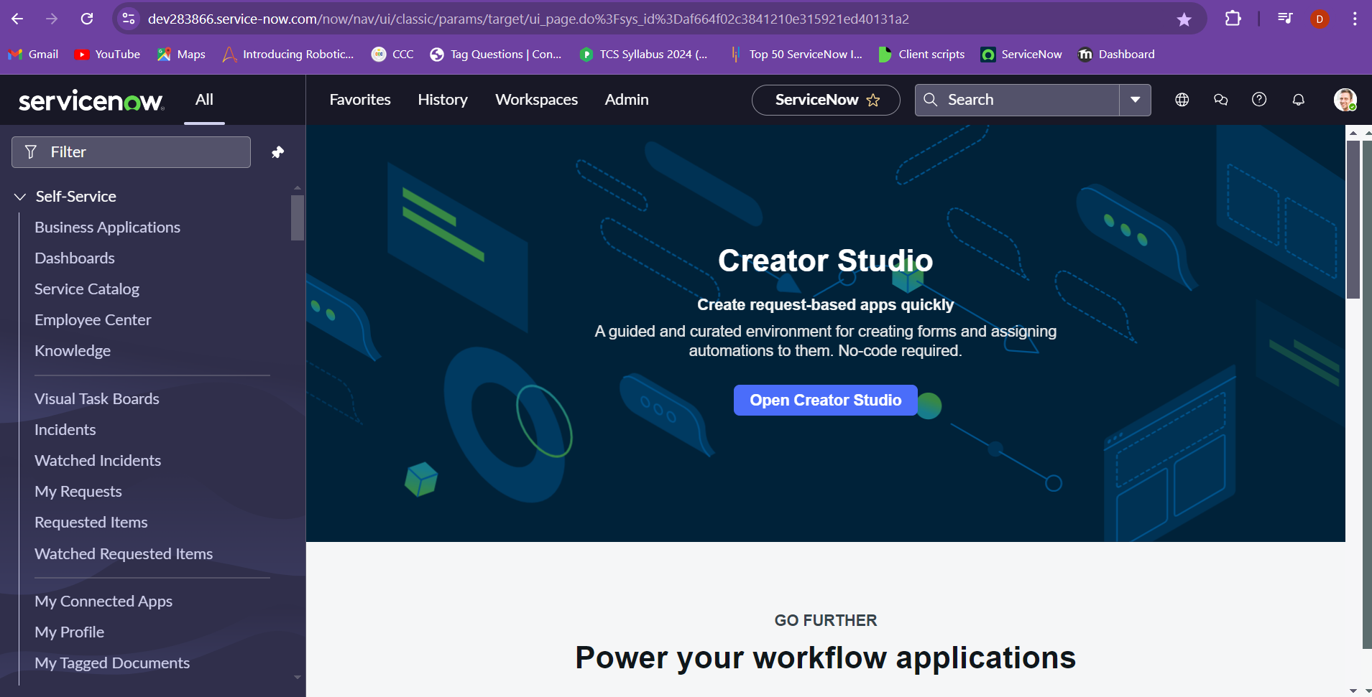

The User Menu provides the following tools:

* Profile: Set profile attributes including name, phone, title, email, date format, time zone
* Impersonate User: Access the instance as another user; available to users with admin or impersonator role
* Elevate Roles: A safety mechanism for high-impact actions; available to System Admin
* Logout: Logout of the ServiceNow instance.

Tools on the Banner Frame include:

* Global Search: Search the entire instance for records matching keywords
* Connect Chat: ServiceNow's real-time messaging tool
* Help: Displays contextual help as available, a badge on the icon indicates embedded help is available, provides access to User Guide, provides access to documentation search tool.

Banner Frame: System Settings

System Settings allows the user to customize the UI to their preference. Settings are grouped as follows:

* General Settings: Configure basic instance preferences such as time zones and languages.
* Theme Settings: Customize the visual appearance of the ServiceNow interface.
* Accessibility Settings: Enable features to ensure the platform is usable by individuals with disabilities.
* List Settings: Adjust the display and interaction options for lists of records.
* Form Settings: Define the layout and behavior of forms for data entry and management.
* Notifications Settings: Manage how and when users receive alerts and notifications.
* Developer Settings: Provide tools and options for customizing and extending the platform through development.

Inorder to create a favourite for any table or a particular record of the table, we need to use navigation and select incidents > all which will redirect you to the incidents table.

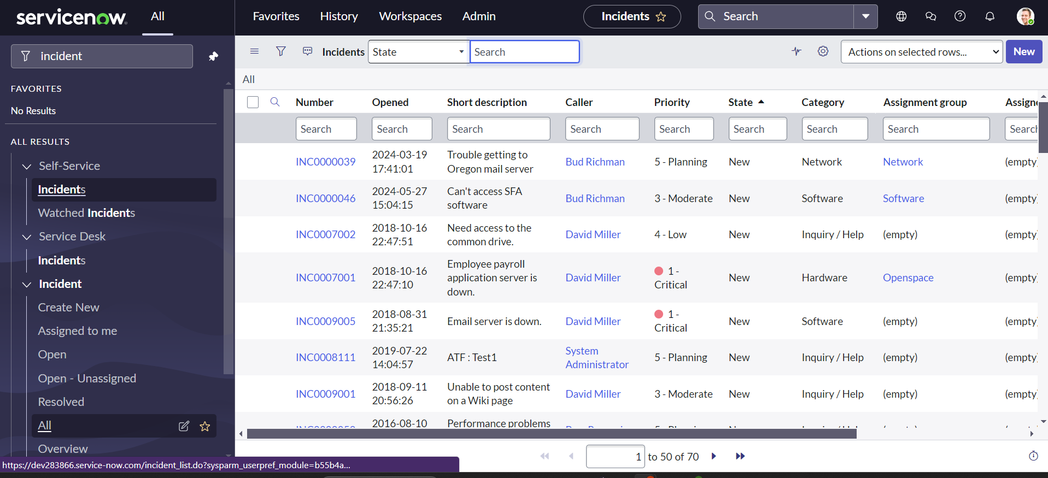

Now choose the star icon beside the all inorder to make the incident table as a favourite.

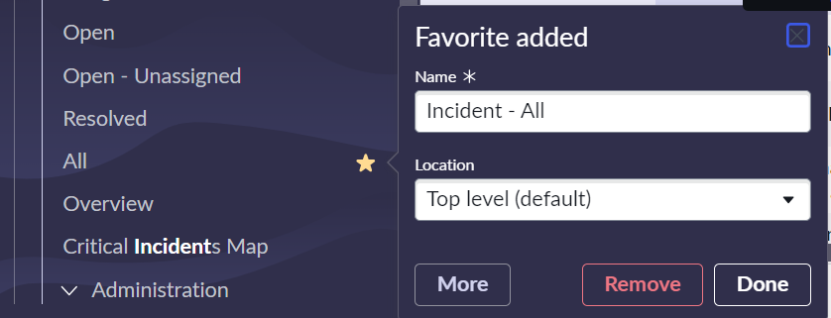

We can also create a favourite for a particular record on the table. To create a favourite for an incident in the incident table we just need to drag and drop that particular incident into the favourites.

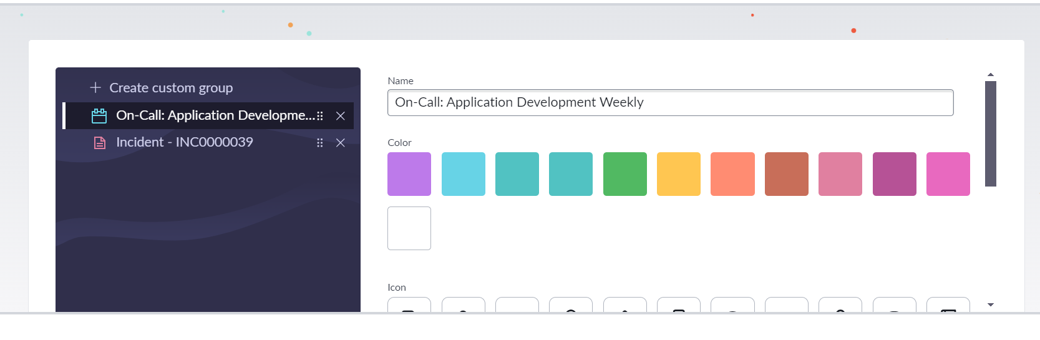

And choose different types of colours and symbols for denoting the specific favourited item.

