**4.ServiceNow Branding Overview**

**Branding:** Customizing the ServiceNow platform's appearance to reflect your organization's identity. This helps build trust and encourages users to adopt the system more quickly.

**Guided Setups:**

* **ITSM Guided Setup:** Helps you configure IT Service Management features.
* **ITOM Guided Setup:** Assists with setting up IT Operations Management tools.

**Service Portal:** A tool that uses widgets to create user-friendly interfaces, making it easier for users to interact with the ServiceNow platform.

**UI Builder:** A tool that lets you design and build custom, functional pages within the platform to meet your specific needs.

To complete the changing of the banner we need to open the instance.

Here I’m using servicenow.developer instance

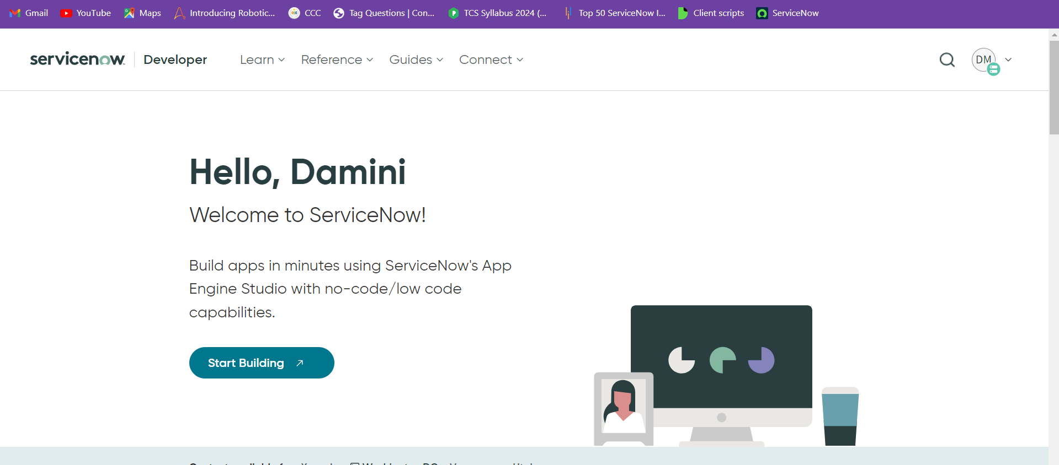

Which would then take me to the instance

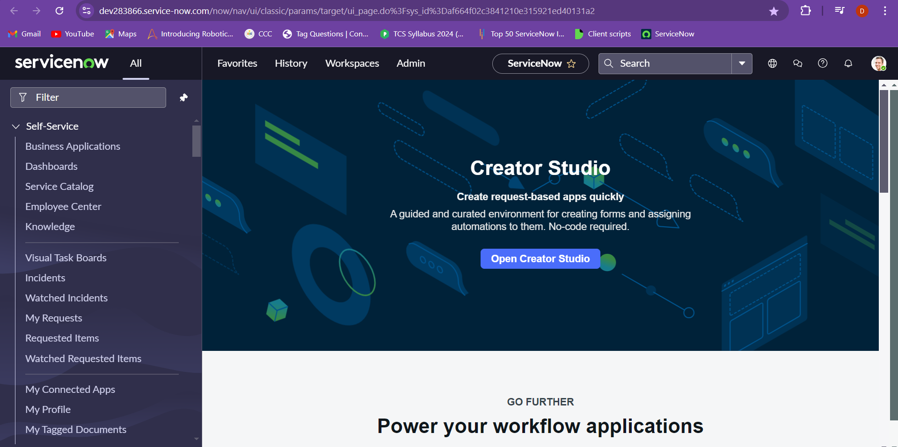

Go to guided setup and choose ITSM guided setup

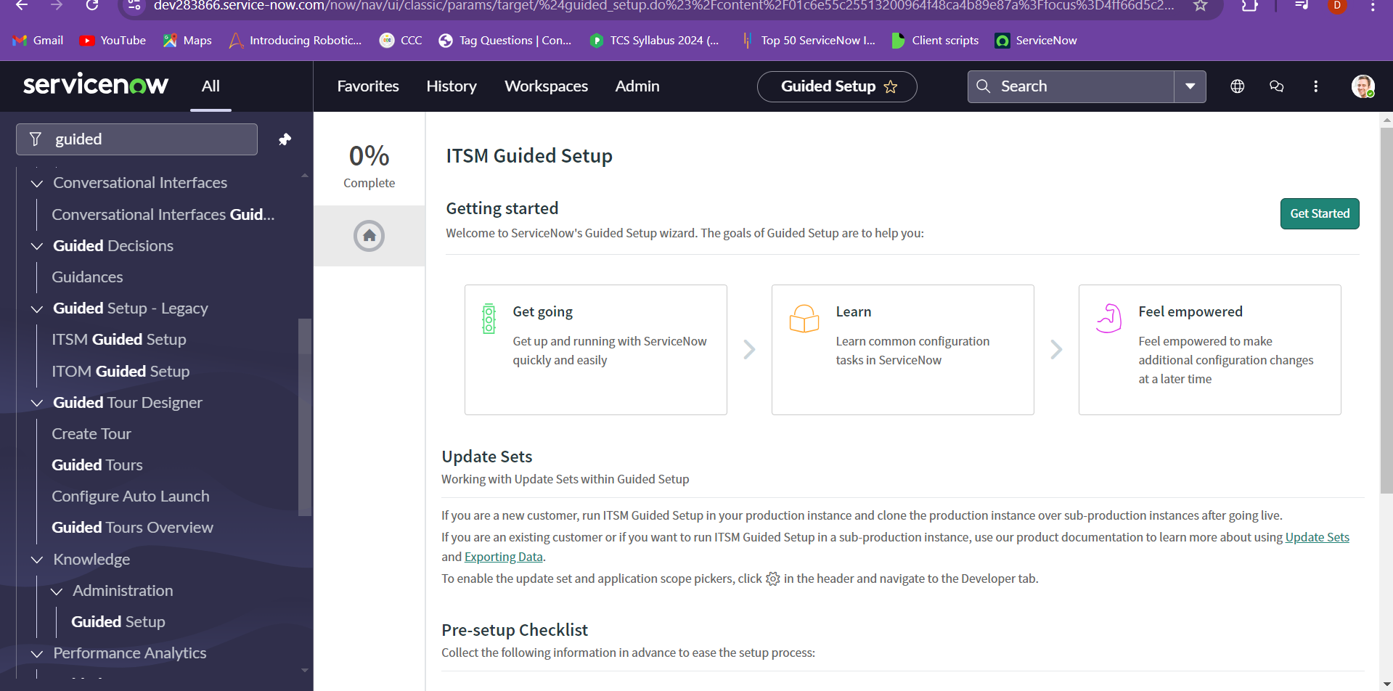

Click on get started. And choose the company, under system configuration choose the get configure.

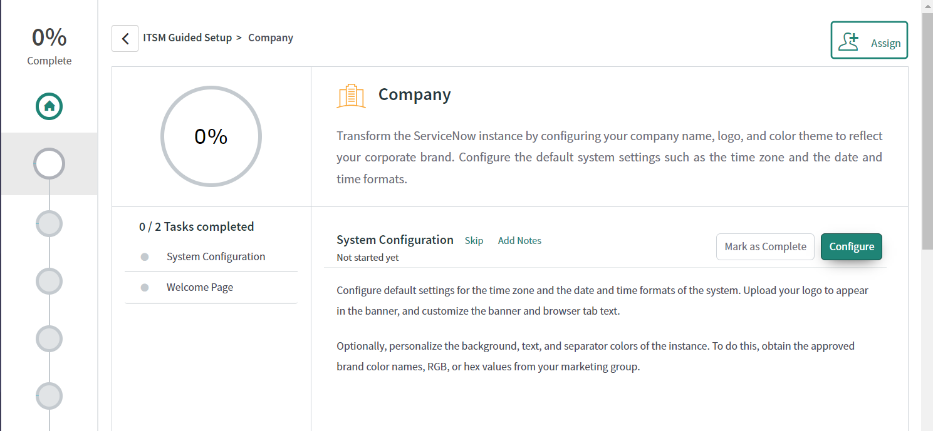

Now we can add the banner image and the banner names as needed for the requirement.

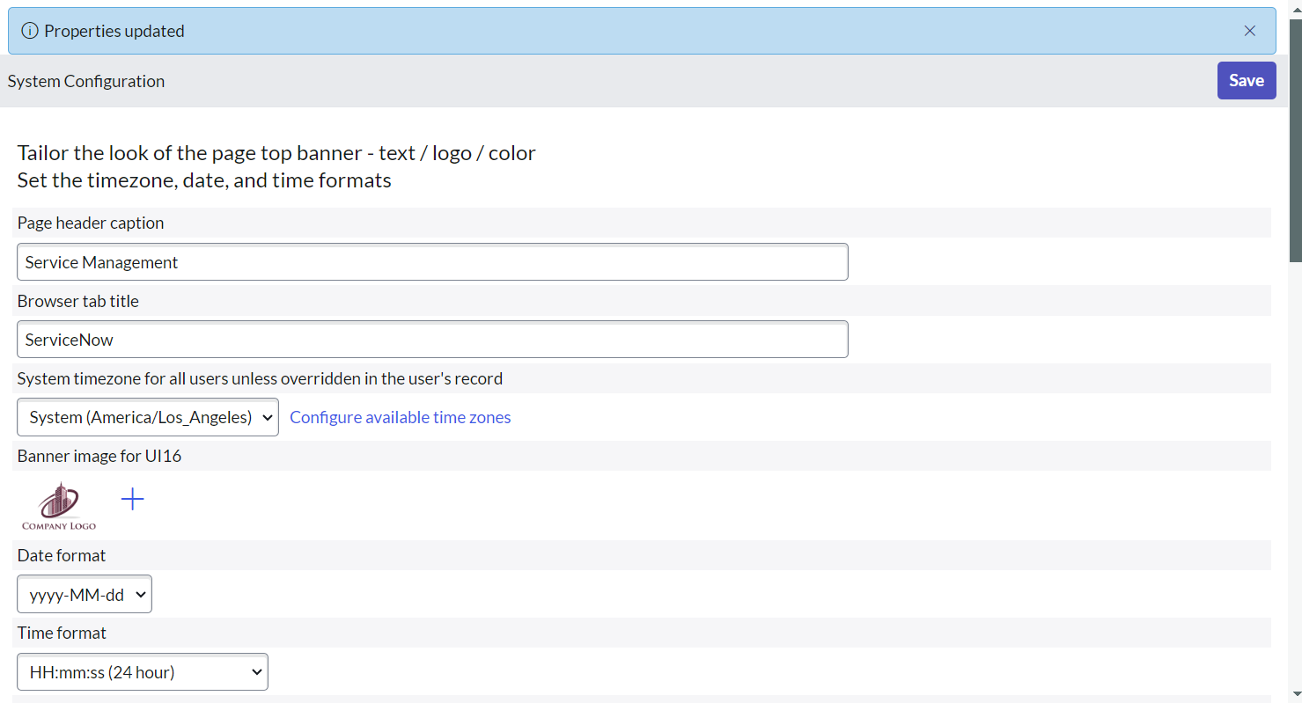

Now we can see the updated logo image.

