**5.ServiceNow Lists and Filters**

**Lists:** Display records from a table in a tabular format, allowing you to view, sort, and manage data.

**Filters:** Enable you to refine and narrow down records by applying specific conditions to display only the relevant data.

Choose the incident and then sub division all is choosen:

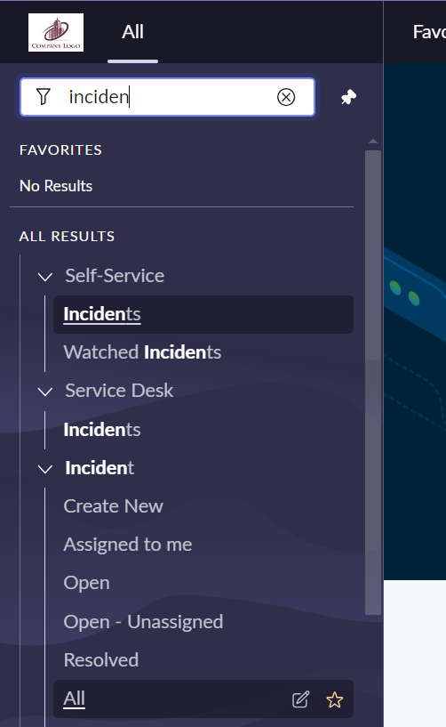

You will be then transferred to the incident list and the whole list is visible or you can choose the incident.list in the navigation bar.

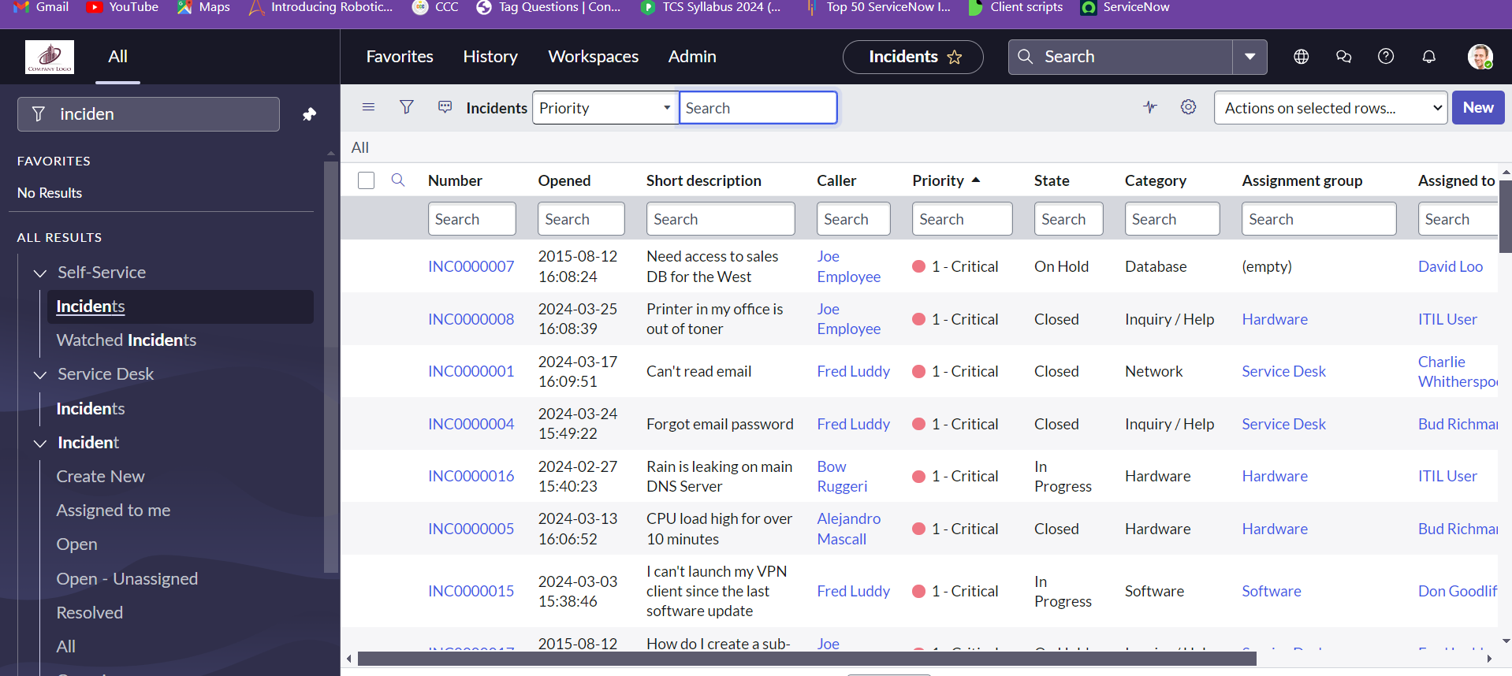

We can create new incident which is a form that gets opened to create a new incident.

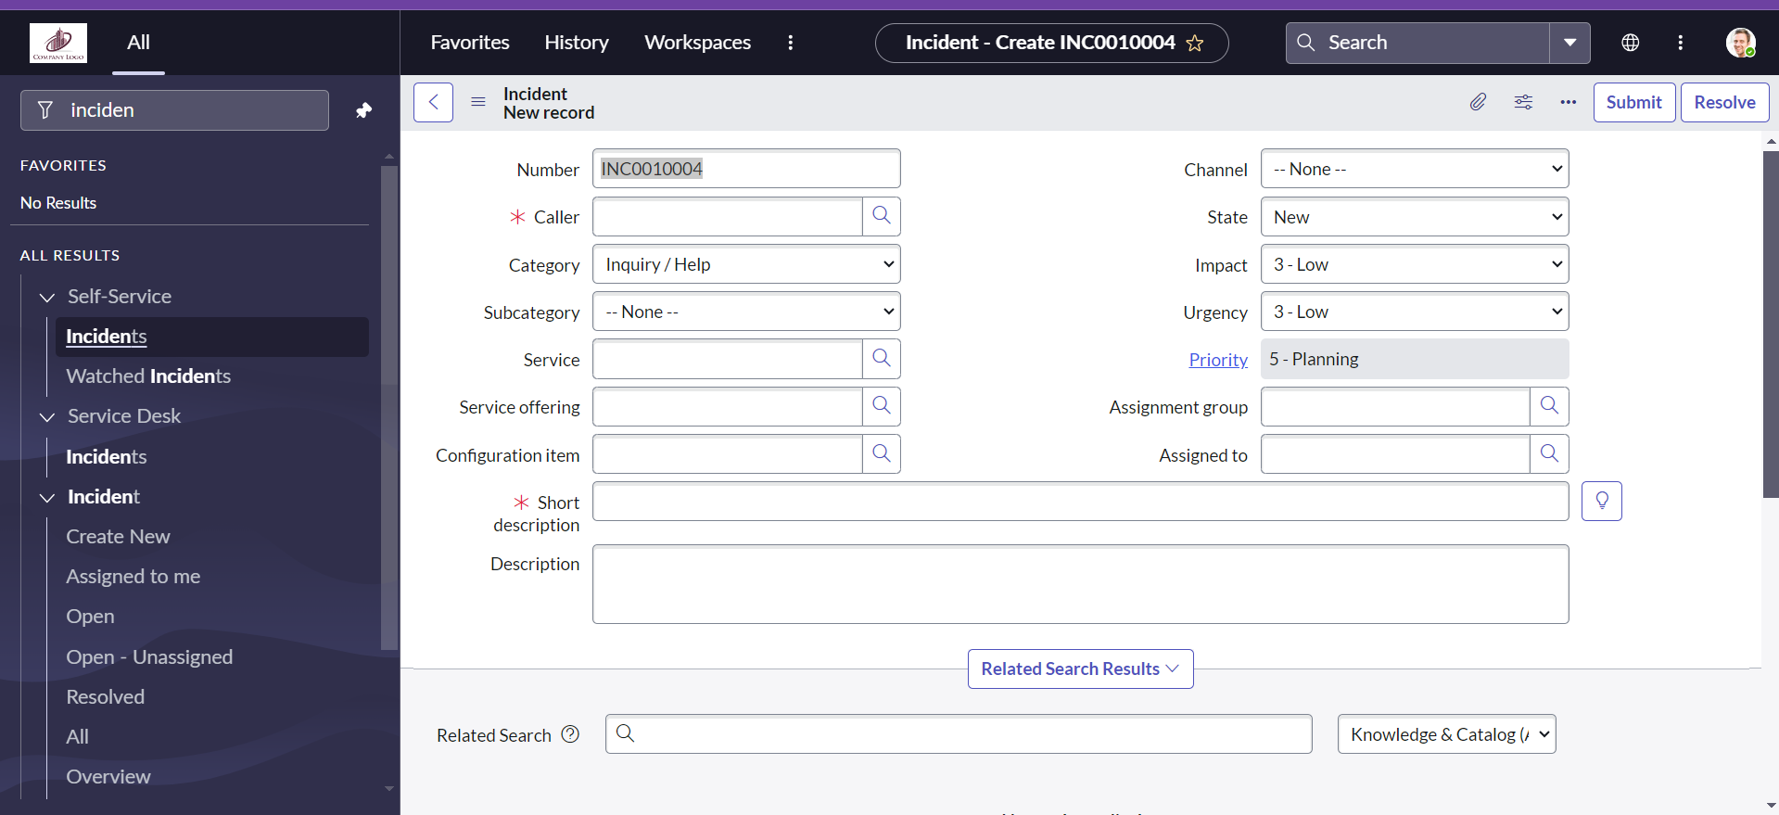

**Accessing Table Views:**

* To see a list of records in any table, type the table name followed by .list in the URL. For example, Task.list will show a list of tasks, and Sys_db_object.list will show a list of database tables.

**Creating New Records:**

* To create a new record in a table, use .form after the table name. For instance, Task.form will open a form to add a new task.

**Personalizing Lists:**

* Use the gear icon to customize which columns are visible in your list view. This personalization only affects your view, not other users’. You can move columns in and out of view and rearrange their order using the arrow keys.

**Filtering Data:**

* The filter icon allows you to add and combine multiple conditions to refine your data. You can also sort and choose which columns to display as part of your filter criteria.

**Visualizing Data:**

* You can view data in graphical formats like bar charts or pie charts. This helps in analyzing and interpreting data trends more easily.