**6. Forms in ServiceNow**

Forms

in servicenow a form is a common set of tools and user-interface elements used to view and update a single record from the database.

Types of records

* Incident Records: These are used to track issues or problems that need to be resolved.
* User Records: These hold information about the users in the system.

Key components of a form

* Header Bar: Displays the record's name, ID, status, and actions like Save or Update.
* Fields: Areas where you input or view data, including text boxes and dropdowns.
* Required Fields: Mandatory fields that must be filled before saving the record.
* Sections: Divisions within the form that organize related fields and information.
* Read-only Fields: Fields that can be viewed but not edited.
* Related Lists: Sections showing records related to the current record.
* Formatters: Visual elements that enhance the form’s layout and readability.

In order to show the components of the form open the all > User Administration > Users

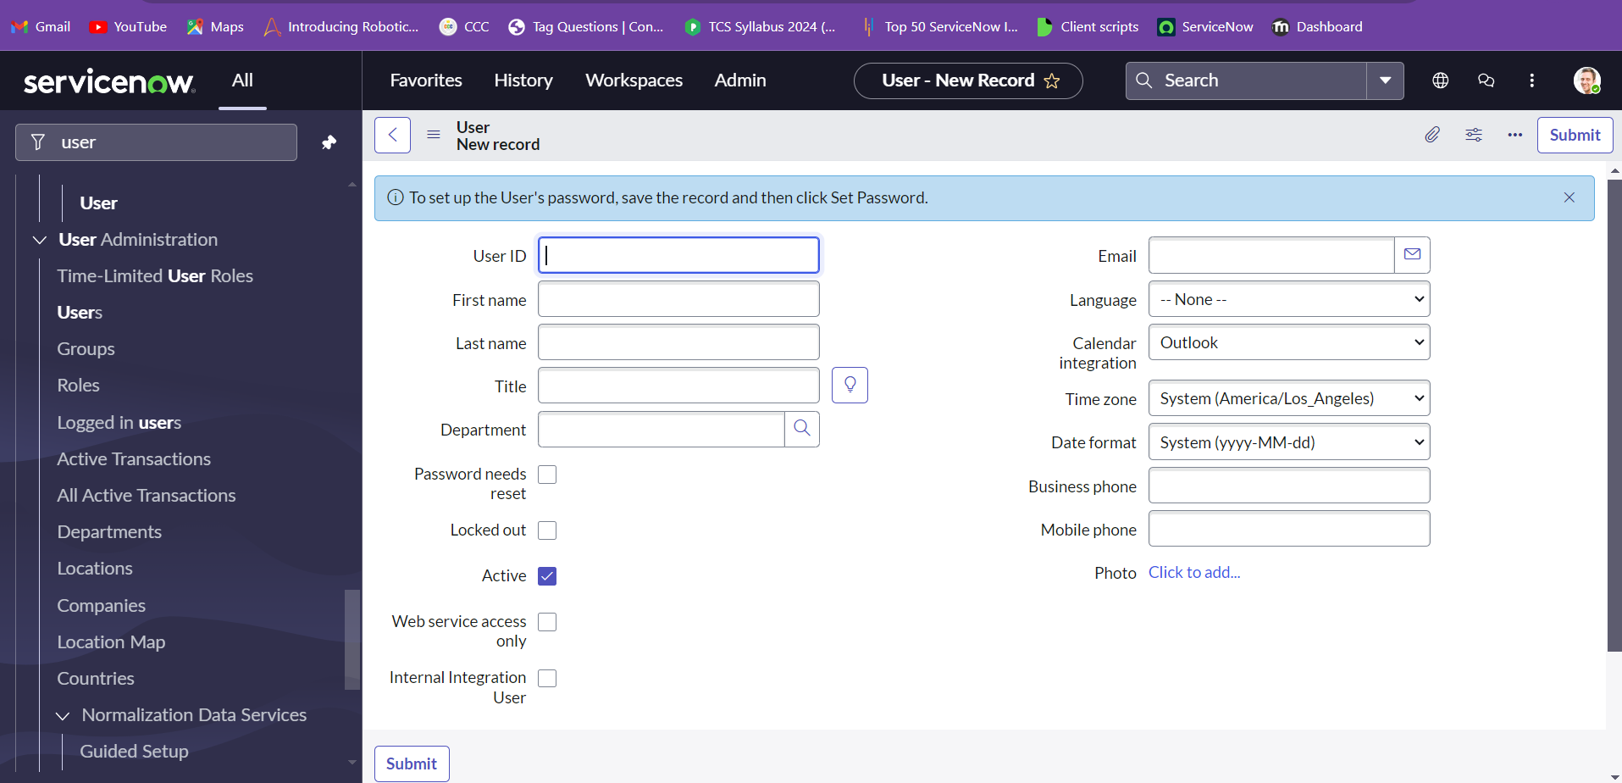Saving Changes

As changes are made on a form, they are NOT automatically saved. Users must proactively save changes by using the Save menu item or Submit/Update button If you attempt to leave a form with unsaved changes, the system will provide notification.

Copying a Record

Most forms provides two methods of creating a new record as a copy of an existing one.

1. Insert: Creates and saves a copy of the current record and returns the user to the list of records

2. Insert and Stay: Creates and saves a copy of the current record and leaves the user on the new record's form

Form Sections

Forms are made up of Sections that organize the fields and other data.

Sections can be viewed as tabs or expandable sections, depending on the preference of the user.

Form Related Lists

A related list is a special form element that displays a list of records from another table that is related to the current record (a one-to-many relationship). For example, a User form might contain a related list displaying all Roles that have been associated with the user.

Form Views

Not every user wants to see a record's data in the same way.

Form views provide the ability to display and organize fields, related lists, and formatters in different ways to meet the needs of specific users.

Form Personalization

Form personalization allows the user to select which fields are displayed on a particular form view.

These changes do not impact any other users.

Clicking Reset will return the form view to its original settings.

Form Attachments

The Manage Attachments button provides the ability to attach files to a record.

Form Templates:

Templates are used to simplify the process of creating new records by populating some form fields automatically.

The more options icon provides the ability to turn on/off the template bar at the bottom of the form.

Any user can toggle on/off the template bar and create templates.

The templates a user can access are dependent on the access controls set within each template.

Templates can set the value of fields regarding of their visibility in the form view.

Field values can include variables.

The template bar provides shortcuts to apply, edit, and create templates for the current form.