**7. A Hands-on ServiceNow Tool Demo**

Go to the servicenow poratal.

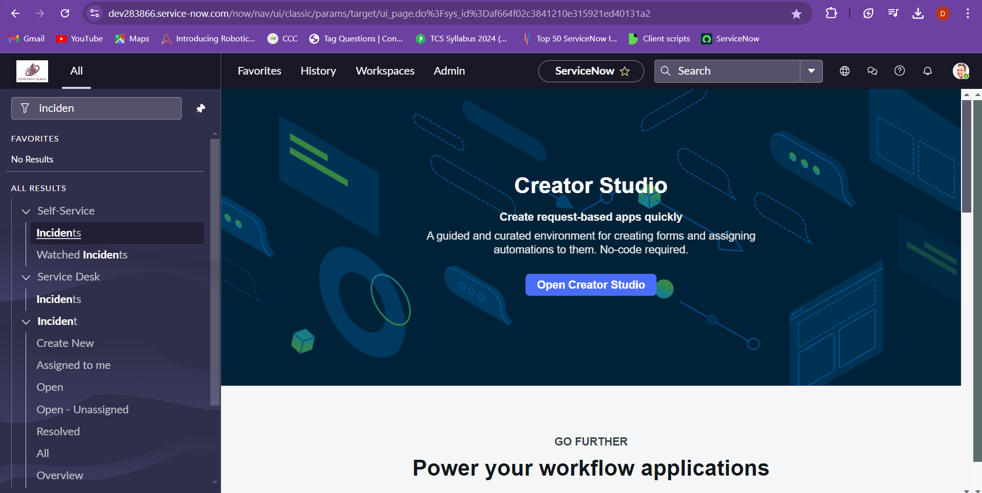

Go to incident and choose the all

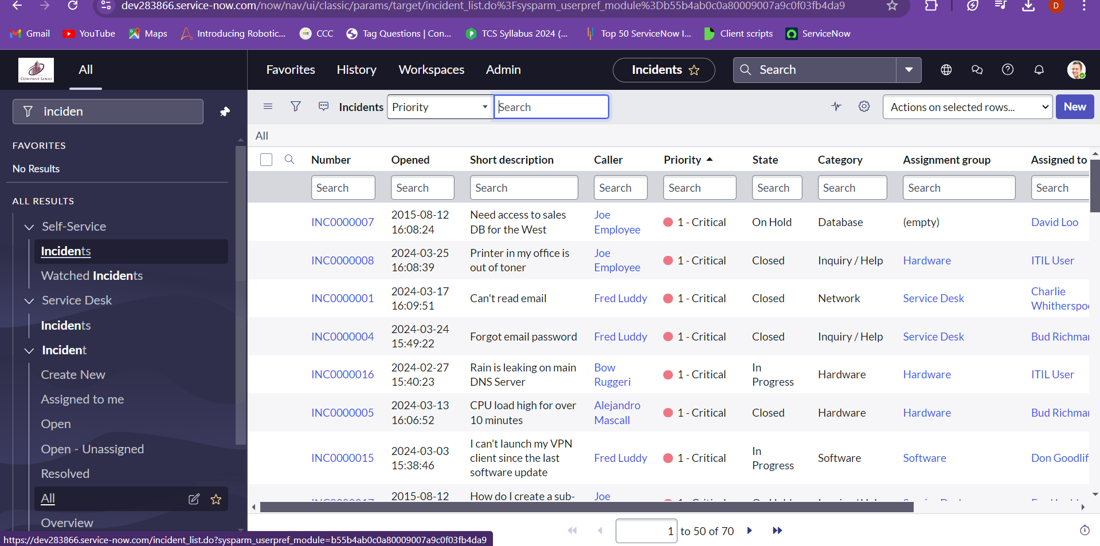

Apply the filter and set the data to “state is new” and “category is software”.

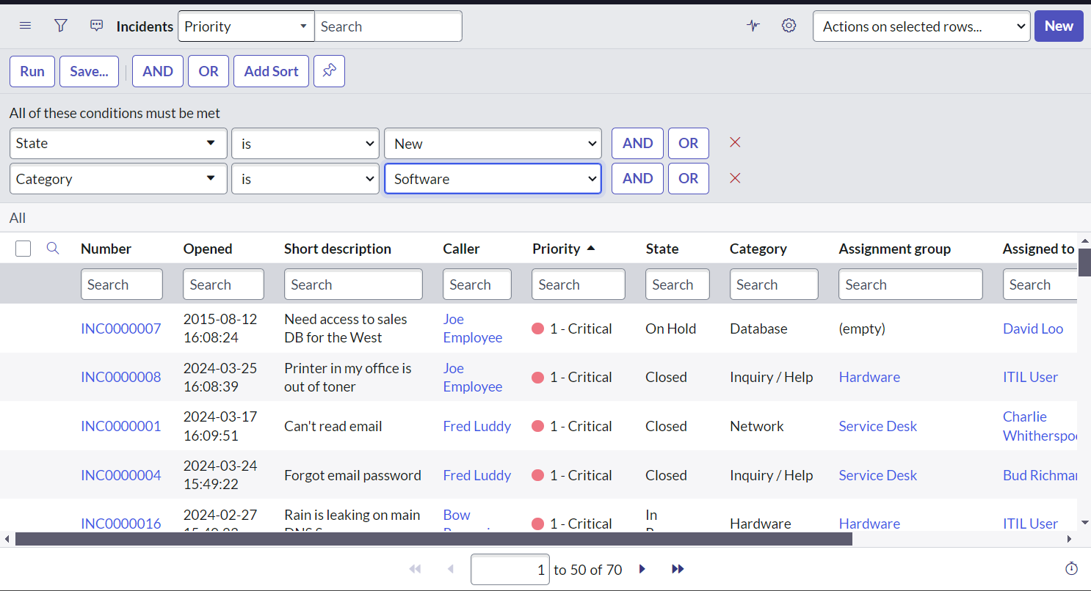

The result.

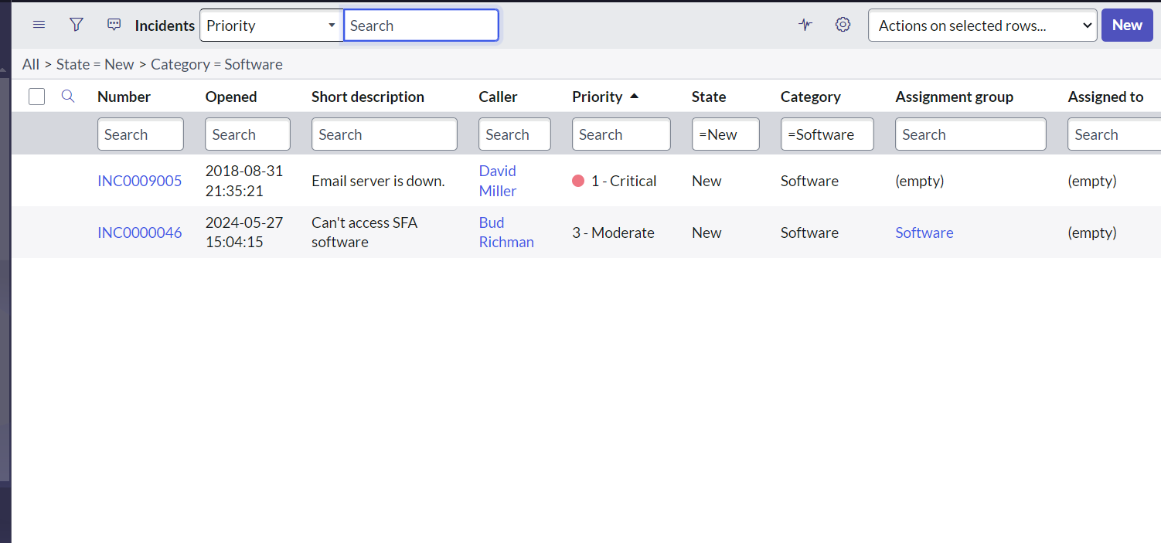

Now search for the incidents and change the priority to state and search for new

