**9.Creating a Data Source in ServiceNow**

If we want to directly access the table we can directly search in the navigation bar and type the tablename.list

Type sys_data_source.ls

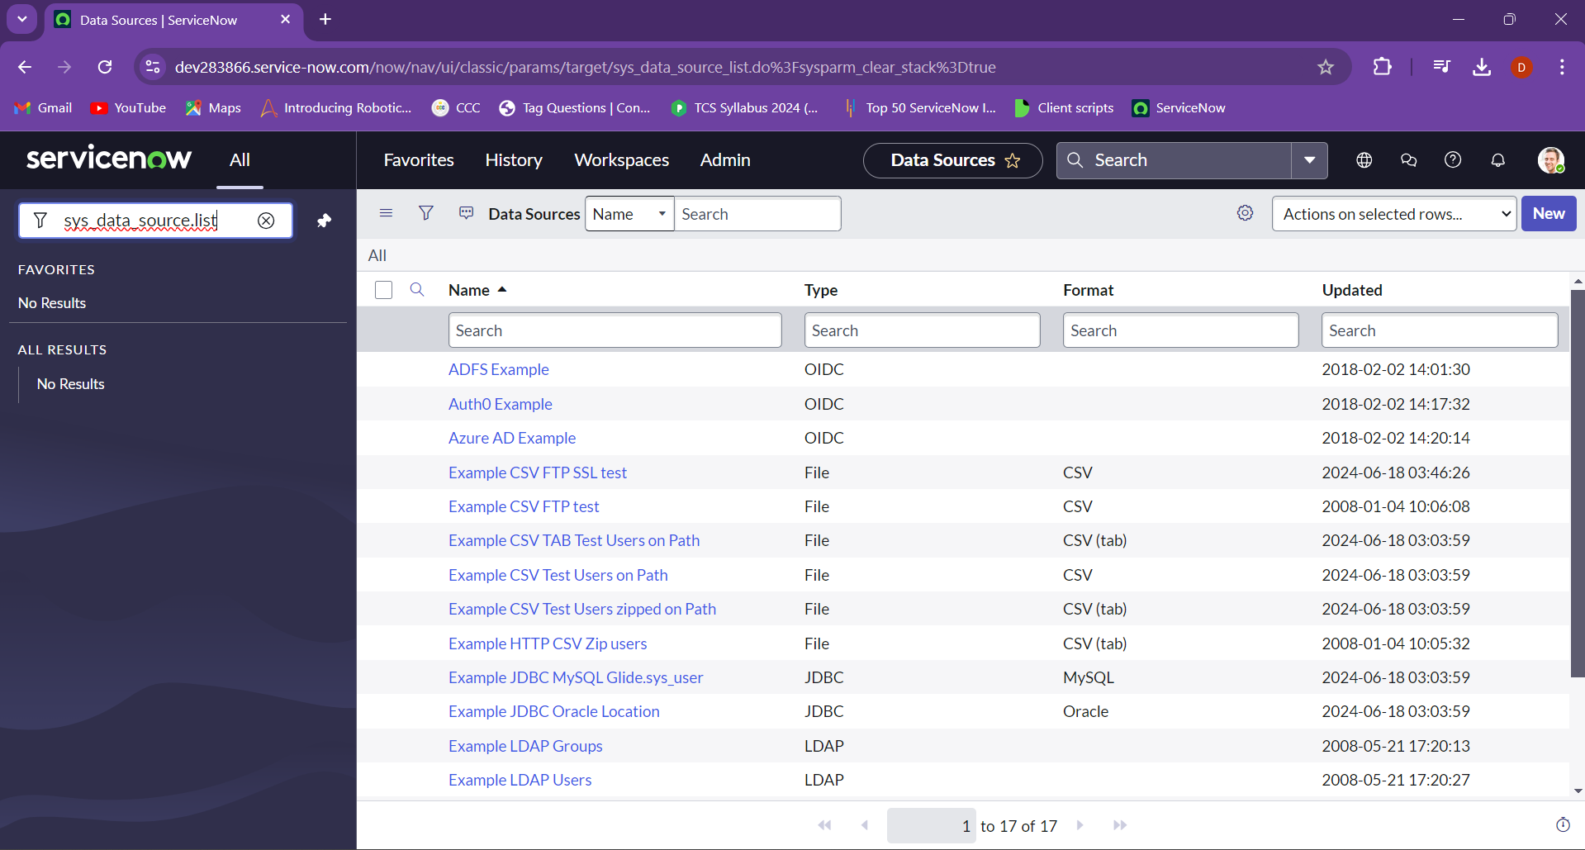

Or we can use the navigation bar and navigate to

System import sets > administration > Data source

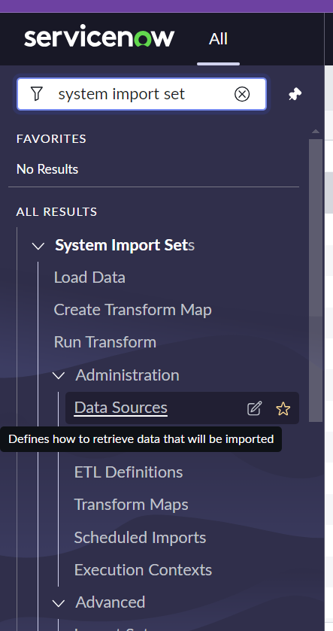

Click the new button

And then the form will be visible add in the fields that are given and can be named as we wish so I named it as test import and the same was given for import set table label when given the both fields import set table name is given automatically.

And if we would choose the type to be jdbc then we have to mention the different formats, database name, database port, username, password, server, query and the sql statement that we wants to get execute.

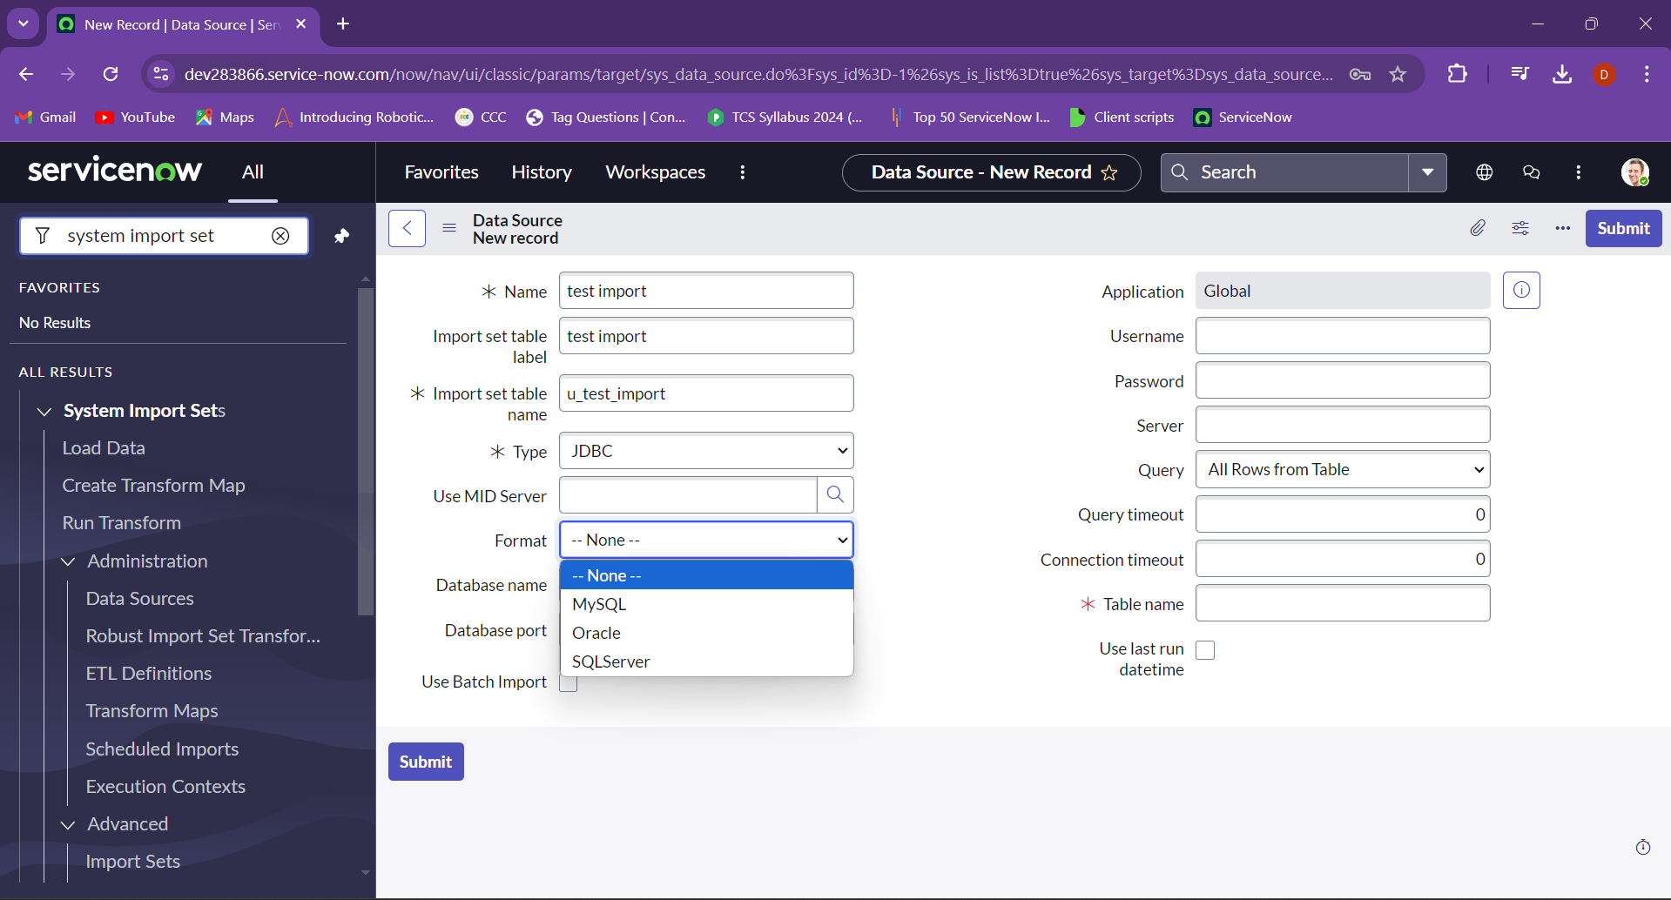

There are different Type available but for as of now we would be choosing file.

Now we would choose the format of the file we can add like csv, excel, xml etc and I choose to add an excel file. The application is set to global. The file retrieval method can be given in different ways and I choose to add my file using attachment method. As of now we can leave the other files

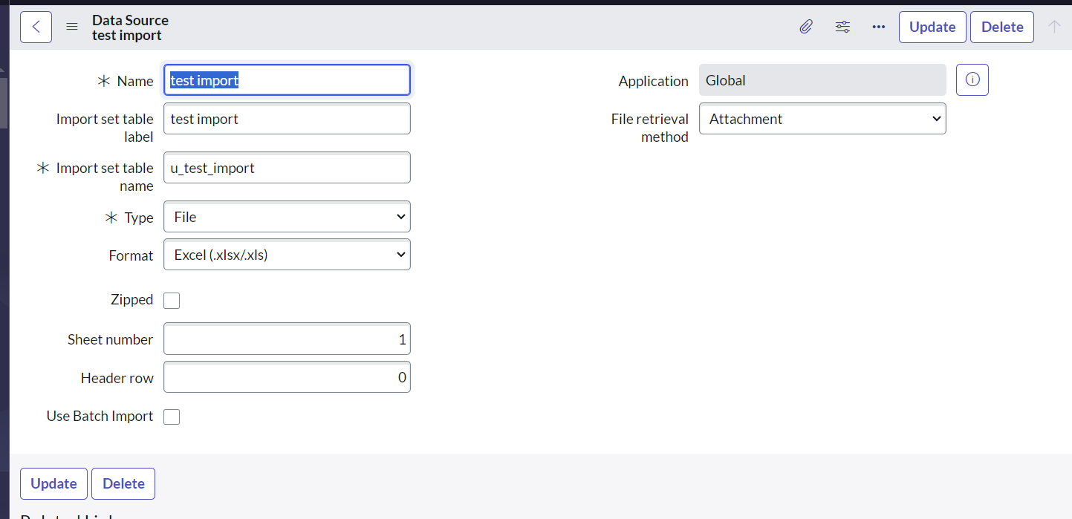

After the fields that are entered is saved add the attachment of excel to the test import

