**3-1 Introduction to ServiceNow**

ServiceNow is a comprehensive cloud-based platform designed to streamline and automate various IT and business processes. It gives us a range of features that enhance service management, workflow automation, and data integration across an organization.

Servicenow platform can be used in different IT Business Management sectors and can be inculcated in any service managements.

Services that servicenow provide:

* **ITSM(IT Service Management):** ITSM is fundamental to ServiceNow and focuses on the end-to-end management of IT services
* **Human Resources Management (HRM)**: This service supports the strategic management of HR functions.
* **Governance, Risk, and Compliance (GRC)**: GRC integrates risk management into daily operations.
* **Integrations**: ServiceNow offers tools and APIs for seamless integration with external systems.
* **IT Asset Management (ITAM)**: ITAM manages the lifecycle of IT assets.
* **Financial Services Operations (FSO)**: FSO supports financial institutions in managing operational risks and compliance.

When creating a ServiceNow instance, it's important to follow the correct process to ensure you have the appropriate access and permissions.

**Requesting for ServiceNow instance:**

Sure, here’s a rephrased version of the steps:

1. Register on the ServiceNow Developer Website:

- Sign up at the developer.servicenow.com site.

2. Complete the Sign-Up Form:

- Fill out the registration details.

3. Confirm Your Account:

- Verify whether the account is correctly registered or not.

4. Access Your ServiceNow Developer Platform:

- Log in to your ServiceNow developer environment.

5. Request or Create an Instance:

- Initiate a request to set up a new instance.

6. Select the ServiceNow Developer Instance Version:

- Choose the version of the ServiceNow Developer instance you want to use.

7. Obtain Instance Credentials:

- Retrieve the login information for your instance.

8. Log In to Your ServiceNow Developer Instance:

- Access your newly created ServiceNow Developer instance using the credentials provided.

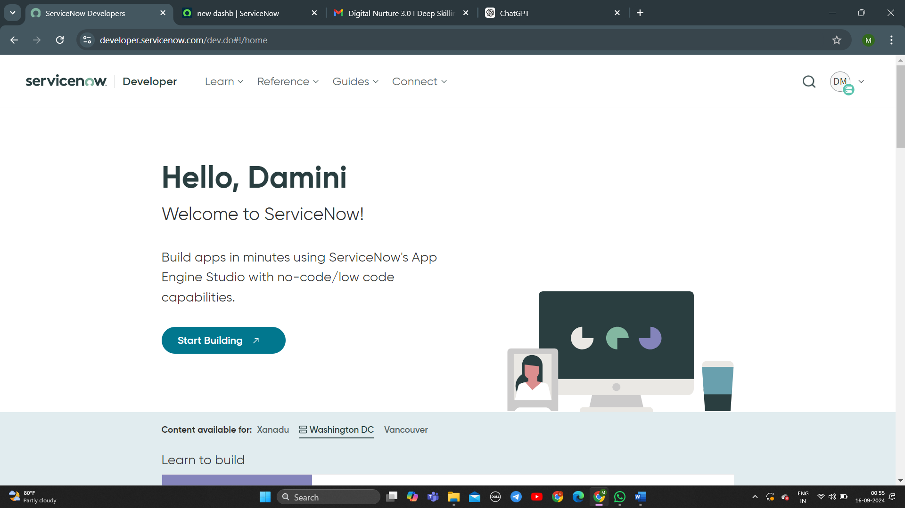

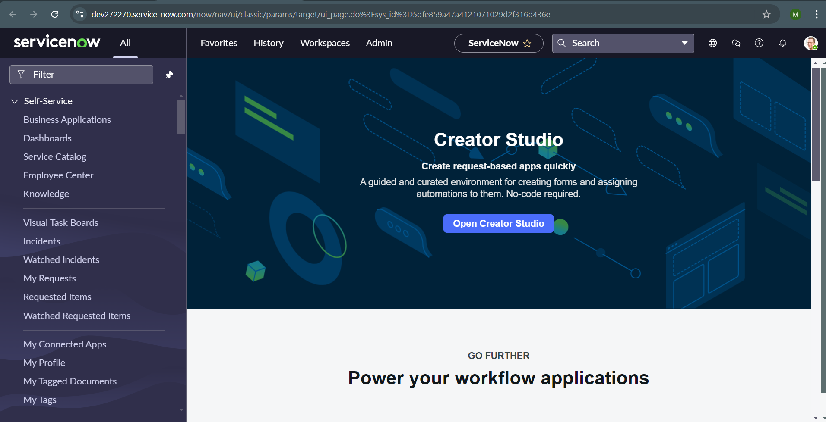

We can change the preferences for any kind of ui actions that take place in your incident by choosing the preferences that are present near the home page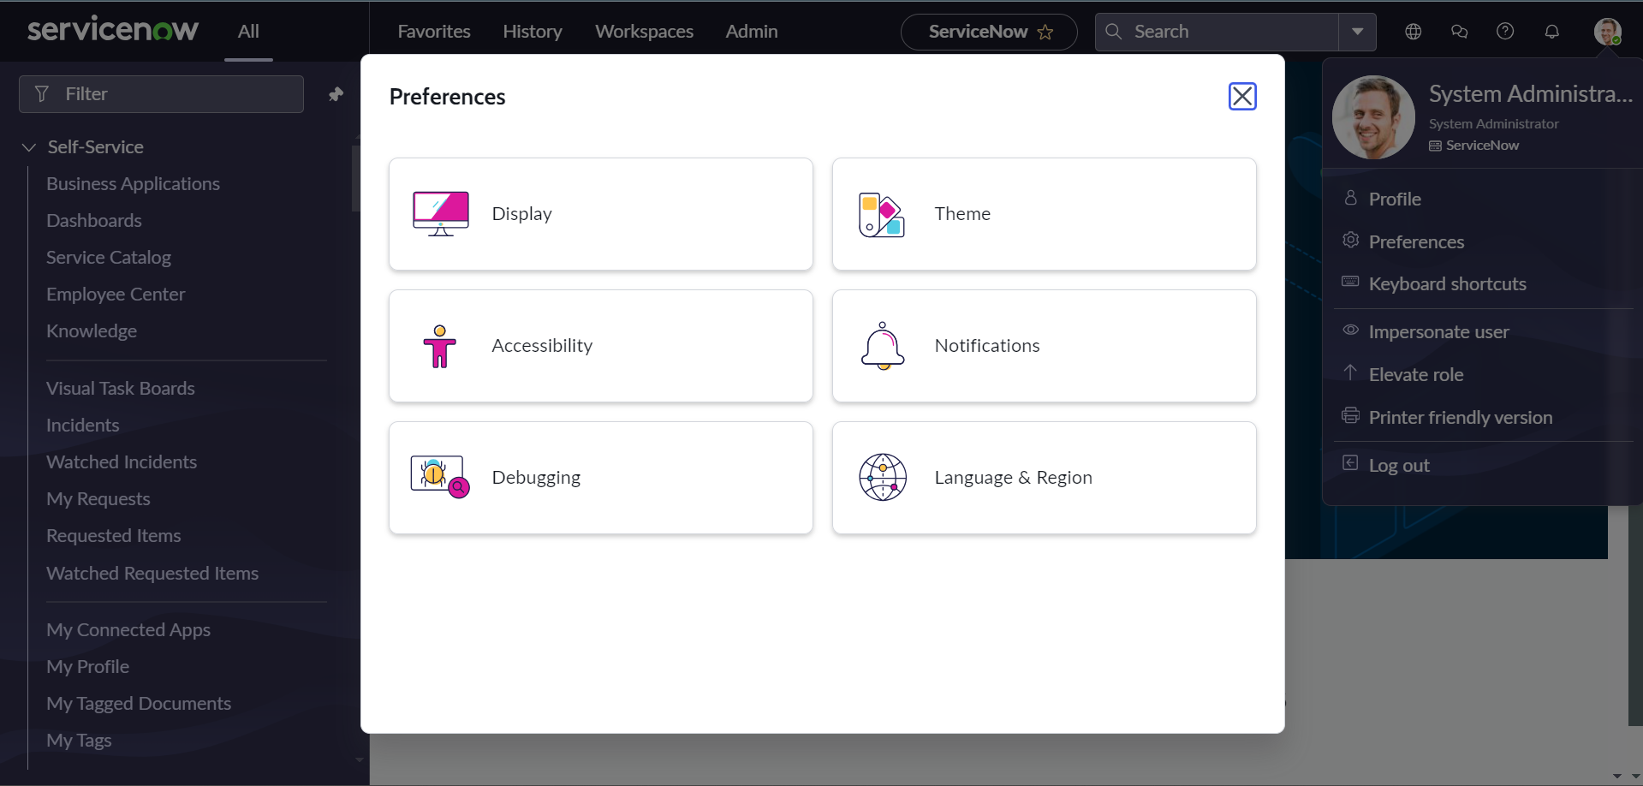

Choosing theme would enable you to use different type of themes as dark or light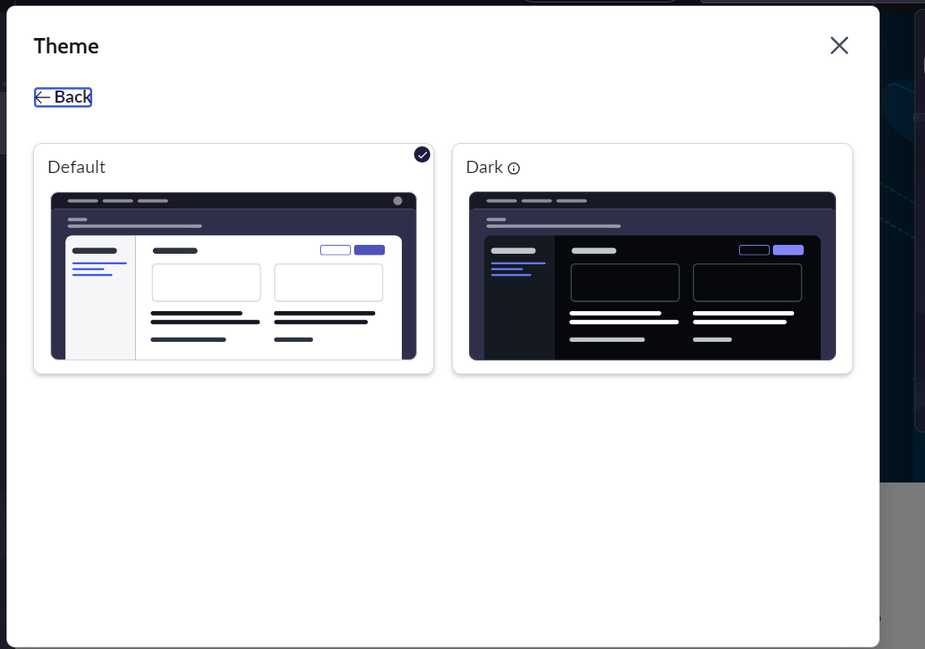

Notification preferences can also be managed using the preference of the type of notification you want to receive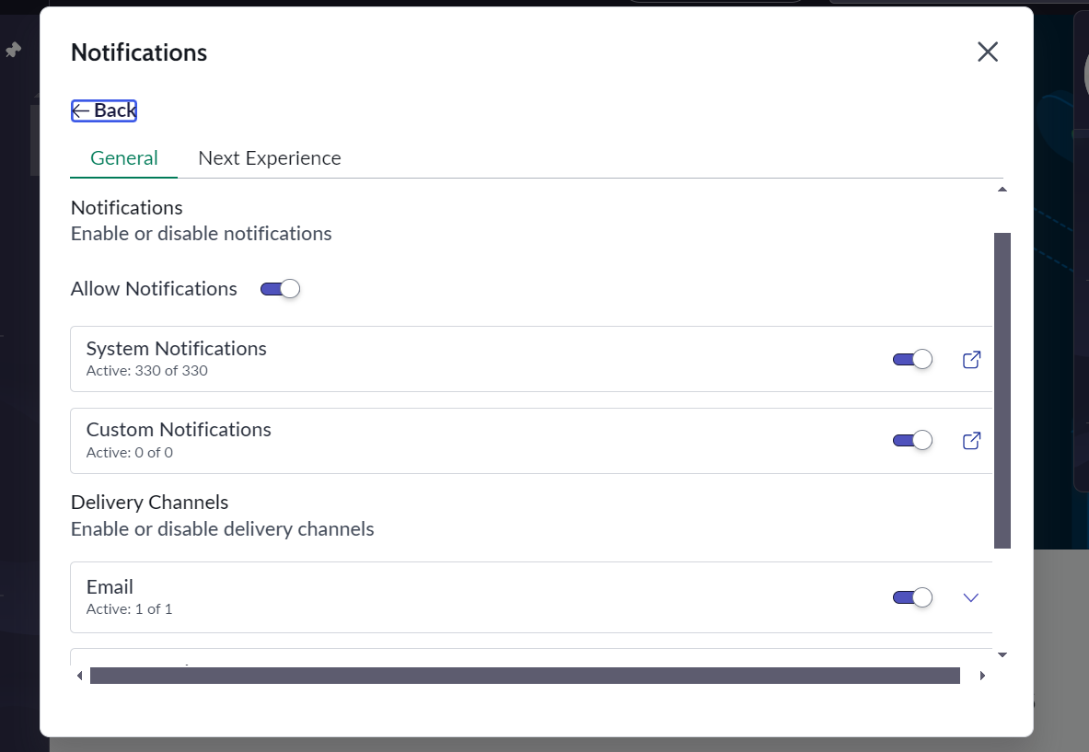

The task table contains three sub groups which are:

* change request
* incident
* problem

These sub division have the inherited attributes from the task table along with their own attributes. We don’t directly create the task table, we create the sub group mentioned above and these get into the task table. There are many other types or divisions based on the type of task we want to mention but we would learn about these three.

Incident Management: the process of managing incidents is designed to ensure that disruptions to business operations are handled efficiently and effectively

Incidents are detected and reported by users, automated systems, or monitoring tools. ServiceNow provides interfaces and notifications to capture and document these incidents promptly.

create an incident for the problem that is faced. 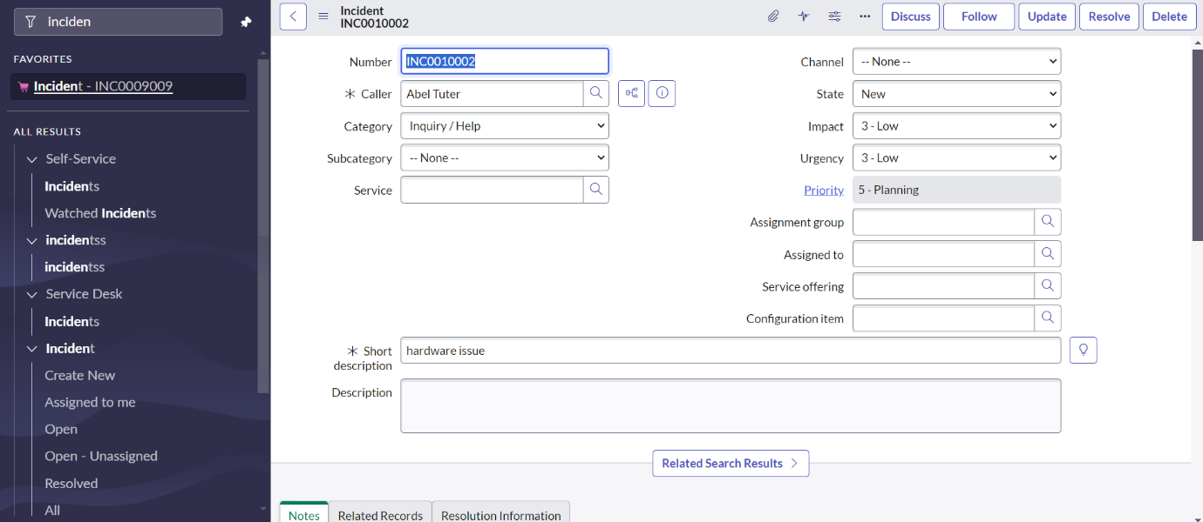

choose the create problem to make the incident into a problem for a better and a quick approach. 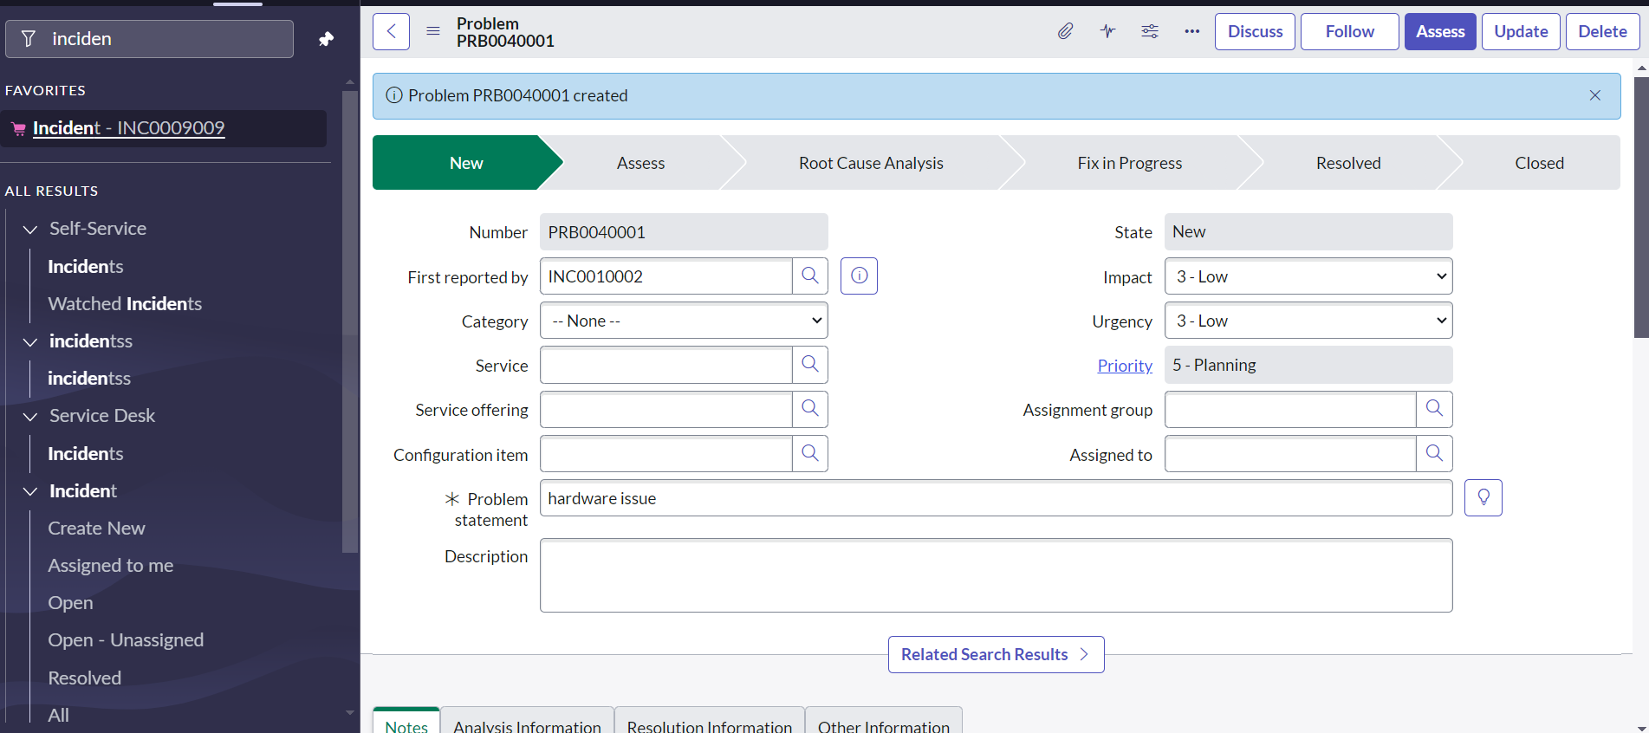 Change Management involves a systematic approach to managing modifications within the IT infrastructure •

Planning: Developing a detailed plan for the proposed change, including objectives, scope, impact, and resources required.

Assessment: Evaluating the potential risks and benefits associated with the change to ensure that it aligns with business goals and minimizes disruption.

Approval: Obtaining authorization from relevant stakeholders or change advisory boards before proceeding with the change.

Implementation: Executing the change according to the approved plan, while ensuring minimal disruption to services.

Monitoring: Tracking the change's progress to ensure that it is implemented as planned and to address any issues that arise.

Review: Assessing the change after implementation to verify that it has achieved the desired outcomes and to identify any lessons learned.

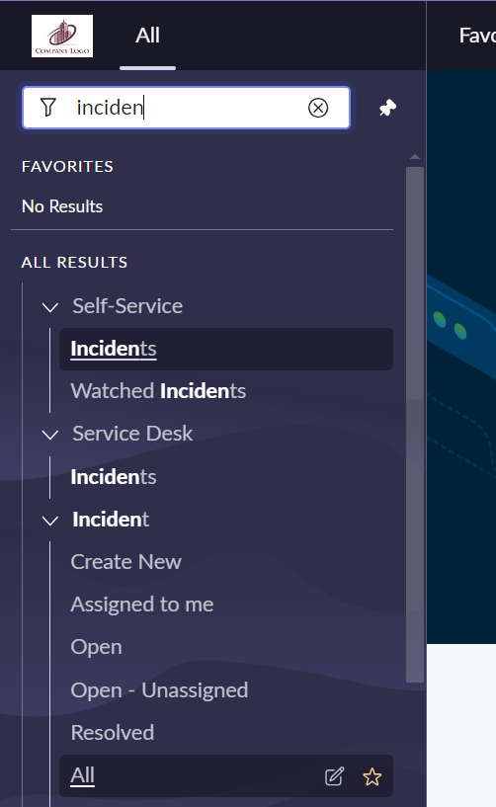

You will be then transferred to the incident list and the whole list is visible or you can choose the incident.list in the navigation bar.

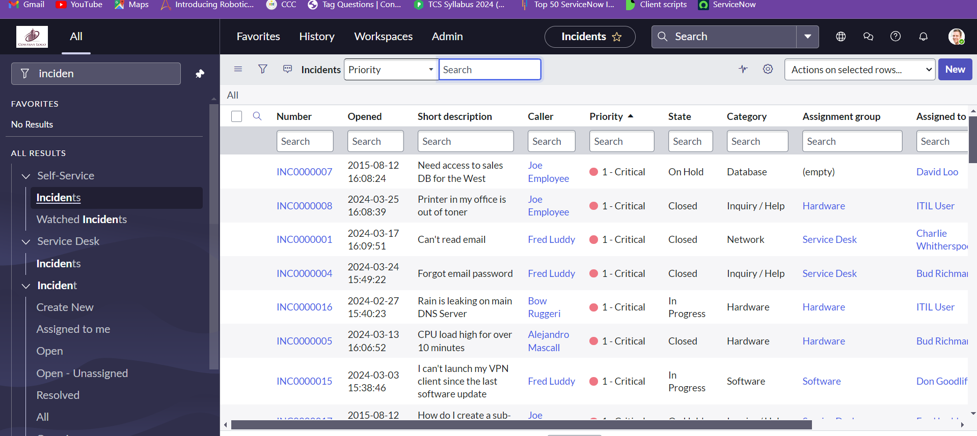

We can create new incident which is a form that gets opened to create a new incident.

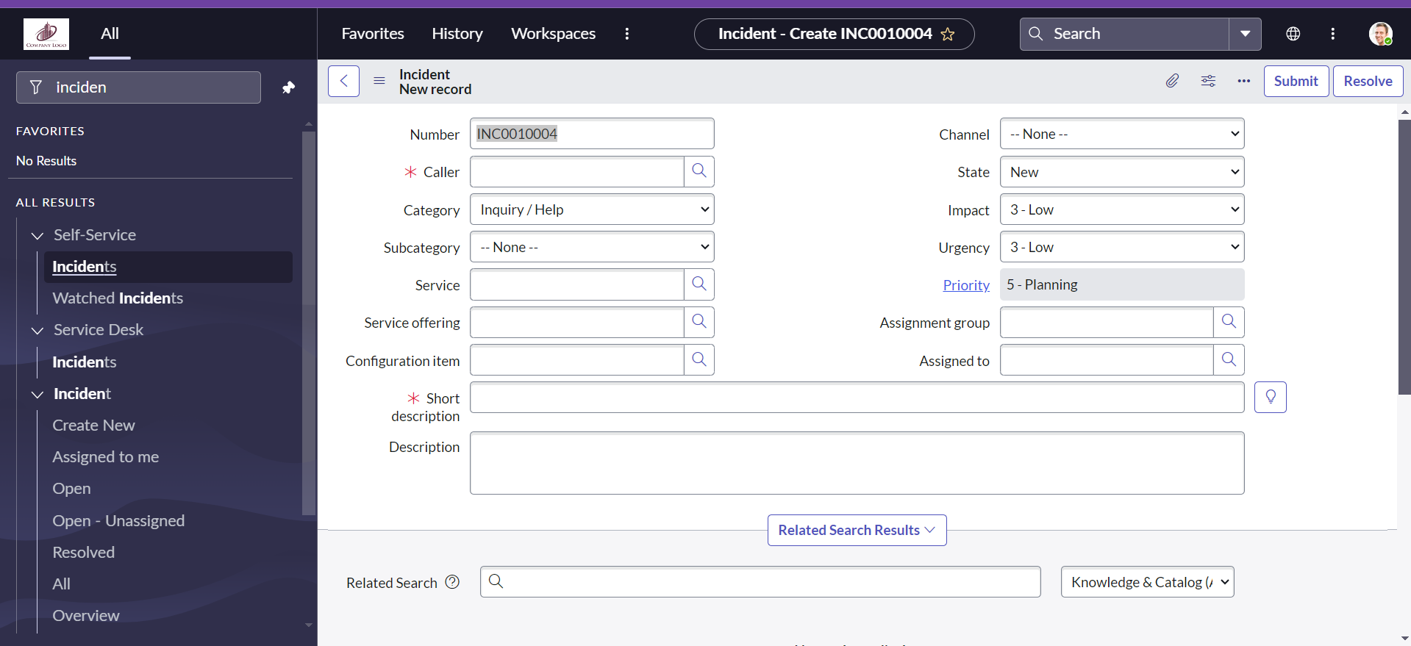

Accessing Table Views:

To see a list of records in any table, type the table name followed by .list in the URL. For example, Task.list will show a list of tasks, and Sys_db_object.list will show a list of database tables.

Creating New Records:

To create a new record in a table, use .form after the table name. For instance, Task.form will open a form to add a new task.

Personalizing Lists:

Use the gear icon to customize which columns are visible in your list view. This personalization only affects your view, not other users’. You can move columns in and out of view and rearrange their order using the arrow keys.

Filtering Data:

The filter icon allows you to add and combine multiple conditions to refine your data. You can also sort and choose which columns to display as part of your filter criteria.

Visualizing Data:

You can view data in graphical formats like bar charts or pie charts. This helps in analyzing and interpreting data trends more easily.

We can see the lists and customize the data that is found and we can take an example of incidents list. And will be able to use the filter on the incident table according to the requirements.

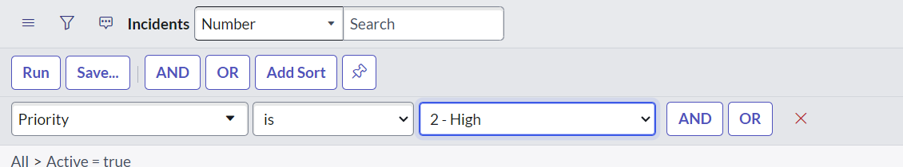

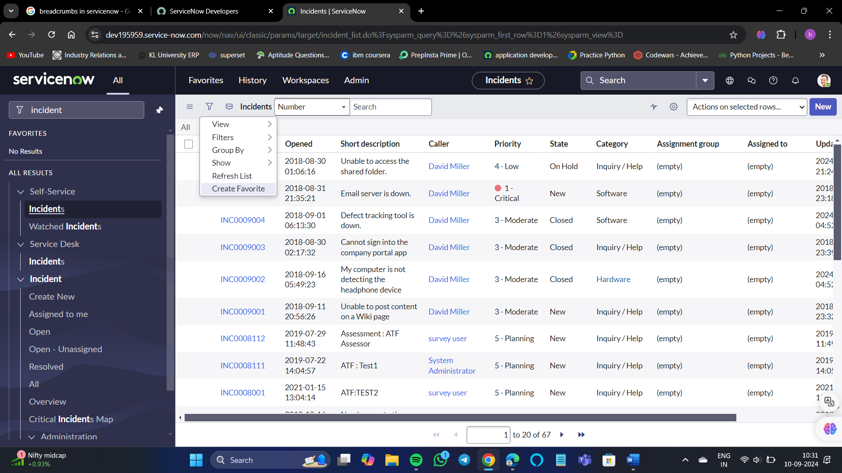

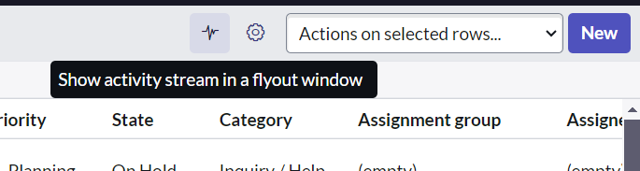

Personalize symbol would help in adding and removing the fields from the incident table.

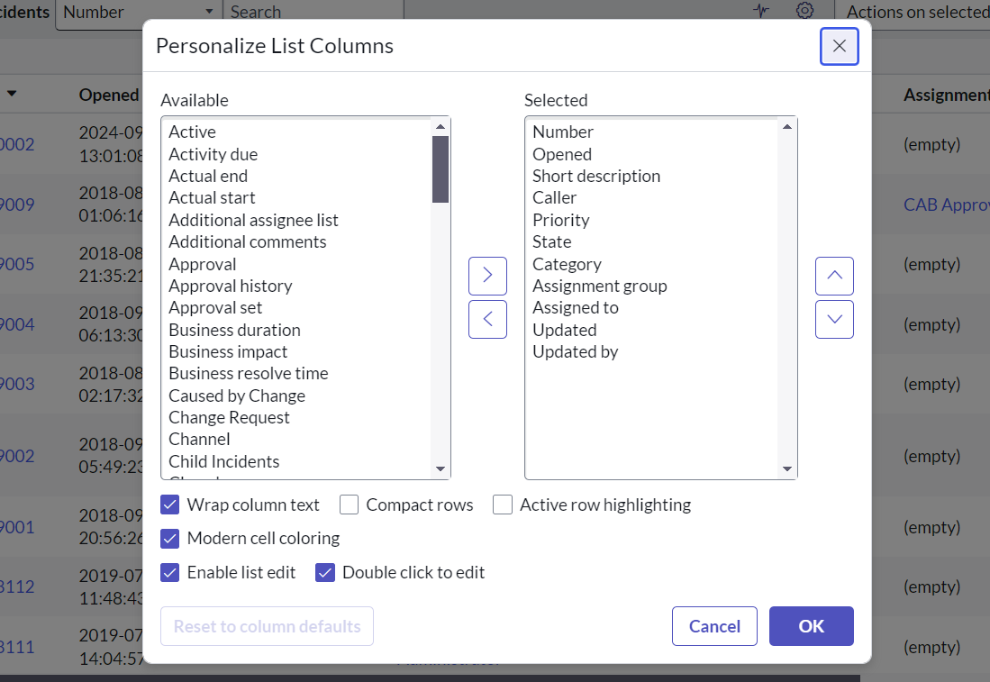now I can remove the assigned to field from the table using personalization list option.

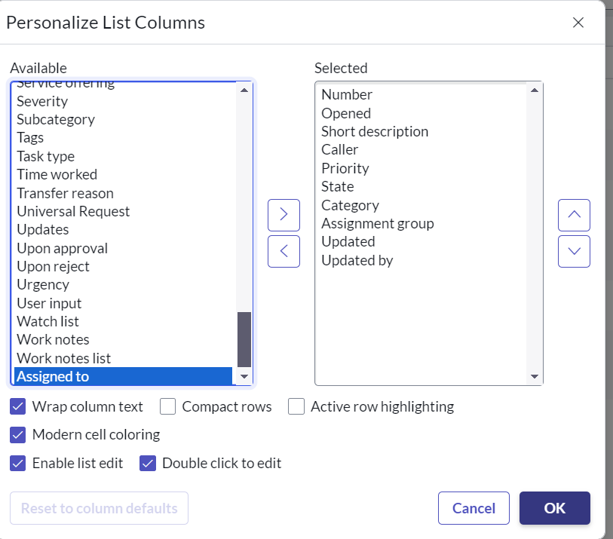

And the assigned to is removed. 