**3-2 ServiceNow Administration & Developer Overview**

Servicenow:

ServiceNow is a comprehensive cloud-based platform designed to streamline and automate various IT and business processes. It gives us a range of features that enhance service management, workflow automation, and data integration across an organization.

ServiceNow offers a Platform-as-a-Service (PaaS) that enables users to create and manage their own applications without having to handle the infrastructure.

Applications of servicenow:

* Manage complex IT operations, streamline service delivery, and handle large volumes of service requests and incidents.
* Automate HR processes such as onboarding, case management, and employee requests. Enhance HR service delivery and improve employee experiences.
* Manage financial operations, compliance, and risk management processes. Automate workflows and enhance operational efficiency.
* Manage patient services, streamline administrative workflows, and ensure compliance with regulations. Improve operational efficiency and patient care.
* Manage administrative processes, student services, and IT operations. Enhance the educational experience and operational efficiency.
* Manage production processes, track equipment maintenance, and streamline supply chain operations.
* Manage software development, IT operations, and customer support. Facilitate innovation and improve service delivery.

User groups of servicenow:

* Employees
* IT support team
* Administrators
* Implementers
* Developers

Service Catalog:

The Service Catalog serves as a centralized hub where users can access and request services, products, and information. It is designed to improve user experience by providing a clear and organized way to manage service requests.

Catalog Items are the individual offerings listed in the Service Catalog. They represent specific services, products, or requests that users can select and request.

Types of catalog items:

1. Service requests
2. Products
3. Information Requests

Now we can request for items in service catalog by navigating to the service catalog. Self service> service catalog.

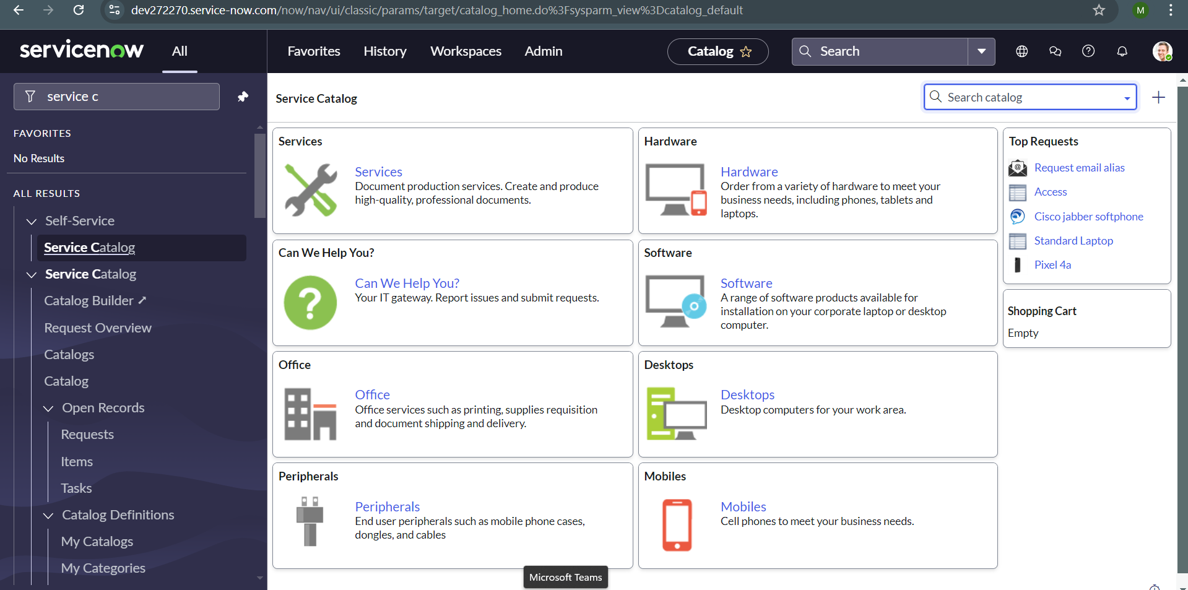choose the type of product that you want to request from the catalog.

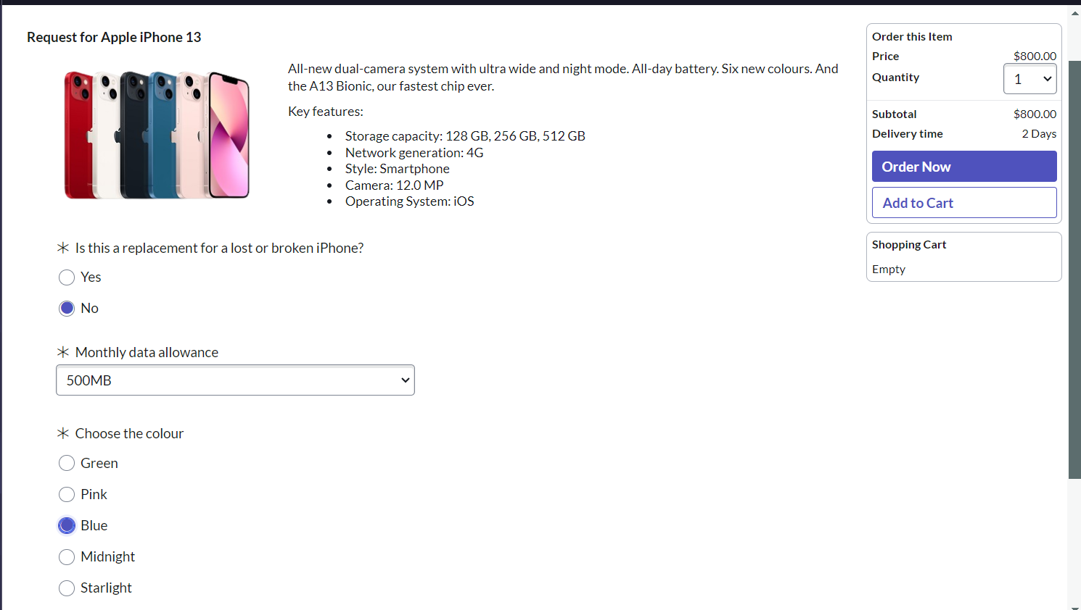choose the preferences if mentioned while ordering and add to cart.

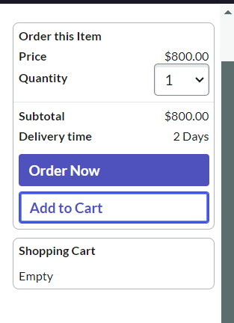 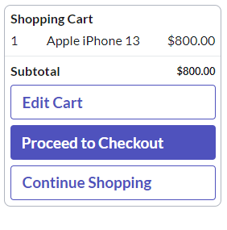now you will find the shopping cart and you can add the items of your requirement and click on proceed to checkout.

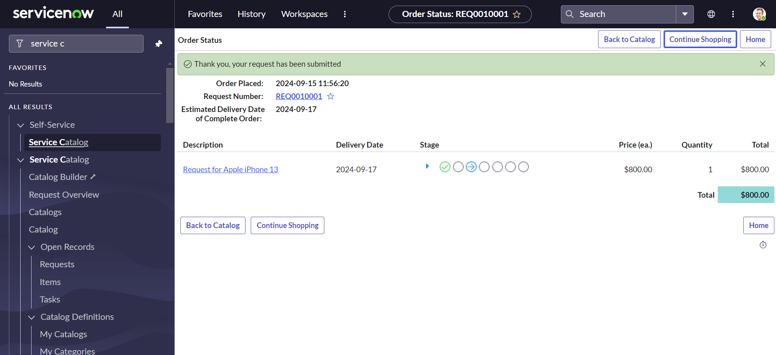you will find the request submission message pop up. Now the higher authorities or the approver will need to approve the request as the confirmation.

Creating a dashboard:

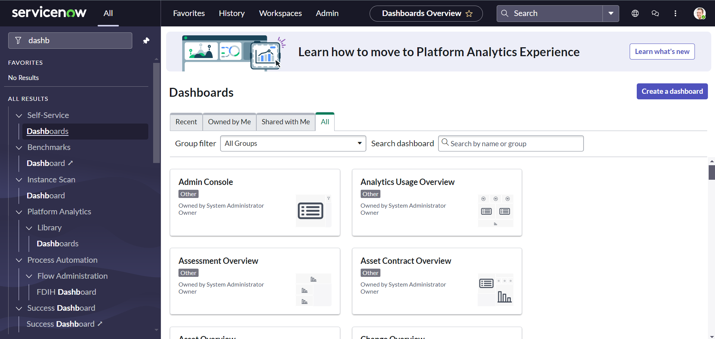navigate to the self service> dashboards and choose create a dashboard. 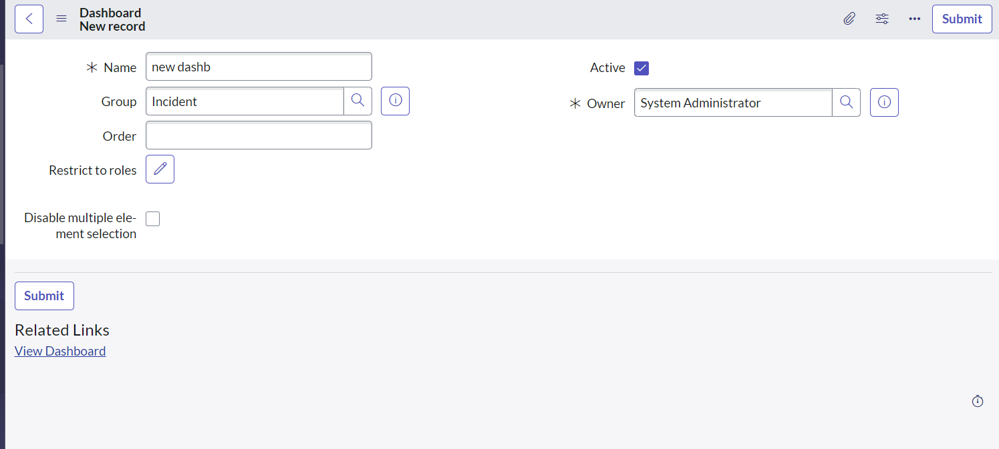

Fill in the details and submit to create new dashboard. And we can add any new widgets according to your choice for the dashboard 