Open AWS console -> open lambda -> create a lambda function by giving name as course-service and runtime as java21 and create a function

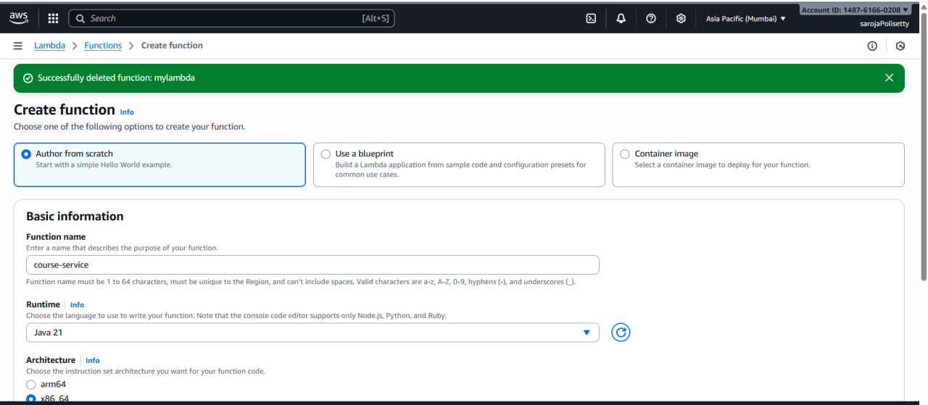

Successfully created a lambda function

In the code tab , click on upload from and select the .zip or .jar file upload the jar file which is in target floder.

Go to runtime settings ->click edit -> update the handler with our package and class name and save

Now, go to test tab , give event name as course-api, and in the event JSON change the path to end point(/courses) and httpMethod as GET and click test

After successfully execute now go to API Gateway 🡪 create Api

Select RESTapi

Give the details and click create api

Click the create resource

Click create create method

And click deploy api

Copy the invoke url and open postman

In postman click new select http add the data

