**Applied Physics**

|  |
| --- |
| **Module-2** |
| **Unit 2.1.Lasers** |

Module Description

Laser, is a device that stimulates atoms or molecules to emit light at particular wavelengths and amplifies that light, typically producing a very narrow beam of radiation. The emission generally covers an extremely limited range of visible, infrared, or ultraviolet wavelengths. Many different types of lasers have been developed, with highly varied characteristics. *Laser* is an acronym for “light amplification by the stimulated emission of radiation.” The first laser, constructed in 1960 by Theodore Maiman (born 1927) based on earlier work by Charles H. Townes, used a rod of ruby. Light of a suitable wavelength from a flashlight excited the ruby atoms to higher energy levels (*see* excitation). The excited atoms decayed swiftly to slightly lower energies (through phonon reactions) and then fell more slowly to the ground state, emitting light at a specific wavelength. The light tended to bounce back and forth between the polished ends of the rod, stimulating further emission. The laser has found valuable applications in microsurgery, compact-disc players, communications, and holography, as well as for drilling holes in hard materials, alignment in tunnel drilling, long-distance measurement, and mapping fine details.

|  |
| --- |
| **Unit 2.1 Lasers** |
| **Unit Table of Contents** | |
| **Unit 2.1** | |
| **Crystal structures** | |
| **Aim** | |
| Instructional Objectives | |
| Learning Outcomes | |
| 2.1.1 Introduction | |
| Self-Assessment Questions | |
| 2.1.2 Characteristics of laser | |
| Self-Assessment Questions | |
| 2.1.3 Pumping Mechanisms | |
| Self-Assessment Questions | |
| 2.1.4 He-Ne Laser | |
| Self-Assessment Questions | |
| 2.1.5 Ruby Laser | |
| Self-Assessment Questions | |
| 2.1.6 Applications | |
| Self-Assessment Questions | |
|  | |
| Summary | |
| Terminal Questions | |
| Answer Keys | |
| Activity | |
| Bibliography | |
| e-References | |
| Image Credits | |
| **AIM** | |
|  | |
| This unit enables the students to understand the laser mechanisms and their types and applications. | |
|  | |
| **INSTRUCTIONAL OBJECTIVES** | |
|  | |
| In this unit, the students will be able to: | |
| • Define basic definitions of light. | |
| • Gain insight to know the laser characteristics | |
| • Understand the various types of mechanisms.   * Demonstrate the working of various types of lasers | |
|  | |
| **LEARNING OUTCOMES** | |
|  | |
| At the end of the unit, the student is expected to:  1. Describe the difference ordinary light and laser.  2. Understands the various mechanisms of light interaction with matter  3. Demonstrates the pumping mechanisms  systems  4. Demonstrates the working of solid state laser and gas laser  5. Know the applications of Laser | |
|  | |
|  | |

**SESSION-1**

**Instructional objective:**

1. Understand the concept of the introduction of LASER
2. Understand the concept of Characteristics of LASER.

**Learning outcomes:**

1. Students gain the knowledge on the concept of the introduction of LASER
2. Students gain the knowledge on the Characteristics of LASER.

**2.1.1. Topic-1: Introduction:**

The word “LASER” is an acronym for “Light Amplification by Stimulated Emission of Radiation”. Albert Einstein in 1917 theoretically proved that the process of stimulated emission must exist but only in 1954, a group of scientists at Colombia University headed by Charles H. Townes operated a micro wave device for micro wave amplification by stimulated emission of radiation (MASER). In 1960 T.H. Maiman constructed a solid state laser at the Hughes research laboratories and first achieved LASER action at optical frequency. Since 1960 the development of LASER has been extremely rapid. Though it was called as “An invention in search of an application”, at the time of its invention, the variety of lasers and the wealth of laser applications developed since 1960 are enormous. New applications are being found even now almost every day.

**2.1.2 Topic-2: Characteristics of a laser:**

**Directionality:** The laser beam is highly directional. It can travel very large distances without divergence. A laser beam sent from earth to moon was recorded on earth after reflection by moon. The degree of directionality is expressed in terms of divergence. The divergence tells how rapidly the beam spreads when it is emitted from the laser. Using small approximation it can be shown that the laser beam increases in size about 1mm for every one meter of beam travel for a beam of divergence of 1 milli radian. At D1 and D2 are the distances from the laser window , if the diameter of the spots are measured to be r1 and r2 respectively.

Then angle of divergence is 

**Monochromaticity:** There is no single wavelength light source in the universe .But compared to other light sources laser is highly monochromatic. Non-monochromacity is expressed as Δѵ/ѵ

For example: For laser beam Δѵ = 50Hz and ѵ = 5x1014Hz.

Non monochromacity = 10-13

**Coherence:** Laser beam is spatially and temporally coherent. It is possible to observe interference effects from two independent laser beams.

**Brightness:** Laser beam is highly intense. Laser is the highest Intensity light source in the universe. Hence it can be used in welding, whole drilling and other material processing works. It produces very high temperatures.

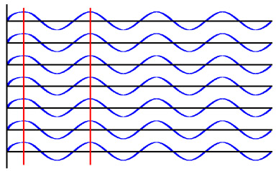

Review:

* 1. Give the detailed introduction of LASER.
  2. List the characteristics of LASER.
  3. Explain Monochromacity
  4. Discuss Directionality
  5. Describe the concept of coherence
  6. Summarize the brightness of LASER
  7. Give the brief discussion of characteristics of LASER.

**SESSION-2**

**Instructional objective:**

1. Understand the concept of the differences between spontaneous emission and stimulated emission.
2. Understand the concept of Population inversion in LASER
3. Understand the concept of Life-time of an energy level in LASER

**Learning outcomes:**

1. Students gain the knowledge on the concept of the differences between spontaneous emission and stimulated emission.
2. Students gain the knowledge on the concept of Population inversion in LASER
3. Students gain the knowledge on the concept of Life-time of an energy level in LASER

**Topic-1: Emission and Absorption**

The interaction of matter with radiation is three types. Those are Stimulated Absorption, Spontaneous emission and **Stimulated emission**. It can be explained one by one.

**Stimulated Absorption / excitation:**

Transition from a lower energy state to a higher energy state is known as stimulated absorption or excitation. An atom can absorb energy provided to get excited. This is a stimulated process.

**Spontaneous and stimulated emission**:

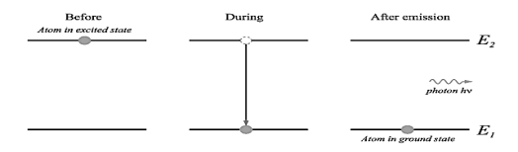When a ground state atom absorbs radiation, it is excited to a higher energy state. Within 10­-8 sec it makes a downward transition to the lower state without any external help. This transition is known as ‘spontaneous emission’. A photon of energy equal to the difference in energy between the excited and lower state is emitted.

Fig 6.2.1 Spontaneous emission

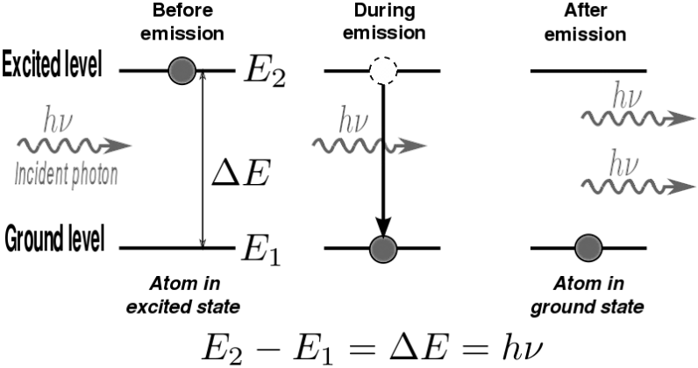

Fig 6.2.2 Stimulated emission

A downward transition can be forced on a higher state atom, if a photon collides with it forcing the transition. This results in a photon, which is in phase with the original photon. If this stimulation continues with all higher state atoms all the photons emitted will be coherent. This transition is known as ‘stimulated emission’. Under normal circumstances spontaneous emission dominates stimulated emission.

**Topic-2: Population inversion:**

Population inversion is the process in which the population of a particular higher energy state is made more that at a specified lower energy state. Under normal circumstances, for a system in thermal equilibrium, the population of any higher state is less than that of a lower energy state. According to Maxwell – Boltzmann distribution the number of atoms in any energy states given as



From this and 

N1 and N2 are the number of atoms in states E1 and E2

If E1 < E2 ⇒ N1 > N2

For laser action to take place N2 must be greater than N1 when E­2 > E1.

When this condition is satisfied Population inversion is achieved. Population inversion can be achieved, if a system has at least one meta-stable state.

In normal excited states an atom spends only a time of 10-8 sec, while in a meta-stable state the atom spent more duration approximately 10-3 sec.

If we could directly or indirectly excite ground states atoms to a meta-stable state, the number of upward transitions will be more than the number of downward transitions and population inversion can be achieved.

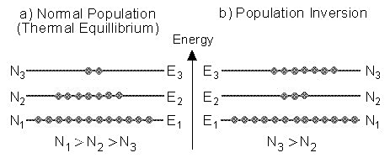

6.2.3 Population inversion in a three-level laser

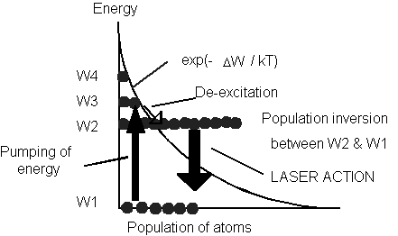

**Topic-3: Life-time of an energy level:**

The time spent by an atom in a state before any transition can take place is known as life-time of the state. For normal states from which only spontaneous emission takes place, the life-time is 10-8 sec, while for meta-stable states from which stimulated emission takes place, the life-time is 10-3 sec.

Review:

1. What is spontaneous emission?
2. Summarize stimulated emission.
3. Give the differences between spontaneous emission and stimulated emission.
4. Discuss on the concept of population inversion.
5. Differences between general population and population inversion.
6. Describe Life-time of an energy level

**SESSION-3**

**Instructional objective:**

1. Understand the concept of the pumping mechanism.
2. Understand the concept of working of He-Ne LASER.

**Learning outcomes:**

1. Students gain the knowledge on the concept of the pumping mechanism.
2. Students gain the knowledge on the concept of working of He-Ne LASER

**2.1.3.Topic-1: Pumping mechanisms:**

Pumping is the process of giving energy to a ground state atom and exciting it to a higher state. This is achieved in several ways.

**Optical pumping**: High intensity lamps like xenon flash lamp are used to excite atoms. This is used in pumping a Ruby laser. Some lasers are used to pumping by another laser.

**Electric discharge:** Gas lasers in a discharge tube can be subjected to several kV/m of electric field. Atoms are ionized and the electrons moving with high velocities and collide with other atoms and excite them too. Argon ion laser is an example.

**Atomic Collisions:** In He-Ne laser electric discharge provides excitation of the atoms that collide with Ne atoms and raise Ne atoms to excited states.

**Chemical reaction:** In chemical lasers a chemical reaction (H2+F2→2 HF) provides sufficient heat to excite atoms to higher levels.

Direct conversion: Electrical energy is directly converted to radiant energy in devices like semiconductor laser diodes.

* + 1. **Topic-2: Helium-neon laser (Gas laser)**

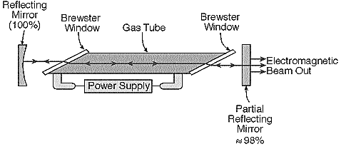In He – Ne laser the atoms are characterized by sharp energy levels and one uses an electric discharge to pump the atoms. He-Ne laser consists of a long and narrow discharge tube made up of fused quartz material(10-100 cm long & 2 mm in dia) filled with He and Ne in the ratio of 10:1 at partial pressures of 1: 0.1 torr.He atoms are used for selective pumping and Ne atoms are responsible for lasing action. The electrodes are connected to a few kV DC source. End windows are set at Brewster angle to polarize the laser light.

Fig5.3.1 He-Ne Laser

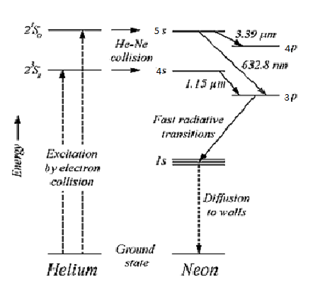

Fig 6.3.2 Energy levels of He-Ne Laser

**Working:**

When an electric discharge is passed through He-Ne gases, electrons are made the collisions with He atoms. Then the He atoms are excited to higher levels. Through atomic collisions(He with Ne) with Ne atoms He atoms transfer their energy to ground state Ne atoms and Ne atoms ate excited to 5s and 4s energy levels.Here Ne atoms makes three types of transitions.

Those are

5s→4p →3.39 µm

5s→3p →0.6328 µm

4s→3p →1.15 µm.

In the above three transitions 5s→4p and 4s→3p are lies under infrared region. Where 5s→3p →0.6328 µm transition lies under visible region. Ne atoms are de-excited from 4p and 3p to 1s level. Here 1s level is meta-stable state. In 1s level Ne atoms are spent more time resultant excitation decreases. To avoid this problem, gas discharge tube made very narrow, resultant ne atoms makes collisions with tube walls and de-excited to ground state of Ne. This process is continues .Hence He-Ne laser is a continuous wave laser.

Review:

1. Pumping mechanism means what
2. Give the different types of pumping mechanisms.
3. Discuss any one type of the gas LASER
4. Discuss the production method of He-Ne LASER.
5. Explain the energy level diagram of the He-Ne LASER.
6. Describe the working principle and construction method of He-Ne LASER.

**SESSION-4**

**Instructional objective:**

1. Understand the concept of the production of the RUBY LASER method.
2. Understand the concept of working of Semiconducting LASER.

**Learning outcomes:**

1. Students gain the knowledge on the concept of the production of the RUBY LASER method.
2. Students gain the knowledge on the concept of working of Semiconducting LASER.
   * 1. **Topic-1: Ruby laser**

Ruby laser is a first solid state laser. It is three level and pulsed laser.

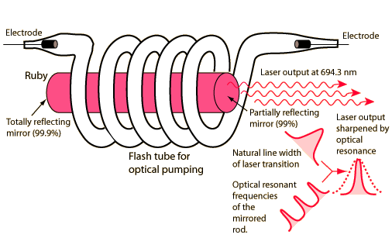**Construction:**

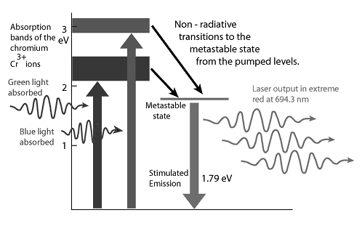Ruby is synthetic Al2O3 with 0.05% of Cr2O3 added to it. The Cr3+ ions are the active ingredient; the ‘Al’ and ‘O’ atoms are inert. The Ruby crystal is cut into a cylindrical rod. The ends of the rod are polished flat to act as the cavity mirrors. Pumping is by light from a Xenon flash lamp. This is shown in the figure below. Elliptical reflectors are sometimes used. Chromium doped Ruby has 3 energy levels as shown in the figure. One energy band is wide and can accept a wide range of wavelengths. It has a short lifetime. The excited Cr3+ ions rapidly relax and drop to the lower level which is meta-stable. This transition is non-radioactive. Consequently Cr3+ ions remain longer in the meta-stable level and population inversion takes place. A photon is emitted spontaneously and triggers an avalanche of photons from the other atoms in this meta-stable state. These photons are trapped inside the rod by the reflecting ends until amplification takes place. Finally a high intensity coherent and collimated laser beam of short duration emerges out of the partially silvered end. The wavelength of this laser light is 694.3 nm. Ruby laser is a pulsed laser.

Fig 6.4.2 Energy level diagram of Ruby Laser

**SESSION-5**

**Instructional objective:**

1. Understand the concept of the applications of LASER.
2. Understand the concept of applications of LASER in industry and medical field.

**Learning outcomes:**

1. Students gain the knowledge on the concept of the applications of LASER.
2. Students gain the knowledge concept of applications of LASER in industry and medical field.
   * 1. **Topic-1: Applications of lasers**

**Communications:** Laser light has a very large bandwidth (105 MHz). A bandwidth of 40000 MHz would permit 107 simultaneous telephone calls or 8000 TV channels. The directionality of laser makes it a useful tool in interpolarity communications. Laser radiation is not absorbed by water and so is utilized in under water communications (LIDAR). In conjunction with optical fibers, laser can be used to transmit audio signals over long distances without attenuation.

**Material Processing:** This involves cutting, welding, hole drilling & surface treatment. Laser radiation can be converted into heat and can be used in the above mentioned applications.

**Military Applications:** Death-ray: Because of its high energy density a laser beam can destroy aircraft, missiles when targeted. Laser gun: A highly emergent laser beam can evaporate targets.

**Lasers in Medicine:** Medical profession in fully utilizing the potential of a laser in the following areas.

**Ophthalmology**: Treatment of detached retina.

**Neurosurgery**: Treatment of lesion in skull and spine

**Gastroenterology**: Treatment of coagulation of gastric intestinal tracts.

**Dermatology**: Removal of skin imperfections.

**Gynecology**: fertility microsurgery, fallopian tube reconstruction.

**ENT**: Ear, nose & throat surgery.

**Computers:** Laser printers. To transmit memory banks from one computer to another. 3 D profiling (holography). CDs – ROM.

**Pure Sciences:** Isotope separation, plasma, thermo-nuclear fusion reactions, holography, nature of chemical bonds, measurements of traces of pollutant gases, making of carbon nanotubes etc., to name a few.

Review:

1. List the applications of LASER.
2. Discuss the general applications of LASER
3. Give the industry applications of LASER.
4. Describe medical applications of LASER.
5. Give brief discussion on Holography.

**SESSION-6:**

**Topic-1: Solved examples**

1. A photon has a wavelength λ of 1.2Ȧ. Calculate (a) the energy E of the photon in eV and (b) the momentum p of the photon.

Sol:

Formula: The energy of the photon E = hc/λ, Momentum of the photon p = h/λ

Ans: E = 10343.8eV, p = 5.52x10-24Kg m/s

1. A radio transmitter radiates 10 kW power at a frequency of 900 kHz. Calculate the number of photons emitted per second by the transmitter.

Sol: Let E1 be the energy emitted per second. E1 = 104J

Formula: The energy carried by one photon E = hν

The number of photons N emitted per second is given by N = E1/E

Ans: E = 596.3x10-30J, N = 16.77x1030

1. For a He-Ne laser at 1m and 2m distances from the laser the output beam spot diameters are 4mm and 6mm respectively. Calculate the divergence.

Sol:

Formula: Divergence θ = (a2 –a1)/2( d2-d1)

Ans: θ= 1m rad

1. Calculate the ratio of stimulated emission to the spontaneous emission for sodium D lines at a temperature of 2500C .

Sol:

Formula: n211/n21 = 1/{exp(hν/kT)-1}

Ans: 5.24x10-21

1. Calculalte the energy difference in eV between the two energy levels of the Neon atoms of a Helium – Neon gas laser, the transitions between these levels results in the emission of a light of wavelength λ=632.8nm.

Sol:

Formula: E2 –E1 = hν = hc/λ

Ans: 1.96eV

1. Find the ratio of population of the two energy states of the Ruby laser, the transition between which is responsible for the emission of photon of wavelength λ = 6928Ȧ. Assume the ambient temperature as 18K.

Sol:

Formula: N = N0.exp(-E/kBT), ΔE = hc/λ

Ans: N2/N1 = 8.85x10-32

1. Calculate the wavelength of emission from GaAs material whose band gap is 1.44eV.

Sol:

Formula: λ = hc/Eg

Ans: 8628Ȧ

1. A He-Ne gas laser of wavelength 6328Ȧ has an output power of 2.3mW. How many photons are emitted per each minute when it is operated.

Sol:

Formula: power = nhc/λ.

Ans: n = 4.39x1017 photons per minute.

**SESSION-7**

**Topic-1: Exercise Problems**

1. A photon has a wavelength of 1.1Ȧ. Calculate (a) the energy of the photon in eV and (b) the momentum of the photon.
2. Calculate the relative population of Na atoms in Na lamp in the first excited state and in the ground state at a temperature of 3000C. Assume λ=590nm.
3. Determine the ratio of stimulated emission to the spontaneous emission at a temperature of 3000C for Na D lines.
4. The power output of a particular He-Ne laser is 4mW. Assuming the wavelength of the He-Ne laser to be 632.8nm, calculate the number of photons emitted per minute during the lasers operation.
5. In GaAs diode laser has peak emission at wavelength λ=8240Ȧ. Calculate its energy gap in eV.

**Short Answer Questions:**

1. What does the term laser stand for?
2. What is absorption of light?
3. What is meant by spontaneous emission?
4. What is stimulated emission?
5. Explain the principle of laser.
6. What are the conditions needed for laser action?
7. What is meant by population inversion? And how can it be achieved?
8. What is meant by active material in a laser?
9. What are the differences between spontaneous emission and stimulated emission?
10. What are the characteristics of a lasers?
11. What are coherent sources?
12. What is meant by pumping of atoms?
13. What are the different types of pumping?
14. What are the different types of laser?
15. Mention any two applications of laser beams.

**Essay Questions:**

1. Explain the different methods used for pumping of atoms.
2. Explain with a neat sketch the construction and working of ruby laser.
3. What is a gas laser? Explain the working of He-Ne laser with relevant diagrams.
4. What is a semiconductor diode laser? Explain the construction and working of a Ga-As laser.