Evolution of databases:

The database completed more than 50n years of journey of its evolution from flat file to object relation database

1. Filebased- 1968

* Data is maintained in flat file
* It has many a and d where A- we have many access methods like sequential, indexed,random
* D- It requires extensive programming

1. Hierarchical

* Charles Bachman designed the first computerised database in the early 1960s. This first database was known as the **Integrated Data Store, or IDS.**
* This was shortly followed by the **Information Management System**, a database created by IBM.
* Both databases were forerunners of the ‘navigational database’.
* Navigational databases required users to navigate through the entire database to find the information they wanted.
* There are two main models of this:
* **hierarchical model (IBM)**

**Parent and child manner(**data is organised like a family tree**)**

Complex implementation, lack structural independence, cant easily handle many-many relationship

* **network model (Charles)**

**complexity**

**(**a record to have more than one parent and child record**)**

1. **relational databases**

A relational database is one that shows the relationship between different data records.

**searchable**

**more space-efficient (reduced  data storage costs)**

* Atomicity
* Consistency
* Integrity
* Durability
* Concurrency
* Query processing

1. cloud database

Cloud database facilitates you to store, manage, and retrieve their structured, unstructured data via a cloud platform. This data is accessible over the Internet. Cloud databases are also called a database as service (DBaaS) because they are offered as a managed service.

**Some best cloud options are:**

* AWS (Amazon Web Services)
* Snowflake Computing
* Oracle Database Cloud Services
* Microsoft SQL server

A – Lower costs , automated-recovery, failover, auto scaling, increased accessbilty

1. No Sql

MongoDB -documented based

A--

* High scalability
* High availability

D—

* Open source - NoSQL is an open-source database, so there is no reliable standard for NoSQL yet
* Management challenge
* Backup

1. The Object-Oriented Databases

* Objects
* Classes
* Inheritance
* Polymorphism
* Encapsulation

1. Graph Databases

A graph database is a NoSQL database. It is a graphical representation of data. It contains nodes and edges. A node represents an entity, and each edge represents a relationship between two edges.

**DBMS (Data Base Management System)**

Database management System is software which is used to store and retrieve the database. For example, Oracle, MySQL, etc.; these are some popular DBMS tools.

* DBMS provides the interface to perform the various operations like creation, deletion, modification, etc.
* DBMS allows the user to create their databases as per their requirement.
* DBMS accepts the request from the application and provides specific data through the operating system.
* DBMS contains the group of programs which acts according to the user instruction.
* It provides security to the database.

An RDBMS is a tabular DBMS that maintains the security, integrity, accuracy, and consistency of the data.

The main objective of the 3 level architecture is to enable multiple users to access the same data with a personalized view that means abstract view the data is stored only once

1. Physical level

The lowest level of abstraction describes how data is stored

* It is the lowest level of abstraction closest to the physical storage method used . It indicates how the data will be stored and describes the data structures and access methods to be used by the database . The internal view is expressed by internal schema.
* The following aspects are considered at this level:
  + Storage allocation eg: B-tree, hashing.
  + Access paths eg. specification of primary and secondary keys, indexes etc.
  + Miscellaneous eg. Data compression and encryption techniques, optimization of the internal structures.

**Conceptual level**

At this level of database abstraction all the database entities and the relationships among them are included . One conceptual view represents the entire database

The conceptual schema hides the details of physical storage structures and concentrates on describing entities, data types, relationships

The conceptual schema hides the details of physical storage structures and concentrates on describing entities, data types, relationships

**External Level**

The conceptual schema hides the details of physical storage structures and concentrates on describing entities, data types, relationships

The conceptual schema hides the details of physical storage structures and concentrates on describing entities, data types, relationships

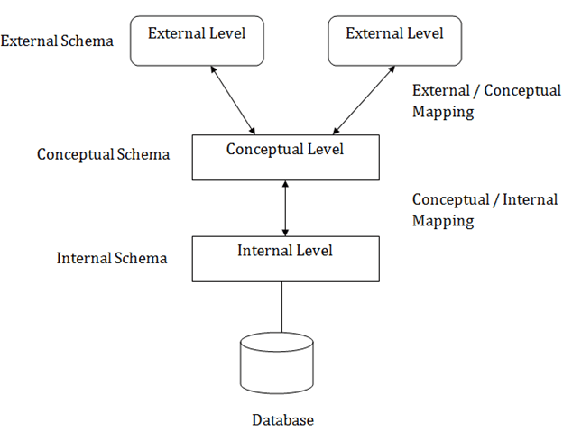

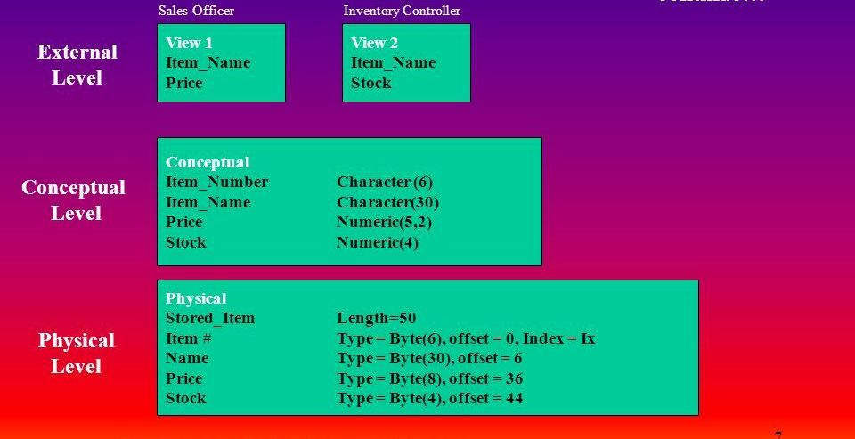

Types of databases

* 1. Centralized database

It is the type of database that stores data at a centralized database system. It comforts the users to access the stored data from different locations through several applications.

D- size of the centralized database is large

* 1. Data consistency is maintained
  2. Distributed Database
* Unlike a centralized database system, in distributed systems, data is distributed among different database systems of an organization. These database systems are connected via communication links.
* Ex: Apache Cassandra,
* **Homogeneous DDB:** Those database systems which execute on the same operating system and use the same application process and carry the same hardware devices.
* **Heterogeneous DDB:** Those database systems which execute on different operating systems under different application procedures, and carries different hardware devices.
  + 1. Relational Database

This database is based on the relational data model, which stores data in the form of rows(tuple) and columns(attributes), and together forms a table(relation). A relational database uses SQL for storing, manipulating, as well as maintaining the data. E.F. Codd invented the database in 1970. Each table in the database carries a key that makes the data unique from others. **Examples** of Relational databases are MySQL, Microsoft SQL Server, Oracle, etc.

Properties of Relational Database

There are following four commonly known properties of a relational model known as ACID properties, where:

**A means Atomicity:** This ensures the data operation will complete either with success or with failure. It follows the 'all or nothing' strategy. For example, a transaction will either be committed or will abort.

**C means Consistency:** If we perform any operation over the data, its value before and after the operation should be preserved. For example, the account balance before and after the transaction should be correct, i.e., it should remain conserved.

**I means Isolation:** There can be concurrent users for accessing data at the same time from the database. Thus, isolation between the data should remain isolated. For example, when multiple transactions occur at the same time, one transaction effects should not be visible to the other transactions in the database.

**D means Durability:** It ensures that once it completes the operation and commits the data, data changes should remain permanent.

* + 1. **NoSql database**

Non-SQL/Not Only SQL is a type of database that is used for storing a wide range of data sets. It is not a relational database as it stores data not only in tabular form but in several different ways. It came into existence when the demand for building modern applications increased. Thus, NoSQL presented a wide variety of database technologies in response to the demands. We can further divide a NoSQL database into the following four types:

* 1. **Key-value storage:** It is the simplest type of database storage where it stores every single item as a key (or attribute name) holding its value, together.
  2. **Document-oriented Database:** A type of database used to store data as JSON-like document.
  3. **Graph Databases:** It is used for storing vast amounts of data in a graph-like structure. Most commonly, social networking websites use the graph database.
  4. **Wide-column stores:** It is similar to the data represented in relational databases. Here, data is stored in large columns together, instead of storing in rows.
  5. Cloud Database

A type of database where data is stored in a virtual environment and executes over the cloud computing platform.

* 1. Object oriented database

The type of database that uses the object-based data model approach for storing data in the database system. The data is represented and stored as objects which are similar to the objects used in the object-oriented programming language.

* 1. Hierarchical database

It is the type of database that stores data in the form of parent-children relationship nodes. Here, it organizes data in a tree-like structure.

* 1. Network Databases

It is the database that typically follows the network data model. Here, the representation of data is in the form of nodes connected via links between them.

* 1. Personal Database

Collecting and storing data on the user's system defines a Personal Database. This database is basically designed for a single user.

* 1. Enterprise Database
* Large organizations or enterprises use this database for managing a massive amount of data. It helps organizations to increase and improve their efficiency. Such a database allows simultaneous access to users.

**RDBMS**

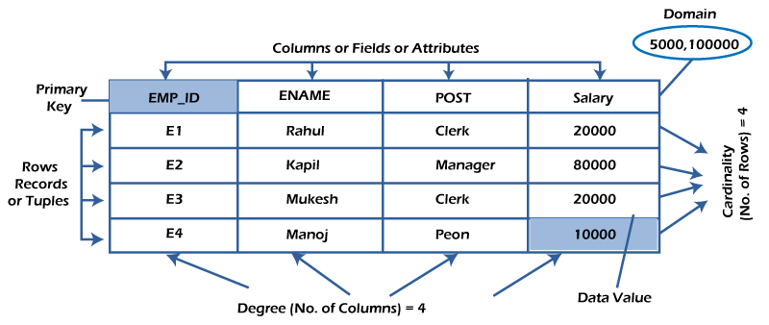

Everything in a relational database is stored in the form of relations. The RDBMS database uses tables to store data. The organized collection of data into a relational table is known as the logical view of the database.

* Each relation has a unique name by which it is identified in the database.
* Relation does not contain duplicate tuples.
* The tuples of a relation have no specific order.
* All attributes in a relation are atomic, i.e., each cell of a relation contains exactly one value.

Cells/ data item

The smallest unit of data in the table is the individual data item.

Domain: The domain refers to the possible values each attribute can contain. F**or example**, An attribute entitled Marital_Status may be limited to married or unmarried values.

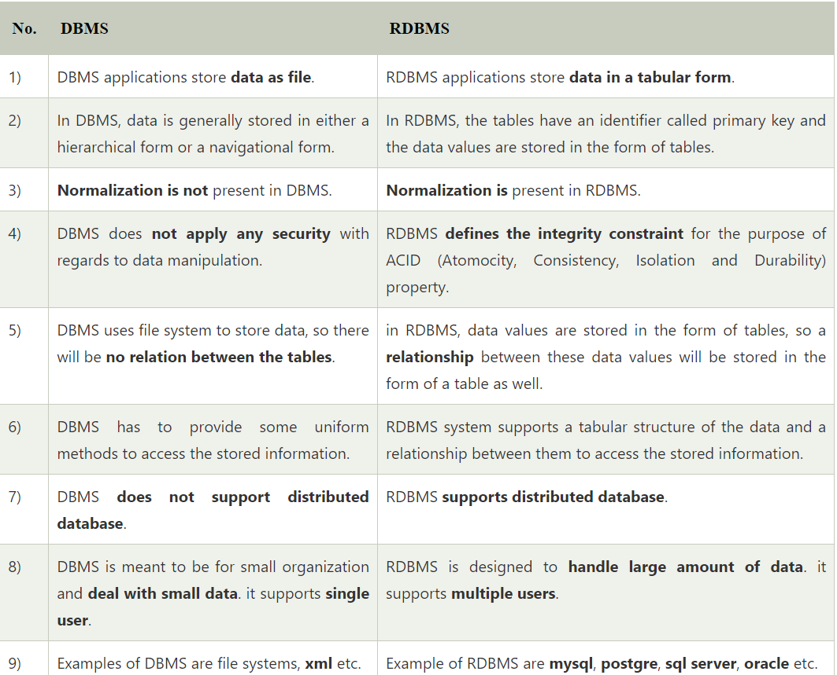

After observing the differences between DBMS and RDBMS, you can say that RDBMS is an extension of DBMS. There are many software products in the market today who are compatible for both DBMS and RDBMS. Means today a RDBMS application is DBMS application and vice-versa.