LAB -1: Demonstration on AWS S3 bucket to host static website

S3 – simple storage service

1.go to aws console open s3 . (region – ohio) click on create bucket.

2.Name the bucket s3bucket31399 and acl should be enabled because it can’t be edited after creation of bucket.

3. block the public access should be unchecked because we are hosting a website but whether in general situation it should be checked. Check the acknowledgement.

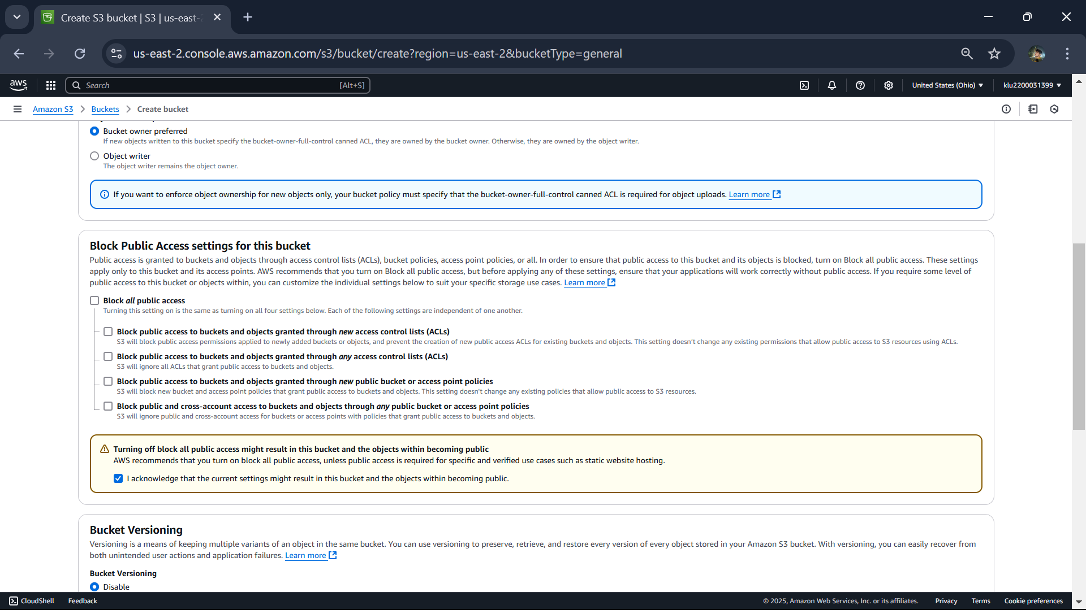

4.Bucket versioning will be disabled

5. keep the remaining as it is

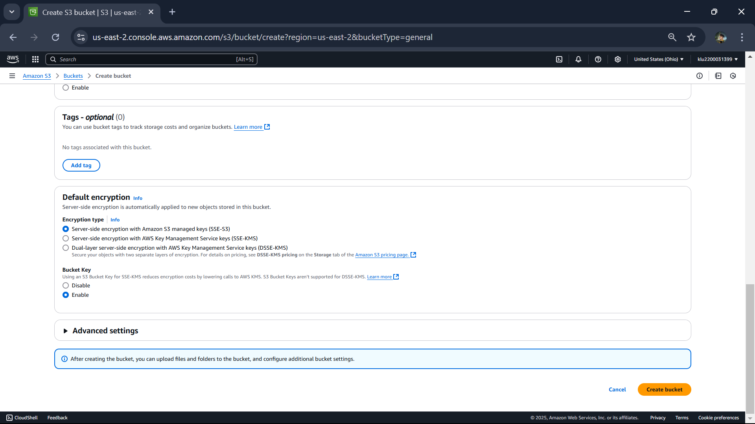

6.In advanced settings object lock must be disabled then click on create bucket.

7.Bucket created successfully.

8.open the bucket and Click on upload .

9. Then click on add files.

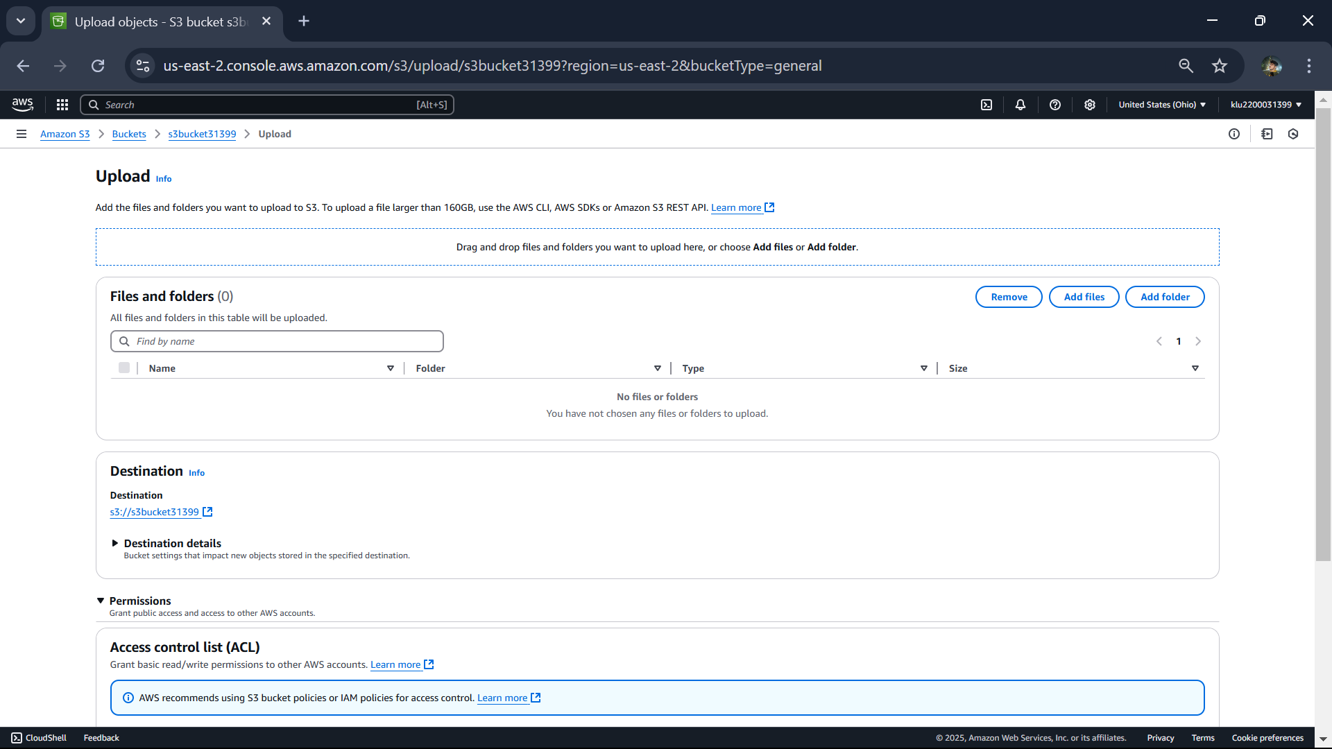

10. in permission go to access control list(ACL)

The predefined acl should be in grant-public access

11. click on upload

12. click on s3 bucket open properties.

13. in that scroll down for static web hosting click on edit. Then enable it.

Name it as index.html and save it.

That code is from chatgpt but it showing error when I was saving it:  
so I cancel it.  
the output of the file we uploaded in se bucket is

Now empty the bucket and delete it.

now delete the bucket

