LAB 13: Demo on cloud formation to create EC2 instance using template.

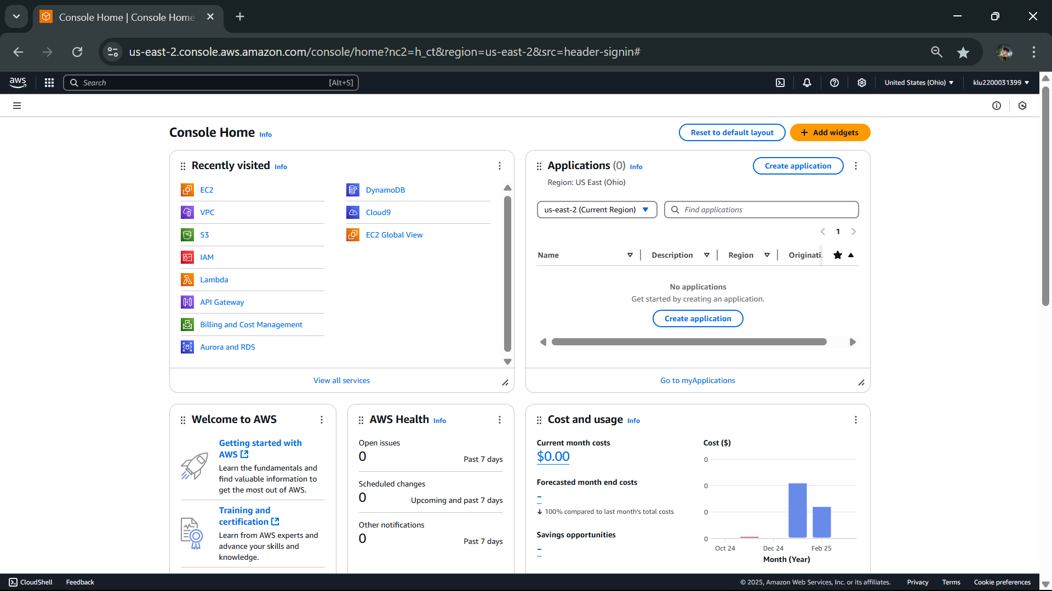

Go to aws console and type cloud formation.

Click on create a stack.

Click on upload file   
upload sample.yml:

The code   
Resources:

  MyInstance:

    Type: AWS::EC2::Instance

    Properties:

      AvailabilityZone: us-east-2a

      ImageId: ami-019f9b3318b7155c5

      InstanceType: t2.micro

After adding the sample.yml  
click on next.

The stack name is: ec2stackmarch14

Click next>next>and submit it.

The stack is created.

Now open new tab for EC2.

In EC2 the instance is created.

NOW DELETE THE STACK.

Same the Instance created in EC2 is also will be shtting down

