**LAB 3** : Demonstration on EC2 instance with Ubuntu OS

EC2 : Elastic Compute Cloud

It is used create virtual server.

Storage,OS(AMI),Network , Security etc…

1.Search for EC2 and open it.

2.Launch instance.

3.name it as ec2serverjan3 and select Ubuntu AMI(OS)

4.in next step create new key pair as keypairjan3

.pem = privacy enhanced mail – AWS

.ppk = putty private key – PUTTY

5. create a new key pair.

6.in network settings check http and https also..

7.keep remaining as it is and click on lunch

Instance is created.

8.select the instance and click on connect.

9.no changes click on connect, it will open in new tab

10.Commands

Sudo su

Sudo apt update

Sudo apt install apache2

Cd /var/www/html

Ls

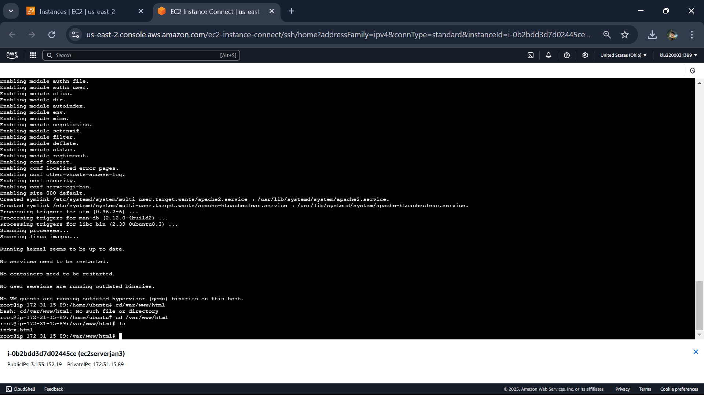

Sudo systemctl start apache2

11.copy the ip address in instance and copy it and open in new tab

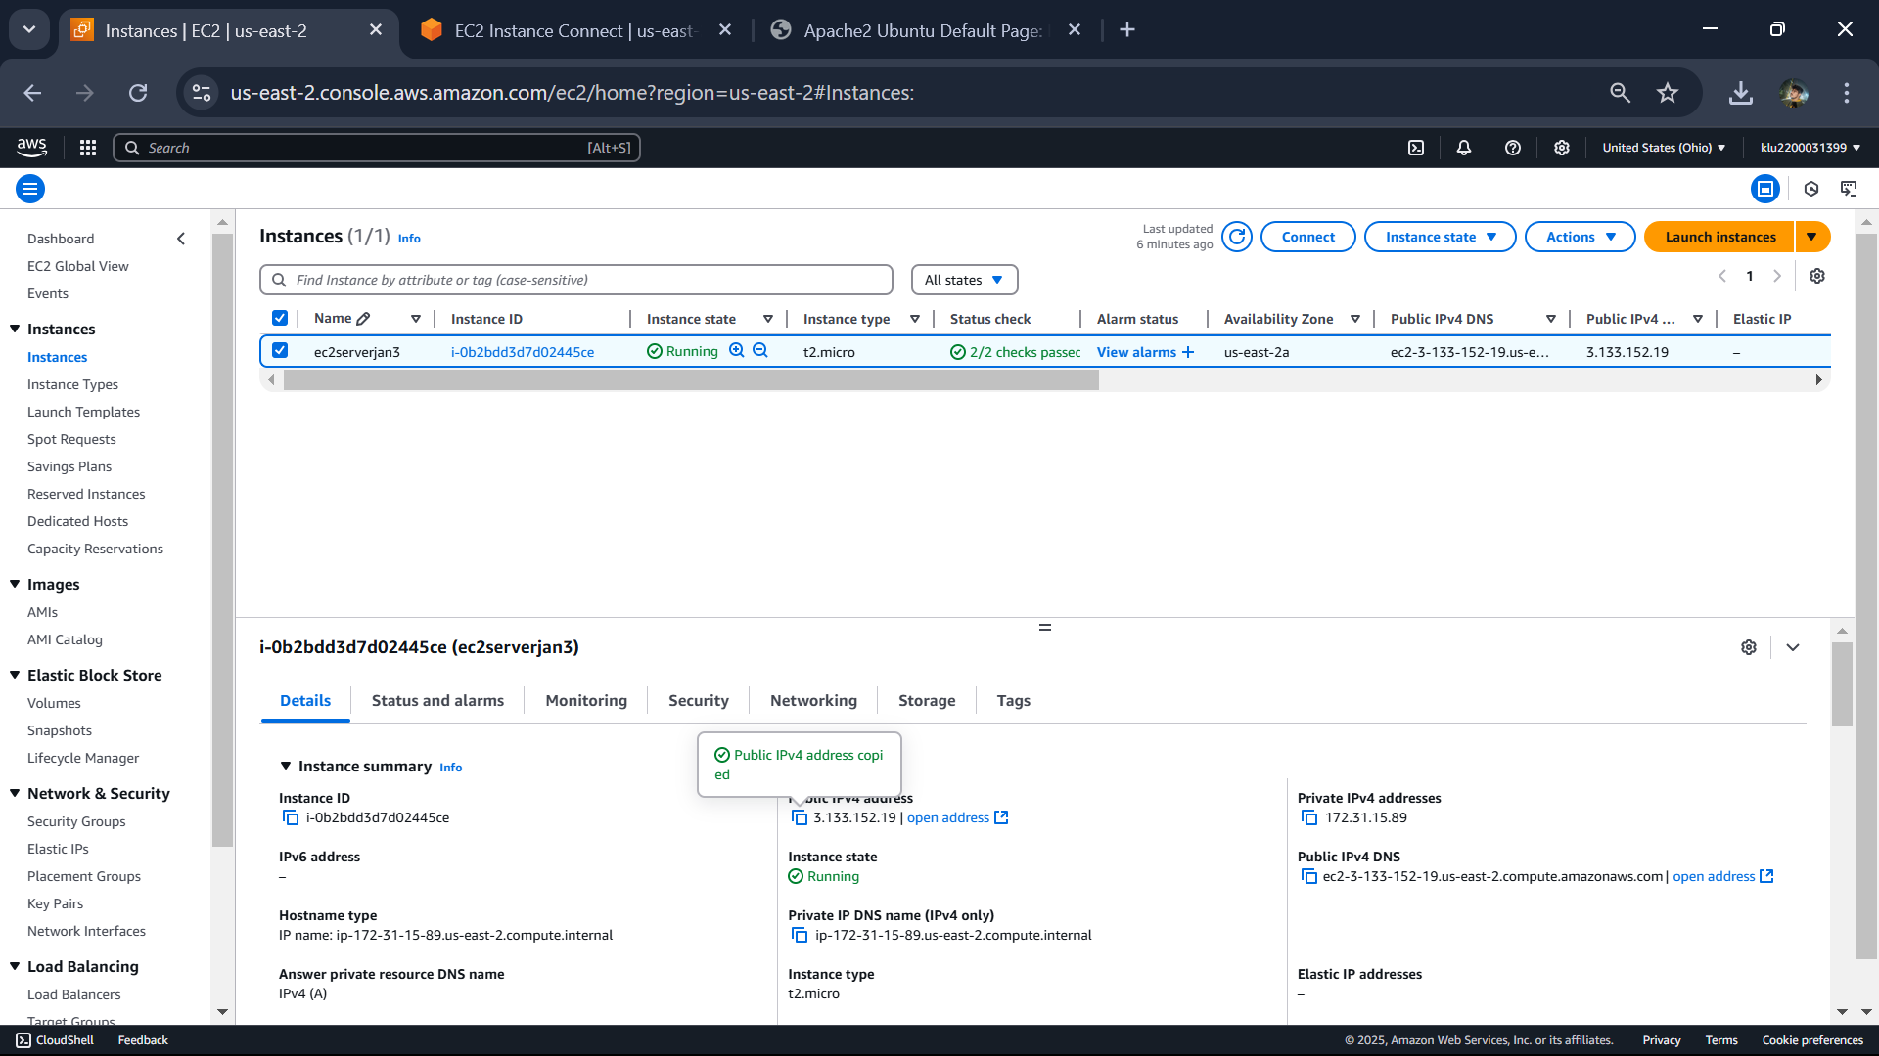

Output:

12.come to terminal and type

Rm index.html

Vi index.html

Then enter I it is insert mode.

13.Then click on esc and :wq

14.enter nano index.html

It will open like this

15.write a sample code and type ctrl+x and then press y and enter.

16.and again sudo systemctl start apache2

Then go to the ip address copied refresh it it will show you like this.

16.Terminate the instance now.

It will delete the instance.