LAB: 5

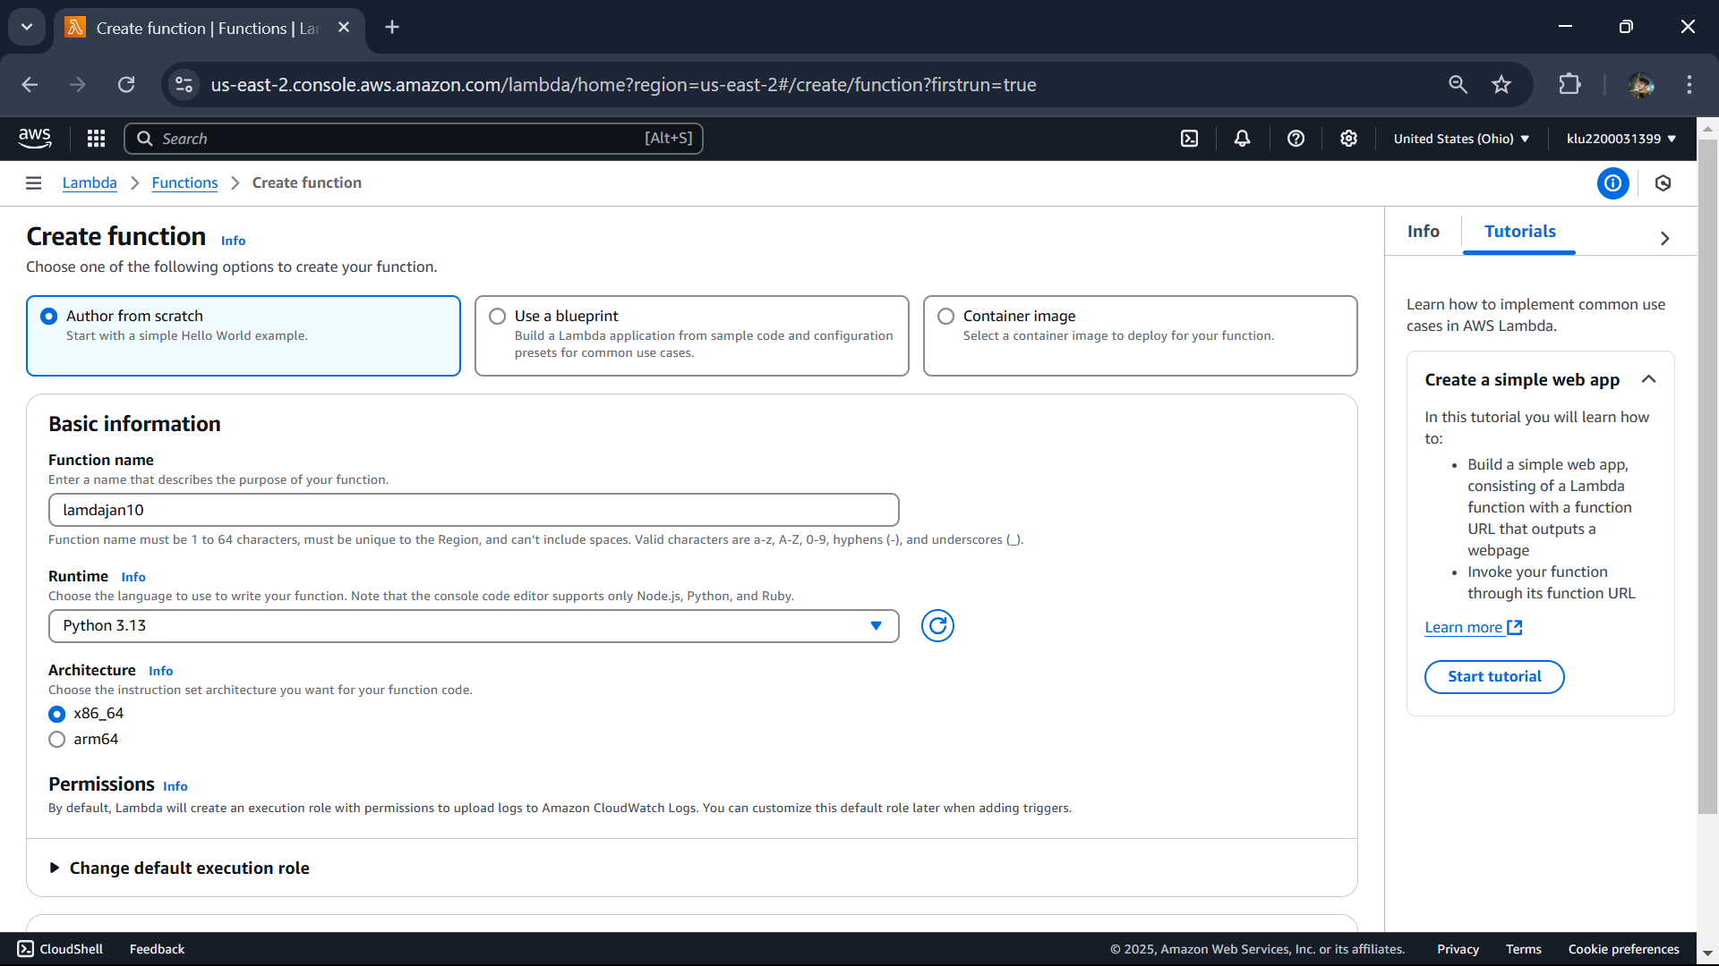

Then delete the lamdafunction