LAB-6: Dynamo DB

Create the table .

The table is created/

Go to explore items and add the the new attribute name empname and add the values.

Adding new record:

Output:

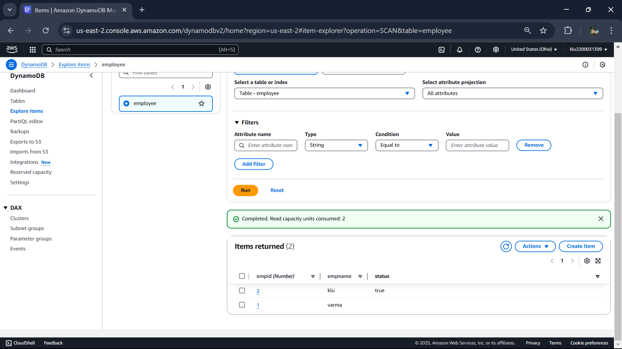

Going for json form:

Also uncheck the toogle on top side of editor.

