LAB -7: Demonstration on EC2 instance to copy the file to S3 bucket.

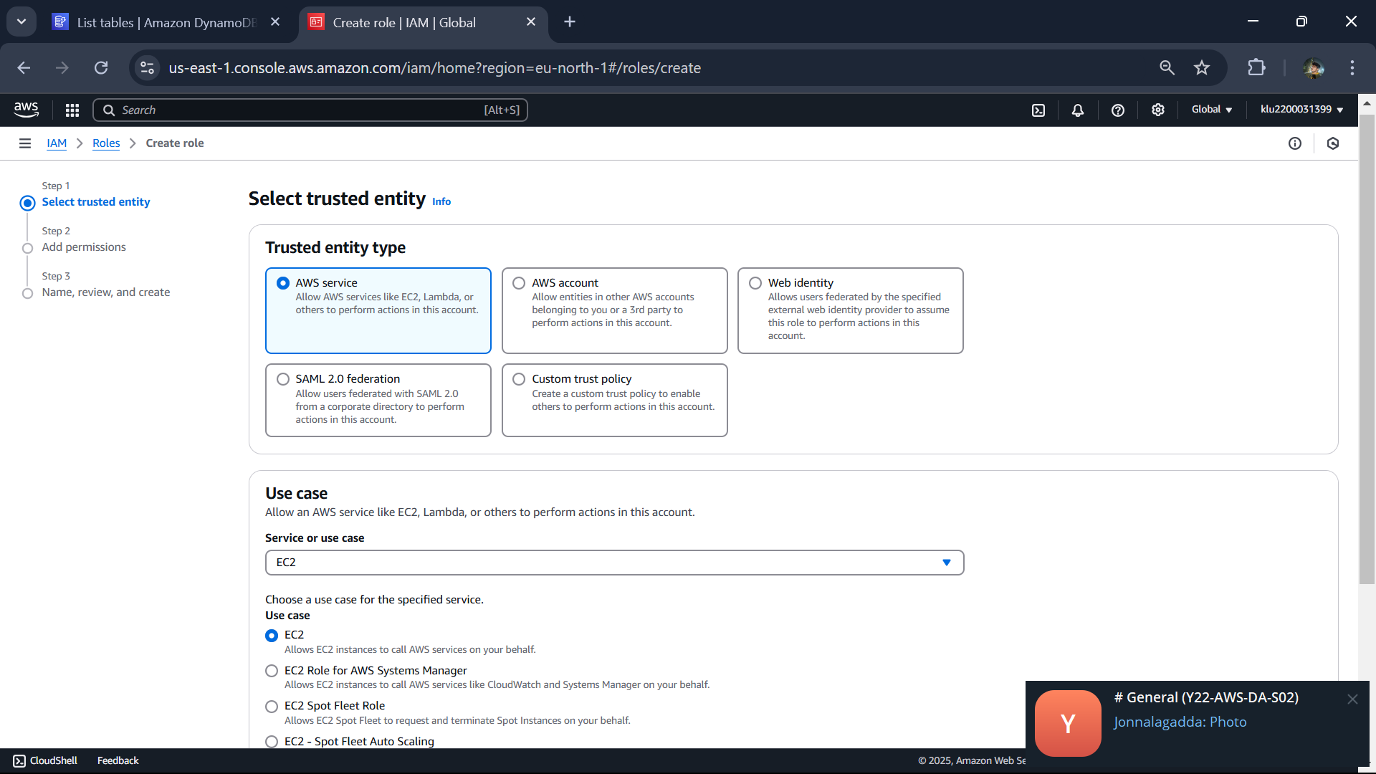

Click next

Type s3 and click s3fullaccess

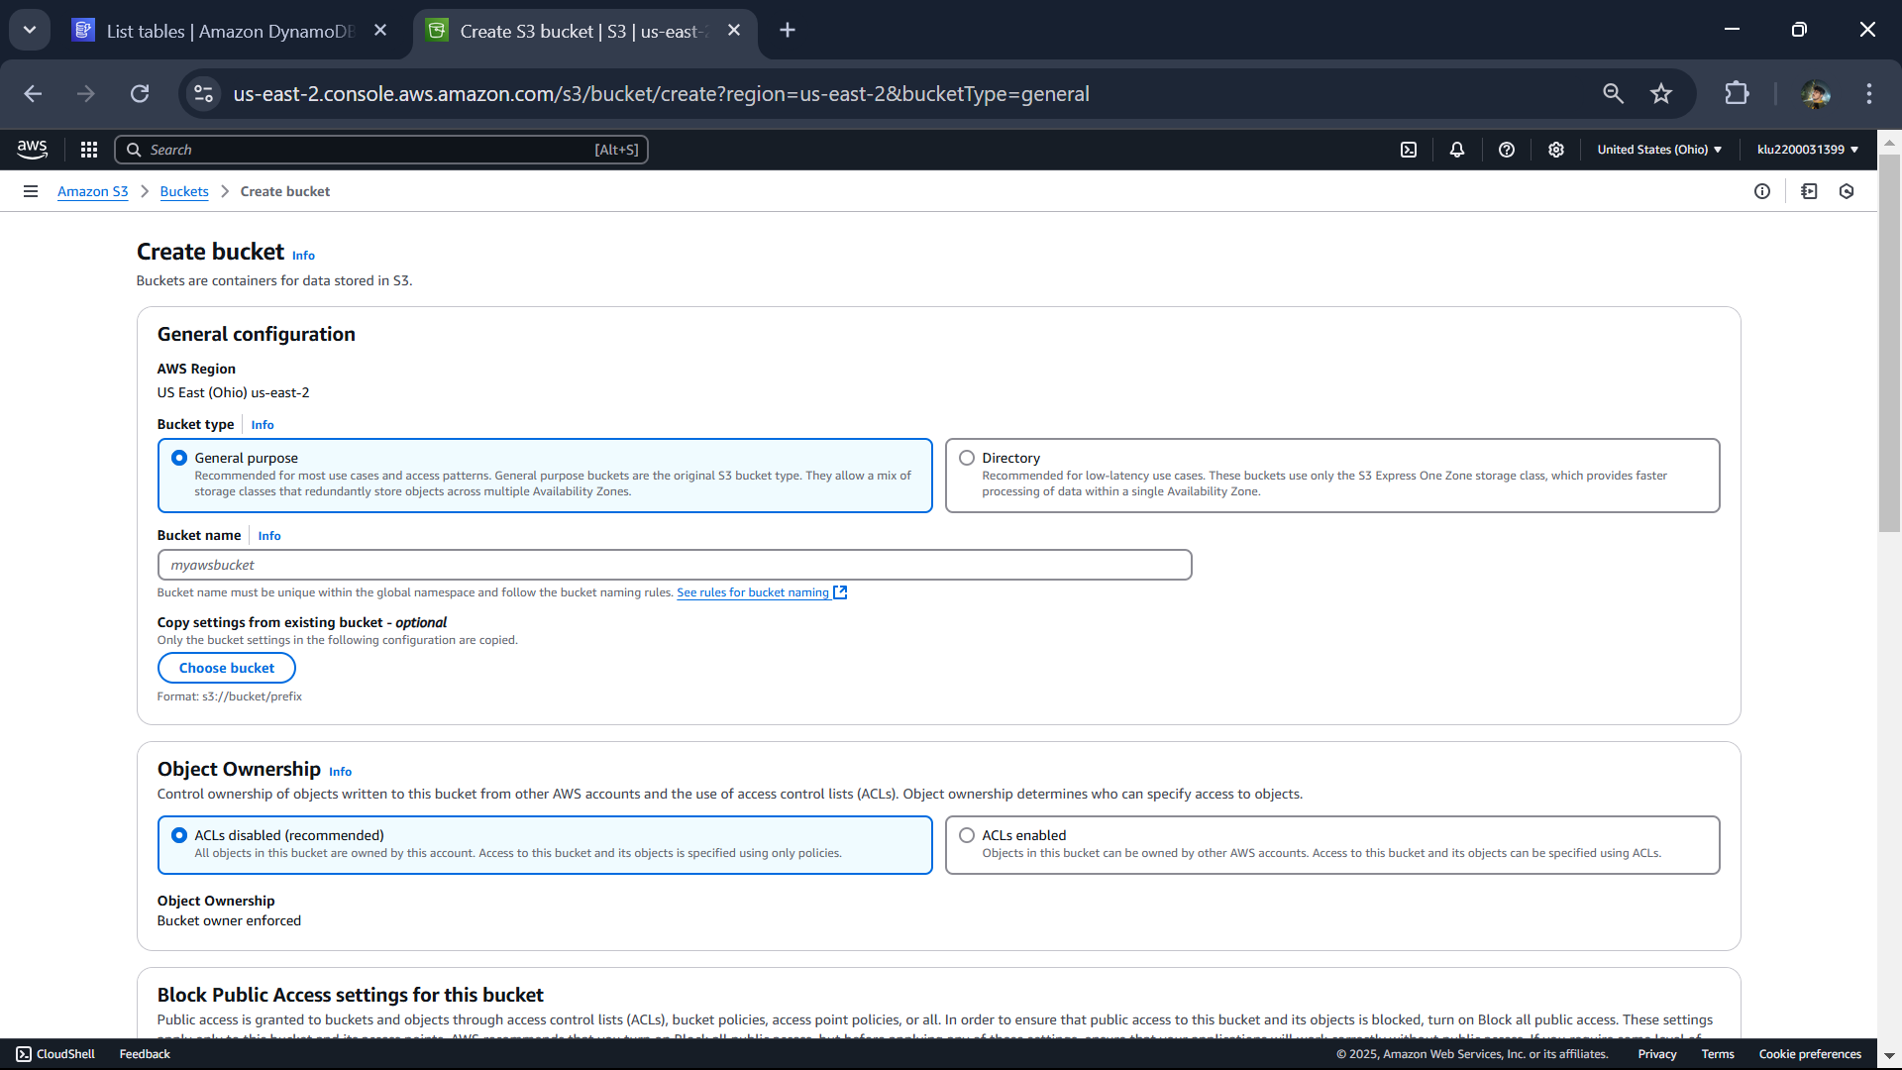

Bucketname : s3bucket31399