Create a folder named- reactapps in AWS DA.

Open it in vs code.

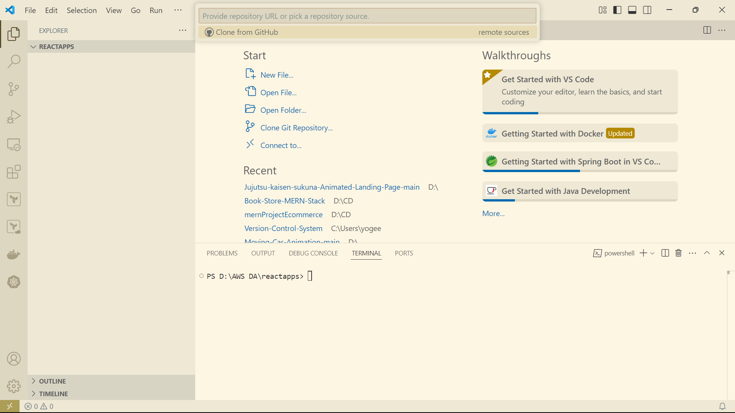

Npm – node package manager.

We are creating the app using vite.

--command is npm create vite

Click enter now select -- react

And select variant : javascript.

Select tab to see like .\demoreactapp\

Type npm install vite.

Not run 🡪npm install

Index.html = spa(single page application)

Run the app.

Type command 🡪 npm run dev

Output:

Jsx = x means extension to java script.

Edit app.jsx like this.

Edit main.jsx

Folder name is Demo.jsx

Code of Demo.jsx:

import React from "react";

**function** Demo(){

    return(

        <>

        <p>K L University</p>

        <p>CSE Department</p>

        </>

    )

}

export default Demo

App.jsx:

*// import { useState } from 'react'*

*// import reactLogo from './assets/react.svg'*

*// import viteLogo from '/vite.svg'*

*// import './App.css'*

import Demo from "./Demo"

**function** App() {

  return (

    <>

     <div>

      <h1>Demo React App</h1>

      <Demo/>

     </div>

    </>

  )

}

export default App

Git commands:

Git init

Git remote add origin <https://github.com/klu2200031399/reactproject.git>

Git add .

Git status

Git config –global user.name”name”

Git config –global user.email”email”

Git commit -m “created project”

Git push origin master.

Push the files in github.