SKILL-2:
T. Siva Harsha Vardhan Reddy
2400030361
Section-09

Screenshots:

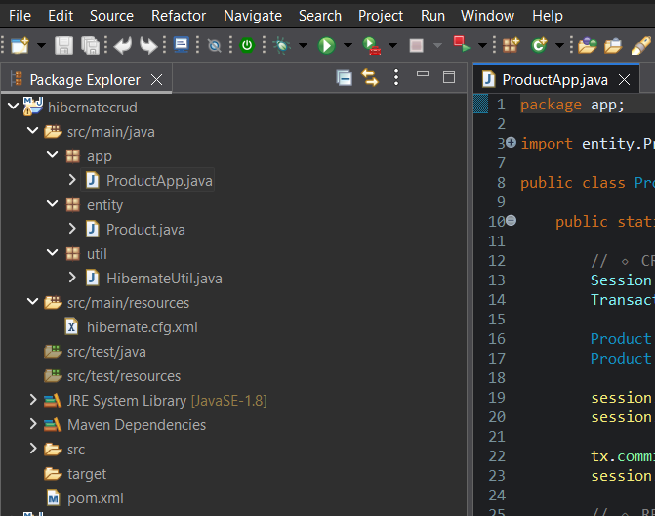
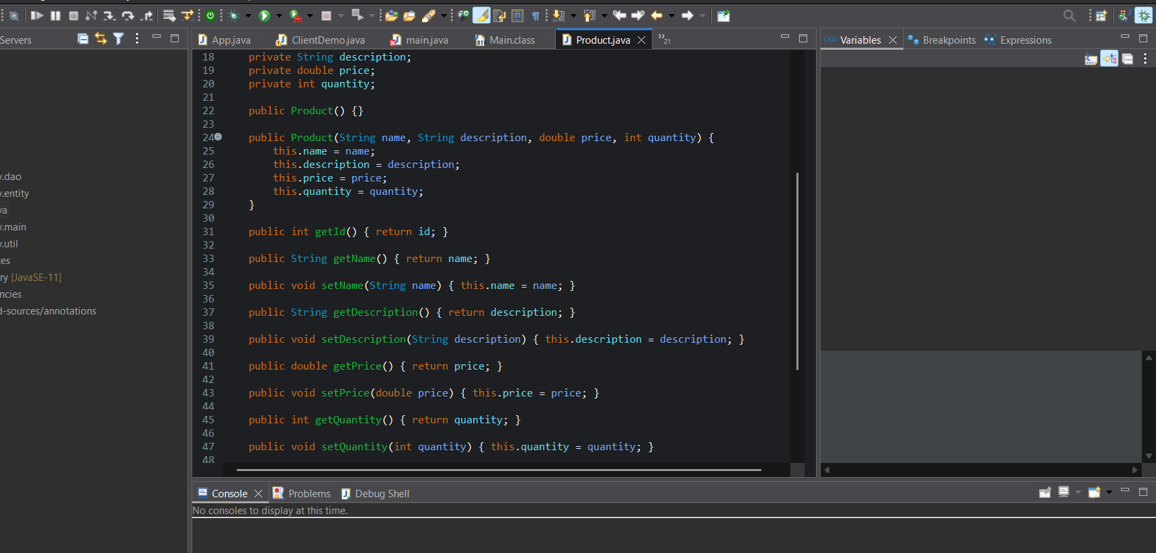
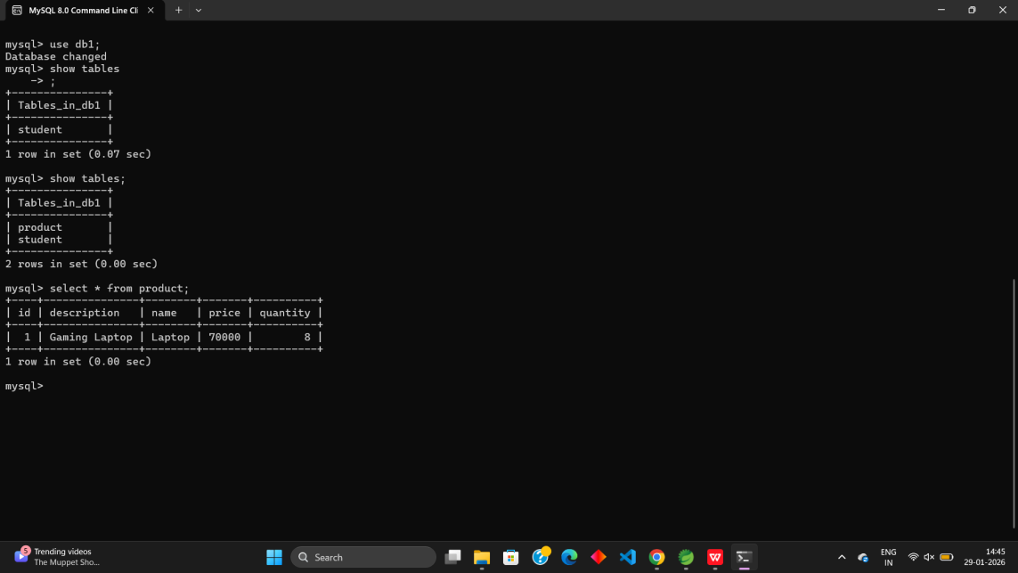

Github REPO Link:
https://github.com/harsha08-2k6/FSAD-WORKBOOK.git

