SKILL-3
T. Siva Harsha Vardhan Reddy
2400030361
Section-09

Screenshots:
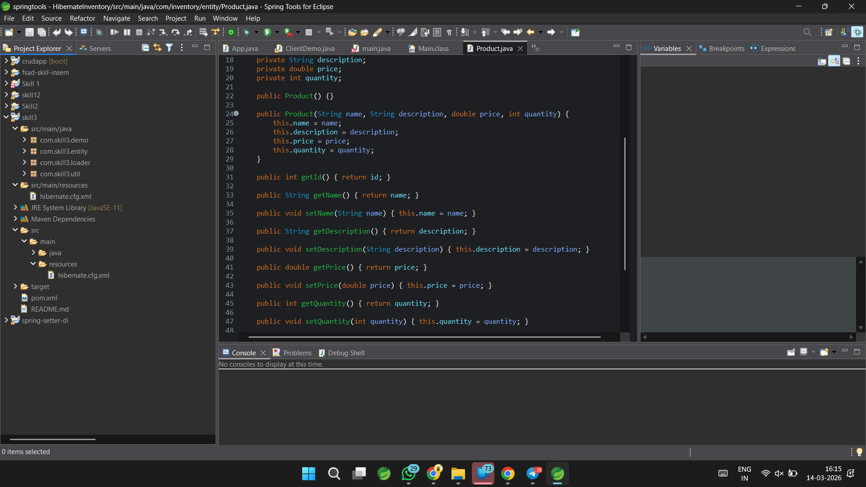
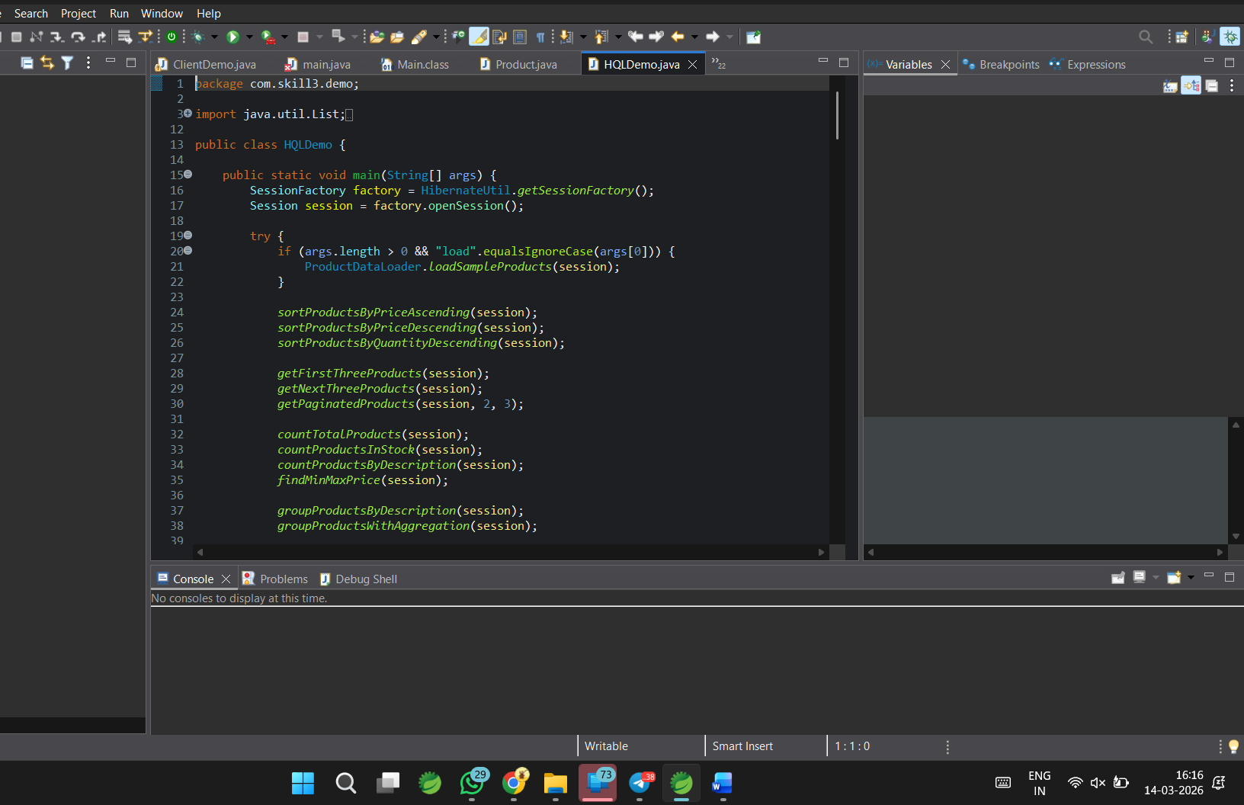

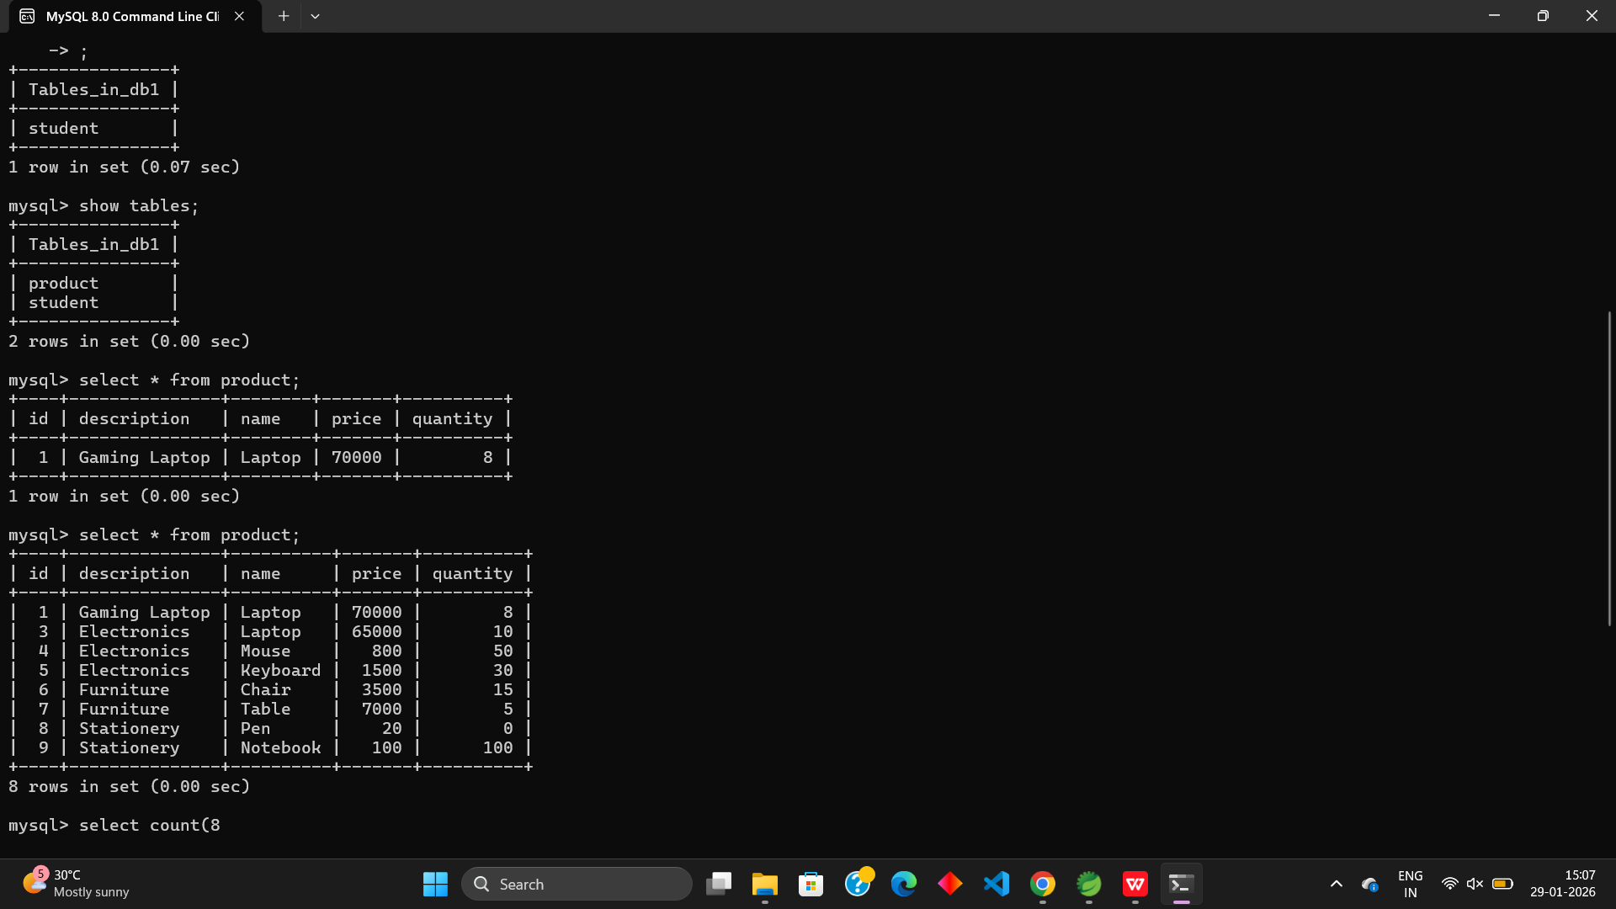
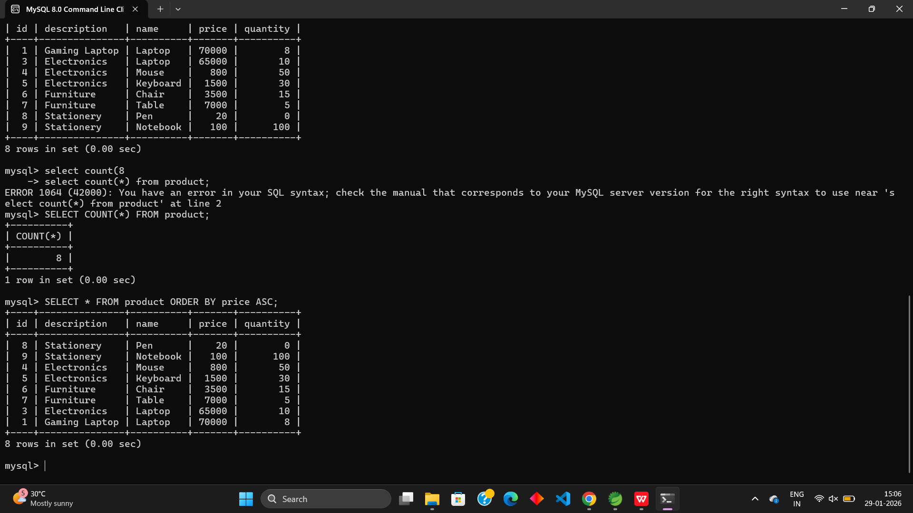

Github REPO Link:
https://github.com/harsha08-2k6/FSAD-WORKBOOK.git
