SKILL-4
T. Siva Harsha Vardhan Reddy
2400030361
Section-09

Screenshots:
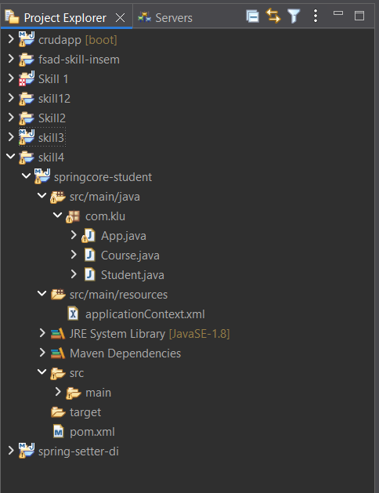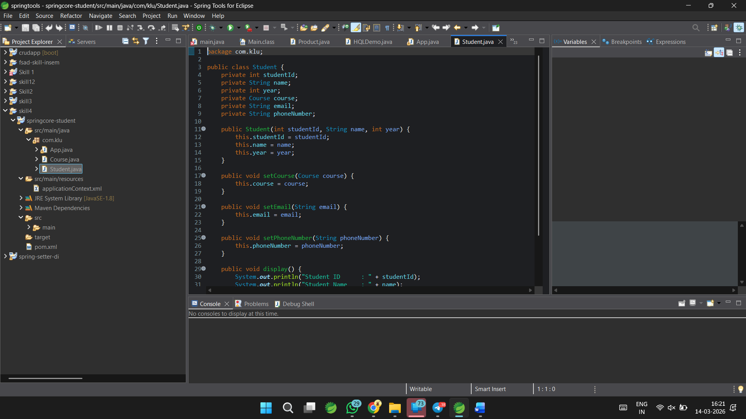
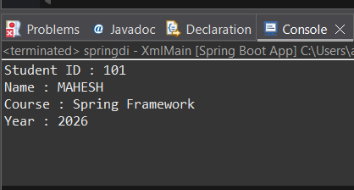
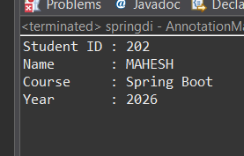

Github REPO Link:
https://github.com/harsha08-2k6/FSAD-WORKBOOK.git
