Neural was the best performance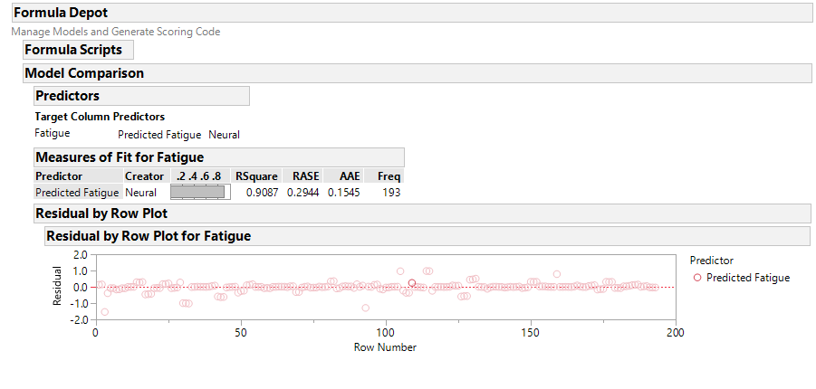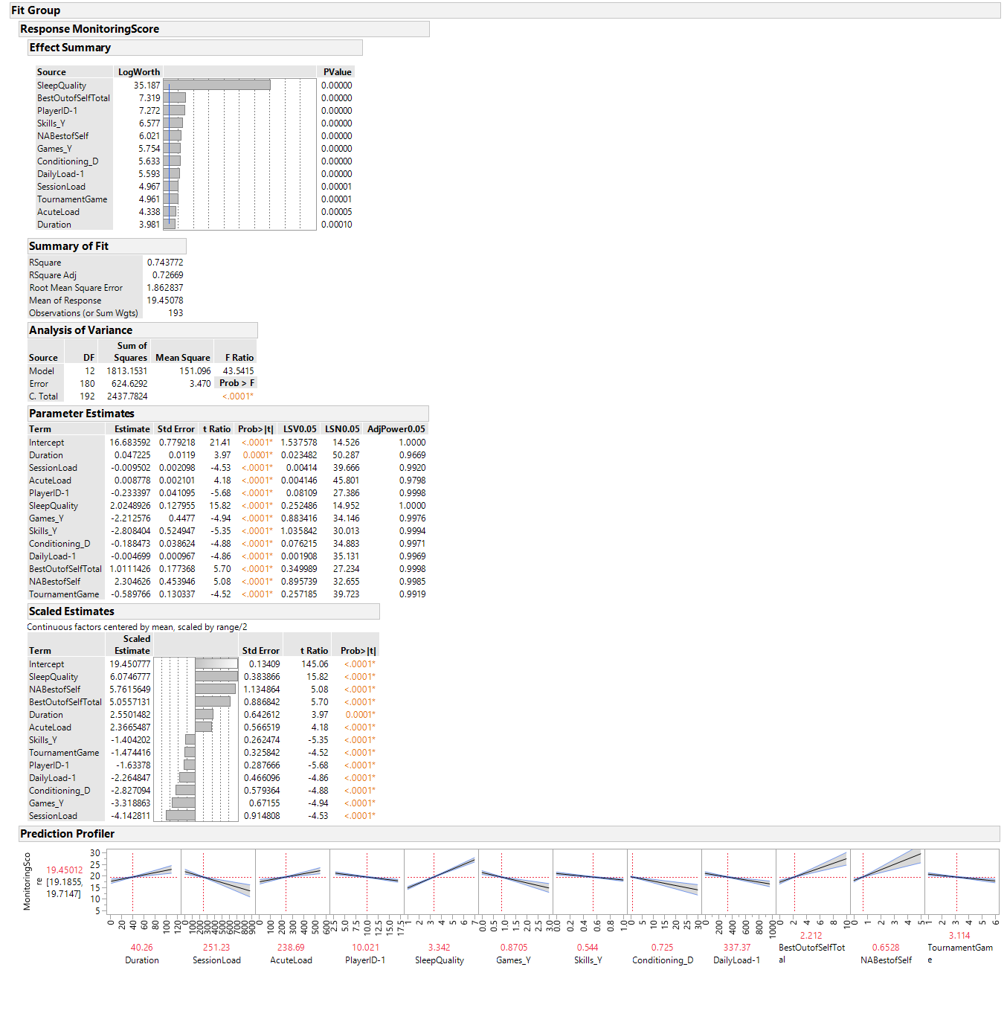

It was found the best predictor of Fatigue is sleep quality.