AKAROS MASTER THESIS DIARY

04/21/2015 :

First « real » day. I had a hangout with Eric Brewer, Barret Rhoden (Boston) and Kevin Klues (Berkeley). I should also meet Ronald Minnich later. For almost one week I have been reading Barret's Thesis about parallelism in systems and I should keep reading it.

During this hangout, we talked a bit about what I could bring to Akaros to make it better. The thing with Akaros is the kernel only runs on one core, and all the other cores are dedicated to applications. So basically, when an application needs to run its thread, it asks the kernel for one, two, a hundred cores. Then the kernel provides those cores and doesn't care about them until the application gives them back to the kernel when it is done. After that, the application can run its thread onto those core.
For now, the application only requests for a number of cores thanks to the syscall function vcore_request( int num ), and the kernel provides then num “random” cores to the application.

However, the topology of the system on a material point of view (hardware) is not considered here.

Network topology is the arrangement of the various elements (links, nodes, etc.) of a computer network. For exemple, a 4 cores machine has actually 4 cores and 8 hyper threaded cores.

Hyper threaded cores : For each processor core that is physically present, the operating system addresses two virtual or logical cores, and shares the workload between them when possible. The main function of hyper-threading is to increase the number of independent instructions in the pipeline; it takes advantage of superscalar architecture, in which multiple instructions operate on separate data in parallel. With HTT, one physical core appears as two processors to the operating system, which can use each core to schedule two processes at once. In addition, two or more processes can use the same resources: if resources for one process are not available, then another process can continue if its resources are available.

Yet, the topology of the system is very important. For example, the application could ask for hyper threaded cores 1 and 2 because it needs to share the same resources, or on the opposite, it could request hyper threaded cores 1 and 4 because it needs to run separate jobs.

For now, Akaros does not consider the system topology either on the point of view of the kernel (the kernel does not know what is the topology of the system) either on the point of view of the application (the application does not know what resources it needs to better run its threads).

So, our tasks for now, would be:

- Give the kernel information about the topology of the system (look how Linux express topology.)
- The kernel should be able to tell the application what is the system topology, or maybe the topology of what resources are still available.
- Think about what kind of information (number of cores, coupled or not, etc.) the application could give to the kernel so it can grant the most appropriated cores to the application.

When an application request cores to the kernel, how does it works. It's like:
API: I want 3 cores
Kernel: Ok take cores 1, 4 and 5.

OR

API: I need some resources what do you have?
Kernel : I have cores 1,4,5,9 what do you need?
API: Well give me 3 of those.
Kernel : Ok well take cores 1, 4 and 5.

I guess for now it works like in the first scenario, but even if it is heavier, could we consider the second one?

I email the team about how I understood what was expected from me. I also wrote a tiny guide to use Akaros through Qemu with GO.

For now, I will keep reading Barret's thesis. It has helped me a lot to understand how Akaros works so far.

04/26/2015 :

Both Kevin and Barrett answered my email and brought their help. Basically, I understood the subject.

BARRET ANSWER:
Sort of. Kernel code can actually run on any core. When a core is
granted to an application, it is up to the application to allow the
kernel to run by entering the kernel (e.g. a syscall). These cores are
the Coarse-Grained cores (CG). The other cores are LL (low-latency, or
management cores). These cores run the single-core processes (SCPs)
and background kernel tasks, including the kernel scheduler tick. Core
0 is the only LL core in the code right now. Conceptually, we can
change the LL/CG cores on the fly.
Our discussions yesterday were mostly about the provisioning and
allocation of the CG cores to the MCPs (Many-Core Process: a process
with multiple cores).
> So basically, when an application needs to run its threads, it asks
> the kernel for one, two, a hundred cores. Then the kernel provides
> those cores and no longer care about them. After that, the
> application can run its thread onto those cores and gives them back
> to the kernel when it has its jobs done.
Yes, with the addition that the kernel can preempt those cores, taking
them away from the process. We do this to give them to other
processes.
We didn't talk about provisioning yesterday, but the short version is
that the user can provision a core, which is a guarantee of future
access to a core (or other resource). When a process requests a core,
if it has a provisioned core, it will get that core - even if it means
the core will be revoked from another process.
You can think about a provision as a "promise". The kernel promises to
allocate a provisioned resource immediately to the user when they ask
for it. In the meantime, the kernel may allocate that resource to
another, lower-priority, process.
> For now, the application only requests the kernel for a number of
> cores thanks to the syscall function *vcore_request( int num ), *and
> the kernel provides then *num* "random" cores to the application.
Pretty much. Technically vcore_request() is a user-level function
where the user tells the kernel how many cores it wants via a
shared-memory write: (user/parlib/vcore.c L 270)
__procdata.res_req[RES_CORES].amt_wanted = nr_vcores_wanted;
and then "kicks" the kernel scheduler which will read that memory:
sys_poke_ksched(0, RES_CORES);
> The topology of the system on a material point of view (hardware)
> is not considered here.
>
> Yet, the topology of the system is very important. For example, the
> application could ask for hyper threaded cores 1 and 2 because it
> needs to share the same resources, or on the opposite, it could
> request hyper threaded cores 1 and 4 because it needs to run separate
> jobs.
Another use case is where a process wants cores 2 and 4 and also wants
to make sure no one *else* is on the hyperthreaded siblings (e.g. they
want 2, want 3 idle, want 4, want 5 idle). I've dealt with this
manually in the past by requesting 2,3,4,5 and then having the user
halt 3 and 5 (vcore_idle(), user/parlib/vcore.c L367).
> For now, Akaros does not consider the system topology either on the
> point of view of the kernel (the kernel does not know what is the
> topology of the system) either on the point of view of the
> application (the application does not know what resources it needs to
> better run its threads).
>
> So, our tasks for now, would be:
>
> -
>
> Give the kernel information about the topology of the system (look
> how Linux express topology.)
> -
>
> The kernel should be able to tell the application what is the
> system topology, or maybe the topology of what resources are still
> available. -
>
> Think about what kind of information (number of cores, coupled or
> not, etc.) the application could give to the kernel so it can grant
> the most appropriated cores to the application.
Sounds like a good place to start. I think the first two are
relatively straight-forward, and the third part is the
harder/interesting one, more of an Akaros problem, and more rewarding.
> Now, I have a question:
>
> When an application request cores to the kernel, how does it works?
> It's like:
>
> API: I want 3 core
>
> Kernel: Ok take cores 1, 4 and 5.
>
>
> OR
>
>
> API: I need some resources what do you have?
>It's like this, which is sort of a mix:
- user: what is the maximum number of cores I can use? (max_vcores(),
which is a shared-memory read in PROCINFO (user/parlib/include/vcore.h
L73).
- user: okay, i'd like N vcores (vcore_request())
- kernel: here's up to N vcores (__core_request(), kern/src/schedule.c
L652)
There's another issue involved here and it is provisioning. In
__core_request(), there is a lot of code to handle the allocation of
cores when processes have provisioned cores. The general idea is to
look for cores that are provisioned to the process, and grant those
cores. Then look for unprovisioned cores.
Provisioning has a few effects on whatever we develop:
- Provisioning and allocation are two separate steps. We'll need
interfaces for both of them - perhaps the same "style" of interface.
Right now, you provision cores based on *core id number*
(tests/prov.c). You request and allocation by core *count*. These
are different styles.
- Telling the user which cores are in use is helpful. They also need
to know which cores are provisioned. The program "prov" is the main
interface for provisioning, though it doesn't have a good way to tell
the user programmatically which cores are provisioned (check out
"prov -s", it's a hack to tell the kernel to printk() the prov map).
> Kernel : I have cores 1,4,5,9 what do you need?
>
> API: Well give me 3 of those.
>
> Kernel : Ok well take cores 1, 4 and 5.
It's like this, which is sort of a mix:
- user: what is the maximum number of cores I can use? (max_vcores(),
which is a shared-memory read in PROCINFO (user/parlib/include/vcore.h
L73).
- user: okay, i'd like N vcores (vcore_request())
- kernel: here's up to N vcores (__core_request(), kern/src/schedule.c
L652)
There's another issue involved here and it is provisioning. In
__core_request(), there is a lot of code to handle the allocation of
cores when processes have provisioned cores. The general idea is to
look for cores that are provisioned to the process, and grant those
cores. Then look for unprovisioned cores.
Provisioning has a few effects on whatever we develop:
- Provisioning and allocation are two separate steps. We'll need
interfaces for both of them - perhaps the same "style" of interface.
Right now, you provision cores based on *core id number*
(tests/prov.c). You request and allocation by core *count*. These
are different styles.
- Telling the user which cores are in use is helpful. They also need
to know which cores are provisioned. The program "prov" is the main
interface for provisioning, though it doesn't have a good way to tell
the user programmatically which cores are provisioned (check out
"prov -s", it's a hack to tell the kernel to printk() the prov map).
> I guess for now it works like in the first scenario, but even if it is
> heavier, could we consider the second one?
I'm definitely open to changing these interfaces. =) My rough plan
was to look into bitmaps, but that doesn't seem like enough. Flags
might help, but it's all an open problem.
Also, we mentioned this yesterday:
http://lxr.free-electrons.com/source/Documentation/cgroups/cpusets.txt

KEVIN STEPS TO GO FURTHER:

- Figure out how Linux gathers all of its information about the topology
- All the info we will likely need, linux provides under
/sys/devices/system/cpu/ also /proc/copuinfo or $ lscpu
- We need to look into how Linux populates this information
2) Build our own topology information and expose it to user-space
- Long term we will probably want to export it through a #t
device, possibly with the same directory/file structure as linux
- For now, it's probably enough to just figure out a way to
represent it and export it as a binary blob in an mmapped file.
3) Start designing a more sophisticated vcore allocation API based on
this topology information
- Currently, the API only allows us to request 'some' number of
cores, with no consideration as to 'which' cores
- We would like something more expressive that takes topology
information into consideration
- Whatever we come up with, we will ideally be able to encapsulate
this in a single system call
- We can then build user-level abstractions on top if it as desired

04/27/2015 :

So I am starting to Figure out how Linux gathers all of its information about the topology. I send an email to a teacher. He told me the best way to get info on the topology of the system would be first to have a look on a simple implementation of an entry like /proc/self.

Kevin came help me a lot. I now understand a bit better how Akaros starts on a code pov:

- kern/src/init.c starts the kernel with kernel_init(multiboot_info_t *mboot_info).
- That calls function arch_init() of kern/src/init.c
- Then we have to go on kern/arch/x86/smp_boot to see the function smp_boot (void). This function first initializes the array of processors on the OS pov and on the hardware pov.
- Then,it allocates a page at the adress trampoline_pg (0x1000) and copies the assembly code of the file kern/arch/x86/smp_entry64.S .
- Then it initializes ipi and trigger them so every cores can catch them and execute the assembly code to call smp_main(void) of kern/arch/x86/smp_boot.c .
- Then, fills the arrays os_coreid_lookup[] & hw_coreid_lookup[] with its proc id.

For now, both os_coreid_lookup[] & hw_coreid_lookup[] are array of integer. The thing would be to create arrays of a suitable structure to give more information about the cores ( socket, siblings and maybe cache).
Note that for now those 2 arrays have the same values inside because there is no difference between OS and Hardware. We would like to change it in order to have on the OS point of view, contiguous cores in socket and coupled siblings in cores.

For now, I need to read how x86 enumerate processor's topology with kuo_CpuTopology_rc1.rh1 .final.pdf .

I am now into smp.h file, trying to had a suitable structure for supporting topology. I am also looking into apic.h where it seems to get the proc id with the lapic_get_id function.
It seems like we can use cpuid (x86.h or exemple in cpuinfo.c l 53) to retrieve the value of siblings (SMT), id and sockets (PACKAGE) in registers.

04/28/2015 :

So the way cpuid works is:

static inline void cpuid(uint32_t info1, uint32_t info2, uint32_t *eaxp,
uint32_t *ebxp, uint32_t *ecxp, uint32_t *edxp)

Here, we give to the function in INPUT the parameter info1 (eax) and info2 (ecx) and it returns in register eax, ebx, ecx and edx the OUTPUT.
Now we have to use this function to retrieve the widht of the core, the id of the socket and the id of the proc, using the pdf Kuo_CpuTopology_rc1.rh1 .final.pdf

04/29/2015 :

So yesterday we faced a problem: to retrieve the topology of the system, when we use the cpuid function with qemu. For now, we decided to ignore this problem, and run a c program under Linux to focus on the system topology.

- http://en.wikipedia.org/wiki/CPUID#EAX.3D4_and_EAX.3DBh:_Intel_thread.2Fcore_and_cache_topology
- http://wiki.osdev.org/Detecting_CPU_Topology_%2880x86%29
- http://www.sandpile.org/x86/cpuid.htm

04/30/2015:

I try to make qemu wrk with cpuid command, modifying go-akaros-qemu.sh. Unfortunatly it does not work.

NUM_THREADS=`lscpu | grep "Thread"|cut -d: -f2`
NUM_CORES=`lscpu | grep "Core"|cut -d: -f2`
NUM_SOCKETS=`lscpu | grep "Socket"|cut -d: -f2`

# Launching qemu
echo "Launching qemu"
$QEMU -s $QEMU_KVM $QEMU_NETWORK $QEMU_MONITOR -cpu $CPU_TYPE -smp $NUM_CPUS,cores=$NUM_CORES,threads=$NUM_THREADS,sockets=$NUM_SOCKETS \
-m $MEMORY -kernel $ROSROOT/obj/kern/akaros-kernel -nographic

05/01/2015:

We are still trying to find a way to make qemu aware of cpuid, but without success so far.

However, I have found a way to fully express the system topology (for now I am working on my linux and not on Akaros). Indeed the use of cpuid enables to know :

I am core: 3, Thread id on the software pov
logical_CPU_number_within_core:0x00000000, Thread id inside the core
apic_id:0x00000006, Thread id on the hardware pov
core_number_within_chip: 0x000000 01, Core id of the Thread
chip_id: 0x00000000, Socket of the Thread (not the id of the socket tho)

So for now, we are going to create a topology.c file inside kern/arch/x86/ where we would implement everything related to the topology. Then we would simply call a buil_topology(*proc_id) function in smp_main() to build the topology.
First of all what we want to do is to replace all the occurrence of the arrays of int (hw_coreid_lookup and os_coreid_lookup) of the os and of the hardware by our new array of struct cpu_topology declared in topology.h.
I am working for the moment on topology.c.

05/05/2015:

We had a meeting today with the team. We are not sure about the way we should populate the topology in akaros. Barret talks about giving a bitmap instead of an int in vcores when an application requests for ressources.
For now, I created my own branch on git, and I am trying to finish to print the topology.

So far,
- Figure out how Linux gathers all of its information about the topology
- All the info we will likely need, linux provides under
/sys/devices/system/cpu/ also /proc/copuinfo or $ lscpu
- We need to look into how Linux populates this informatio
- Build our own topology information and expose it to user-space
- Long term we will probably want to export it through a #t
device, possibly with the same directory/file structure as linux
- For now, it's probably enough to just figure out a way to
represent it and export it as a binary blob in an mmapped file
- Replace all occurrences of previous array for hw and os and make akaros still work.
- Start designing a more sophisticated vcore allocation API based on
this topology information
- Currently, the API only allows us to request 'some' number of
cores, with no consideration as to 'which' cores
- We would like something more expressive that takes topology
information into consideration
- Whatever we come up with, we will ideally be able to encapsulate
this in a single system call
- We can then build user-level abstractions on top if it as desired

07/05/2015:

So lets go and try to replace all occurences of the previous structures (hw_coreid_lookup & os_coreid_lookup) by our new structures (topology.h).

So we spoke a lot with Kevin, and I see things more clearly.
-First of all, we will only keep the hw topology. We will have 2 arrays, an array of pointer (this is our topology array) which for each cell (i=thread_id) will point to our array of structure.
-Then we start to talk about a very interesting problem. How does the application request for cores:
Actually, the application doesn't “request” for cores, it basically says what it needs to execute in the shared memory between the kernel and the application (each app share a shared memory with the kernel). The API for now doesn't see the system topology and shouldn't see which cores are available or provisioned.
Basically, it goes this way: The kernel change the shared memory to say (amt_wanted) “I want 2 cores” and poke the kernel. Then the kernel will read the shared memory and give or not the cores to the API. If it does not give the cores to the API, either the API waits, either it formulates a new demand and poke the kernel again. Anyway, when the API is done , it changes the shared memory again and yield the kernel so he can retrieve the core that are not needed anymore.
Now, the demand of the API to the kernel in the shared memory has to be STATELESS, which means that it should be a resume of what the API needs to work so it is not a “demand”, it is more like a resume of the wished resources of the API.

We thought about a bitmap the API could fill, but it is not explicit enough for demand like “I want all core 2, thread 5 and any core in which I can have the 2 threads”.
So we have now to think about a way to do that. We tried to think about a complicated structure, with list and stuff, the problem is that when you give a core to an API which requested “any available core” the application has to write itself into the shared memory to change the resources it has. Otherwise, the kernel could either give him an other core, or can't retrieve it the core after a yield call.
We also tried to think about a way that all API have a list of available/provisioned cores and can pick some cores among it. However the problem is, if you do that, maybe an other API would take those cores, and then what? You wait? You change your demand? Anyway there is a problem.

08/05/2015:

I read a long mail of Barret and modify some things. Tomorrow I will change the way we fill the array of structure, because we should be able to call just once cpuid instead of calling it for every cores.

12/05/2015:

So yesterday we worked with Kevin on the topology. The thing is we come back from scratch. We actually didnt change anything in any file (some includes).
We added our file topology.c & topology.h. We call a function that builds topology (topology_init()) in init.c, right after we know the number of cpu thanks to acpiinit(). Our new file contains an array of structure, called cpu_topology[]. A cell contains the numa_id, the socket_id, the core_id and the thread_id of the thread given its index.
We kept the lookup arrays that were already implemented. So we also have 2 arrays of integer, hw_core_id_lookup and os_core_id_lookup. Those arrays will always be complementary, which means, if hw_coreid_lookup[i] = j, then os_coreid_lookup[j] = i. The value returned by os_coreid_lookup[i] (= j), is the index of the topology for hardware core “j” or os core “i” at cpu_topology[j]. That should be enough to ensure that given an index (os or hardware) we can retrieve the good topology for the considered core.
Finally, if the system doesn't manage to use cpuid, we just build a flat topology (numa_id = socket_id = core_id = 0 only thread_id is modified). Which looks like what you did before we start the topology thing.

19/05/2015:

So I sent an email to everybody in order to ask about what we should do next: (Barret,

> Hey guys, how are you?
>
> I would like to move on and start designing a more sophisticated vcore
> allocation API based on the new topology information we have.
Sounds good. I'll take a look at your latest topology branch, and in
the meantime we can start thinking about the next steps. =)
> Here is what I understood about how an API requests cores:
>
> Actually, the application doesn't “request” for cores, it basically
> write into he shared memory for what it needs to execute. The API for
> now doesn't see the system topology and only ask for a number of
> cores. Basically, the API edits the shared memory to say
> (*amt_wanted)* “I want 2 cores” and poke the kernel. Then the kernel
> reads the shared memory and gives or not the cores to the API.
Yes, with the slight different that the kernel scheduler may also check
the amt_wanted fields without being poked. The poke is the request for
the scheduler to look immediately. That could be changed, if needed.
Whatever we come up with needs to handle cases where processes are
yielding vcores as well as waking up when events arrive
(__sched_mcp_wakeup). For instance, there used to be cases where
amt_wanted would be 0, but the process is RUNNABLE, so we'd +1
amt_wanted. (check out get_cores_needed()).
> If it does not give the cores to the API, either the API waits,
> either it formulates a new demand and poke the kernel again.
The API (vcore_request()) doesn't wait - it just updates its request
and moves on. New requests will do a new poke.
> Anyway, when the API is done with its cores, it edits again the
> shared memory and *yield* the kernel so it can retrieve the cores
> that are not needed anymore.
Part of the issue here is that Vcore code decreases its amount wanted
so that the kernel doesn't immediately give the core back to the
process. We need a process to be able to give up its cores, and then
not have the kernel think that the process still wants a particular
core.
Old versions of Akaros actually had the kernel decrement amt_wanted in
proc_yield(), but I wanted that value to be adjusted from userspace
only. Having proc_yield() be an implicit "decrement amt_wanted" would
make it harder to do various things - one of which is this topology
awareness.
> The demand of the API to the kernel in the shared memory has to be
> *STATELESS*, which means that it should be a resume of what the API
> needs to work so it is not a “demand”, it is more like a resume of
> the wished resources of the API.
Yeah - the idea is that we just the desired resources in shared
memory. I'd like to do this for all resources (e.g. RAM). But
apparently we'll need a different format.
> A bitmap the API could fill, doesn't seem explicit enough for
> demands like “I want all core 2, thread 5 and any core in which I can
> have the 2 threads”.
Agreed. Perhaps coming up with a totally general system is too much
hassle for not enough benefit. Maybe a bitmap with some flags would
suffice. Flags could be stuff like "I want entire cores only, same
socket only, all or nothing, etc".
Maybe split up the desire into two parts: long-term placement/strategy,
and short-term amount. Maybe the bitmap and the flags are the
long-term restrictions (like cpu_sets), and we keep amt_wanted as the
actual quantity of cores to give out. Maybe the long-term part ties
in to provisioning. But note that provisioning has historically been
something the process does not require knowledge of, so maybe this
long-term part is separate.
> So we thought about some complicated structure, with list and stuff,
> the problem is that when you give a core to an API which request “any
> available core” the application has to write itself into the shared
> memory to change the resources it actually gets from the kernel (or
> the kernel has to do it). Otherwise, the kernel could give him an
> other core, or could not be able to retrieve the core after a yield
> call.
>
> We also tried to think about a way that all API have a list of
> available/provisioned cores and can pick some cores among it. However
> the problem is, if you do that, maybe an other API would take those
> cores, and then what? You wait? You change your demand? Anyway there
> is a problem.
>
> Am I wrong on any of this point? Do you guys have an idea where I
> should start? Like should I keep thinking about a stateless way to
> formulates demand?
For now, maybe just brainstorm different approaches. I'm partial to
stateless, but we can consider anything.
Here's a few generic things to do:
- Come up with and write down the users requirements. Stuff like:
desires for hyperthreading, NUMA placement, or the "give me any core"
approach
- Come up with the system's requirements. Stuff like how we need to
handle yielding, preemption, and event delivery. How the allocation
requests interacts with provision requests.
- Come up with a list of options. amt_wanted is the current one.
bitmap is another.
- For each option, figure out how it satisfies (or doesn't satisfy) the
user and system requirements. Or maybe it doesn't. Think about how
these options would actually work in the code.
By going through these steps, we can distill the essence of the problem
and come up with something we thing will work.
For instance, let's take the bitmap approach. One issue is that it is
hard to express "give me any N cores, up to N". (What does the bitmap
look like if cores 1-3 are unavailable?). So from that, we have a
couple requirements:
- user might ask for "give me any N cores, up to N"
- system may change allocation frequently.
Then we iterate from there. We might modify the bitmap plan and say
"what if the system tells the user that the overall allocation
changed?" One way to do that would be through shared memory (exposed
to *all* processes), but would we need to send events to processes?
What if a process was sleeping? How would it update its bitmap?
Anyway, eventually we'll have a bunch of requirements, and we can look
for a common theme.
If you make a google doc or something to keep track, then we can all
chip in. I can help come up with some of the requirements and use
cases. I'll probably do this in response to particular strategies
(like the bitmap approach).

So let's go for a google doc!

21/05/2015:

Yesterday with Kevin, we found a problem on the topology file we did. The problem was that the socket id was random instead of being 0,1,2...etc. I fixed this morning, everything should be ok now.

We also discuss about a structure to replace those things in schedule.c.

/* Process Lists. 'unrunnable' is a holding list for SCPs that are running or
* waiting or otherwise not considered for sched decisions. */
struct proc_list unrunnable_scps = TAILQ_HEAD_INITIALIZER(unrunnable_scps);
struct proc_list runnable_scps = TAILQ_HEAD_INITIALIZER(runnable_scps);

Here is what we thought about:

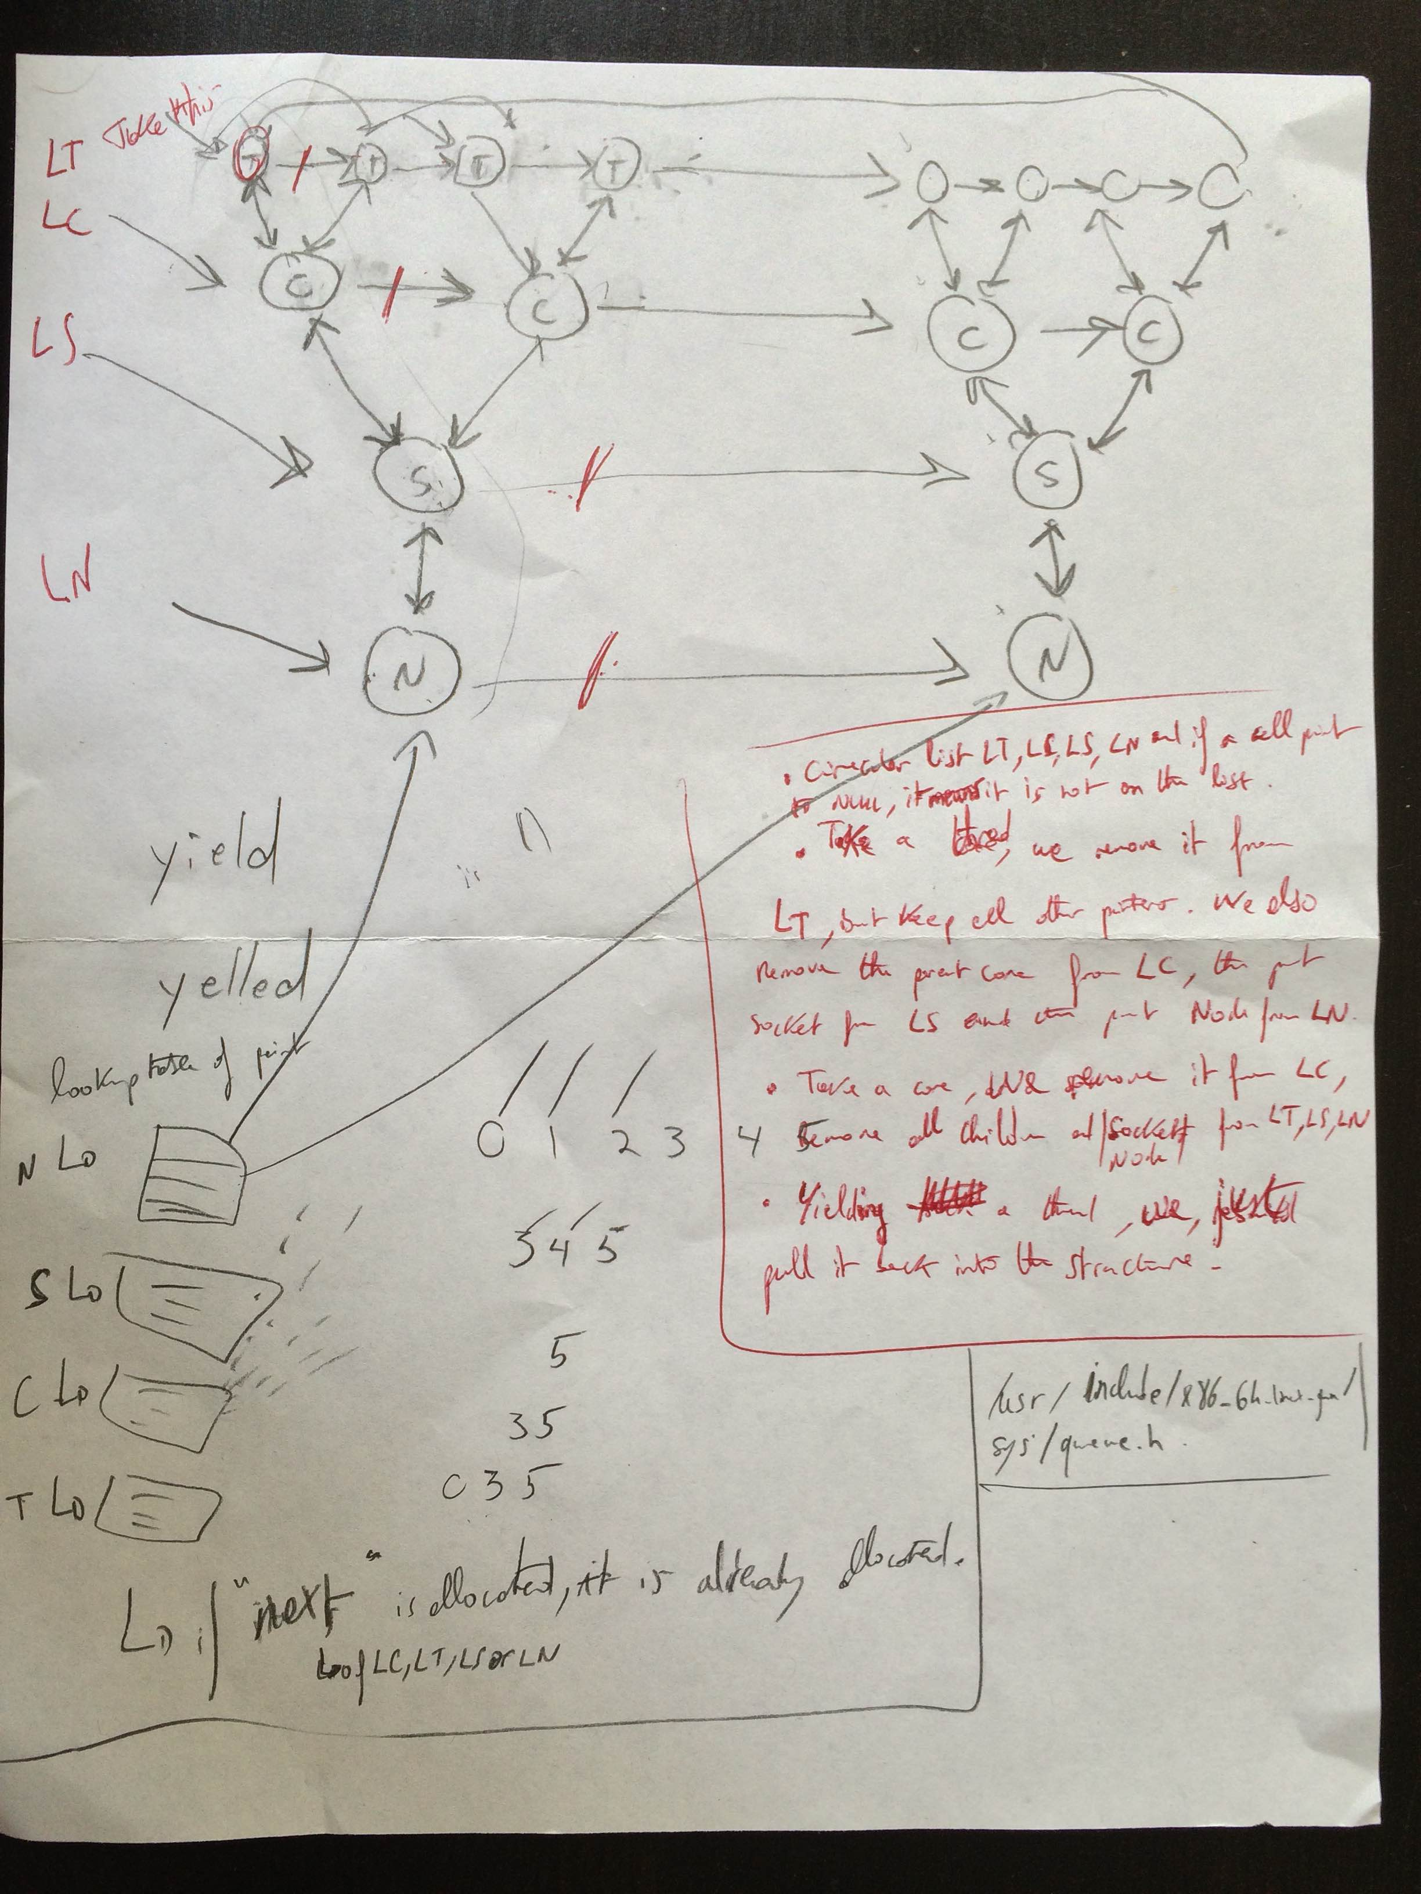

So basically there are:

- We have 4 circular lists LT, LC, LS and LN, for threads, cores, sockets and nodes. This way, if a cell points to NULL it means it is not on the list.
- When we take a thread, we remove it from LT but keep all other pointers to the parents. We also remove the parent core from LC, the parent socket from LS and the parent numa from LN.
- When take a core, a socket or a numa, we actually remove the children threads. Which will remove the parents.
- Yielding a thread we jut put it back in the LT list.
- Eventually we have 4 arrays of threads, cores, sockets and nodes. The index of each array correspond to the id of threads, cores, sockets and numa.

22/05/2015:

So let's go for cding this structure. Kevin did a git “cputopology” repository I just cloned. I will work first on LinuX and import it to Akaros then. I will use this library to implement my queues: /usr/include/x86_64-linux-gnu/sys/queue.h

01/06/2015:

We have done a lot of great things with Kevin this week. We have fully implemented our structure to handle our resources. I just saw Eric this morning and we spoke about what we ve done so far. I explain him the way our structure is working and he was quite satisfied with that. However he recommends a nice optimization: When we require a node, lets say core 2 of chip1 of socket 0, we should do something so the next time we ask for a core it gives us the core 3 of chip1 of socket0. This way, we maximize the number of entire chip and socket.
To do that we thought about two solutions:
-You can move the available sibling of the requested core to the front of the queue (this way, next time you ask your any core, you will be given the other core of the chip.
When we want to put back a core into the structure, if its sibling is available, we put it back at the end of the list of available cores, if its sibling is not available, we put it back at the front of the list of available cores.
-You can use a scoring int that you decrease when your sibling is getting allocated and you increase when you put your sibling back to the available resources. This way, you have to go through the list to find the best core to allocate next. But let's say you start the scoring int at 0, you know if a core has -1 that means you can directly take this one because it can't goes lower.
When you put back a core into the structure, you simply increment your sibling scoring.

In the next 2 weeks, lets focus on putting back a core into the structure, and test our structure, with several threads.

02/06/2015:

Instead of simply using a boolean to trace if a node is available or not, we thought about using a reference counter. The reference counter is initialized for all nodes at 0, which means the node is available.
When we request for a node, we will go through its children recursively until we reach the core level. At this level (so for all the cores off the requested node), we will request this core if it is available, increment the refcont of the core, remove it from the list of available cores and do the same actions on the parents. This way, if we request an entire chip, we will have the refcount of cores at 1, and the refcount of the chip at 2. Also, if we request an entire socket (4 hyperthreaded chips), the refcount of cores will be 1, the one of chips will be 2 and the one of the requested socket will be 8.
That is actually very useful, because when we put a core back in the available structure, we simply recursively decrease its refcount and his father's refcount. Taking back my socket example, if we put back one core, then its refcount will be 0 (available), its chip's refcount will be 1 (not available yet, we would need the other core of the chip to be yielded so it could decrease the refcount to 0) and the socket refcount will still be 7.

03/06/2015:

We also thought using an int “score”. This score will enable us to determine which node we should better give when we are asked for “any_node”. Indeed, if core 2 is already allocated and we ask for “any_core” it would be better to give core 3 because this way, we let chip0 completely available.
To implement this score thing, we thought about summing all the ancestors (parents) refcount and the refcount of the current node. This way, the node with the highest score and with refcount = 0 (condition for a nide to be available) should be the one we choose.
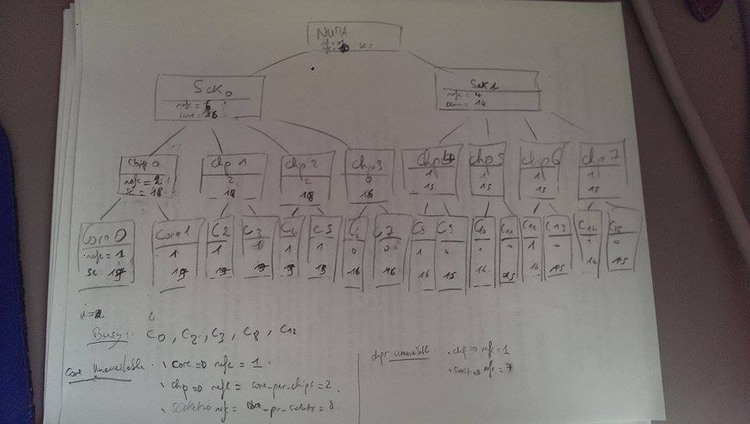

04/06/2015:

We did something that is working! We discuss with Eric on the fact we should now try to optimize our structure, our function and tests them. I started a multi threaded program to test what we did. It is working so far of course, let's see if it's still ok with some improvement we can do.

06/06/2015:

Here are some things we fixed up:

- Fix up some print formatting
- Walk the tree to find best_node based on refcounts
- Add max_refcount array for new scoring function
- Separate num_children into global array
- Walk over flat node list to update scores
- Rename create_nodes() to init_nodes()
- Use flat array of nodes, not 4 separate arrays
- No need for level of indirection with children
- Move update_scores() into incref_node_recursive()
- Turn tail recursion into a loop
- Rename request->alloc and yield->free
- Remove our node_list completely.
- Add a node_label array of strings for printing
- New versions of update_scores and find_best_node
- Remove remove_node, rename remove_node_recursive
- Rename resources_init() -> nodes_init()

08/06/2015:

We get rid off score because we know walk the whole tree to find the correct node. That is actually better because we don't have to walk the three for every node to change the score like what we did before.
We meet up with Kevin this morning to talk about what we did. It turns out there is a problem when we want to find the best node to allocate: Indeed, for now we are just walk down the tree comparing which node has the highest refcount and sometimes, we get on a branch where for exemple no chips are available while the refcount is the highest.
So we thought about a 4x4 entry array that will tell us about the refcount of the level of the current node but also its deeper levels. On the example higher, socket (type = 2) will have in its array:
n->refcount[0] = 6 core level (6 cores are allocated in this socket)
n->refcount[1] = 3 chips level (6 chipss are allocated in this socket)
n->refcount[2] = 1 socket (The socket is partially or fully allocated)
i=3: 0 numa

Then when we want to allocate for example a chip, we check at numa level every socket node n to see if a chip is available (n->refcount[1] < nb_chips_per_numa ).

We had a meeting with Eric and Kevin and discuss a certain number of points:

- We remember that provision a resource means priority access to it. So if you provision a core, you are guarantee to get it one day. Also, a core can only be previsioned by one API at a time. You cannot preempt a core that is provisonned.
- SO we decide that API can only do specific requests on cores that are provisioned. Otherwise, it has to do some any_request calls.
- When a request_any is received by the kernel, this one should give core that are not provisonned first. If all cores are provisionned then it's fine to give a provioned core.
- We no longer want to change the vcore_request fonction. We keep that function as it is and will change how the provisions are working. Now we will provision a whole socket for example and then request the cores (specific or any) of this provisioned socket.
- Information on shared memory pages should have a version field so it can tell with which kernel version it works.
- Keep the API separated from the kernel.

So for now the steps we have to do now on our schedule file (that is still underdevelopment on liNux and not on AKAROS) are:

- Implement our array of refcount.
- Return linked lists of cores instead of returning sockets, or chips. That is going to be better because we can add or remove some cores from the list we want.
- Add an owner field in our structure node.
- Add a provisioned field to our structure node.
- Change the “allocate” function so we can request a number of any node.

09/06/2015:

Yesterday with Kevin we said what we had to do. Today, I will wok on the implementation of the refcount array. We want our refcount array to behave like that :
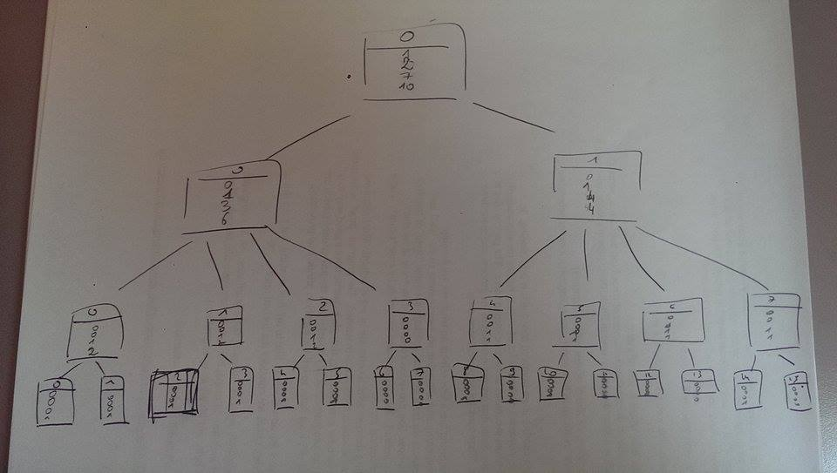
This way, at every level, we know how many are available at any level.

Discussing about our algorithm to find the best node, we noticed that we had
no way to be sure the highest refcount node we choose at any level has the
resource we want. For exemple, if I want to allocate a chip. I could choose to
pick it in socket 1 because it has the highest refcount. However, I cannot be
sure that a chip is entirely available in this socket.
To solve this problem, our int refcount is now a 4 entry array (one for each
level). This enable us to know at every level how many nodes are allocate.
For example in the case we have allocated chip0, chip2 and core7, then the numa
node will have numa->refcount[NUMA]=1 (not available), numa->refcount[SOCKET]=1
(one socket allocated in this numa), numa->refcount[CHIP]=3 (three chips
allocated in this numa) and numa->refcount[CORE]=5 (five cores allocated in
this numa). If we look at chip3 refcount, we will only see
chip3->refcount[CHIP]=1 (not available) and chip3->refcount[CORE]=1 (one core
is allocated is this chip). 09/06/2015:

11/06/2015:

Implement our array of refcount should now be ok (all tests are working).
Now, let's try to return linked lists of cores instead of returning sockets, or chips. That is going to be better because we can add or remove some cores from the list we want.

17/06/2015:

With Kevin we did a number of improvement. We do return a list of nodes, we also added fields allocated_to and provisioned_to in our node structure. Both of those fields are of type struct proc*. This structure is declared in the kernel of Akaros. As we now work on linux, we will create an artificial structure proc.

Here is a sum up of what we discuss for our next step:
- So far we are happy with the implementation we have for allocating a node.
- We may only keep alloc_core_specific() & alloc_core_any() functions and get rid off other alloc_*() functions. Just remember that alloc_specific_core(int id) will return the asked core only if it has previously been provisioned by the API. Also, alloc_core_any(int amt_wanted) will first try to return as many cores as we can among the core that have been provisioned by the API and then return other cores.
- Also, we need to maintain for every proc the list of cores it owns.
- We spoke about moving a proc from a distant core if a closer core become available.
- We also want cores owned by different proc to be as far as possible from each other && cores owned by same proc to be as close as possible from each other.For that we decide two things:
- If the proc as no core allocated, we allocate it with kind of an opposite implementation of find_best_node(). That should ensure our first statement.
- If the proc has already a core allocated in the system, then we have to allocate the closest core to the cores that are already allocated to this proc.
For this 2nd point, we thought about 2 things:
- We request the other hyper threaded core of the pair for all cores the proc already possess. If no cores are available, we request a core on the siblings chips for all cores the proc already possess. If no cores are available, we do the same on sockets and numa.
- We create a local array of distance which will tell us for each core its distance from any other core of the system. Then to allocate a new core, for every available core i, we sum the distances from this core i to the cores the proc owns. At the end we return the core i that has the lowest sum of distances. By the way if you go through cores left to right, you can stop doing this when you meet a core that has a highest distance than the one before.

So for now, before I begin to implement anything, I will look for algorithm of memory allocator and see if they can be use for our core allocation.
=> The more I think about it the more I agree with the first approach and only consider hyper threaded pair of cores we already own (then chips, then sockets...). However, in the case proc0 owns 3 cores, core3 (chip1,socket0,numa0), core100 (chip50,socket17,numa1) and core110 (chip55,socket18,numa1). We would prefer to allocate either core101 or core111 over core2. So the idea I come with is why we don't mix your approach with mine and for each available hyperthreaded core of the core we own, calculate the total distance from this core the one we own. This way, you will have a score of 2+6+8 on core101 and core111 and a score of 2+8+8 on core2 => You pick core 111.
If no cores are available, we simply do the same thing with cores in siblings chips of the chips of the cores the proc owns.
And the thing is you still can stop when you reach a core that has a higher score than the previous one, so it won't take too long and you are sure that you actually get the best core you can at the moment.

With Kevin we have done nice improvement on using the topology of the system to better allocate resources. Last week, we wrote an algorithm to allocate a new core to a proc based on those 2 statement :
- We want cores owned by different proc to be as far as possible from each other.
- We want cores owned by same proc to be as close as possible from each other.
Basically, if the proc doesn't own any core, we allocate the farthest possible core from the others allocated cores. If the proc already owns some cores, we try to allocate the best core among the cores of the pair we already own. If no cores among this list is available, we do the same at socket level or even numa level.
First example: if proc1 owns core 0, 2 and 100, we will pick a core among cores 1,3 and 101. Also, as cores 1 and 3 are on the same socket, they are the best core to be allocated instead of core 101.
Second exemple: Now if cores 1,3 and 101 are already allocated to other cores, we go on socket level, and try to allocate an other core of the socket of the cores we own. Here we have to pick a core among socket 0 and socket 12 (assuming 7 cores per socket). Which means we need to pick a core among cores 4,5,6,7, 96, 97, 98, 99, 102, 103. But here again, as cores 4, 5, 6 ,7 are closer to the cores we already have, we will pick among those cores instead of the cores of socket 12.
Now, you know what we are working on, I have few questions about the way we want to handle provisioning.
- Can we allocate a core to a proc while it is already provisioned by an other proc? If yes, and considering what I spoke about above, do you think we should allocate a core that is the best core to be allocated for the proc but which is also already provisioned by an other proc? Taking back my first example, should we allocate core 1 or 3 while they are already provisioned by an other proc?
I would say yes to it but I don't have enough hindsight to judge.

18/06/2015:

Improvment of find_best_node: We now return the first node of the type in parameter when there are no other node of the same type at the level we consider. For exemple, lets say we have socket0 and socket1 with 4 chips per socket. On socket0, chip 1,2 and 3 are available (so chip 0 is allocated). On socket1, chip 0,1,2,3 are available. If we ask for any chip (resp any core), we will
find out at the socket level that no chip (resp core) have ever been allocated in socket1. Which means, we can return chip0 (core0) because we know it will be the best.

- Right now, I will change how we request_*_any(int amt) to request_*_any(int amt, struct proc *p). The first step will be then to maintain for every proc the list of cores they are using.

First try with considering proc to allocate a core
We now want to consider a proc when allocating a node for him. I have only been
working on allocating cores so far. The function :
struct core_list aloc_core_any(int amt) is now
void alloc_core_any2(in amt, struct proc *p). It now calls
void conat_list2(int amt, struct proc *p, enum node_type type). This last
function verifies if the proc p has already a core allocated, otherwise, it
calls struct node *find_first_core() which will return the farthest available
core from the other in the system. Otherwise, it simply add the best available
node like we did before.
By the way I correct my last push for find_best_node, it should be ok now.
Next step is to modify find_best_node so it takes in consideration the proc we
give in parameter.
20/06/2015:

Speaking about our topology stuff, here is where I am now:
- I got rid off all our functions alloc_node any and specific and we now can only request cores.
- I created an array of array of score and initialized it when we initialize our nodes. Maybe we can write something better here.
- I implemented the algorithm I spoke to you in my previous mail :
-First if the proc has no core, I wrote a function find_first_core, responsible to find the farther possible core from the others.
-Then I implemented a find_best_core function that determine the best cores sibling to allocate and if no siblings are available determine which core of the chips sibling to allocate. I guess I should also do it for socket but even if that works, it is poorly written (I will try to make it better tomorrow).

This morning, I optimized the function init_score . I am more satisfied with the way we initialize our array of score now. We use a 4 size array called cores_per_type in which we have the number of cores per core (default 1), chip, socket and numa.

29/06/2015:

It has been an easy week. I had to wait a bit for Kevin's comments on my code. I got some syntax things change and we seem satisfied by the code we have. I should meet him this morning to speak about what we want to do next.
Also, we started thinking about how we want to handle systems were we have gaps between cores (0,1,2,3,4...,15,32,33...47) and also systems whith a non power of 2 number of cores (for exemple 24). For that we Change semantics of core_info. Previously, all core_info ids were relative to the level they existed at (e.g. there could be multiple cpu_id 4s, each under a different socket_id). Now we use absolute ids accross the board. This commit also reorganizes the code so that *only* os_coreid_lookup needs to have holes in it to accomodate the holes in the apic_ids. Every other structure is now indexed by os_coreid. We do away with the
hw_corid_lookup rray completely, in favor of just using the cpu_topology_info.core_list.

30/06/2015:

We also Add functions to provision and deprovision core . Those functions will be used to provision or deprovision a core. For now we assume that we can only provision a core which is not provisionned or allocated. Also, we assume we can only deprovision a core which is already provisioned.
We assume that we can allocate a core to a proc if it has been provisioned by this proc, or if it hasn't been allocated or provisioned by any other core. When we allocate a core to a proc, we need to deprovision it.

06/07/2015:

I have few questions about the way we want to handle provisioning. Those questions come when a proc wants a random core.
- Can we allocate a core to a proc while it is already provisioned by an other proc? If yes, and considering what I spoke about above, do you think we should allocate a core that is the best core to be allocated for the proc but which is also already provisioned by an other proc? Taking back my first example, should we allocate core 1 or 3 while they are already provisioned by an other proc?
- In the case the proc already provisioned some cores. Should we only consider those provisioned cores and allocate the best of them? Or should we keep doing our way and allocate the best core overall?

Here are the answer to those questions :
When allocating a core, we don't unprovision it, and if the proc that provisioned the core request for it, we should preempt the current proc which is running it and give it to the proc that has provisioned the core.
Whatever happens we want to give the provisioned cores first, so we should just do the algorithm on provisioned cores.

Sum up meeting with Eric and Kevin:
Today we spoke about what we should do for provisioning and allocating cores. Here is the thing we should do:

- Try to find the best core for a proc (proc1). REMEMBER TO TRY ALLOCATING A CORE THAT HAS BEEN PROVISIONNED.
- If the core we found (coreX) is provisioned by an other proc (proc2), try to find an equivalent core (in terms of distance) and allocate this core.
- If we can't find an equivalent core, we give coreX to proc1 and try to reprovision coreX for proc2 by an equivalent or better core. (se later)
- If we can't find an equivalent or better core, we let coreX provisioned by proc2 and when proc2 will request coreX, we will give it to him and give proc1 the best possible core.

So here is what we should do this week :)

07/07/2015:

So first thing we need to do is to handle the fields allocated_to & provisionned_to. I am thinking of doing it in alloc_core and in free_core.

alloc_core(n0, p0):

- If n0 is provisioned by p0
  - If n0 is already allocated to p1
    - Remove the core from the list of core_owned of p1 and give a new core to p1 (call alloc_core_any)
  - else if n0 is not allocated to any proc, nothing to do
  - Anyway give n0 to p0.
- If n0 isn't provisioned by p0 and n0 isn't allocated to any proc
  - Give n0 to p0.

Handle alloc_core_specific (n0,p0): Simply what we do in alloc_core(n0 , p0)

Handle alloc_core_any (1, p0) : What we do in alloc_core(n0 , p0) and in addition,
- if p0 has some core provisioned, find the best one among.
- else if p0 has no core provisioned or if we couldn't find an available core among the provisioned core.
  - If the best core we found c0 for p0 is provisioned by an other proc p1
    - Try to find an equivalent core (in term of score), if none exist, reprovision the best core for the proc1.
  - Else if the best core c0 we found isn't provisioned we do nothing
  - Anyway, we give c0 to p0.

