Katie Lunceford

GUI Interface

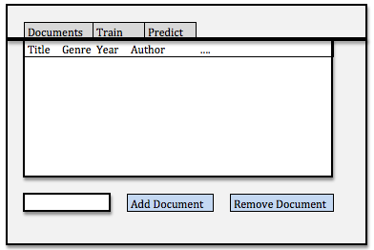

This will be the main screen of the GUI that lists all of the documents that you have uploaded and any attributes that are attached to those documents. At the bottom, you have the option to add (by typing it in next to the button) or remove (by selecting it in the list of documents) any document. From this screen you can also access tabs to train a statistical method, or predict an attribute.

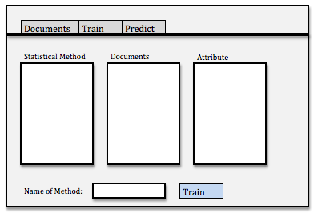

This is the training screen of the GUI. The user will be able to select a statistical method, as many documents as they want and an attribute to run the training on. They can also name the method so that they can use it later to make a prediction.

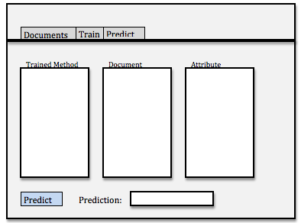

This is the screen that can be used to predict attributes of a document. The user can select a trained method, a document, and an attribute that they want to make the prediction about. When the press the button, the answer will appear at the bottom.

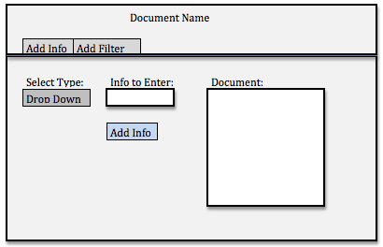

On the first screen, if you double click on one of the documents, then a new window will pop up for the specific document. There are two tabs on this window where you can add info about the document or apply a filter. On the tab where you add info, there is a drop down menu for possible pieces of info to add. There is a place to type in the label that you want, and there is a list of documents to be selected. There is a button to add the info.

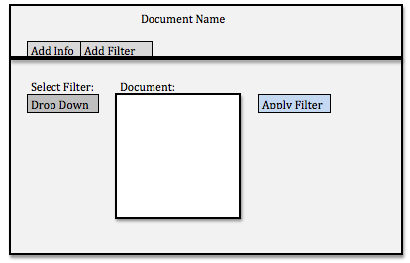

On the screen where you select a filter, there is a list of potential drop down filters and a list of the documents to choose from. There is a button to apply the filter.