Name: Kim Luong
UT EID: knl942
Differentially Expressed Genes of Liver Hepatocellular Carcinoma

Thesis
This project investigates differential gene expression by comparing AJCC Stage III (including IIIA, IIIB, or IIIC) liver hepatocellular carcinoma samples to stage II liver hepatocellular carcinoma samples using TCGA-LIHC RNA-seq data. The goal is to identify transcriptomic changes associated with tumor progression, as understanding molecular differences between early and late stage cancers may reveal potential biomarkers or therapeutic targets for advanced hepatocellular carcinoma.

Methods
The Genomic Data Commons (GDC) data portal was used to identify and access transcriptomic and associated clinical data that met the control conditions (Heath et al., 2021). Gene expression and clinical data for liver hepatocellular carcinoma (LIHC) were obtained from The Cancer Genome Atlas (TCGA) via the Genomic Data Commons (GDC) data portal. The results reported here are in part based upon data generated by the TCGA Research Network (https://www.cancer.gov/tcga). The control conditions were primary tumor samples of liver cancer (TCGA-LIHC) specifically diagnosed as hepatocellular carcinoma (NOS), under the adenomas and adenocarcinomas category with available open-access data for copy number variation (CNV), simple somatic mutations (SSM), and gene expression quantification. To organize the cases for analysis, samples were grouped by their AJCC pathologic stage. Group 1 included samples with Stage II, while Group 2 included samples diagnosed with Stage III or its subtypes (IIIA, IIIB, or IIIC). Sample sheets containing the relevant cases and sample identifiers was exported from the GDC data portal and used as the input for sample selection.
The Bioconductor packages within RStudio were used to acquire the GDC data needed for the differential expression analysis (RStudio Team, 2020). From the TCGAbiolinks package, the GDCquery function was used to search for datasets from The Cancer Genome Atlas database related to liver hepatocellular carcinoma (TCGA-LIHC) based off the sample identifier from the sample sheets (Colaprico et al., 2016). To fine tune this search, parameters, such as the project, data.category, workflow.type, data.type, and access, were included (Durinck et. al, 2009). Since the TCGA-LIHC data contained numerous project files, a second query search was done to filter the list of case barcodes that were found to specifically match the samples of the two groups. Following this filtering, the GDCdownload function was used to download the corresponding gene expression files, and GDCprepare function was used to process the files into a SummarizedExperiment object. This object contained raw gene-level expression counts, clinical metadata for each sample, and gene annotation information, providing a structured and unified format for downstream analysis (Morgan et. al, 2024).
After structuring the data into a SummarizedExperiment object, sample-level filtering was performed using principal component analysis (PCA) on normalized gene expression counts. A custom PCA function was used to visualize clustering and identify outlier samples based on their position along the second principal component axis via ggplot2 package (Wickham, 2016). Samples that deviated significantly from their respective group clusters were flagged and removed to reduce potential confounding effects. Following sample filtering, loci were further refined by calculating the proportion of samples with zero raw counts in both groups. In other words, loci with a high frequency (≥90%) of zero counts in both groups were excluded to avoid inflated significance values and minimize noise. These filtering steps ensured that the dataset used for differential expression analysis contained only representative samples and loci with reliable expression profiles.
Following data filtering and subsetting, differential expression analysis was carried out using the DESeq2 package to compare gene expression profiles from Group 2 to Group 1 (Love et al., 2014). The DESeq function from the DESeq2 package was used to quantify the differential expression in each group by fitting a negative binomial generalized linear model (GLM) to count data (Love et al., 2014). To visualize significant expression changes, a volcano plot was generated using ggplot2, displaying –log10 of the adjusted p-values against log2 fold changes (Wickham, 2016). In this plot, genes were considered significantly differentially expressed if they had an adjusted p-value below 0.05. Moreover, the top 10 significant differentially expressed genes were labeled on the volcano plot using ggrepel to aid in interpretation (Slowikowski, 2021).
Results
Before sample filtering, there were 50 samples for group 1 and 50 samples for group 2. A principal component analysis (PCA) was performed on the dataset as a standard quality control measure to evaluate sample clustering based on AJCC pathologic stage and to assess how the clustering patterns reflect the variance in genes. Figure 1 shows the PCA plot before sample filtering and Figure 2 shows the PCA plot after sample filtering. After sample filtering via the PCA plots, there were 49 samples for Group 1 and 50 samples for Group 2 in the DESeq2 analysis. 38836 genes were included in the DESeq2 analysis after filtering.

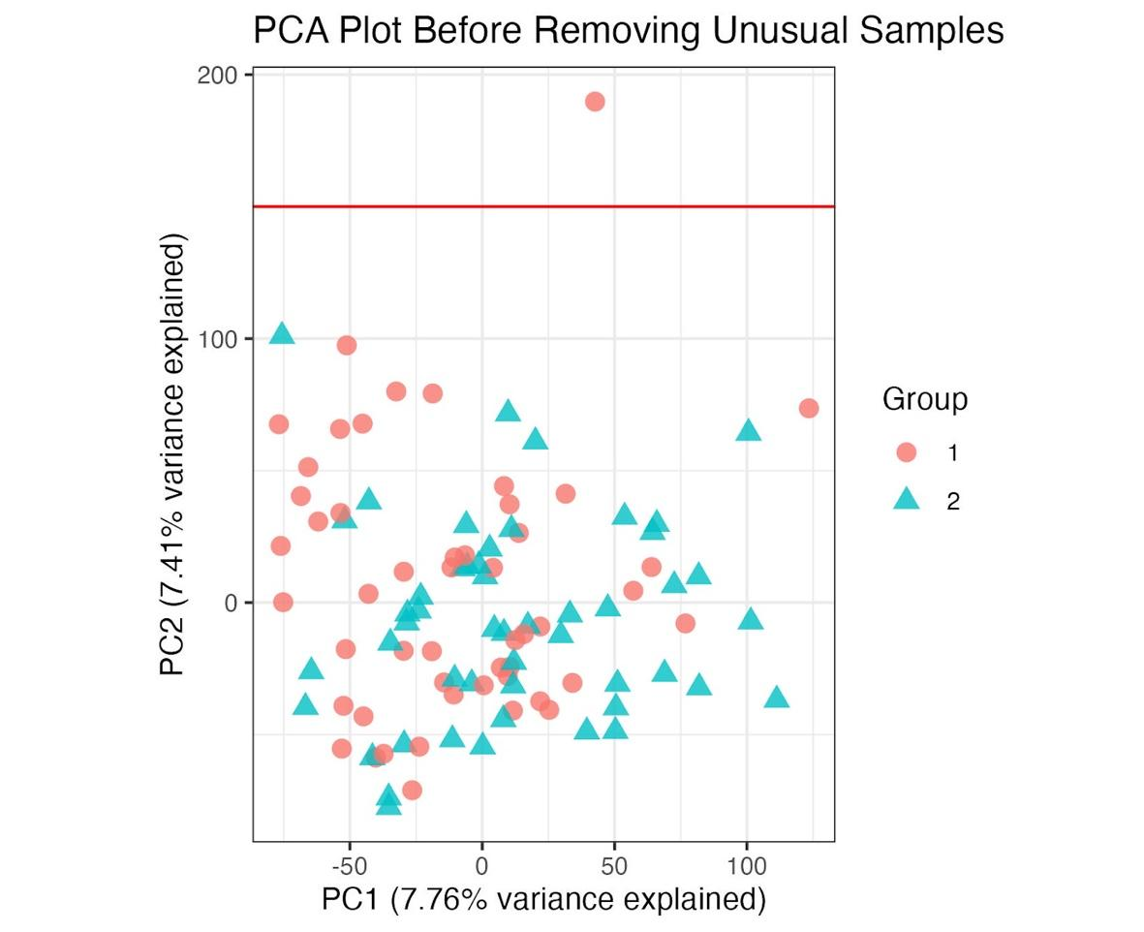
Figure 1 - PCA Plot Before Removing Unusual Samples: Initial quality control is conducted through principal component analysis. The PCA plot was visualized using ggplot2 (Wickham, 2016). The first principal component (PC1) accounted for 7.76% of the variance, while the second principal component (PC2) explained 7.41%. Group 1 represents stage II samples with red circles, while Group 2 represents stage III samples with teal triangles. One sample was flagged and removed based on the outlier values for PC2 (cutoff indicated by red vertical line).

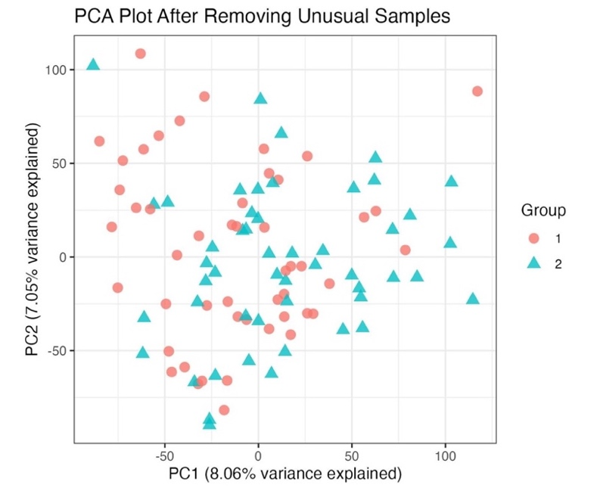
Figure 2 - PCA Plot After Removing Unusual Samples: A principal component analysis (PCA) was performed on the remaining samples following initial quality control filtering to assess sample clustering based on AJCC pathological stage and to evaluate gene-level variance. The PCA plot was generated using ggplot2, with PC1 and PC2 accounting for 8.06% and 7.05% of the variance, respectively (Wickham, 2016). No additional extreme outliers were observed. The clustering was deemed sufficiently consistent across groups, and all remaining samples were retained for differential expression analysis.

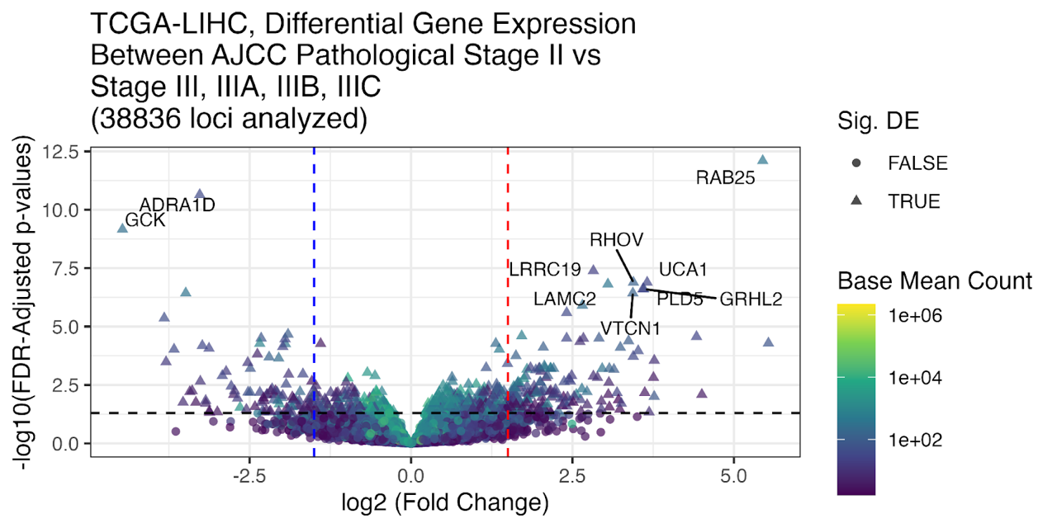
Figure 3 – Volcano Plot: Volcano plot visualizing differential expression for 38836 genes and 99 liver hepatocellular carcinoma samples, comparing AJCC stage III/IIIA/IIIB/IIIC (Group 2) to stage II (Group 1). The top 10 most significantly differentially expressed genes with absolute log2 fold change values greater than 1.5 were labeled with their gene symbols using ggrepel (Slowikowski, 2021). Vertical dashed lines indicate the ±1.5 log2 fold change cutoff, and the horizontal dashed line marks the FDR-adjusted p-value cutoff of 0.05. The color gradient represents the base mean expression of each gene on a log scale, with darker purple indicating lower expression and bright yellow indicating higher expression. Point shape differentiates significance status, with triangles representing genes that passed the significance threshold and circles representing non-significant genes. The volcano plot was created using ggplot2 (Wickham, 2016).

In this analysis, log2 fold change values were used to measure the difference in gene expression between AJCC stage II and AJCC stage III or its subtypes in liver hepatocellular carcinoma samples. The comparison was set up such that samples in stage II (Group 1) served as the less advanced or more "wild-type", and samples in stage III or its subtypes (Group 2) were treated as the more deviated group. In the DESeq2 analysis, Group 2 is compared to Group 1. With this setup, genes showing a positive log2 fold change are considered upregulated in group 2, indicating higher expression in more advanced-stage tumors. Conversely, genes with a negative log2 fold change are downregulated in group 2, meaning they are more highly expressed in earlier-stage tumors.
After filtering, 38836 genes were included in the differential expression analysis. Differential expression analysis identified a total of 715 significantly differentially expressed genes between AJCC pathologic stage II and AJCC pathologic stage III or its subtypes in liver hepatocellular carcinoma samples, based on a false discovery rate (FDR)-adjusted p-value threshold of 0.05. Among the significantly differentially expressed genes, 269 genes were significantly downregulated in Group 2 relative to Group 1, meaning these genes had higher expression in the earlier-stage tumors. Hence, these genes had log2 fold change values less than zero, indicating reduced expression in the more advanced-stage tumors. Conversely, 446 genes were significantly upregulated in Group 2 relative to Group 1, reflecting elevated expression in later-stage tumors. Therefore, these genes had log2 fold change values greater than zero, meaning their expression was increased in the more advanced-stage tumors compared to the earlier stage. The top 10 differentially expressed genes, ranked by significance, are labeled in the volcano plot in Figure 3 and listed in Table 1. Several of these genes are known to play roles in cancer-related pathways and may warrant further investigation as potential biomarkers or therapeutic targets.

Table 1 - Top 10 Differentially Expressed Genes: The table lists the gene name, associated p-value, and log2 fold change of the top 10 differentially expressed genes extracted from the supplementary file “Loci.csv.” Positive log2 fold change values indicate genes upregulated in Group 2 relative to Group 1, while negative values indicate genes downregulated in Group 2. Genes are ranked by statistical significance (p-value).
Gene Name | p-value | Log2FoldChange | Upregulated / Downregulated
RAB25 | 2.98E-17 | 5.446348287 | Upregulated
ADRA1D | 1.69E-15 | -3.272229328 | Downregulated
GCK | 7.72E-14 | -4.469074494 | Downregulated
LRRC19 | 6.08E-12 | 2.8234395 | Upregulated
RHOV | 2.48E-11 | 3.444022701 | Upregulated
UCA1 | 2.88E-11 | 3.656503575 | Upregulated
LAMC2 | 4.00E-11 | 3.048714985 | Upregulated
GRHL2 | 7.65E-11 | 3.604949035 | Upregulated
PLD5 | 8.37E-11 | 3.589980415 | Upregulated
VTCN1 | 1.46E-10 | 3.434997364 | Upregulated

Analysis
After filtering and cleaning the TCGA-LIHC data, the results for this DE analysis helped determine whether the individual genes were significantly, differentially expressed and whether they were upregulated or downregulated (Figure 3). Among the most biologically interesting genes were those ranked highest by statistical significance, including RAB25, which showed strong upregulation in AJCC stage III hepatocellular carcinoma samples compared to stage II, with a log2 fold change of 5.45 and p-value of $2.98×{10}^{-17}$(Table 1). This expression pattern motivates further investigation into RAB25’s role in tumor progression. RAB25, a member of the RAS superfamily of small GTPases, has been identified as an oncogenic factor in various epithelial cancers due to its involvement in vesicle trafficking, cellular polarity, and promotion of the AKT/mTOR signaling pathway (Wang et al., 2017). The AKT/mTOR pathway is a key intracellular signaling cascade that regulates cell growth, proliferation, survival, and metabolism (Bang et al., 2023). While its dysregulation is a hallmark of many cancers, it plays a particularly critical role in HCC due to the liver’s unique biology. As a central metabolic organ, the liver is highly responsive to changes in nutrient availability, insulin, and growth factors, all of which feed into the AKT/mTOR axis (Bang et al., 2023). This makes hepatocytes especially sensitive to perturbations in this pathway. Overall, RAB25 overexpression has been shown to significantly increase the invasive capacity and growth rate of HCC cells, suggesting that elevated RAB25 expression may contribute directly to key hallmarks of cancer (Geng et al., 2016). Its consistent upregulation in later-stage tumors in this analysis points to its potential as both a biomarker for disease progression and a therapeutic target for advanced hepatocellular carcinoma.
In addition to RAB25, GCK also emerged as one of the most biologically relevant genes in this analysis, displaying significant downregulation in AJCC stage III hepatocellular carcinoma samples compared to stage II, with a log2 fold change of -4.54 and a p-value of $4.70×{10}^{-12}$ (Table 1). This consistent downregulation highlights GCK’s potential involvement in tumor progression and metabolic reprogramming in liver cancer. GCK (glucokinase) is a liver-enriched enzyme that plays a central role in glucose metabolism by catalyzing the phosphorylation of glucose to glucose-6-phosphate, a critical step in glycolysis (Li et al., 2021). In healthy hepatocytes, GCK activity helps regulate glucose homeostasis and energy balance. However, in hepatocellular carcinoma, there is a metabolic shift where GCK expression is suppressed and replaced by the higher-affinity isoenzyme hexokinase 2 (HK2), which supports the glycolytic phenotype of cancer cells and is associated with poor prognosis (Perrin-Cocon et al., 2021). This isoenzyme switch enables tumor cells to prioritize energy production and biosynthesis even under hypoxic conditions, favoring survival and growth (Perrin-Cocon et al., 2021). Therefore, the marked downregulation of GCK observed in this analysis reflects this metabolic shift and suggests that GCK loss may contribute to dedifferentiation and tumor aggressiveness. Its stage-associated suppression highlights its potential utility as a biomarker for tumor progression and a possible therapeutic entry point for restoring normal metabolic control in hepatocellular carcinoma.
The analysis successfully addressed its primary objective of identifying transcriptomic differences associated with tumor progression between AJCC stage II and stage III hepatocellular carcinoma samples. By comparing RNA-seq data from early and late stage tumors, the differential expression analysis revealed genes such as RAB25 and GCK that exhibited significant expression changes, aligning with known metabolic pathways involved in cancer progression. These transcriptomic shifts not only enhance our understanding of molecular differences between stages but also help generate a shortlist of genes that may serve as potential biomarkers for tumor aggressiveness or therapeutic targets for advanced disease. For example, the consistent upregulation of RAB25 in stage III tumors highlights its potential utility in distinguishing advanced-stage cancers or guiding pathway-specific therapies.
However, it is important to emphasize that this analysis identifies correlations, not causal relationships. While genes like RAB25 and GCK were differentially expressed between stages, their association with tumor progression does not imply they directly contribute to or drive these changes. These differences may result from several limitations, such as the lack of control over other important variables from the patient medical history, such as treatment status, environmental exposures, or preservation methods, all of which could confound gene expression patterns. For instance, while most samples were preserved using the same method (OCT), slight variations in preservation protocols can introduce technical variability that affects RNA quality and stability, leading to artificial differences in gene expression. This can result in biased expression profiles, where some genes appear upregulated or downregulated due to preservation artifacts rather than true biological differences.
Future research should focus on validating the functional roles of genes like RAB25 and GCK in hepatocellular carcinoma progression. Experimental studies such as in vitro knockdown or overexpression assays in liver cancer cell lines, as well as in vivo mouse models, could help determine whether these genes actively influence tumor growth or metabolism. Additionally, integrating transcriptomic data with patient treatment history, immune profiles, and genomic mutations would offer a more comprehensive view of how these factors interact. Expanding the dataset to include more diverse populations and standardized sample processing protocols would also improve the robustness and generalizability of the findings.

Works Cited

Bang, J., Jun, M., Lee, S., Moon, H., & Ro, S. W. (2023). Targeting egfr/pi3k/akt/mtor signaling in hepatocellular carcinoma. Pharmaceutics, 15(8), 2130. https://doi.org/10.3390/pharmaceutics15082130
Colaprico, A., Silva, T. C., Olsen, C., Garofano, L., Cava, C., Garolini, D., Sabedot, T. S., Malta, T. M., Pagnotta, S. M., Castiglioni, I., Ceccarelli, M., Bontempi, G., & Noushmehr, H. (2016). TCGAbiolinks: An R/Bioconductor package for integrative analysis of TCGA data. Nucleic Acids Research, 44(8), e71–e71. https://doi.org/10.1093/nar/gkv1507
Durinck, S., Spellman, P. T., Birney, E., & Huber, W. (2009). Mapping identifiers for the integration of genomic datasets with the R/Bioconductor package biomaRt. Nature protocols, 4(8), 1184–1191. https://doi.org/10.1038/nprot.2009.97
Geng, D., Zhao, W., Feng, Y., & Liu, J. (2016). Overexpression of Rab25 promotes hepatocellular carcinoma cell proliferation and invasion. Tumour Biology: The Journal of the International Society for Oncodevelopmental Biology and Medicine, 37(6), 7713–7718. https://doi.org/10.1007/s13277-015-4606-5
Heath, A.P., Ferretti, V., Agrawal, S. et al. The NCI Genomic Data Commons. Nat Genet 53, 257-262 (2021). https://doi.org/10.1038/s41588-021-00791-5
Kamil Slowikowski (2024). ggrepel: Automatically Position Non-Overlapping Text Labels with 'ggplot2'. R package version 0.9.6. https://CRAN.R-project.org/package=ggrepel
Li, S., Fu, J., Yang, J., Ma, H., Bhutani, D., Mapara, M. Y., Marcireau, C., & Lentzsch, S. (2021). Targeting the GCK pathway: A novel and selective therapeutic strategy against RAS-mutated multiple myeloma. Blood, 137(13), 1754–1764. https://doi.org/10.1182/blood.2020006334
Love, M. I., Huber, W., & Anders, S. (2014). Moderated estimation of fold change and dispersion for RNA-seq data with DESeq2. Genome Biology, 15(12), 550. https://doi.org/10.1186/s13059-014-0550-8
Morgan, M., Obenchain, V., Hester, J., & Pagès, H. (2024). SummarizedExperiment: A container (S4 class) for matrix-like assays. R package version 1.36.0. https://bioconductor.org/packages/SummarizedExperiment
Perrin-Cocon, L., Vidalain, P.-O., Jacquemin, C., Aublin-Gex, A., Olmstead, K., Panthu, B., Rautureau, G. J. P., André, P., Nyczka, P., Hütt, M.-T., Amoedo, N., Rossignol, R., Filipp, F. V., Lotteau, V., & Diaz, O. (2021). A hexokinase isoenzyme switch in human liver cancer cells promotes lipogenesis and enhances innate immunity. Communications Biology, 4(1), 1–15. https://doi.org/10.1038/s42003-021-01749-3
RStudio Team (2020). RStudio: Integrated Development Environment for R. RStudio, PBC, Boston, MA URL http://www.rstudio.com/.
Wang, S., Hu, C., Wu, F., & He, S. (2017). Rab25 GTPase: Functional roles in cancer. Oncotarget, 8(38), 64591–64599. https://doi.org/10.18632/oncotarget.19571
Wickham Hadley. (2016). ggplot2: Elegant Graphics for Data Analysis. https://ggplot2.tidyverse.org/

Acknowledgements

The results shown here are in whole or part based upon data generated by the TCGA Research Network: https://www.cancer.gov/tcga.

