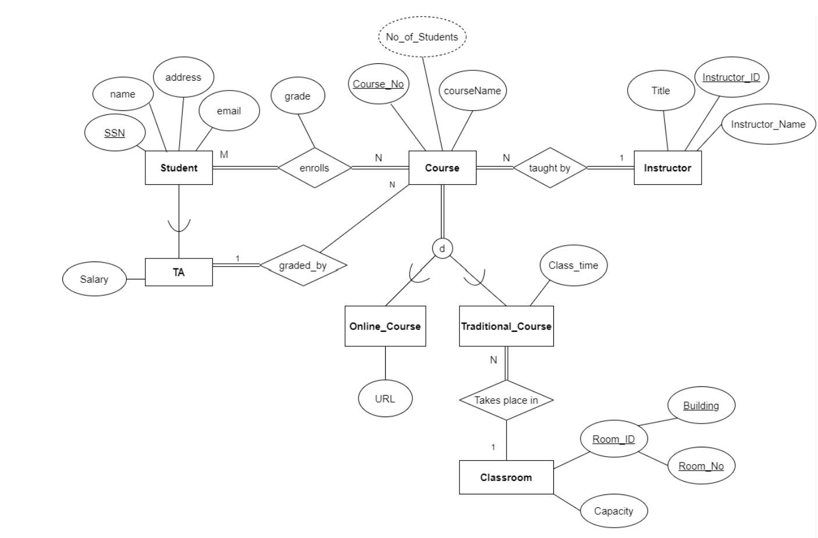
Khanh Luu
CSC174 – Assignment 1

