

**DATE: 14TH Feb 2023**

**TO: HEAD ICT**

**THRU: MANAGER CORE BANKING AND BUSINESS APPLICATIONS**

**FROM: DATABASE ADMINISTRATOR**

**SUBJECT: Jan 2023 – DATABASE BACKUP INVENTORY**

1. **Background**

According to the Backup Policy, in order to minimize any potential loss or corruption of this data, units responsible for providing and operating administrative applications need to ensure that data is adequately backed up by establishing and following an appropriate system backup procedure.

The data backup policy stipulates the following:

* Software: All software, whether purchased or developed internally for FTB business, is to be protected by at least one full backup prior to its usage and original or master copies must be stored in a secure location.
* System data: System data are to be backed up with at least one backup per month.

User data: All user data located on the file-servers are to be protected by means of full daily backups (except for Sundays and public holidays).

* Storage: All backup media must be stored in a safe and secure location extraneous to the location of the backed up systems. All backup media must be stored in a fireproof safe. All software full backup and monthly backup media must be stored in an off-site backup archive location.

The backups listed herein are related to Core Banking and Business Applications. The core purpose is to be able to restore to an earlier point in time to help the business recover from unplanned event and prevent data loss.

1. **Current status**

During the month of Jan 2023, all the production databases were successfully backed up and transferred to tape with unique ID **ACD811M8**, which has a capacity of **8.5 TB** with a free space of **8.5 TB.** The total number of backups that were moved to tape was **50**. **9** of themwere of full backup type while **42** were of differential back up type. The total size of all backups was **2.42 TB.** The list below gives the detail.

|  |  |  |  |  |  |  |
| --- | --- | --- | --- | --- | --- | --- |
| **#** | **Application** | **Backup File** | **Size** | **Type** | **Back up Type** | **Backup Date** |
| 1 | BRNET | AFN02012023DIFF | 8.66 | GB | DIFF | 02-Jan-23 |
| BFN02012023DIFF | 2.05 | GB | DIFF | 02-Jan-23 |
| AFN03012023DIFF | 12.5 | GB | DIFF | 03-Jan-23 |
| BFN03012023DIFF | 9.58 | GB | DIFF | 03-Jan-23 |
| AFN04012023DIFF | 15 | GB | DIFF | 04-Jan-23 |
| BFN04012023DIFF | 13 | GB | DIFF | 04-Jan-23 |
| AFN05012023FULL | 351 | GB | FULL | 05-Jan-23 |
| BFN05012023DIFF | 6 | GB | DIFF | 05-Jan-23 |
| AFN06012023DIFF | 7 | GB | DIFF | 06-Jan-23 |
| BFN06012023DIFF | 12 | GB | DIFF | 06-Jan-23 |
| AFN07012023DIFF | 11.6 | GB | DIFF | 07-Jan-23 |
| BFN07012023DIFF | 8 | GB | DIFF | 07-Jan-23 |
| AFN09012023FULL | 337 | GB | FULL | 09-Jan-23 |
| BFN09012023DIFF | 12.5 | GB | DIFF | 09-Jan-23 |
| AFN10012023DIFF | 7 | GB | DIFF | 10-Jan-23 |
| BFN10012023DIFF | 1.55 | GB | DIFF | 10-Jan-23 |
| AFN11012023DIFF | 11.6 | GB | DIFF | 11-Jan-23 |
| BFN11012023DIFF | 8.03 | GB | DIFF | 11-Jan-23 |
| AFN12012023FULL | 339 | GB | FULL | 12-Jan-23 |
| BFN12012023DIFF | 12.1 | GB | DIFF | 12-Jan-23 |
| AFN13012023DIFF | 7.23 | GB | DIFF | 13-Jan-23 |
| BFN13012023DIFF | 1.76 | GB | DIFF | 13-Jan-23 |
| AFN14012023DIFF | 11.4 | GB | DIFF | 14-Jan-23 |
| BFN14012023DIFF | 7.99 | GB | DIFF | 14-Jan-23 |
| AFN16012023FULL | 341 | GB | FULL | 16-Jan-23 |
| BFN16012023DIFF | 12.6 | GB | DIFF | 16-Jan-23 |
| AFN17012023DIFF | 7.31 | GB | DIFF | 17-Jan-23 |
| BFN17012023DIFF | 1.79 | GB | DIFF | 17-Jan-23 |
| AFN18012023DIFF | 11.6 | GB | DIFF | 18-Jan-23 |
| BFN18012023DIFF | 8.36 | GB | DIFF | 18-Jan-23 |
| AFN19012023FULL | 72.6 | GB | FULL | 19-Jan-23 |
| BFN19012023DIFF | 12.5 | GB | DIFF | 19-Jan-23 |
| AFN20012023DIFF | 8.15 | GB | DIFF | 20-Jan-23 |
| BFN20012023DIFF | 1.68 | GB | DIFF | 20-Jan-23 |
| AFN23012022FULL | 344 | GB | FULL | 23-Jan-23 |
| AFN230122022DIFF | 13.7 | GB | DIFF | 23-Jan-23 |
| BFN23012023DIFF | 9.66 | GB | DIFF | 23-Jan-23 |
| AFN24012023DIFF | 7.6 | GB | DIFF | 24-Jan-23 |
| BFN24012023DIFF | 1.76 | GB | DIFF | 24-Jan-23 |
| AFN25012023DIFF | 11 | GB | DIFF | 25-Jan-23 |
| BFN25012023DIFF | 8.07 | GB | DIFF | 25-Jan-23 |
| AFN27012023DIFF | 16.98 | GB | DIFF | 27-Jan-23 |
| BFN27012023DIFF | 13 | GB | DIFF | 27-Jan-23 |
| AFN28012023DIFF | 6.47 | GB | DIFF | 28-Jan-23 |
| BFN28012023DIFF | 1.14 | GB | DIFF | 28-Jan-23 |
| AFN30012023DIFF | 8.5 | GB | DIFF | 30-Jan-23 |
| BFN30012022DIFF | 8.18 | GB | DIFF | 30-Jan-23 |
| AFN31012023FULL | 348 | GB | FULL | 31-Jan-23 |
| BFN31012023DIFF | 14.5 | GB | DIFF | 31-Jan-23 |
| 2 | BREFT | BRPOS19012023FULL | 28.9 | GB | FULL | 19-Jan-23 |

Below are screenshots from the Veam Backup Tool

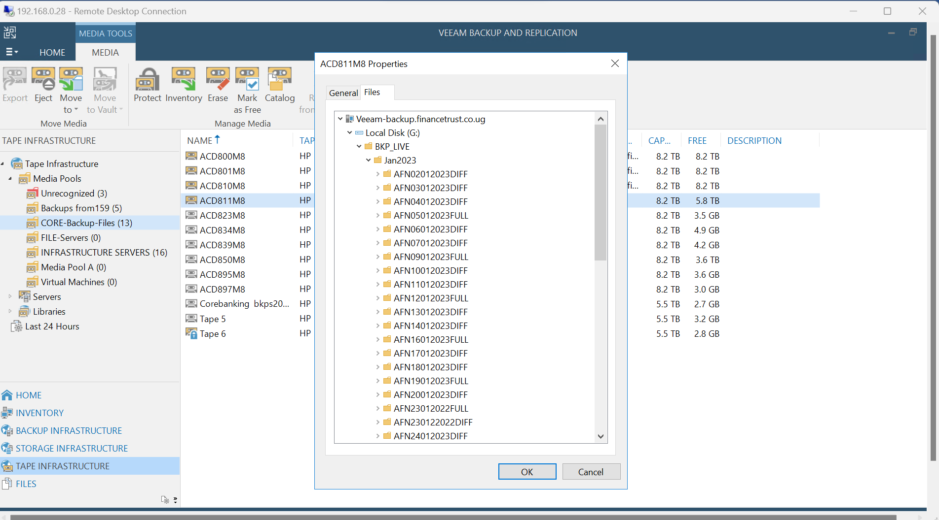

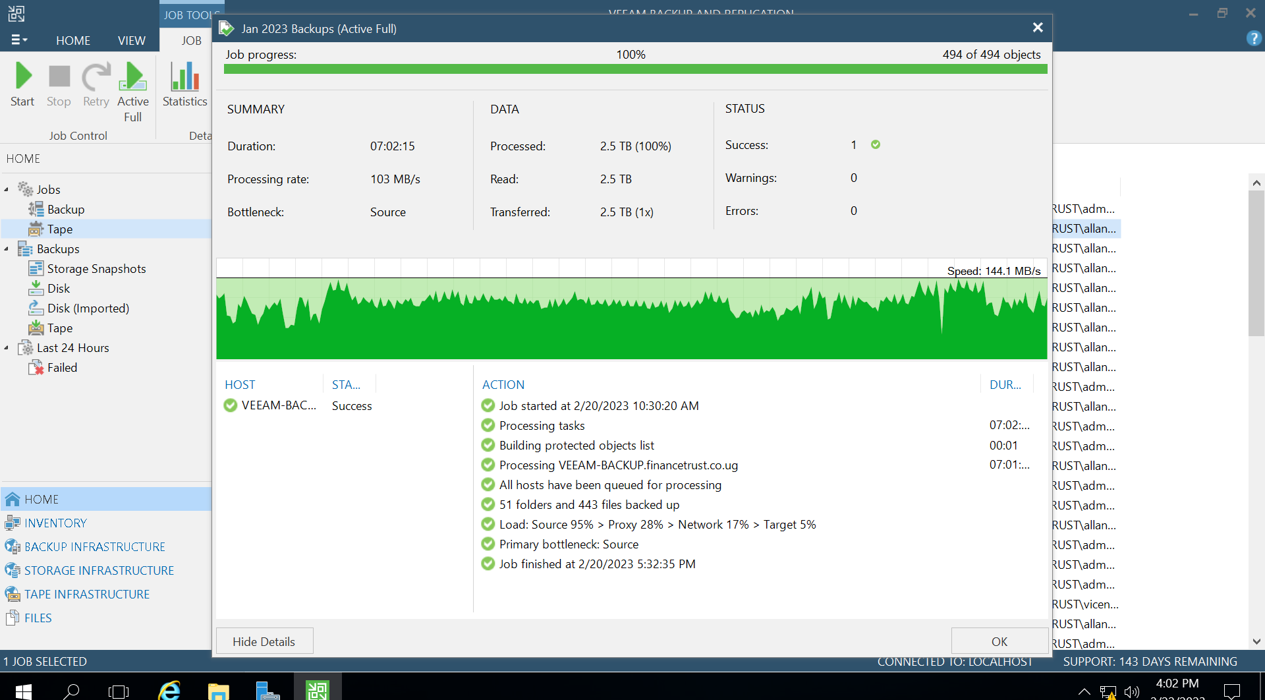

1. **Conclusion.**

Much as the policy stipulates that full backups shall be taken daily, it is not sustainable. The full backups on the Core Banking are taken twice in a week and the differentials are taken on the other days. The backup policy is going to be reviewed to address this.

**Signoff**

|  |  |  |  |
| --- | --- | --- | --- |
| **#** | **Name** | **Designation** | **Signature & Date** |
|  | **Compiled by:**  Allan Musembya | Database Administrator | 14/Feb/2023 |
|  | **Reviewed by:**  Deborah Kisaale | Manager Core Banking And Business Applications |  |
|  | **Approved by:**  Lawrence Filly | Head ICT |  |