DAG Consistency_Chapter 2
Karen Velásquez C
2025-11-07
library(dagitty)
library(tidyverse)
library(kableExtra)
library(knitr)

DAG - Small mammal abundance and Ecological integrity
DAG_abu <- downloadGraph("dagitty.net/mhXq8GEfk")
#plot(DAG_abu)
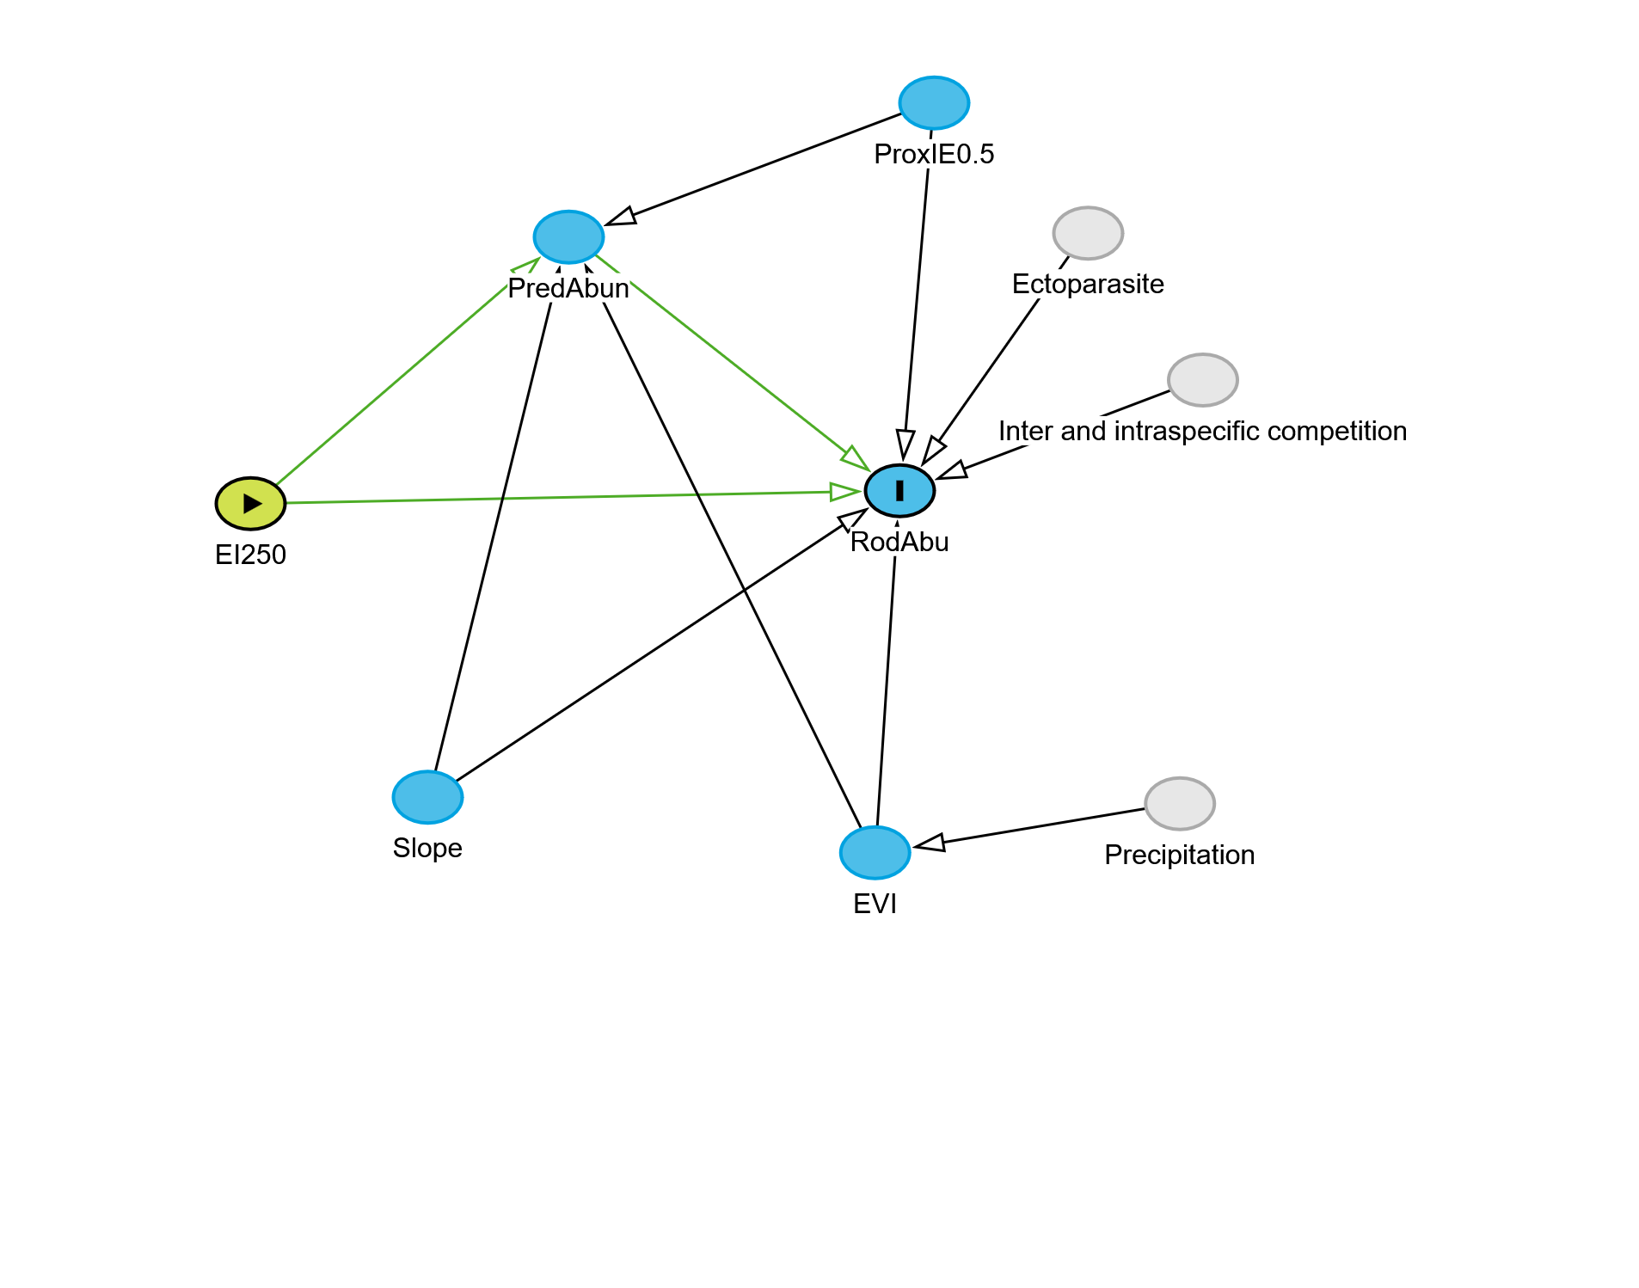
 | estimate | p.value | 2.5% | 97.5%
EI25 || EVI | -0.0679744 | 0.7789416 | -0.4977932 | 0.3867679
EI25 || PIE0 | 0.4496462 | 0.0458641 | 0.0088954 | 0.7647939
EI25 || Slop | -0.1866820 | 0.4360722 | -0.5863334 | 0.2789926
EVI || PIE0 | -0.4576689 | 0.0415207 | -0.7700264 | -0.0189951
EVI || Slop | -0.0155551 | 0.9488582 | -0.4563552 | 0.4309775
PIE0 || Slop | 0.1007422 | 0.6768359 | -0.3581357 | 0.5229205
Acá explicar para que se hace el ajuste del p-value
 | estimate | p.value | 2.5% | 97.5%
EI25 || EVI | -0.0679744 | 1.0000000 | -0.4977932 | 0.3867679
EI25 || PIE0 | 0.4496462 | 0.2491242 | 0.0088954 | 0.7647939
EI25 || Slop | -0.1866820 | 1.0000000 | -0.5863334 | 0.2789926
EVI || PIE0 | -0.4576689 | 0.2491242 | -0.7700264 | -0.0189951
EVI || Slop | -0.0155551 | 1.0000000 | -0.4563552 | 0.4309775
PIE0 || Slop | 0.1007422 | 1.0000000 | -0.3581357 | 0.5229205
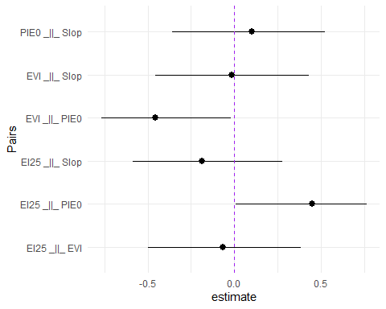

DAG Small mammal diversity and Ecological integrity
DAG_Div <- downloadGraph("dagitty.net/maX7kEkAu")
#plot(DAG_div)
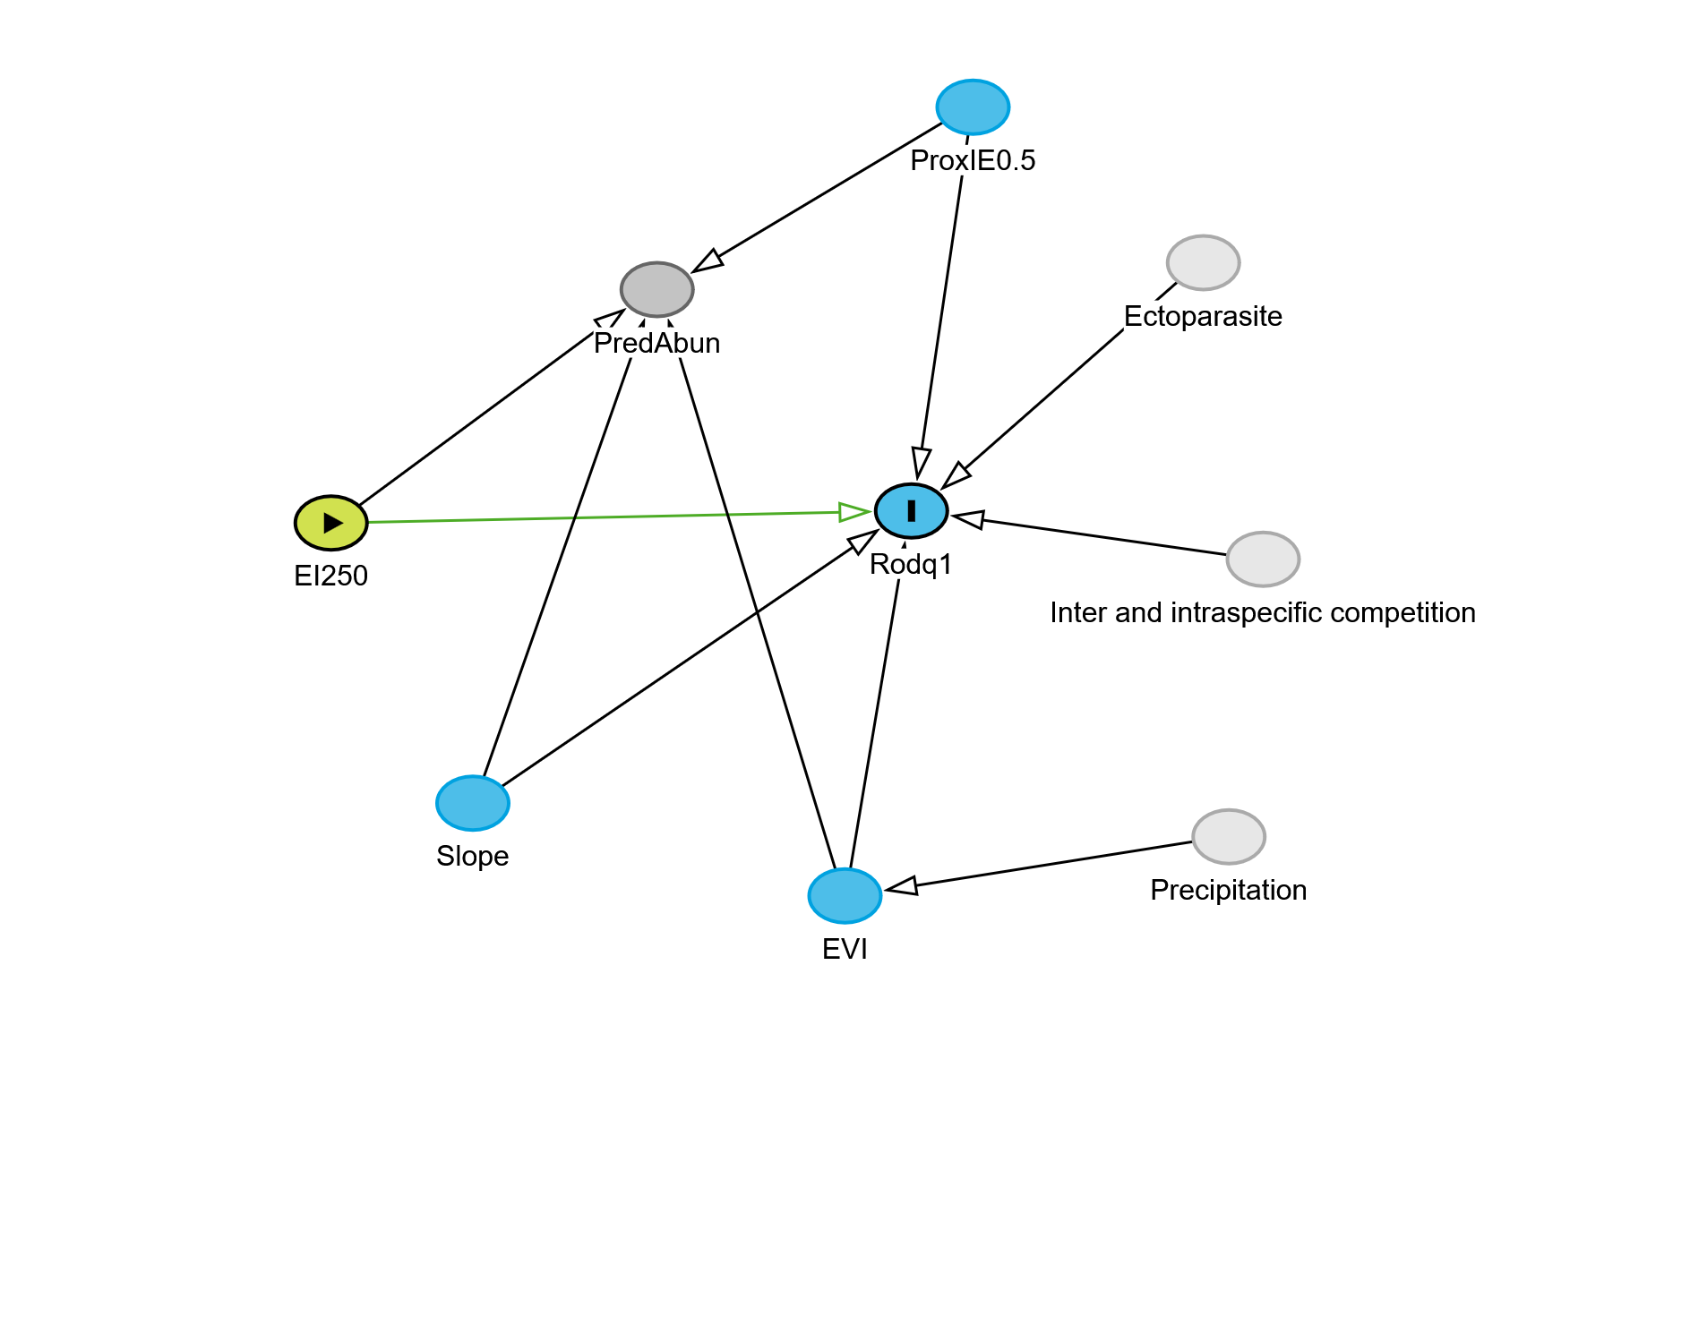
 | estimate | p.value | 2.5% | 97.5%
EI25 || EVI | -0.0679744 | 0.7789416 | -0.4977932 | 0.3867679
EI25 || PIE0 | 0.4496462 | 0.0458641 | 0.0088954 | 0.7647939
EI25 || Slop | -0.1866820 | 0.4360722 | -0.5863334 | 0.2789926
EVI || PIE0 | -0.4576689 | 0.0415207 | -0.7700264 | -0.0189951
EVI || Slop | -0.0155551 | 0.9488582 | -0.4563552 | 0.4309775
PrdA || Rdq1 | EI25, EVI, PIE0, Slop | 0.0580860 | 0.8339266 | -0.4519357 | 0.5417036
PIE0 || Slop | 0.1007422 | 0.6768359 | -0.3581357 | 0.5229205
Acá explicar para que se hace el ajuste del p-value
 | estimate | p.value | 2.5% | 97.5%
EI25 || EVI | -0.0679744 | 1.0000000 | -0.4977932 | 0.3867679
EI25 || PIE0 | 0.4496462 | 0.2906449 | 0.0088954 | 0.7647939
EI25 || Slop | -0.1866820 | 1.0000000 | -0.5863334 | 0.2789926
EVI || PIE0 | -0.4576689 | 0.2906449 | -0.7700264 | -0.0189951
EVI || Slop | -0.0155551 | 1.0000000 | -0.4563552 | 0.4309775
PrdA || Rdq1 | EI25, EVI, PIE0, Slop | 0.0580860 | 1.0000000 | -0.4519357 | 0.5417036
PIE0 || Slop | 0.1007422 | 1.0000000 | -0.3581357 | 0.5229205
