DAG Consistency_Chapter 2
Karen Velásquez C
2025-11-07
library(dagitty)
library(tidyverse)
library(kableExtra)
library(knitr)
library(DHARMa)
library(AICcmodavg)
library(ggplot2)
library(glmmTMB)
library(piecewiseSEM)

DAG - Small mammal abundance and Ecological integrity
DAG_abu <- downloadGraph("dagitty.net/mhXq8GEfk")
#plot(DAG_abu)
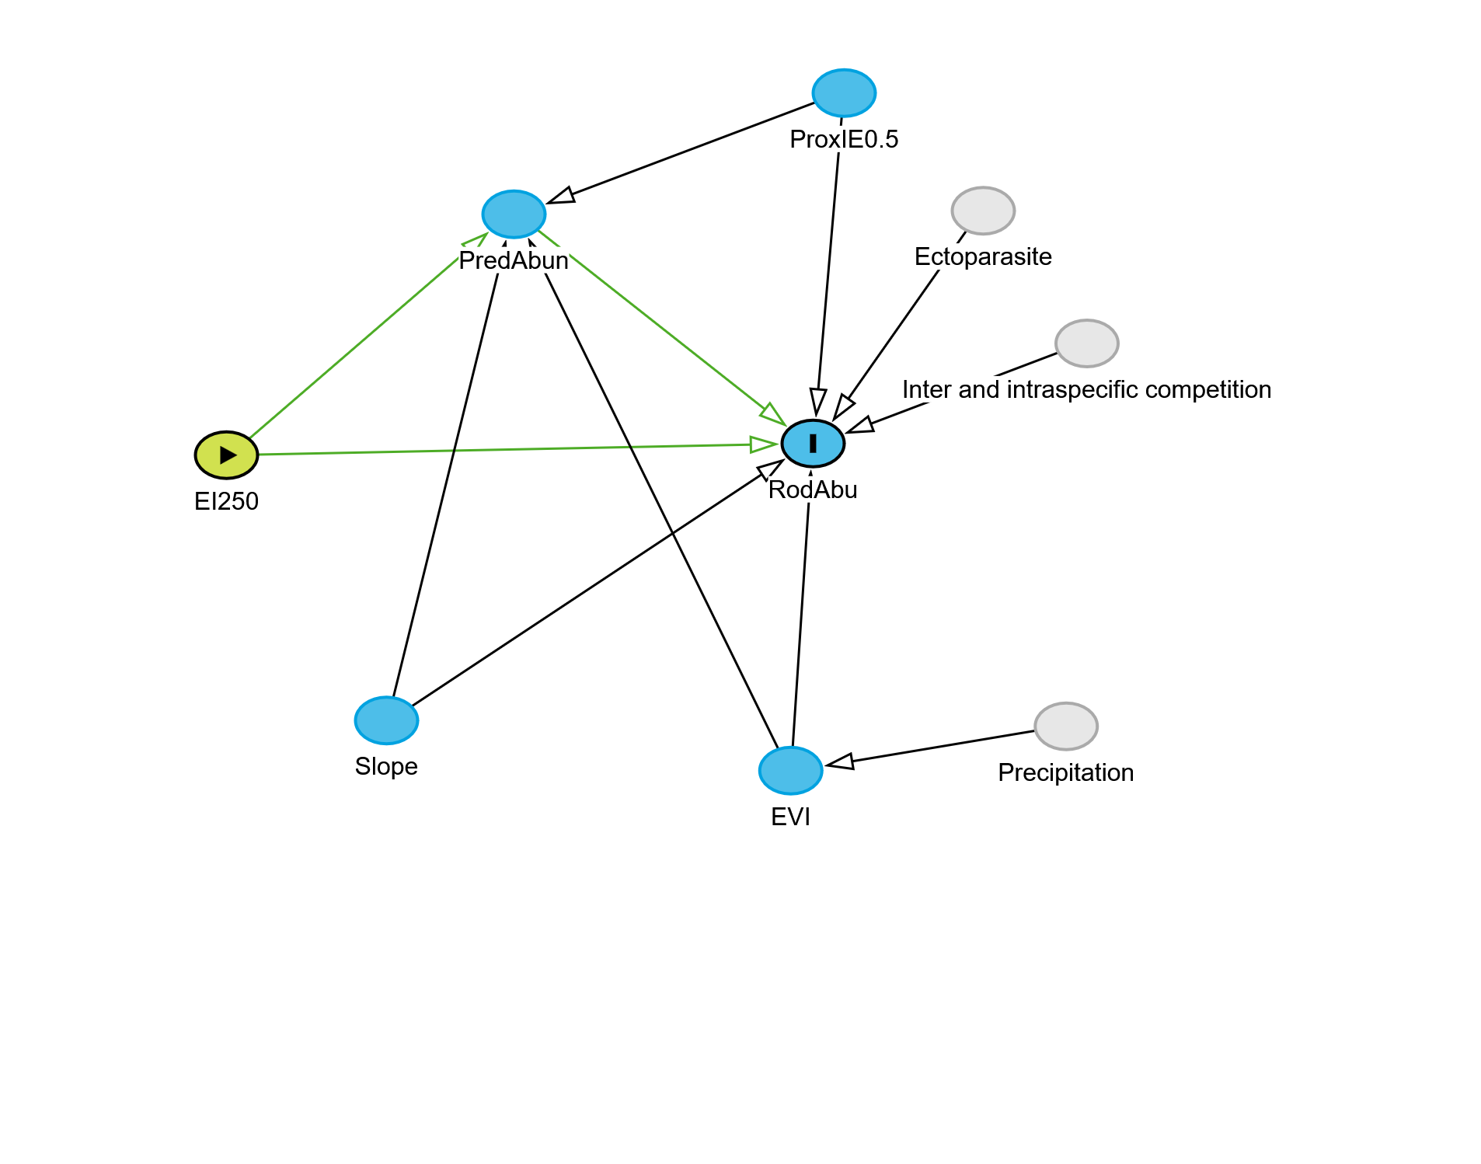
 | estimate | p.value | 2.5% | 97.5%
EI25 || EVI | -0.0679744 | 0.7789416 | -0.4977932 | 0.3867679
EI25 || PIE0 | 0.4496462 | 0.0458641 | 0.0088954 | 0.7647939
EI25 || Slop | -0.1866820 | 0.4360722 | -0.5863334 | 0.2789926
EVI || PIE0 | -0.4576689 | 0.0415207 | -0.7700264 | -0.0189951
EVI || Slop | -0.0155551 | 0.9488582 | -0.4563552 | 0.4309775
PIE0 || Slop | 0.1007422 | 0.6768359 | -0.3581357 | 0.5229205
Acá explicar para que se hace el ajuste del p-value
 | estimate | p.value | 2.5% | 97.5%
EI25 || EVI | -0.0679744 | 1.0000000 | -0.4977932 | 0.3867679
EI25 || PIE0 | 0.4496462 | 0.2491242 | 0.0088954 | 0.7647939
EI25 || Slop | -0.1866820 | 1.0000000 | -0.5863334 | 0.2789926
EVI || PIE0 | -0.4576689 | 0.2491242 | -0.7700264 | -0.0189951
EVI || Slop | -0.0155551 | 1.0000000 | -0.4563552 | 0.4309775
PIE0 || Slop | 0.1007422 | 1.0000000 | -0.3581357 | 0.5229205
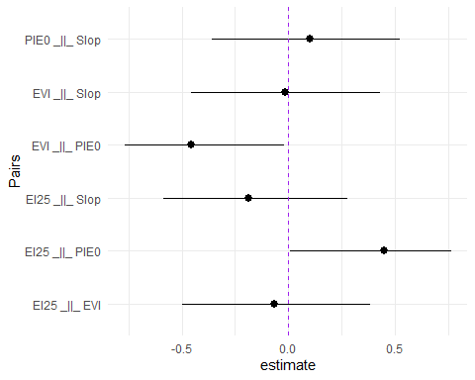

DAG Small mammal diversity and Ecological integrity
DAG_Div <- downloadGraph("dagitty.net/maX7kEkAu")
#plot(DAG_div)
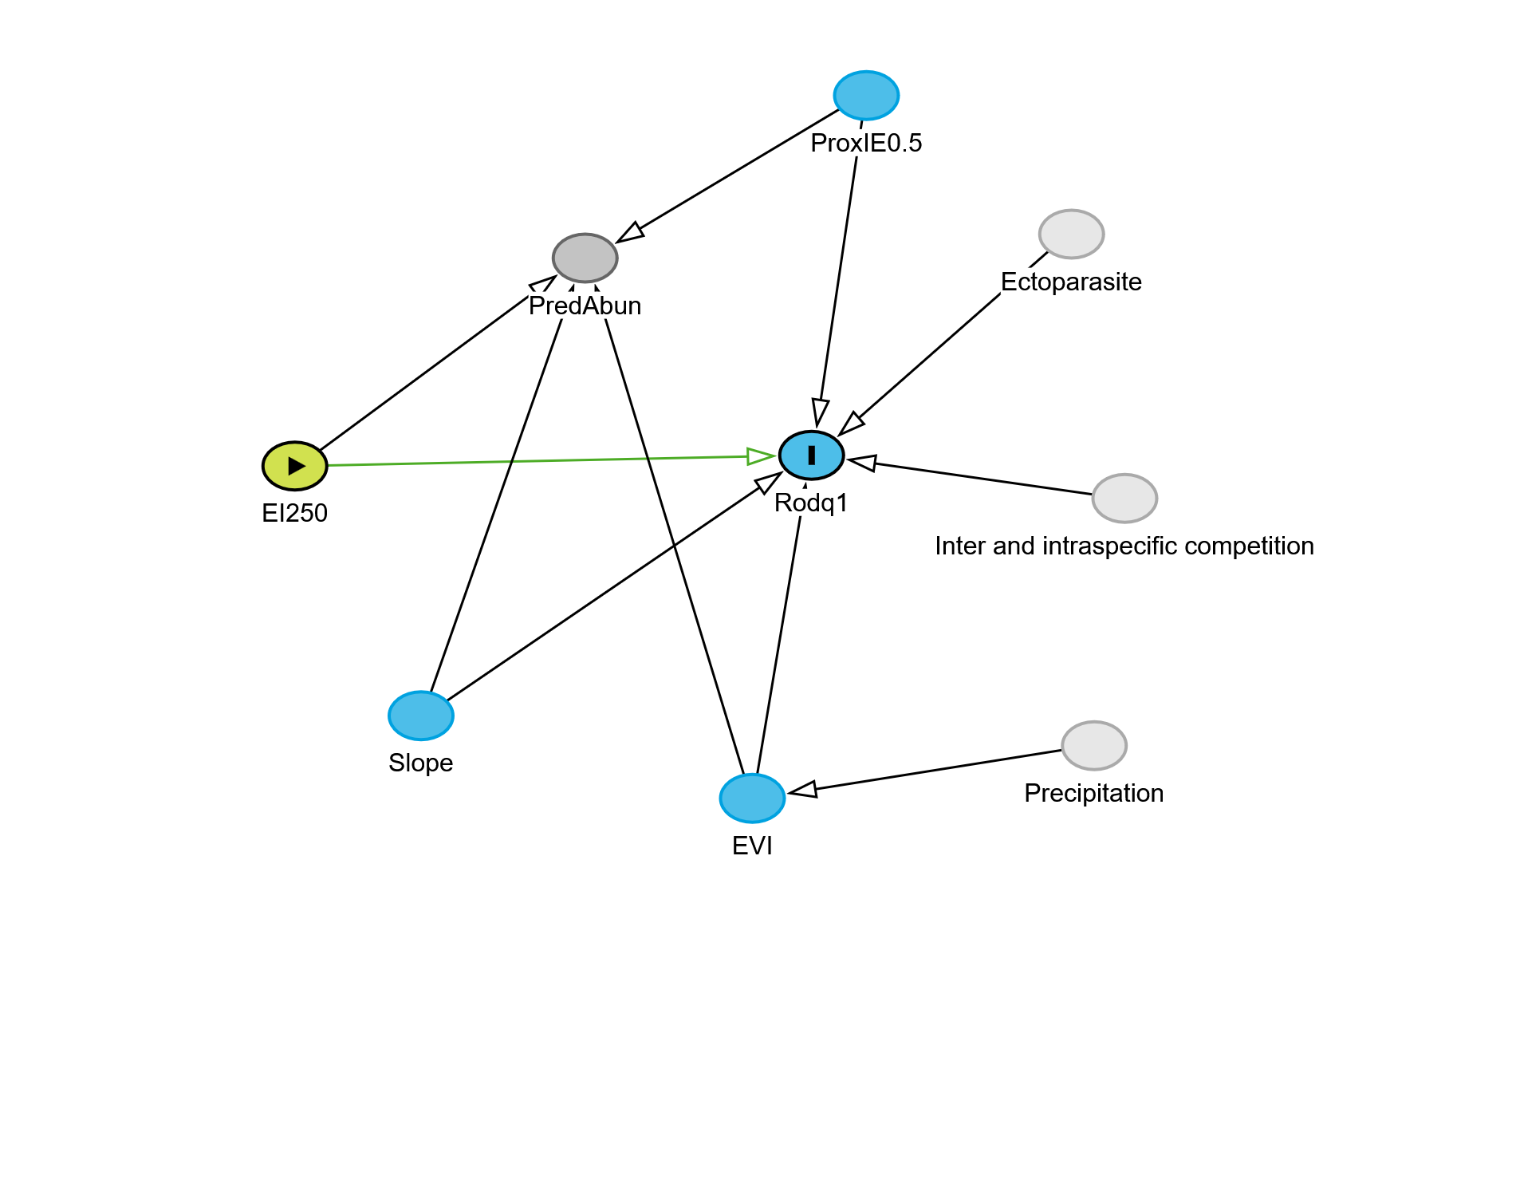
 | estimate | p.value | 2.5% | 97.5%
EI25 || EVI | -0.0679744 | 0.7789416 | -0.4977932 | 0.3867679
EI25 || PIE0 | 0.4496462 | 0.0458641 | 0.0088954 | 0.7647939
EI25 || Slop | -0.1866820 | 0.4360722 | -0.5863334 | 0.2789926
EVI || PIE0 | -0.4576689 | 0.0415207 | -0.7700264 | -0.0189951
EVI || Slop | -0.0155551 | 0.9488582 | -0.4563552 | 0.4309775
PrdA || Rdq1 | EI25, EVI, PIE0, Slop | 0.0580860 | 0.8339266 | -0.4519357 | 0.5417036
PIE0 || Slop | 0.1007422 | 0.6768359 | -0.3581357 | 0.5229205
Acá explicar para que se hace el ajuste del p-value
 | estimate | p.value | 2.5% | 97.5%
EI25 || EVI | -0.0679744 | 1.0000000 | -0.4977932 | 0.3867679
EI25 || PIE0 | 0.4496462 | 0.2906449 | 0.0088954 | 0.7647939
EI25 || Slop | -0.1866820 | 1.0000000 | -0.5863334 | 0.2789926
EVI || PIE0 | -0.4576689 | 0.2906449 | -0.7700264 | -0.0189951
EVI || Slop | -0.0155551 | 1.0000000 | -0.4563552 | 0.4309775
PrdA || Rdq1 | EI25, EVI, PIE0, Slop | 0.0580860 | 1.0000000 | -0.4519357 | 0.5417036
PIE0 || Slop | 0.1007422 | 1.0000000 | -0.3581357 | 0.5229205
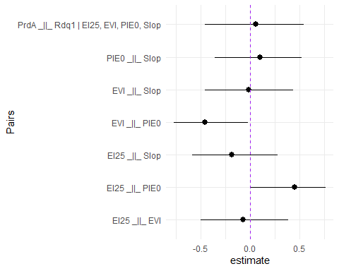

Modelos abundancia y diversidad basados en el DAG

Data —-
chap2 <- read.csv("~/INECOL/Doctorado/Proyecto2020/Capitulo 2/Analisis SEM/Data/dataSEM.csv", header = T)

Modelos candidatos
cand_Abun <- list(ModAbu1,ModAbu2,ModAbu3,ModAbu4,ModAbu5,ModAbu6)
names_Abun <- c("RodAbu~IE250",
"RodAbu~IE250+PredAbun",
"RodAbu~IE250+EVI",
"RodAbu~IE250+Slope",
"RodAbu~IE250+ProxIE0.5",
"RodAbu~IE250+ProxIE0.5+Slope+EVI"
)
##
## Model selection based on AICc:
##
## K AICc Delta_AICc AICcWt Cum.Wt LL
## RodAbu~IE250+ProxIE0.5 4 169.92 0.00 0.58 0.58 -79.62
## RodAbu~IE250 3 171.79 1.88 0.23 0.80 -82.15
## RodAbu~IE250+EVI 4 173.92 4.01 0.08 0.88 -81.63
## RodAbu~IE250+PredAbun 4 174.63 4.72 0.05 0.94 -81.98
## RodAbu~IE250+Slope 4 174.81 4.90 0.05 0.99 -82.07
## RodAbu~IE250+ProxIE0.5+Slope+EVI 6 177.43 7.51 0.01 1.00 -79.48

Test dispersión y Zero inflado

Modelo seis RodAbu~IE250+ProxIE0.5+Slope+EVI
testDispersion(ModAbu6)
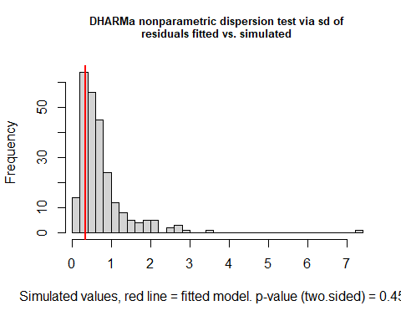
##
## DHARMa nonparametric dispersion test via sd of residuals fitted vs.
## simulated
##
## data: simulationOutput
## dispersion = 0.47024, p-value = 0.456
## alternative hypothesis: two.sided
ModAbu6_residuals <- simulateResiduals(ModAbu6)
plot(ModAbu6_residuals)
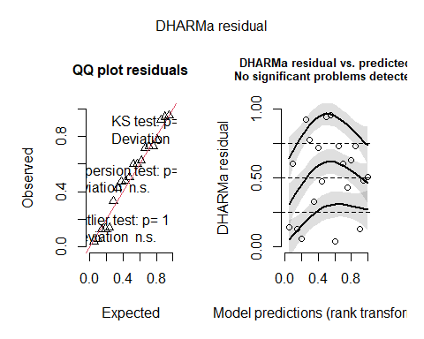
testZeroInflation(ModAbu6)
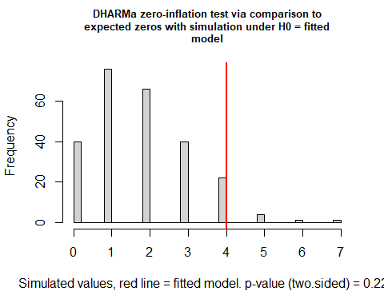
##
## DHARMa zero-inflation test via comparison to expected zeros with
## simulation under H0 = fitted model
##
## data: simulationOutput
## ratioObsSim = 2.2272, p-value = 0.224
## alternative hypothesis: two.sided

Modelo cinco RodAbu~IE250+ProxIE0.5
testDispersion(ModAbu5)
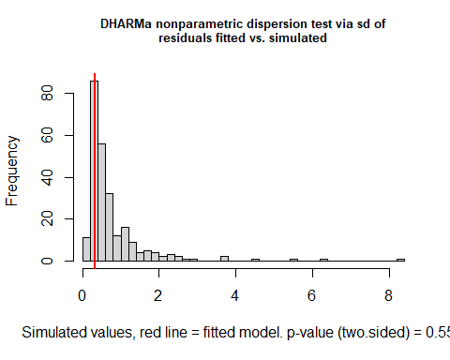
##
## DHARMa nonparametric dispersion test via sd of residuals fitted vs.
## simulated
##
## data: simulationOutput
## dispersion = 0.427, p-value = 0.552
## alternative hypothesis: two.sided
ModAbu5_residuals <- simulateResiduals(ModAbu5)
plot(ModAbu5_residuals)
## qu = 0.25, log(sigma) = -2.677313 : outer Newton did not converge fully.
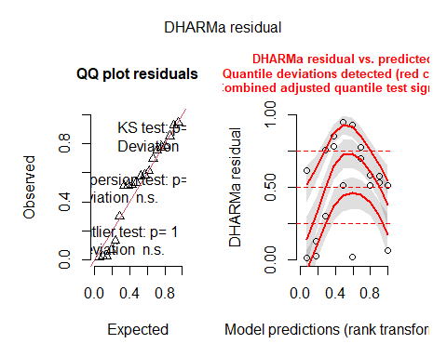
testZeroInflation(ModAbu5)
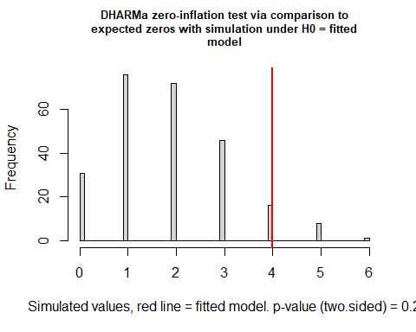
##
## DHARMa zero-inflation test via comparison to expected zeros with
## simulation under H0 = fitted model
##
## data: simulationOutput
## ratioObsSim = 2.1368, p-value = 0.2
## alternative hypothesis: two.sided

Modelo uno RodAbu~IE250
testDispersion(ModAbu1)
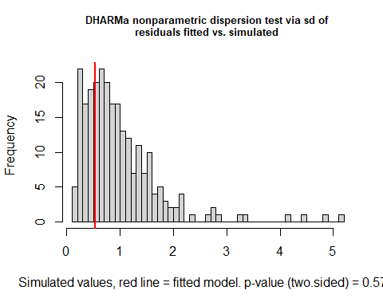
##
## DHARMa nonparametric dispersion test via sd of residuals fitted vs.
## simulated
##
## data: simulationOutput
## dispersion = 0.55293, p-value = 0.576
## alternative hypothesis: two.sided
ModAbu1_residuals <- simulateResiduals(ModAbu1)
plot(ModAbu1_residuals)
## qu = 0.5, log(sigma) = -2.404042 : outer Newton did not converge fully.
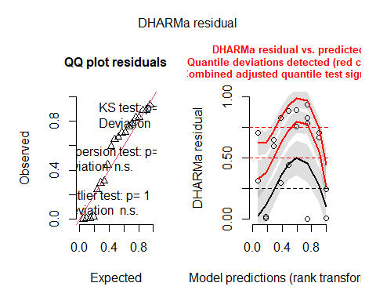
testZeroInflation(ModAbu1)
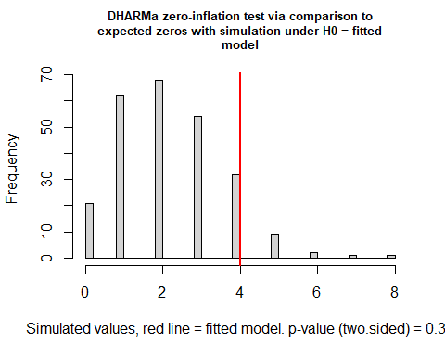
##
## DHARMa zero-inflation test via comparison to expected zeros with
## simulation under H0 = fitted model
##
## data: simulationOutput
## ratioObsSim = 1.7857, p-value = 0.36
## alternative hypothesis: two.sided

Diversity models
summary(ModDiv1 <- (glmmTMB(Rodq1~IE250, data = chap2, family = gaussian())))
## Family: gaussian ( identity )
## Formula: Rodq1 ~ IE250
## Data: chap2
##
## AIC BIC logLik -2*log(L) df.resid
## 76.6 79.5 -35.3 70.6 17
##
##
## Dispersion estimate for gaussian family (sigma^2): 1.99
##
## Conditional model:
## Estimate Std. Error z value Pr(>|z|)
## (Intercept) -0.3612 5.0594 -0.071 0.943
## IE250 2.9707 5.7897 0.513 0.608
summary(ModDiv2 <- (glmmTMB(Rodq1~IE250+Slope, data = chap2, family = gaussian())))
## Family: gaussian ( identity )
## Formula: Rodq1 ~ IE250 + Slope
## Data: chap2
##
## AIC BIC logLik -2*log(L) df.resid
## 78.5 82.5 -35.3 70.5 16
##
##
## Dispersion estimate for gaussian family (sigma^2): 1.99
##
## Conditional model:
## Estimate Std. Error z value Pr(>|z|)
## (Intercept) -0.115504 5.374775 -0.021 0.983
## IE250 2.822247 5.890610 0.479 0.632
## Slope -0.005601 0.041500 -0.135 0.893
summary(ModDiv3 <- (glmmTMB(Rodq1~IE250+EVI, data = chap2, family = gaussian())))
## Family: gaussian ( identity )
## Formula: Rodq1 ~ IE250 + EVI
## Data: chap2
##
## AIC BIC logLik -2*log(L) df.resid
## 74.2 78.2 -33.1 66.2 16
##
##
## Dispersion estimate for gaussian family (sigma^2): 1.6
##
## Conditional model:
## Estimate Std. Error z value Pr(>|z|)
## (Intercept) 2.862 4.766 0.601 0.5481
## IE250 2.190 5.204 0.421 0.6739
## EVI -5.462 2.474 -2.208 0.0273 *
## ---
## Signif. codes: 0 '***' 0.001 '**' 0.01 '*' 0.05 '.' 0.1 ' ' 1
summary(ModDiv4 <- (glmmTMB(Rodq1~IE250+Slope+EVI, data = chap2, family = gaussian())))
## Family: gaussian ( identity )
## Formula: Rodq1 ~ IE250 + Slope + EVI
## Data: chap2
##
## AIC BIC logLik -2*log(L) df.resid
## 76.1 81.1 -33.1 66.1 15
##
##
## Dispersion estimate for gaussian family (sigma^2): 1.6
##
## Conditional model:
## Estimate Std. Error z value Pr(>|z|)
## (Intercept) 3.221055 5.046096 0.638 0.5233
## IE250 1.976211 5.292155 0.373 0.7088
## Slope -0.007976 0.037202 -0.214 0.8302
## EVI -5.476976 2.472028 -2.216 0.0267 *
## ---
## Signif. codes: 0 '***' 0.001 '**' 0.01 '*' 0.05 '.' 0.1 ' ' 1
cand_Div <- list(ModDiv1,ModDiv2,ModDiv3,ModDiv4)
names_Div <- c("Rodq1~IE250",
"Rodq1~IE250+Slope",
"Rodq1~IE250+EVI",
"Rodq1~IE250+Slope+EVI"
)
AICc_Div <- aictab(cand_Div,
modnames = names_Div,
second.ord = T,
sort = T)

Test dispersión y Zero inflado

Modelo uno Rodq1~IE250
testDispersion(ModDiv1)
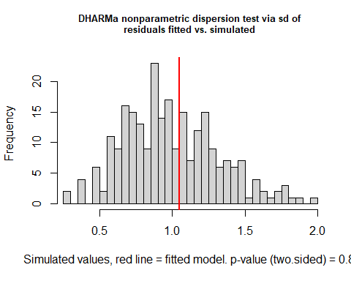
##
## DHARMa nonparametric dispersion test via sd of residuals fitted vs.
## simulated
##
## data: simulationOutput
## dispersion = 1.0585, p-value = 0.8
## alternative hypothesis: two.sided
ModDiv1_residuals <- simulateResiduals(ModDiv1)
plot(ModDiv1_residuals)
## qu = 0.75, log(sigma) = -3.142656 : outer Newton did not converge fully.
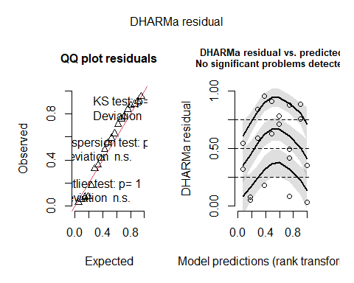
testZeroInflation(ModDiv1)
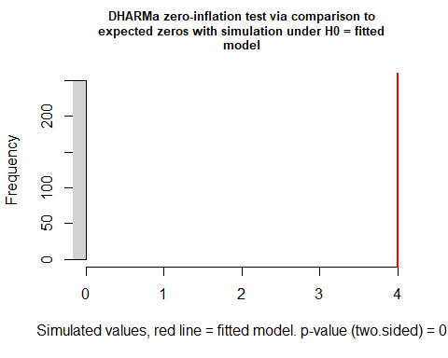
##
## DHARMa zero-inflation test via comparison to expected zeros with
## simulation under H0 = fitted model
##
## data: simulationOutput
## ratioObsSim = Inf, p-value < 2.2e-16
## alternative hypothesis: two.sided
testDispersion(ModDiv4)
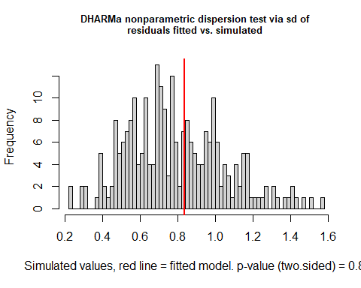
##
## DHARMa nonparametric dispersion test via sd of residuals fitted vs.
## simulated
##
## data: simulationOutput
## dispersion = 1.0585, p-value = 0.8
## alternative hypothesis: two.sided
ModDiv4_residuals <- simulateResiduals(ModDiv4)
plot(ModDiv4_residuals)
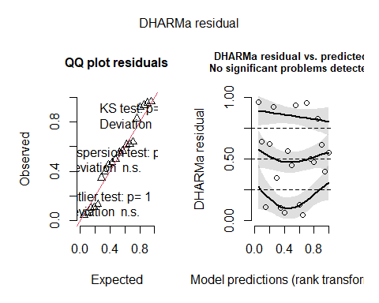
testZeroInflation(ModDiv4)
##
## DHARMa zero-inflation test via comparison to expected zeros with
## simulation under H0 = fitted model
##
## data: simulationOutput
## ratioObsSim = Inf, p-value < 2.2e-16
## alternative hypothesis: two.sided

