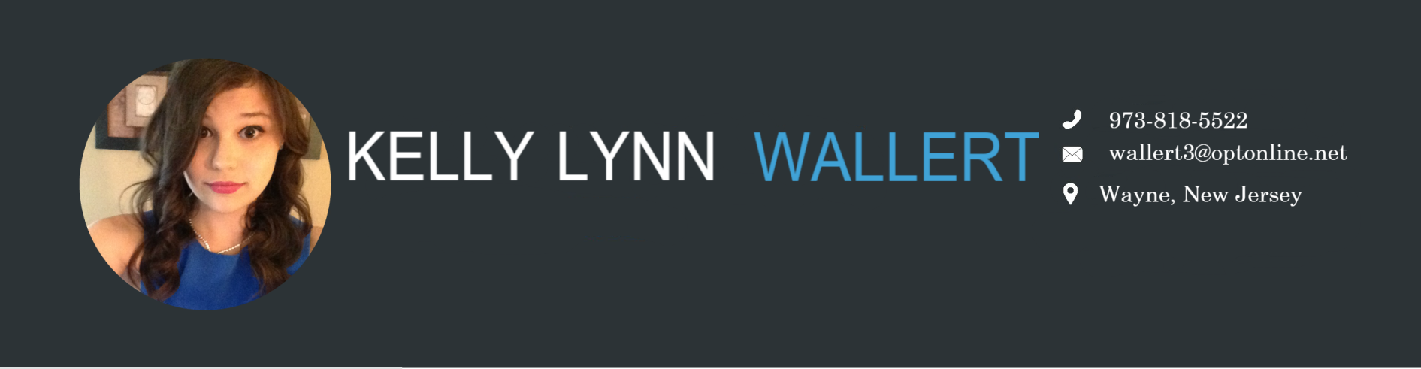

**MY EXPERIENCE**

## STEERING COMMITTEE NJ STEM GIRLS

Nov 2016 - Current

## WINNER OF THE THIRD ANNUAL CONGRESSIONAL APP CHALLENGE

Nov 2016

## CO- CAPTAIN OF JDROIDS Team 7026

## FIRST TECH CHALLENGE (robotics)

June 2016 – Current

**EDUCATION**

## WAYNE HILLS HIGH SCHOOL

Sept 2013 – June 2017

## THE NATIONAL SOCIETY OF HIGH SCHOOL SCHOLARS

Jan 2017 – Current



**) REFERENCES**

## RODNEY P FRELINGHUYSEN

## CONGRESS OF THE UNITED STATES

### 11th District, New Jersey

## LAURA HAFTEK

## OUR LADY OF CONSOLATION CHURCH

### Head of the Youth Ministry Program

## TODD GREEN

## WAYNE HILLS HIGH SCHOOL

### Calculus Teacher

### 

### JDroids 7026 Robotics Team: Co-Captain, Outreach Team, and Programmer

My role is to continuously improve the team's operating model, designated capability areas (communicate with the Programmers), and provide backup support to other capability areas (communicate with the Outreach Captain, Coaches, Mentors, and Treasurer). I also relay any information that I get from the Captain, and to work with him on making decisions on behalf of the team. For Outreach, I help get in contact with professionals to give us some helpful tips with how to improve our robot, create Team Spirit Activities, liase with other teams, and create a promotional video for the season.

### NJ STEM Girls: Membership and Steering Committee

As a member of NJ STEM Girls, I identify ways to encourage young girls to join the STEM community, teach them about programming, and understand what STEM is. As part of the Steering Committee, I help plan events for future STEM Girls events, and arrange outreach events.

### The Congressional App Challenge

I put together a team, where we created an application that won The Third Annual Congressional App Challenge. The application called Book Browser was designed to, benefit schools by allowing them to donate old used textbooks to underprivileged schools and communities. This application will be displayed with other winners of the competition on the House of Representatives webpage. Congress has scheduled a formal presentation ceremony on Capitol Hill on April 4, 2017.

### The National Society of High School Scholars

As part of the National Society of High School Scholars (NSHSS) I am part of a group of high-achieving scholars with a drive to succeed, and a desire to change their world for the better. NSHSS is proud to be an inclusive organization, drawing from a broad, diverse pool of students. They are committed to supporting our members by connecting them with opportunities to learn, lead and change the world.

### Vice President of the Wayne Hills Computer Club

We gather once a week to teach others how to code, and work on personal projects that can have a positive impact on the school, and get other students involved with STEM. Currently I am assisting in organizing a Teen Tech Help day that will be held at the high school to help the community with any of their technology based questions.

### Volunteer Work MY BEST SKILLS

### Computer Science

### Java

### HTML

### CSS

### VB

### C++/C#

### Leader

### Motivated

### Productive

### Antioch Retreat: Team Member and Leader

### CCD Assistance: Substitute Teacher

### Veteran’s Day Music (Flute and Trumpet Concert)

### Web Designer: Packanack Lake Club

