Some text

data placed here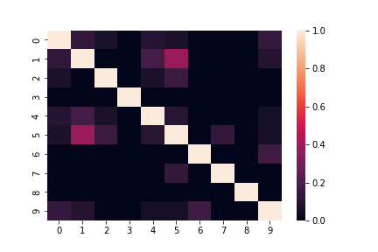

|  |  |  |  |  |  |  |  |  |  |
| --- | --- | --- | --- | --- | --- | --- | --- | --- | --- |
| 1.000000000000002 | 0.1340301154826311 | 0.07101088991116374 | 0.0 | 0.09788175684647928 | 0.07738232325341368 | 0.0 | 0.0 | 0.0 | 0.14387999942448 |
| 0.1340301154826311 | 1.0000000000000002 | 0.0 | 0.0 | 0.1825741858350554 | 0.3849001794597505 | 0.0 | 0.0 | 0.0 | 0.09759000729485333 |
| 0.07101088991116374 | 0.0 | 0.9999999999999996 | 0.0 | 0.07254762501100116 | 0.15294382258037448 | 0.0 | 0.0 | 0.0 | 0.0 |
| 0.0 | 0.0 | 0.0 | 1.0 | 0.0 | 0.0 | 0.0 | 0.0 | 0.0 | 0.0 |
| 0.09788175684647928 | 0.1825741858350554 | 0.07254762501100116 | 0.0 | 0.9999999999999999 | 0.10540925533894598 | 0.0 | 0.0 | 0.0 | 0.05345224838248488 |
| 0.07738232325341368 | 0.3849001794597505 | 0.15294382258037448 | 0.0 | 0.10540925533894598 | 1.0000000000000002 | 0.0 | 0.13608276348795434 | 0.0 | 0.0563436169819011 |
| 0.0 | 0.0 | 0.0 | 0.0 | 0.0 | 0.0 | 1.0 | 0.0 | 0.0 | 0.1690308509457033 |
| 0.0 | 0.0 | 0.0 | 0.0 | 0.0 | 0.13608276348795434 | 0.0 | 1.0000000000000002 | 0.0 | 0.0 |
| 0.0 | 0.0 | 0.0 | 0.0 | 0.0 | 0.0 | 0.0 | 0.0 | 1.0 | 0.0 |
| 0.14387999942448 | 0.09759000729485333 | 0.0 | 0.0 | 0.05345224838248488 | 0.0563436169819011 | 0.1690308509457033 | 0.0 | 0.0 | 1.0 |