Article
Predicting Vessel Time at Berth for Smart Berth Planning: A Machine-Learning Approach on a Governed Data Lakehouse at the Port of Sines
[Author details removed for double-blind peer review]

Abstract:
Accurate prediction of vessel time at berth is essential for smart berth planning, but berth-allocation research often treats processing time as a given input rather than a learned operational variable. This study develops a governed data lakehouse blueprint for port operational data and uses the prediction of vessel time at berth to demonstrate what openly available port records currently support, with the Port of Sines, Portugal, as a case study. Following a design science research approach, a medallion pipeline organised in Bronze, Silver and Gold layers was implemented twice from a single design — on a managed cloud platform and on open-source components on a single machine — to show that the architecture is portable rather than tied to one vendor. Four years of port administrative data (October 2020 to September 2024) were ingested and curated, yielding 8,148 berth visits across 6,550 vessel calls and 1,923 vessels. Under rolling-origin temporal validation across five cut-offs, a Random Forest regressor attained a mean R2 of 0.260 with a mean absolute error of 10.1 h, against 13.5 h for the median-stay heuristic a planner would otherwise use, and predicted 52.6% of calls within a six-hour tolerance. SHapley Additive exPlanations identified the vessel's own previous stay, the berth and vessel size as the strongest predictors. Quantitative measurement of the pipeline shows near-linear scaling and a hundredfold query speed-up over recomputation from raw sources. Predictive accuracy remains bounded by the absence of exogenous operational variables; the contribution is the evidence that a governed, portable lakehouse can be operated at negligible cost and provides the data foundation that predictive berth planning would require.

Keywords: Smart Ports; Lakehouse Architecture; Maritime Data Analytics; Data Governance; Data Integration; Digital Transformation.

1. Introduction
Container ports are critical nodes of global supply chains and operate within a data environment defined by growing volume, velocity and variety, as sensors, administrative systems and automatic identification platforms generate continuous records of vessel and cargo activity [1]. Under sustained pressure to raise throughput while containing cost and environmental impact, port authorities increasingly pursue the Smart Port model, in which digital technologies and analytics coordinate operations, improve resource utilisation and support evidence-based management [2]. International policy reviews reinforce this direction, urging the sector to accelerate digitalisation and to adopt advanced analytics to remain competitive and sustainable [3].
A central operational problem in container terminals is berth planning, which determines when and where arriving vessels are accommodated along the quay. Improving berth occupancy prediction contributes directly to terminal efficiency, vessel turnaround, resource allocation, and overall port logistics performance, as more reliable estimates of berth occupancy allow terminal operators to optimise infrastructure utilisation and reduce operational uncertainty. Decades of operations research have framed berth allocation and the related quay-crane scheduling as combinatorial optimisation problems, producing a substantial body of exact and heuristic methods [4-6]. These approaches optimise allocation given assumed processing times, but they depend on reliable estimates of how long each vessel will occupy a berth. Accurate, data-driven estimation of vessel time at berth is therefore a prerequisite for effective planning, yet it has received comparatively little attention relative to the scheduling formulations it supports. This study takes that estimation problem as its primary focus and asks how far vessel time at berth can be predicted from routinely collected operational data.
Realising such data-driven analytics requires a data platform able to integrate heterogeneous operational records and to serve both reporting and machine-learning workloads from a consistent, governed foundation. Smart Port environments are characterised by heterogeneous sources, fragmented information systems and complex stakeholder ecosystems, so the value of operational data depends not only on its availability but also on its integration, quality and governance. The data lakehouse has emerged as a candidate architecture for this purpose: it implements data-warehouse capabilities (transactional consistency, schema enforcement and governance) directly on low-cost object storage holding data in open formats, thereby serving diverse workloads from a single copy of the data [7]. Although the lakehouse has attracted rapid academic and industrial interest, evaluations in operational maritime settings remain scarce; the vessel data lakehouse of Park et al. is among the few maritime instances reported [8].
This study addresses the resulting gap at the intersection of two fields: the maritime operations literature, which has not widely adopted data-driven estimation of berth occupation, and the data-engineering literature, which has not extensively evaluated the lakehouse in port environments. The overarching aim is to determine whether routinely collected open port data can support reliable, interpretable prediction of vessel time at berth, and to build the governed data foundation that such prediction requires. The research is therefore guided by one central question: how accurately can vessel time at berth be predicted from open operational data, and which operational factors drive that prediction? To answer it, and following a design science research methodology [9], the work pursues two coupled and explicitly defined objectives. The first and primary objective is to develop and evaluate, on real operational data, a machine-learning model that predicts vessel time at berth, and to identify through interpretability analysis the operational factors that most influence it. The second and enabling objective is to design, implement and assess a scalable, governed data lakehouse that integrates a Smart Port data ecosystem from heterogeneous open sources, using open-source technologies on a managed cloud platform. These objectives are pursued at the Port of Sines, the largest Portuguese port by cargo volume and one of Europe’s fastest-growing container hubs.
The contributions are threefold. First, the study provides a replicable and portable reference architecture for integrating and governing heterogeneous Smart Port data, implemented from one design on both a managed platform and open-source components, and validated with measured throughput, storage and query performance rather than qualitative assertion. Second, it offers an empirical and honestly reported evaluation of machine learning for berth-occupation estimation under temporal validation, with an interpretability analysis that links the prediction to operational drivers and connects the data-engineering and operations-research literatures on berth planning. Third, it reports practical data-acquisition and data-quality lessons relevant to other ports pursuing analytics initiatives, including a documented case in which the governed pipeline detected a structural collapse in the completeness of an administrative field.

2. Related Work

2.1. Smart Ports and Data-Management Challenges
Ports act as critical nodes connecting maritime transport with international supply chains. As operations grow more complex, port authorities face pressure to improve efficiency, sustainability, resilience and competitiveness, and digital transformation has become a strategic priority across the sector, driven by artificial intelligence, the Internet of Things, automation and advanced analytics [3]. These developments underpin Smart Port initiatives, in which digital technologies enhance operational visibility, resource utilisation and decision-making, and in which information becomes a strategic asset rather than a by-product of operations [2].
The increasing digitalisation of port environments produces data ecosystems characterised by large volumes of structured, semi-structured and unstructured data originating from vessel movements, berth operations, cargo handling, logistics services and administrative systems. The growing availability of data does not, however, translate automatically into better decisions. Smart Port data are typically distributed across independent systems and stakeholders, creating challenges of integration, quality assurance, governance and analytical exploitation. Traditional data warehouses, designed for structured data and fixed resources, accommodate this diversity poorly, while reliance on raw storage alone tends to reproduce data silos and quality problems. The success of Smart Port initiatives therefore depends not only on data collection but on data architectures capable of managing information across its lifecycle, thereby ensuring consistency, lineage and controlled access, so that heterogeneous records can be turned into trustworthy analytical assets [10].

2.2. Evolution of Data Architectures: From Warehouses to Lakes to the Lakehouse
The architecture proposed in this study is best understood against the evolution of enterprise data platforms (Figure 1). Data warehouses provide reliable, governed analytics on structured data through schema-on-write and ACID transactions, but they scale poorly and at high cost to the volume and variety of contemporary data and are ill-suited to raw or machine-learning workloads [11]. Data lakes responded with inexpensive, schema-on-read object storage for heterogeneous data, gaining scale and flexibility but losing the transactional consistency, quality controls and governance required for dependable analytics; without disciplined management they degrade into unreliable “data swamps” [10]. Maintaining warehouse and lake in parallel introduces duplication, latency and governance complexity.
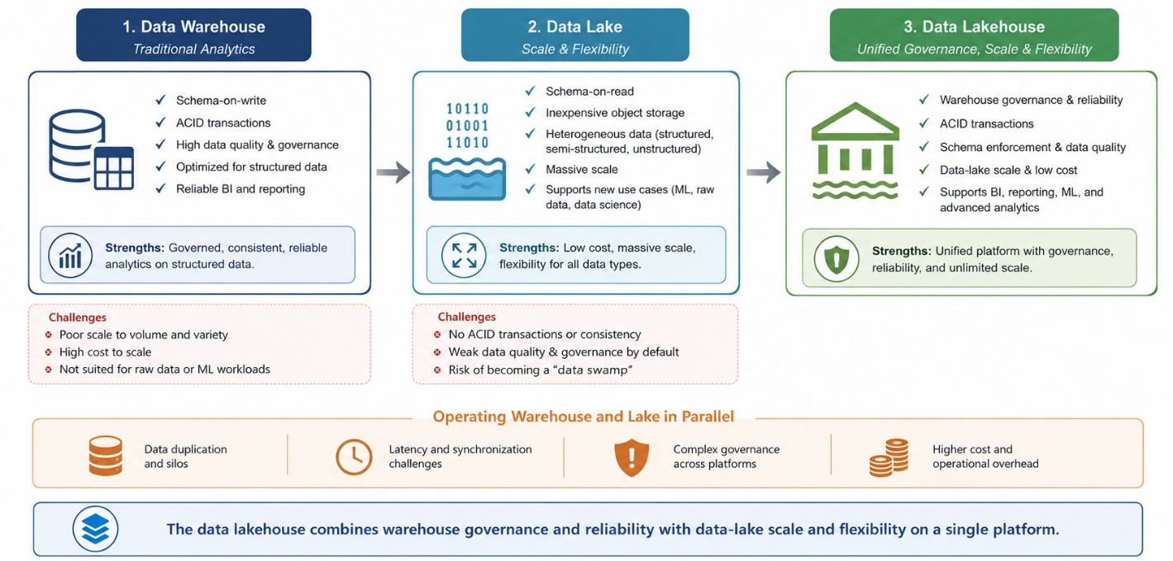
Figure 1. Evolution of enterprise data architectures. The data lakehouse combines warehouse governance and reliability with data-lake scale and flexibility on a single platform.
The data lakehouse was formalised to resolve this tension by implementing warehouse functions (ACID transactions, schema enforcement and governance) directly on low-cost object storage holding data in open file formats, thereby serving diverse workloads from a single copy of the data [7]. Recurring technical enablers include a transactional metadata layer over open table formats that provides ACID semantics, schema evolution and time travel [12]; centralised governance, lineage and access control; and the separation of storage and compute, which lets each resource scale independently and underpins the cloud cost model [13]. By consolidating structured, semi-structured and unstructured data within one governed environment, the lakehouse reduces data silos and supports reporting, business intelligence, data science and machine learning without duplicating data across systems [14-15].

2.3. Berth Planning and the Prediction of Vessel Time at Berth
Berth allocation and quay-crane scheduling are among the most studied problems in container-terminal operations. Successive surveys document a large body of exact and heuristic optimisation methods that allocate berths and cranes to minimise objectives such as total service time or tardiness [4-6]. A common assumption in these formulations is that vessel processing (or handling) time is a known input. In practice, time at berth is uncertain and shaped by cargo type, equipment and labour availability, weather and tidal windows. The data-driven estimation of berth occupation that would supply realistic inputs to these planners has received far less attention than the scheduling formulations themselves. This study addresses that imbalance by treating vessel time at berth as a prediction target learned from routinely collected operational data, and by examining which operational factors drive it.

2.4. The Lakehouse in Practice: Thematic Synthesis and Research Gap
To situate the enabling architecture, a bibliometric and thematic review was conducted on a corpus of 123 documents retrieved from the Scopus database for the term “data lakehouse” and closely related terms, covering 2021 to early 2026 [16]. The scientific output on data lakehouse architectures has grown rapidly: annual production rose from four documents in 2021, the year the concept was formalised [7], to 49 in 2025, and more than nine in ten documents were published in 2023 or later (Figure 2). The partial 2026 count reflects early-access items indexed at the retrieval date and understates the eventual total, so the growth should be read descriptively, as evidence of rising scholarly attention rather than of architectural maturity or practical adoption.
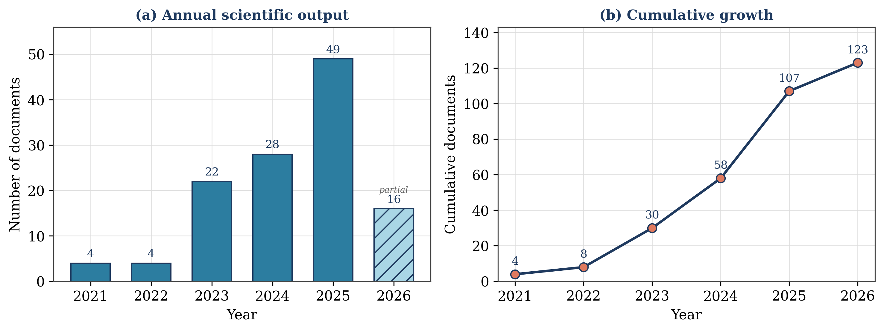
Figure 2. Scientific output on data lakehouse architectures (Scopus, n = 123): (a) annual number of documents, with 2026 shown as a partial count; (b) cumulative growth.
Citation impact is highly skewed, with the foundational definition of Armbrust et al. alone accounting for roughly one third of all citations in the corpus. Evidence is dominated by conceptual and proof-of-concept work disseminated through conference venues rather than independent evaluations in production environments. A thematic reading of the most influential works organises the literature into five overlapping clusters (Table 1).
Table 1. Principal thematic clusters identified in the data lakehouse literature.
Cluster | Focus | Representative works
Foundational architecture and concepts | Definition, components, comparative positioning | [7,11,14,17-18]
Governance, data quality and metadata | Transactions, lineage, security, access control | [17,12,19]
Advanced analytics, AI and machine learning | BI, data science and ML on a single governed copy | [7-8,20]
Domain and spatial/temporal applications | Spatial, temporal, IoT and maritime adaptations | [8,21-24]
Emerging organisational paradigms | Relation to data mesh, data fabric, multi-cloud | [14,25-26]

Three observations define the gap addressed here. First, the literature is conceptually rich but empirically thin: a stable definition and a recognised set of components exist, yet independent evaluations in production environments are scarce. Second, governance and the management of heterogeneous data are identified as the central value proposition, but few studies provide empirical evidence of governance outcomes in practice; industrial reports of large-scale modernisation illustrate adoption at scale but are not independent evaluations [27]. Third, domain coverage is uneven: the maritime and port-logistics context, characterised by heterogeneous, multi-stakeholder operational data, is represented by only isolated contributions [8]. The present study responds by evaluating a data lakehouse in a real Smart Port setting where data integration, governance and analytical exploitation are simultaneously required, and by using it to support an interpretable predictive task of direct operational relevance.

3. Materials and Methods
This section describes the research design, the study site, the data sources and ingestion procedure, the data lakehouse architecture and technology stack, the medallion data pipeline, and the predictive modelling procedure. All processing was performed on a single managed cloud cluster, and the implementation followed established software-engineering practices, with version control and structured workflows to support reproducibility and reuse. The results of applying this procedure are reported separately in Section 4.

3.1. Research Design
The work follows design science research (DSR), an established paradigm in information systems and computer science that creates and evaluates an artefact to address a practical problem through a structured, iterative process [9]. DSR is well suited to this study because it links scientific rigour to engineering relevance. Six phases were applied (Figure 3). Phase 1 (problem identification) established, through the review of Section 2, the converging gaps in machine learning for berth planning and in scalable port data architectures. Phase 2 (solution objectives) defined the requirements: ingest, transform and serve heterogeneous port data; enforce quality and consistency through ACID-compliant storage; provide centralised governance; and support the end-to-end lifecycle of a predictive model. Phase 3 (design and build) implemented the artefact. Phase 4 (demonstration) applied it to real operational data. Phase 5 (evaluation) assessed data quality, model performance and interpretability. Phase 6 (communication) is realised through this paper.
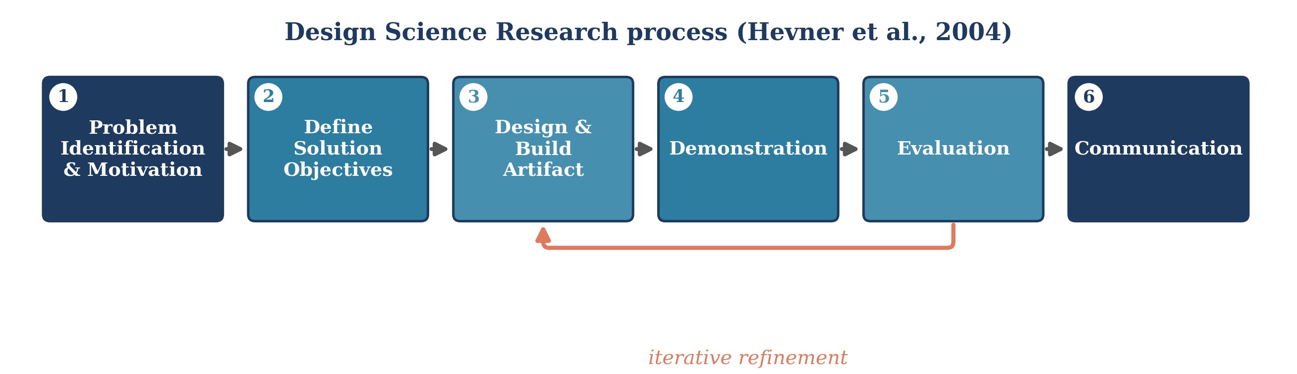
Figure 3. The six-phase design science research process applied in this study, with iterative refinement between evaluation and design.

3.2. Study Site: The Port of Sines
The Port of Sines, on the southwest coast of Portugal, is the national leader in total cargo handled and the country’s principal container port. Its deep-water access, with natural depths reaching 28 m, allows it to receive large vessels and to connect directly to major international shipping routes [28]. The port comprises specialised terminals for liquid bulk, petrochemicals, multipurpose cargo, liquefied natural gas, and containers (Terminal XXI). In 2024 the port handled a record 1.9 million twenty-foot equivalent units (TEU) and 47.8 million tonnes of cargo, and over the preceding decade the container terminal grew at an average annual rate of about 14.7% [28]. This combination of operational scale and rapid growth makes the port a representative and demanding setting in which data-driven planning carries material consequences, making it an appropriate setting for evaluating a governed data platform.

3.3. Data Sources and Ingestion
Operational data were obtained from the Janela Unica Logistica (JUL) administrative service of the Sines and Algarve Port Authority, which records every vessel call at the port. Four source extracts were ingested (Table 2): the reporting-point log, which timestamps each berthing, unberthing, anchoring and pilot-boarding event and is the basis for the target variable; the ship-particulars register, keyed by IMO number; the operations report, which documents equipment and cargo handling; and the manifested-tonnage table, which records the cargo volume declared for each call. The extracts cover October 2020 to September 2024.
Table 2. Source extracts ingested from the APS Janela Unica Logistica, October 2020 to September 2024. Record counts are those observed at ingestion.
Dataset | Description | Records
Reporting Point | Berthing, unberthing, anchoring and pilot events per call | 36,773
Ship Particulars | Vessel characteristics, keyed by IMO number | 8,671 IMO
Operations Report | Equipment and cargo-handling records per call | 1,171
Manifested Tonnage | Cargo tonnage declared for each vessel call | 5,545 calls
Vessel calls (derived) | Calls reconstructed from the reporting-point log | 6,631
IMO, International Maritime Organization vessel identifier. Vessel calls are not a delivered table; they are reconstructed in the Silver layer by pairing reporting-point events.

3.4. Data Lakehouse Architecture and Technology Stack
The artefact is a medallion lakehouse pipeline specified independently of any particular platform, and then realised twice to demonstrate that the design, rather than the vendor, carries the contribution. The first realisation uses a managed cloud analytics platform with Spark, Delta Lake and a unified catalogue; the second uses only open-source components on a single machine, with Parquet for storage, pandas for processing and a local MLflow store for experiment tracking. Table 4 maps each architectural concern onto the two substrates. Layer semantics, lineage and quality controls are identical in both; what changes is the execution engine and the degree to which governance is automated. This portability matters practically, because it lets a port authority adopt the design at the scale it can afford and migrate later without redesigning the pipeline. Table 3 reports the Python version and the main libraries used in the analysis.
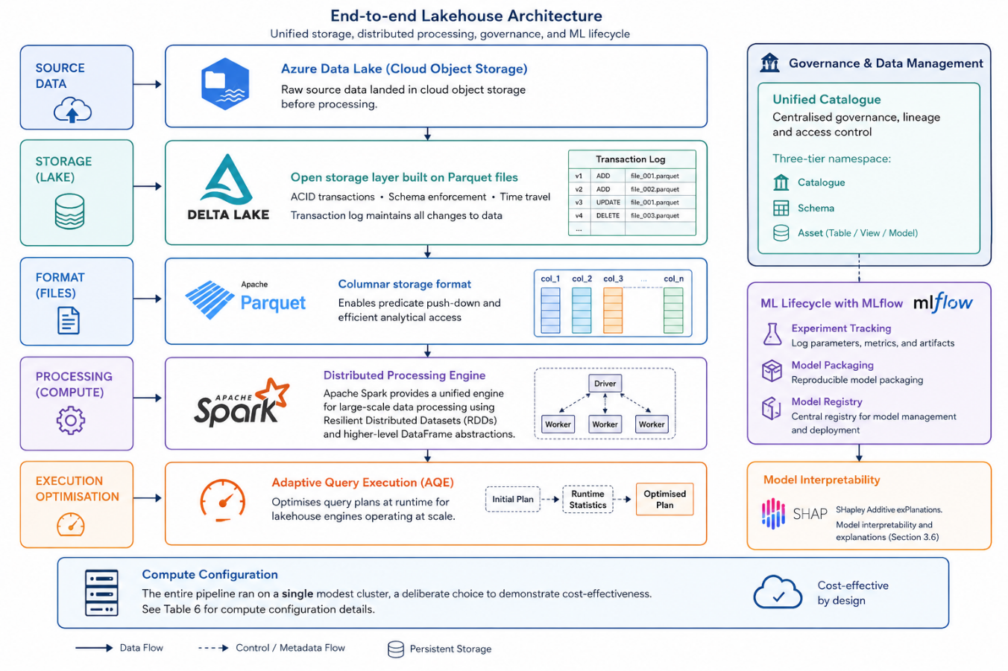
Figure 4. End-to-end data lakehouse architecture for the Smart Port data ecosystem, from open-data sources through ingestion and the governed lakehouse platform to analytical consumption.
Table 3. Python version and main libraries used in the analysis.
Component | Version / libraries
Python | Python >=3.11; executed on runtime Python 3.12.3
Data handling | pandas >=2.2.3; numpy >=2.2.6; pyarrow >=20.0.0
Modelling | scikit-learn >=1.6.1; Optuna >=4.3.0; joblib >=1.5.1
Interpretability | SHAP >=0.47.2
Visualization | matplotlib >=3.10.3; seaborn >=0.13.2

Table 4. The medallion blueprint realised on two substrates. Layer semantics, lineage and quality controls are preserved across the substitution; the execution engine and the degree of automated governance differ.
Architectural concern | Managed platform | Open-source, single node
Storage format | Delta Lake | Apache Parquet
Processing engine | Apache Spark | pandas / DuckDB
Catalogue and lineage | Unified catalogue | Directory layout and schema manifest
Layer semantics | Bronze / Silver / Gold | Bronze / Silver / Gold
Experiment tracking | Managed MLflow | Local MLflow
Orchestration | Platform workflows | Python entry points
Quality controls | Table constraints | Bounds and quarantine in Silver
Reproducibility | Table versioning | Immutable dated snapshots

3.5. Medallion Data Pipeline
Data were progressively refined through a medallion pipeline organised as a directed acyclic graph of three layers (Figure 5). The Bronze layer ingests raw records with minimal transformation, parsing timestamps, standardising column names and recording the source file and ingestion time so that lineage is preserved. The Silver layer performs quality assessment and cleansing: berthing and unberthing events are paired into berth visits by an ordered scan within each call, since a single call may involve several berth occupations; values falling outside physical bounds are quarantined rather than silently dropped; port service craft are separated from commercial calls; and field completeness is profiled and written out so that changes in data delivery are detectable. The Gold layer produces the analytics-ready table by joining vessel particulars on the IMO number and manifested tonnage on the call identifier, and by engineering the modelling features. The principal Gold output is an analytical table of vessel time at berth consumable directly by exploratory analysis, business-intelligence tools and the machine-learning model.
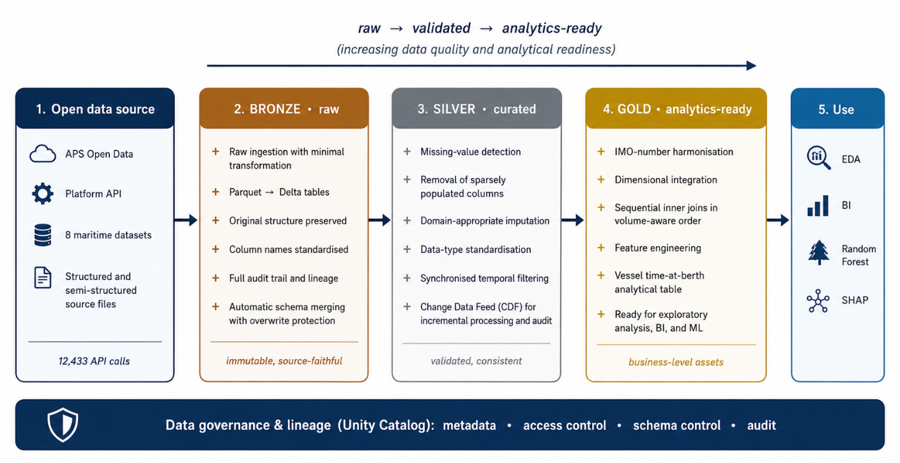
Figure 5. Medallion data pipeline. Open operational data are ingested into the Bronze layer (raw), cleansed and standardised in the Silver layer (curated) and integrated into analytics-ready Gold datasets under centralised governance and lineage; the Gold tables feed exploratory analysis, business intelligence and the Random Forest model with SHAP interpretation.

3.6. Predictive Modelling and Interpretation
Vessel time at berth was modelled with a Random Forest regressor, an ensemble method that aggregates many decision trees, each trained on a bootstrap sample of the data and on a random subset of features at each split [34]. This dual randomisation decorrelates the trees and reduces variance relative to a single tree, yielding robust predictions that are comparatively insensitive to noise and outliers [35-36]. The target variable, time at berth, is the interval between the berthing and unberthing reporting points recorded for each berth occupation, and is modelled on a logarithmic scale to accommodate its pronounced right skew; all reported metrics are back-transformed and expressed in hours.
Feature admissibility follows a single rule: a variable may enter the model only if its value is known at the moment the vessel takes the berth. This excludes every quantity measured at or after departure, including the total duration of the port call, which contains the target and is therefore not a predictor but a restatement of the answer. Two legitimate waiting measures are retained, both fully observed at berthing: the hours elapsed between port entry and berthing, and the hours spent at anchorage. The strictly lagged duration of the same vessel's previous berth stay is also included. Features are grouped into three tiers: vessel particulars and berth context, which are always available; the vessel's own call history; and manifested cargo tonnage, which the port holds in advance but does not publish consistently, and which is therefore reported separately so that its contribution can be measured.
Two validation protocols are reported because they answer different questions. Rolling-origin temporal validation trains on all observations preceding a cut-off and tests on the following six months, repeated at five cut-offs between July 2022 and April 2024; this reproduces the deployment condition, in which the future is always predicted from the past, and shows whether a result depends on one fortunate split. Vessel-grouped validation holds out entire vessels, so that no ship appears in both training and test partitions; this measures generalisation to previously unseen vessels and is preferred over discarding repeated calls, which costs sample size without improving validity. Hyperparameters were selected with Optuna over 25 trials per model family, minimising mean absolute error in hours on a validation period that strictly precedes the test period, so that no future information reaches model selection; every family received an identical trial budget so that the comparison between them reflects performance rather than search effort. For the tree ensembles the search covered the number of trees (200 to 900), maximum depth (6 to 40), minimum samples per leaf (1 to 20) and per split (2 to 20), and the fraction of features sampled at each split (0.2 to 1.0); for the boosting families it covered the number of iterations, the learning rate, tree size and regularisation strength. The selected Random Forest configuration was 500 trees, maximum depth 30, a minimum of eight samples per leaf and five per split, and 0.57 of the features sampled at each split. Final models were refitted on the combined training and validation periods. Performance is reported as R2, root-mean-square error, mean and median absolute error in hours, and the share of calls predicted within stated tolerances. SHAP was used to interpret the fitted model [37].
Use of generative AI. A generative artificial-intelligence assistant (a large language model) was used to support the drafting, structuring and language editing of this manuscript. It was not used to generate, process or interpret the operational data, to design or implement the data lakehouse architecture, or to produce the analytical results, which are the author’s own work. The author reviewed and verified all AI-assisted text and takes full responsibility for the content of the manuscript.

4. Results

4.1. Data Profile and Quality
The ingested reporting-point log contained 36,773 events across 6,631 vessel calls and 1,963 distinct IMO numbers. Pairing berthing with unberthing events produced 8,205 berth visits, of which 8,180 lasted no longer than 336 h; removing port service craft left 8,148 visits across 6,550 calls and 1,923 vessels, which constitute the modelling population (Figure 6). Vessel particulars were matched for 97.7% of visits and manifested tonnage for 83.6%. Assessment of completeness revealed one materially non-random pattern: manifested tonnage is 94% to 99% complete between 2020 and 2023 but only 29.1% complete in 2024. This is a change in the administrative delivery of the extract rather than a random process, and it demonstrably degrades any model that depends on the field, which is why manifested cargo is reported as a separate feature tier rather than pooled into the main specification. The episode also illustrates a governance point: missingness in port administrative data is structural, complete-case deletion therefore biases the retained sample toward routine and fully documented calls, and detecting such drift is a function the curated pipeline performs automatically rather than an assumption the analyst must make.

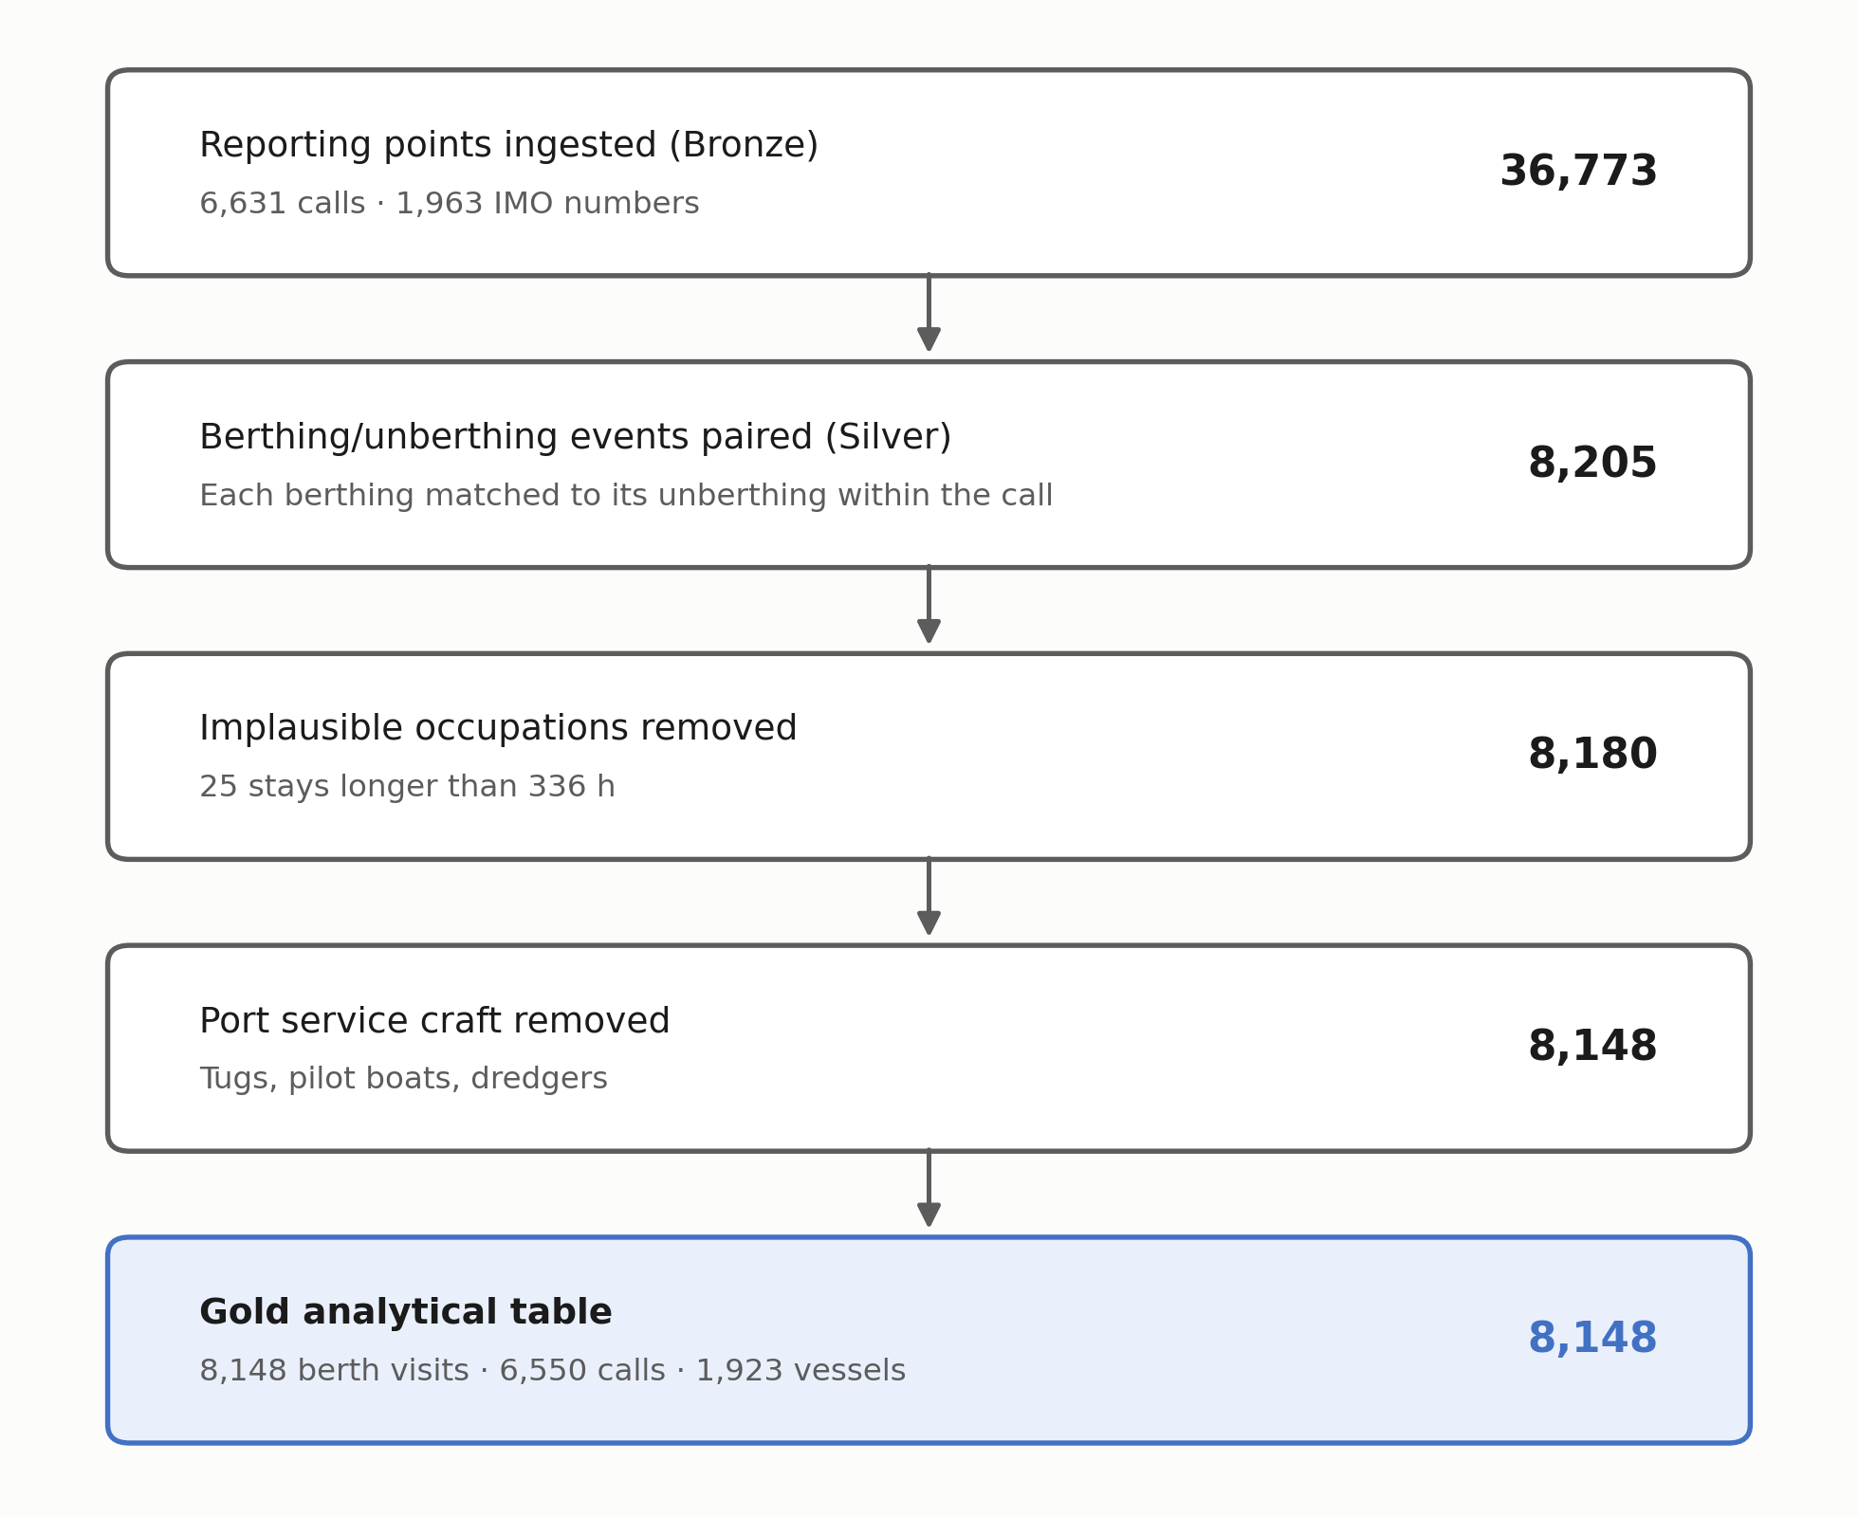
Figure 6. Records retained at each stage of the medallion pipeline, from ingested reporting points to the Gold analytical table.
Categorical analysis revealed strongly imbalanced operational patterns (Table 5). Container ships and chemical or product tankers dominate the vessel mix, and activity concentrates at the liquid-bulk terminal and Terminal XXI, with a long tail of rare vessel types and locations. Among numerical vessel attributes, deadweight, gross tonnage, length overall and beam are strongly intercorrelated, consistent with naval-architecture expectations and indicating redundancy among size descriptors that the ensemble model accommodates without difficulty.
Table 5. Most frequent categories for the principal operational variables, translated from the source records.
Variable | Leading categories (count)
Vessel type | Container ships; chemical and product tankers; LPG carriers
Location | Liquid-bulk terminal (6,928); Terminal XXI (6,116); multipurpose (2,000)
Berth visits per call | One visit in most calls; 1,655 calls involve more than one berth occupation

4.2. Vessel Time at Berth
Berthing and unberthing were the most frequent events in the reporting-point log, each occurring slightly more than eight thousand times, confirming that the dataset is well suited to characterising berth occupancy. The distribution of time at berth is strongly right-skewed (Figure 7): the first quartile is 13.9 h, the median 21.9 h and the third quartile 32.6 h, while the mean of 26.9 h exceeds the median and the standard deviation reaches 23.4 h. The dispersion of the target is thus of the same order as the target itself, which is precisely what makes berth occupation difficult to anticipate and motivates a predictive treatment.
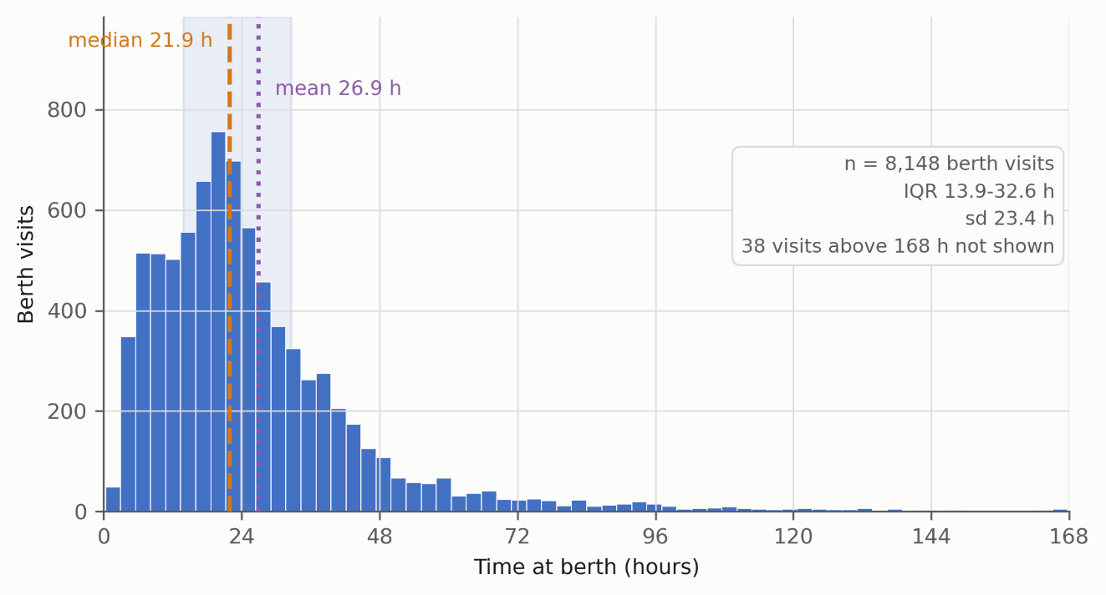
Figure 7. Distribution of vessel time at berth across 8,148 berth visits, restricted to stays of up to 168 h for display. The box summarises the quartiles, the dashed lines mark the median and the mean.

4.3. Model Benchmark and Random Forest Performance
Four tree-ensemble families were compared under identical conditions: the same feature set, the same temporal partition, and an identical Optuna budget of 25 trials each, tuned on a validation period preceding the test period (Table 6). The families are statistically indistinguishable. Tuned R2 spans 0.251 to 0.279 and mean absolute error spans 10.4 h to 10.6 h, differences that fall within the seed-to-seed variation of any single model. Tuning itself changes little: Random Forest attains R2 = 0.272 with default settings and 0.270 after search. An earlier untuned comparison on a random split had suggested a substantially higher score for the Extra Trees regressor; that advantage does not survive tuned, temporally validated comparison and is attributable to the untuned single-seed protocol. Random Forest is therefore retained for detailed evaluation and interpretation not because it is more accurate, which it is not to any meaningful degree, but because it exhibited the lowest seed-to-seed variance in the panel, provides a native out-of-bag estimate, and admits exact tree-path SHAP attribution.
Table 6. Benchmark of regression model families for predicting time at berth, evaluated on the held-out test period (from January 2024) and averaged over three seeds.
Model family | Tuning | R2 | RMSE (h) | MAE (h) | Median AE (h) | Within 6 h
Gradient Boosting | Optuna | 0.279 | 19.5 | 10.5 | 5.8 | 51.5%
Random Forest | Optuna | 0.270 | 19.6 | 10.4 | 5.7 | 52.1%
HistGradientBoosting | Optuna | 0.259 | 19.8 | 10.6 | 5.9 | 50.6%
Extra Trees | Optuna | 0.251 | 19.9 | 10.5 | 5.7 | 52.3%
Random Forest | Defaults | 0.272 | 19.6 | 10.5 | 5.8 | 51.1%
Extra Trees | Defaults | 0.269 | 19.7 | 10.5 | 5.7 | 51.5%
HistGradientBoosting | Defaults | 0.264 | 19.7 | 10.8 | 6.0 | 49.8%
Gradient Boosting | Defaults | 0.249 | 19.9 | 10.9 | 6.0 | 49.8%

AE, absolute error. Training period before July 2023; validation July to December 2023; test from January 2024 (5,368 / 1,111 / 1,669 berth visits). Final models were refitted on the combined training and validation periods.

Under rolling-origin validation the Random Forest regressor attained a mean R2 of 0.260 with a standard deviation of 0.023 across the five cut-offs, a mean absolute error of 10.11 h with a standard deviation of 0.27 h, and predicted 52.6% of berth visits within six hours (Figure 8). The narrow spread indicates that the result does not depend on the particular partition chosen. On the single held-out test period from January 2024 the model attained R2 = 0.270, a root-mean-square error of 19.6 h, a mean absolute error of 10.4 h and a median absolute error of 5.7 h (Table 7). Under vessel-grouped validation, which holds out entire ships, R2 reached 0.299. The median-stay heuristic that a planner would otherwise apply incurs a mean absolute error of 13.5 h and places 37.4% of calls within six hours, so the model reduces mean absolute error by approximately 22% and raises six-hour accuracy by fifteen percentage points. Because root-mean-square error is dominated by a small number of very long occupations, the absolute-error measures and the tolerance shares are the more informative summaries for operational purposes.
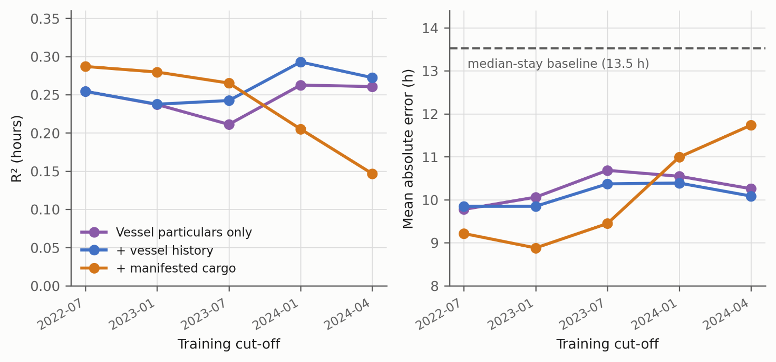
Figure 8. Rolling-origin temporal validation across five training cut-offs, each tested on the following six months: (a) coefficient of determination; (b) mean absolute error, with the median-stay baseline shown as a dashed line.
Table 7. Random Forest performance on the held-out test period from January 2024 (1,669 berth visits). All metrics are expressed in hours on the original scale.
Metric | Value
Rolling-origin R2 (mean of five cut-offs) | 0.260 (sd 0.023)
Vessel-grouped R2 | 0.299
Test-period R2 | 0.270
Test-period mean absolute error | 10.4 h
Test-period root-mean-square error | 19.6 h

4.4. Feature Importance
SHAP analysis identified the operational drivers of the prediction (Figure 9; Table 8). The most influential feature is the duration of the same vessel's previous stay at the port, with a mean absolute SHAP value of 0.162 on the log-hours scale, followed by the berth (0.091) and the index of the berth occupation within the call (0.062). Vessel size descriptors follow at a lower level. The prominence of the vessel's own recent history is operationally coherent: a ship calling on a regular service with a stable cargo profile behaves similarly from call to call, and that regularity is the single most exploitable signal in openly available records. The berth ranks second because different terminals handle structurally different cargo with different equipment. Notably, no variable measured concurrently with the target appears in this ranking, which distinguishes it from interpretations produced under the earlier feature set.
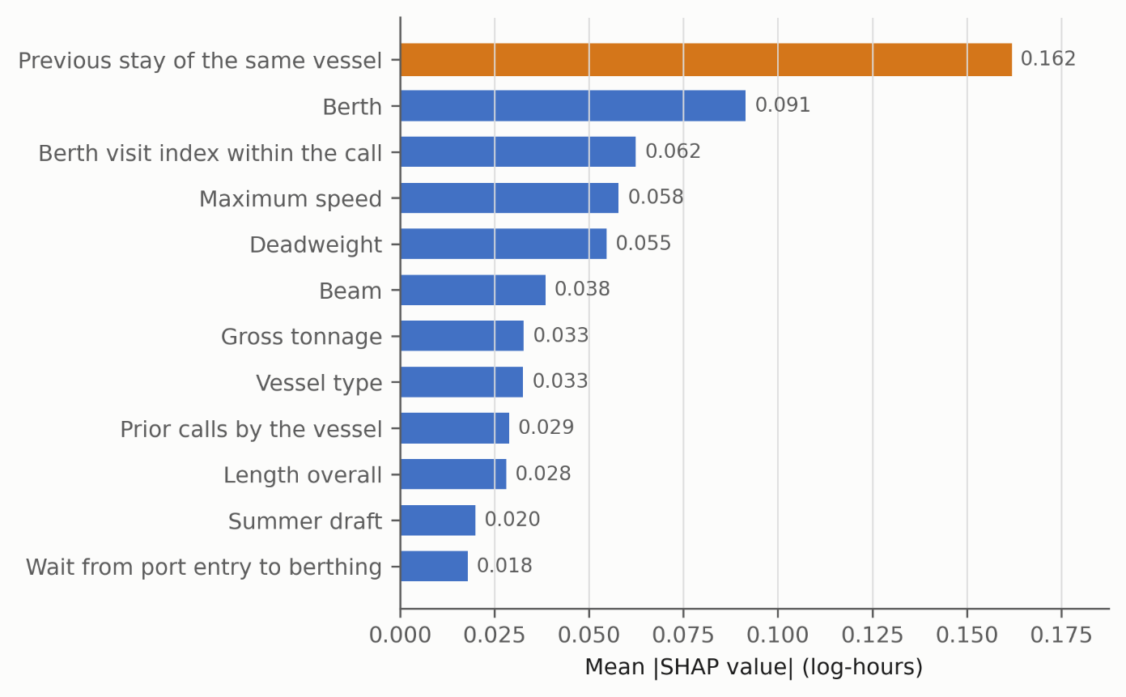
Figure 9. Global feature importance from SHapley Additive exPlanations (SHAP), expressed as the mean absolute SHAP value on the log-hours scale for the twelve leading predictors.
Table 8. Leading predictors of vessel time at berth by mean absolute SHAP value, leakage-free specification.
Predictor | Mean |SHAP value|
Previous stay of the same vessel | 0.162
Berth | 0.091
Berth visit index within the call | 0.062
Maximum speed | 0.058
Deadweight | 0.055
Beam | 0.038
Gross tonnage | 0.033
Vessel type | 0.033
Prior calls by the vessel | 0.029
Sum of the remaining 22 features | 0.196

4.5. Architecture Validation
Beyond the predictive task, the architecture was validated by measurement rather than by assertion (Table 9). Running the complete pipeline over 25%, 50%, 75% and 100% of the source volume yields runtimes of 0.54 s, 1.06 s, 1.51 s and 1.99 s respectively, a sustained throughput of 16,700 to 18,500 reporting points per second and an empirical scaling exponent of 0.93, which is linear within measurement error. Curation compacts 4.98 MB of source CSV into a 0.76 MB Gold table, a factor of 6.6. The analytical query the Gold layer exists to serve, namely occupancy statistics per berth, completes in 22.5 ms against the curated table versus 2.26 s when recomputed from the raw sources, a hundredfold speed-up that constitutes the concrete operational benefit of maintaining the layer. The Silver layer reports the quality actions it performed rather than asserting quality: 3,081 service-craft records separated, 8 values quarantined against physical bounds, and the collapse in manifest coverage described in Section 4.1 detected automatically. That the entire pipeline completes in two seconds on a single machine, from the same design that runs on a managed cluster, is the substance of the portability claim.
Table 9. Measured performance of the open-source single-node realisation of the blueprint. Timings are means over five repetitions on a commodity machine.
Measurement | Result
End-to-end runtime, full volume | 1.99 s for 36,773 reporting points
Sustained throughput | 16,700-18,500 points per second
Empirical scaling exponent | 0.93 (linear within measurement error)
Storage compaction, source to Gold | 4.98 MB to 0.76 MB (6.6x)
Berth-occupancy query, Gold table | 22.5 ms
Same query recomputed from raw sources | 2.26 s (100x slower)
Quality actions recorded in Silver | 3,081 service craft separated; 8 values quarantined

5. Discussion
The results support two distinct conclusions: that predicting vessel time at berth from currently available operational data is feasible but, at present, of limited accuracy; and that a data lakehouse can serve as an effective, governed and economical foundation for the Smart Port data ecosystem that makes such prediction possible. These are discussed in turn and related to the literature reviewed in Section 2.

5.1. Predicting Vessel Time at Berth for Smart Berth Planning
Predicting vessel time at berth from openly available administrative records is feasible but of limited accuracy, and the reasons are structural rather than methodological. The Random Forest model explains approximately 26% of the variance under rolling-origin validation, with a mean absolute error of 10.1 h against a median stay of 21.9 h. Time at berth is governed by stochastic operational factors, namely labour and equipment availability, weather, tidal windows and cargo-specific handling rates, none of which appear in the open feed; the interpretability analysis is consistent with this reading, since the leading predictors capture operational context and vessel regularity rather than the real-time conditions that determine handling speed. Two pieces of evidence bound the achievable accuracy. First, adding manifested cargo tonnage, a single variable the port already holds but does not publish consistently, raises R2 from 0.237 to 0.280 and lifts six-hour accuracy from 51.7% to 60.7% in periods where the field is well populated. Second, comparison with the literature (Table 10) shows that studies achieving materially better accuracy draw on internal terminal systems rather than open data, while the one comparable study using open data enriched with meteorological and tidal records over eleven years reports mean absolute errors of 10.6 h to 14.6 h, of the same order as ours. The ceiling is therefore set by data availability, and the gap to the best published results quantifies the value of the operational data that ports do not yet publish.
What accuracy would be operationally useful is a separate question, and the honest answer is that this model supports some planning decisions and not others. Against the median-stay heuristic a planner would otherwise apply, the model reduces mean absolute error from 13.5 h to 10.1 h and raises the share of calls predicted within six hours from 37% to 53%. Set against a typical container-ship occupation the error remains large: container ships account for 2,540 of the 8,148 berth visits, with a median stay of 20.3 h and an interquartile range of 13.8 h to 28.8 h, so an average error of about ten hours is roughly half a typical stay. That margin is useful for indicative planning over a horizon of days, such as anticipating berth pressure, sequencing expected arrivals and flagging calls likely to overrun. It is not sufficient for shift-level resource allocation, which would require errors reliably inside an eight-hour window; roughly a quarter of calls still fall outside a twelve-hour tolerance. We state this boundary explicitly because the practical value of a berth-time estimator depends entirely on which of the two decisions it is asked to support.
Table 10. Reported performance of machine-learning studies predicting vessel time in port, with the data each study had available.
Study | Port | Data available | Reported performance
Stepec et al. [39] | Bordeaux | 11 years; weather and tides | MAE 10.6-14.6 h; RMSE 17.9-27.5 h
Yoon et al. [40] | Busan New Port | Terminal operational systems | R2 = 0.72
Chu et al. [41] | Hong Kong | Port arrival and departure records | MAE 3.9 h; RMSE 6.1 h
Evmides et al. [42] | Cyprus (arrival time) | AIS | R2 = 0.88; MAE 100 min
This study | Sines | Open administrative records only | R2 = 0.260; MAE 10.1 h

Despite the modest accuracy, the analysis is informative for the maritime operations literature, which has predominantly addressed berth planning through combinatorial optimisation that assumes processing times as inputs [4-6]. The present results provide empirical evidence on how far those processing times can be learned from routinely collected administrative data, and identify vessel regularity and berth identity as the most promising signals for a berth-occupation estimator. Rather than competing with optimisation-based berth allocation, a data-driven estimate of time at berth is best understood as a complement that could supply more realistic, vessel-specific processing times to such planners; Kolley et al. [43] demonstrate one such coupling, feeding machine-learning predictions into a robust berth-allocation procedure with dynamic time buffers. In this sense the study connects the data-engineering and operations-research strands that the literature has tended to treat separately, and it complements the rare maritime lakehouse application of Park et al. [8] by pairing a port data platform with an interpretable predictive task and an honest account of its current limits.

5.2. The Lakehouse as Smart Port Infrastructure
The enabling architecture met its objectives and offers three lessons. First, the measurements in Section 4.5 substantiate what was previously only asserted: the pipeline runs end to end in two seconds on a single commodity machine, which places governed port analytics within reach of authorities without dedicated data-engineering teams. Second, the same design executes on a managed cluster and on open-source components without alteration to its layer semantics, lineage or quality controls, so adoption need not begin with a platform commitment. Third, the staged maturation of the project yielded a transferable lesson on data acquisition: ad hoc collection through commercial feeds and document-sharing services surfaced pervasive data-quality and integration problems, whereas programmatic ingestion into a governed lakehouse provided the reliability and lineage required for sustained analytics. The detection of the 2024 manifest-coverage collapse illustrates the point concretely: embedding quality management within the pipeline rather than treating it as a separate administrative step is what made a silent change in an upstream data feed visible before it corrupted a conclusion. This operational evidence responds directly to the gap identified in Section 2, where production evaluations of the lakehouse, particularly in maritime settings, were found to be scarce relative to conceptual and proof-of-concept work [8,14,38].

6. Conclusions

6.1. Summary and Contributions
This study designed a governed data lakehouse blueprint for port operational data and used the prediction of vessel time at berth at the Port of Sines to demonstrate what openly available records currently support. Following a design science research methodology, four years of administrative data were integrated through a medallion pipeline and served to both analytical and machine-learning workloads without duplication, running end to end in two seconds on a single machine from a design that also executes on a managed cluster. Under rolling-origin temporal validation a Random Forest model attained a mean R2 of 0.260 and a mean absolute error of 10.1 h, against 13.5 h for the median-stay heuristic. This is a limited but non-trivial result whose ceiling is attributable to the absence of exogenous operational variables rather than to the architecture or to model selection, a diagnosis supported by the measured gain from a single additional port-held variable. The vessel's own previous stay, the berth and vessel size were identified as the most influential predictors.
The academic contribution is threefold. First, the study provides a replicable and portable reference architecture for integrating and governing heterogeneous Smart Port data, realised on two substrates from a single design and validated with measured throughput, storage and query performance. Second, it offers an empirical and honestly reported evaluation of machine learning for berth-occupation estimation under temporal validation, including an interpretability analysis that links the prediction to operational drivers and connects the data-engineering and operations-research literatures on berth planning. Third, it reports practical data-acquisition and data-quality lessons relevant to other ports pursuing analytics initiatives, including a documented instance in which the governed pipeline detected a structural change in an upstream data feed.
From a logistics perspective, the framework provides the governed data foundation that berth planning, resource allocation and operational coordination require, and it establishes what level of predictive accuracy is currently attainable from open records. Demonstrating gains in those activities would require coupling the estimator with a planning model and evaluating it against current practice, which this study does not attempt; the contribution is the foundation and the honest measurement of its present predictive ceiling, not a demonstrated operational improvement.

6.2. Limitations
Several limitations qualify these findings. First, the evaluation covers a single port, so multi-port data would be required to establish external validity, and the four-year window, while sufficient to capture seasonality, spans a period that includes pandemic-affected traffic. Second, data-quality issues, notably the collapse in manifest coverage during 2024, reduce the usable sample for the richest feature tier and may bias the retained subset toward routine calls. Third, the feature set omits exogenous determinants of handling time, such as meteorological, tidal and resource-availability data, that are likely to carry substantial predictive signal. Fourth, the architecture was operated in batch mode, so the present evaluation does not address streaming or real-time prediction. Finally, the bibliometric synthesis in Section 2 is based on a single database and a specific search expression, so relevant work indexed elsewhere or using different terminology may be under-represented [16]; the citation indicators are also time-dependent given the recency of the field.

6.3. Future Work
Future work should pursue four directions. The first is to integrate the exogenous sources that the interpretability analysis and the manifest experiment indicate are necessary to raise accuracy beyond its current ceiling, namely weather, tidal windows, and equipment and labour availability, and to negotiate consistent publication of the cargo-manifest field whose predictive value this study quantifies. The second is to extend ingestion to further ports so that the architecture and the estimator can be evaluated for transferability. The third is to couple the resulting berth-time estimator with optimisation-based berth-allocation and quay-crane scheduling models, so that learned processing times feed directly into planning and the operational benefit can be measured rather than assumed. The fourth is to extend the batch architecture toward real-time streaming and, in the longer term, toward digital-twin and cross-port data-sharing scenarios. Each direction builds on the governed data foundation established here without requiring it to be redesigned.

Supplementary Materials: Not applicable; no supplementary materials are provided for this submission.
Author Contributions: Author contribution details have been removed for double-blind peer review and will be provided in the non-anonymized version of the manuscript.
Funding: Funding information has been removed for double-blind peer review and will be restored in the non-anonymized version of the manuscript, if applicable.
Institutional Review Board Statement: Not applicable. This study used publicly available operational records and published scientific literature and did not involve human participants, human data, animals, interviews, surveys, or the collection of personal data; ethical approval was therefore not required.
Informed Consent Statement: Not applicable. This study did not involve human participants, human data, or identifiable personal information.
Data Availability Statement: The pipeline implementation, modelling code and generated result files that produce every table and figure reported in this article are available in the project repository, and each reported figure is regenerated by a named script. The underlying source extracts from the Sines and Algarve Port Authority remain subject to the confidentiality conditions of the funded project under which they were obtained and cannot be redistributed by the authors; researchers may request them directly from the data provider. Repository details have been withheld from this anonymized manuscript and will be supplied to the editors and restored in the non-anonymized version.
Acknowledgments: Acknowledgments have been removed for double-blind peer review and will be restored in the non-anonymized version of the manuscript, if applicable.
Conflicts of Interest: The authors declare no conflict of interest.
Preprint Statement: This manuscript has not been posted as a preprint, has not been published previously, and is not under consideration by another journal.

References
1. Liu, R.; Isah, H.; Zulkernine, F. A Big Data Lake for Multilevel Streaming Analytics. arXiv 2020, arXiv:2009.12415. https://doi.org/10.48550/arXiv.2009.12415
2. Molavi, A.; Lim, G.J.; Race, B. A Framework for Building a Smart Port and Smart Port Index. Int. J. Sustain. Transp. 2020, 14, 686–700. https://doi.org/10.1080/15568318.2019.1610919
3. United Nations Conference on Trade and Development. Review of Maritime Transport 2024: Navigating Maritime Chokepoints; UNCTAD: Geneva, Switzerland, 2024. Available online: https://unctad.org/publication/review-maritime-transport-2024 (accessed on 22 June 2026).
4. Bierwirth, C.; Meisel, F. A Survey of Berth Allocation and Quay Crane Scheduling Problems in Container Terminals. Eur. J. Oper. Res. 2010, 202, 615–627. https://doi.org/10.1016/j.ejor.2009.05.031
5. Bierwirth, C.; Meisel, F. A Follow-Up Survey of Berth Allocation and Quay Crane Scheduling Problems in Container Terminals. Eur. J. Oper. Res. 2015, 244, 675–689. https://doi.org/10.1016/j.ejor.2014.12.030
6. Carlo, H.J.; Vis, I.F.A.; Roodbergen, K.J. Seaside Operations in Container Terminals: Literature Overview, Trends, and Research Directions. Flex. Serv. Manuf. J. 2015, 27, 224–262. https://doi.org/10.1007/s10696-013-9178-3
7. Armbrust, M.; Ghodsi, A.; Xin, R.; Zaharia, M. Lakehouse: A New Generation of Open Platforms that Unify Data Warehousing and Advanced Analytics. In Proceedings of the 11th Annual Conference on Innovative Data Systems Research (CIDR), Online, 11–15 January 2021.
8. Park, S.; Yang, C.-S.; Kim, J. Design of Vessel Data Lakehouse with Big Data and AI Analysis Technology for Vessel Monitoring System. Electronics 2023, 12, 1943. https://doi.org/10.3390/electronics12081943
9. Hevner, A.R.; March, S.T.; Park, J.; Ram, S. Design Science in Information Systems Research. MIS Q. 2004, 28, 75–105. https://doi.org/10.2307/25148625
10. Azzabi, S.; Alfughi, Z.; Ouda, A. Data Lakes: A Survey of Concepts and Architectures. Computers 2024, 13, 183. https://doi.org/10.3390/computers13070183
11. Harby, A.A.; Zulkernine, F. From Data Warehouse to Lakehouse: A Comparative Review. In Proceedings of the 2022 IEEE International Conference on Big Data (Big Data), Osaka, Japan, 17–20 December 2022; pp. 389–395. https://doi.org/10.1109/BigData55660.2022.10020719
12. Begoli, E.; Goethert, I.; Knight, K. A Lakehouse Architecture for the Management and Analysis of Heterogeneous Data for Biomedical Research and Mega-Biobanks. In Proceedings of the 2021 IEEE International Conference on Big Data (Big Data), Orlando, FL, USA, 15–18 December 2021; pp. 4643–4651. https://doi.org/10.1109/BigData52589.2021.9671534
13. Kumar, D.; Li, S. Separating Storage and Compute with the Databricks Lakehouse Platform. In Proceedings of the 2022 IEEE 9th International Conference on Data Science and Advanced Analytics (DSAA), Shenzhen, China, 13–16 October 2022. https://doi.org/10.1109/DSAA54385.2022.10032386
14. Schneider, J.; Gröger, C.; Lutsch, A.; Schwarz, H.; Mitschang, B. The Lakehouse: State of the Art on Concepts and Technologies. SN Comput. Sci. 2024, 5, 449. https://doi.org/10.1007/s42979-024-02737-0
15. Wieder, P.; Nolte, H. Toward Data Lakes as Central Building Blocks for Data Management and Analysis. Front. Big Data 2022, 5, 945720. https://doi.org/10.3389/fdata.2022.945720
16. Donthu, N.; Kumar, S.; Mukherjee, D.; Pandey, N.; Lim, W.M. How to Conduct a Bibliometric Analysis: An Overview and Guidelines. J. Bus. Res. 2021, 133, 285–296. https://doi.org/10.1016/j.jbusres.2021.04.070
17. Schneider, J.; Gröger, C.; Lutsch, A.; Schwarz, H.; Mitschang, B. Assessing the Lakehouse: Analysis, Requirements and Definition. In Proceedings of the 25th International Conference on Enterprise Information Systems (ICEIS), Prague, Czech Republic, 24–26 April 2023; Volume 1, pp. 44–56. https://doi.org/10.5220/0011840500003467
18. Orescanin, D.; Hlupic, T. Data Lakehouse: A Novel Step in Analytics Architecture. In Proceedings of the 2021 44th International Convention on Information, Communication and Electronic Technology (MIPRO), Opatija, Croatia, 27 September–1 October 2021; pp. 1242–1247. https://doi.org/10.23919/MIPRO52101.2021.9597091
19. Janssen, N.; Ilayperuma, T.; Jayasinghe, J.; Bukhsh, F.; Daneva, M. The Evolution of Data Storage Architectures: Examining the Secure Value of the Data Lakehouse. J. Data Inf. Manag. 2024, 6, 219–238. https://doi.org/10.1007/s42488-024-00132-1
20. Gebler, R.; Reinecke, I.; Sedlmayr, M.; Goldammer, M. Enhancing Clinical Data Infrastructure for AI Research: Comparative Evaluation of Data Management Architectures. J. Med. Internet Res. 2025, 27, e74976. https://doi.org/10.2196/74976
21. Ait Errami, S.; Hajji, H.; Ait El Kadi, K.; Badir, H. Spatial Big Data Architecture: From Data Warehouses and Data Lakes to the Lakehouse. J. Parallel Distrib. Comput. 2023, 176, 70–79. https://doi.org/10.1016/j.jpdc.2023.02.007
22. Bakken, M.; Soylu, A. Chrontext: Portable SPARQL Queries over Contextualised Time Series Data in Industrial Settings. Expert Syst. Appl. 2023, 226, 120149. https://doi.org/10.1016/j.eswa.2023.120149
23. Zhang, Y.; Peng, B.; Du, Y.; Su, J. GeoLake: Bringing Geospatial Support to Lakehouses. IEEE Access 2023, 11, 142503–142517. https://doi.org/10.1109/ACCESS.2023.3343953
24. Routaib, H.; Seddik, S.; Elmounadi, A.; El Haddadi, A. Enhancing E-Business in Industry 4.0: Integrating Fog/Edge Computing with Data Lakehouse for IIoT. Future Gener. Comput. Syst. 2025, 166, 107653. https://doi.org/10.1016/j.future.2024.107653
25. Levandoski, J.; Casto, G.; Deng, M.; Desai, R.; Edara, P.; Hottelier, T.; Hormati, A.; Johnson, A.; Johnson, J.; Kurzyniec, D.; et al. BigLake: BigQuery’s Evolution toward a Multi-Cloud Lakehouse. In Proceedings of the 2024 ACM SIGMOD International Conference on Management of Data, Santiago, Chile, 9–15 June 2024. https://doi.org/10.1145/3626246.3653388
26. He, Z.; Fang, W. Research Data Management in Institutional Repositories: An Architectural Approach Using Data Lakehouses. Digit. Libr. Perspect. 2025, 41, 145–178. https://doi.org/10.1108/DLP-02-2024-0022
27. Chattopadhyay, B.; Pedreira, P.; Agarwal, S.; Sun, Y.; Vakharia, S.; Li, P.; Liu, W.; Narayanan, S. Shared Foundations: Modernizing Meta’s Data Lakehouse. In Proceedings of the 13th Annual Conference on Innovative Data Systems Research (CIDR), Amsterdam, The Netherlands, 8–11 January 2023.
28. Sines and Algarve Port Authority (APS). 2024 Is the Best Year Ever for the Port of Sines. Available online: https://www.apsinesalgarve.pt/en/ (accessed on 22 June 2026).
29. Zaharia, M.; Xin, R.S.; Wendell, P.; Das, T.; Armbrust, M.; Dave, A.; Meng, X.; Rosen, J.; Venkataraman, S.; Franklin, M.J.; et al. Apache Spark: A Unified Engine for Big Data Processing. Commun. ACM 2016, 59, 56–65. https://doi.org/10.1145/2934664
30. Armbrust, M.; Das, T.; Sun, L.; Yavuz, B.; Zhu, S.; Murthy, M.; Torres, J.; van Hovell, H.; Ionescu, A.; Łuszczak, A.; et al. Delta Lake: High-Performance ACID Table Storage over Cloud Object Stores. Proc. VLDB Endow. 2020, 13, 3411–3424. https://doi.org/10.14778/3415478.3415560
31. Floratou, A. Columnar Storage Formats. In Encyclopedia of Big Data Technologies; Sakr, S., Zomaya, A.Y., Eds.; Springer: Cham, Switzerland, 2019. https://doi.org/10.1007/978-3-319-77525-8_248
32. Xue, M.; Chen, S.; Lam, A.; Li, Y.; Bu, Y.; van Hovell, H.; Ma, Y.; Li, X.; Paranjpye, S.; Somani, A.; et al. Adaptive and Robust Query Execution for Lakehouses at Scale. Proc. VLDB Endow. 2024, 17, 3947–3959. https://doi.org/10.14778/3685800.3685818
33. Zaharia, M.; Chen, A.; Davidson, A.; Ghodsi, A.; Hong, S.A.; Konwinski, A.; Murching, S.; Nykodym, T.; Ogilvie, P.; Parkhe, M.; et al. Accelerating the Machine Learning Lifecycle with MLflow. IEEE Data Eng. Bull. 2018, 41, 39–45.
34. Breiman, L. Random Forests. Mach. Learn. 2001, 45, 5–32. https://doi.org/10.1023/A:1010933404324
35. Rigatti, S.J. Random Forest. J. Insur. Med. 2017, 47, 31–39. https://doi.org/10.17849/insm-47-01-31-39.1
36. Doz, D.; Cotič, M.; Felda, D. Random Forest Regression in Predicting Students’ Achievements and Fuzzy Grades. Mathematics 2023, 11, 4129. https://doi.org/10.3390/math11194129
37. Lundberg, S.M.; Lee, S.-I. A Unified Approach to Interpreting Model Predictions. In Advances in Neural Information Processing Systems 30 (NIPS 2017), Long Beach, CA, USA, 4–9 December 2017; pp. 4765–4774.
38. Harby, A.A.; Zulkernine, F. Data Lakehouse: A Survey and Experimental Study. Inf. Syst. 2025, 127, 102460. https://doi.org/10.1016/j.is.2024.102460
39. Stepec, D.; Martincic, T.; Klein, F.; Vladusic, D.; Pita Costa, J. Machine Learning Based System for Vessel Turnaround Time
Prediction. In Proceedings of the 21st IEEE International Conference on Mobile Data Management (MDM), Versailles, France, 30
June - 3 July 2020.
40. Yoon, J.-H.; Kim, S.-W.; Jo, J.-S.; Park, J.-M. A Comparative Study of Machine Learning Models for Predicting Vessel Dwell
Time Estimation at a Terminal in the Busan New Port. J. Mar. Sci. Eng. 2023, 11, 1846. https://doi.org/10.3390/jmse11101846
41. Chu, Z.; Yan, R.; Wang, S. Vessel Turnaround Time Prediction: A Machine Learning Approach. Ocean Coast. Manag. 2024,
249, 107021. https://doi.org/10.1016/j.ocecoaman.2024.107021
42. Evmides, N.; Aslam, S.; Ramez, T.T.; Michaelides, M.P.; Herodotou, H. Enhancing Prediction Accuracy of Vessel Arrival
Times Using Machine Learning. J. Mar. Sci. Eng. 2024, 12, 1362. https://doi.org/10.3390/jmse12081362
43. Kolley, L.; Ruckert, N.; Fischer, K. A Robust Berth Allocation Optimization Procedure Based on Machine Learning. In
Logistics Management; Buscher, U., Lasch, R., Schonberger, J., Eds.; Springer: Cham, Switzerland, 2021; pp. 107-122.
https://doi.org/10.1007/978-3-030-85843-8_7

