Customer Shopping Trend Analysis

1.Project Overview:
This report presents a detailed analysis of customer shopping behavior using transactional data from 3,900 purchases across multiple product categories. This analysis aims to support data-driven decision-making in marketing, product planning, and customer retention strategies. The findings help identify high-value customer segments, seasonal buying trends, and factors that influence purchasing decisions.

2. dataset summary
  - Rows: 3900
  - Columns: 18
  - Key Features:
    - Customer demographics (Age, Gender, Location, Subscription Status)
    - Purchase details (Item Purchased, Category, Purchase Amount, Season, Size, Color)
    - Shopping behavior (Discount Applied, Promo Code Used, Previous Purchases
    - Frequency of Purchases, Review Rating, Shipping Type)
  - Key Features: Missing Data: 37 values in Review Rating column

3. data analysis using python
We began with data preparation and cleaning in Python:
  - Data Loading: Imported the dataset using Pandas.
  - Initial Exploration: Used df.info() to check structure and df.describe() for summary statistics.
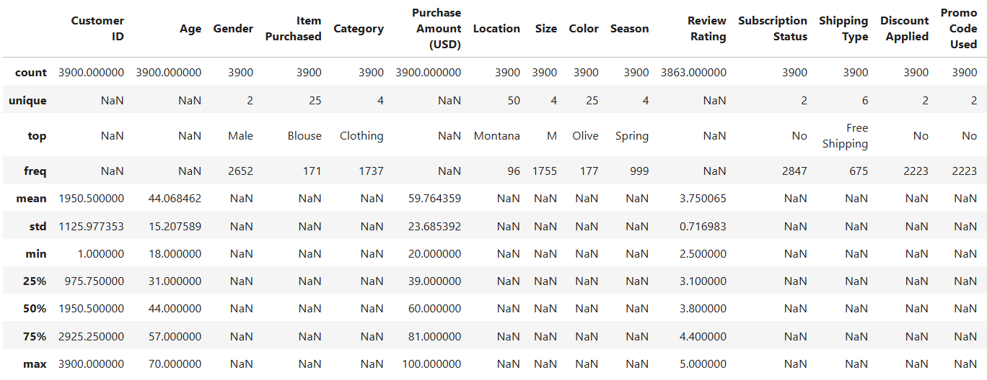
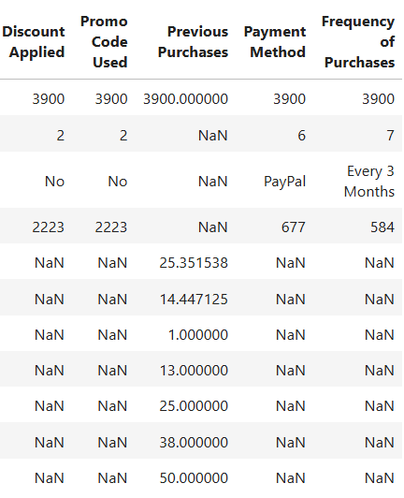
  - Missing Data Handling: Checked for null values and imputed missing values in the Review Rating column using the median rating of each product category.
  - Column Standardization: Renamed columns to snake case for better readability and documentation.
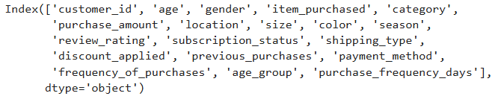
  - Column creation: Created age_group column and purchase_frequency_days column using customer age and purchase data.
  - Data Consistency Check: Verified if discount_applied and promo_code_used were redundant; dropped promo_code_used.
  - Database Integration: Connected Python script to PostgreSQL and loaded the cleaned DataFrame into the database for SQL analysis.
4. data analysis using sql
We performed structured analysis in SQL to answer key business questions:
- Revenue by Gender: Compared total revenue generated by male vs. female customers.
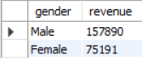
- High spending Discount users: Identified customers who used discounts but still spent above the average purchase amount.
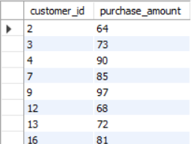
- Top 5 products by rating: Found products with the highest average review ratings.
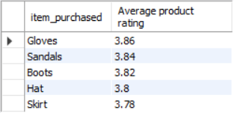
- Shipping type Comparison: Compared average purchase amounts between Standard and Express shipping.
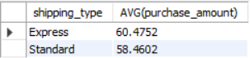
- Subscribers vs Non-Subscribers: Compared average spend and total revenue across subscription status.
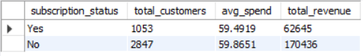
- Discount dependent Products: Identified 5 products with the highest percentage of discounted purchases.
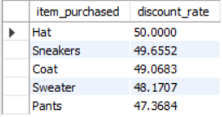
- Customer Segmentation: Classified customers into New, Returning, and Loyal segments based on purchase history.
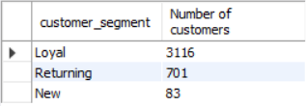
- Top 3 products per Category: Listed the most purchased products within each category.
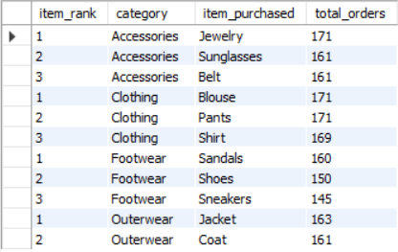
- Repeat buyers & Subscription: Checked whether customers with >5 purchases are more likely to subscribe.
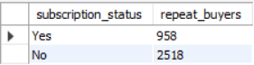
- Revenue by age group: Calculated total revenue contribution of each age group.
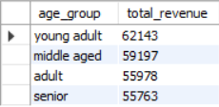
5. dashboard in power bi
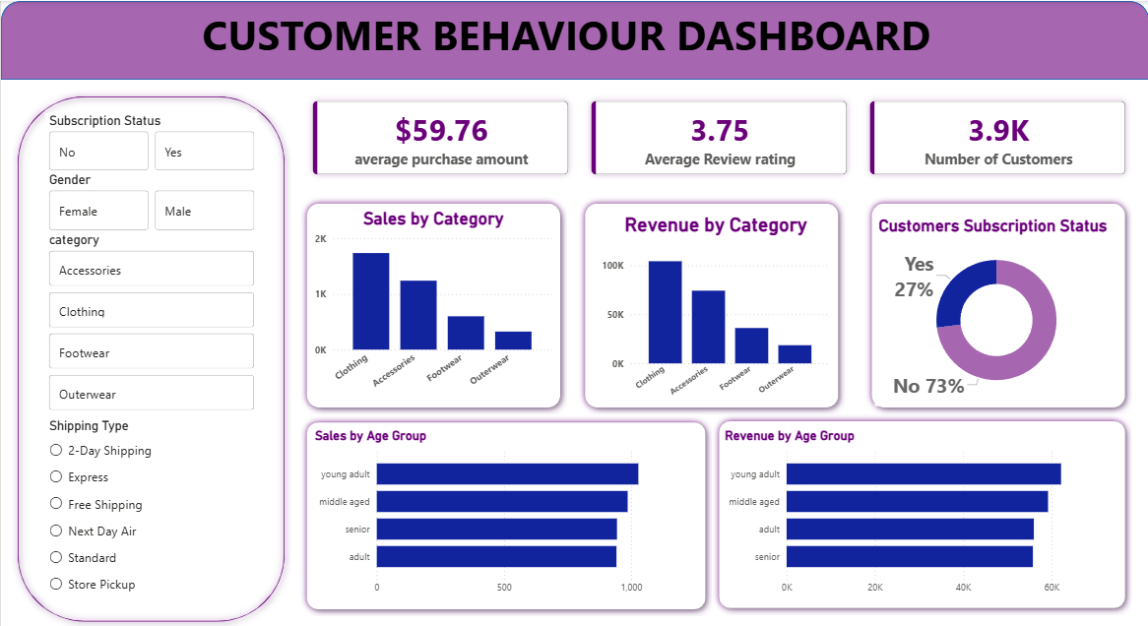
4. business recommendations:
From the above analysis following are the recommendations:
- Boost Subscriptions: Promote exclusive benefits for subscribers.
- Customer Loyalty Programs: Reward repeat buyers to move them into the “Loyal” segment.
- Review Discount Policy: Balance sales boosts with margin control.
- Product Positioning: Highlight top-rated and best-selling products in campaigns.
- Targeted Marketing: Focus efforts on high-revenue age groups and express-shipping users.

