1. 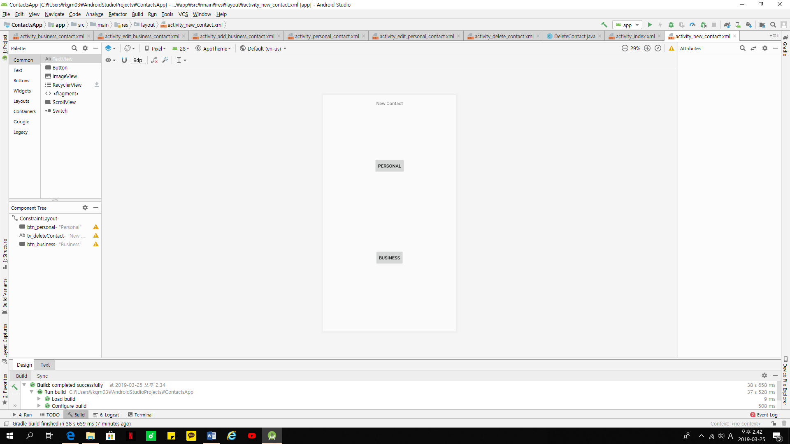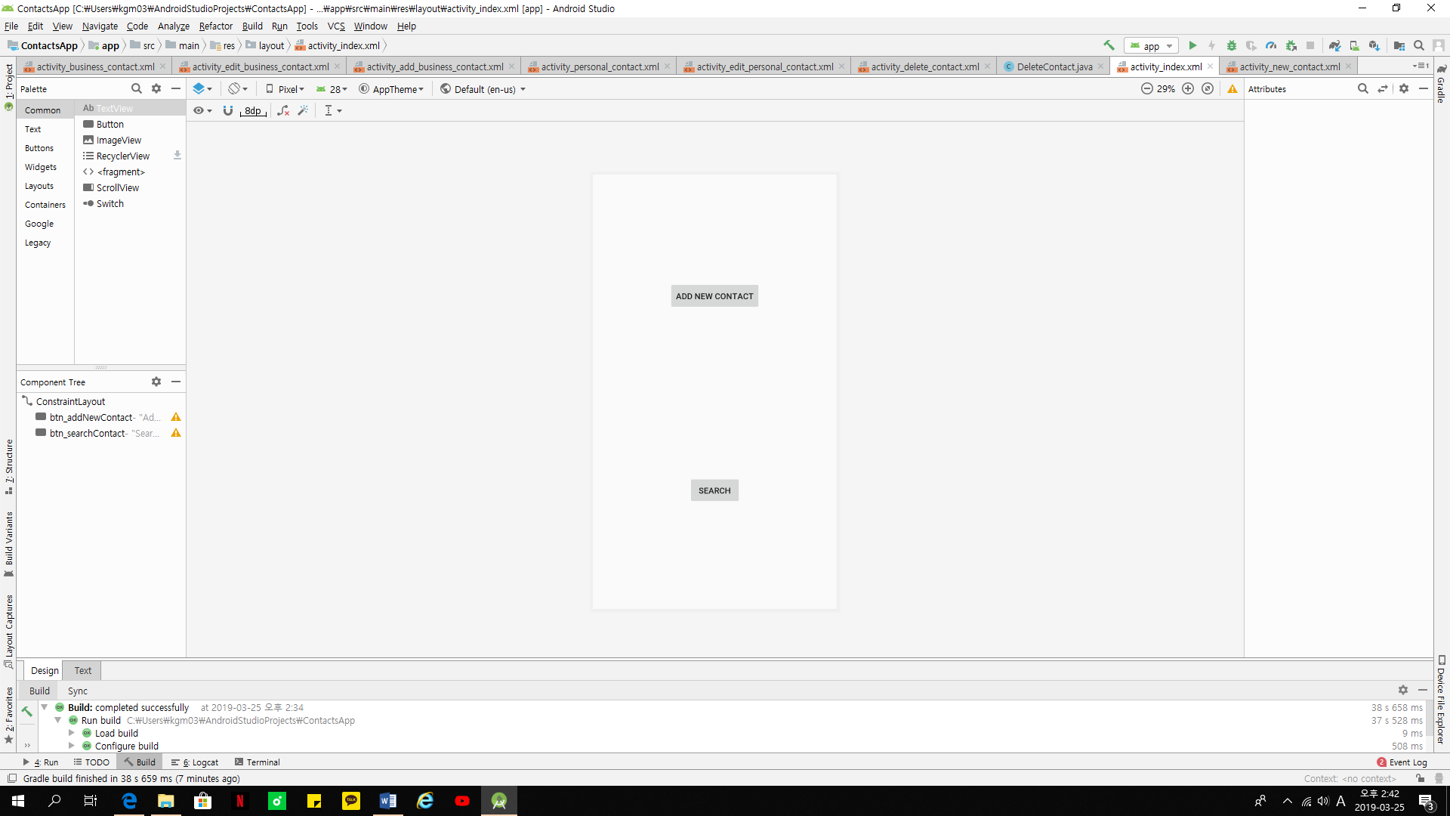First page would be search and add new contact. You can search by name, phone number, city, email, etc. when you click “add new contact”, you can choose either personal contact or business contact.

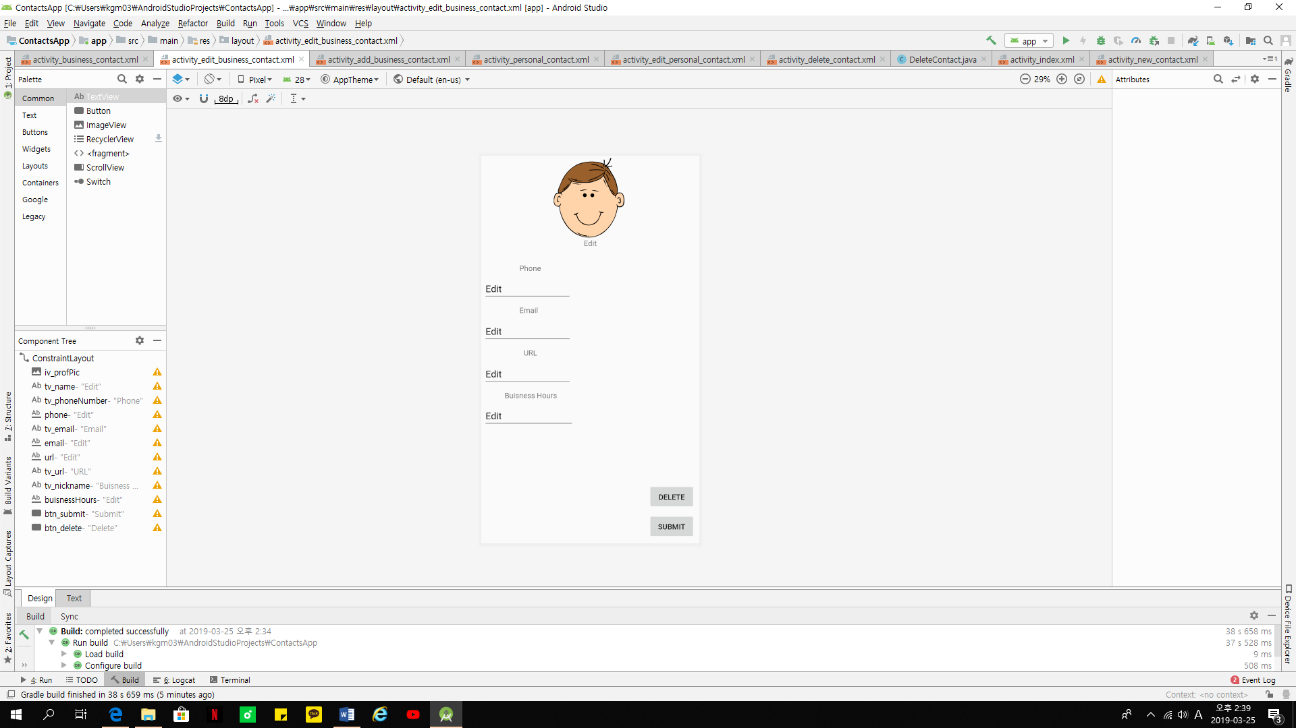

1. When you choose “personal contact”, you can edit picture and add phone number, email, and etc. if you click submit, it will save in your app and if you click delete, it won’t be saved in your phone.



1. Business contact would be same as personal contact. But it would be saved in business contact group.