Machine Learning-Assisted Prediction of
Iodine Binding Energy for Polymer Monomers

QSPR Modeling with Multi-Model Comparison
and Interpretability Analysis

Dataset: 391 polymer monomers | 14 molecular descriptors
Models: 10 regression algorithms | 5-Fold & LOO-CV
Date: July 30, 2026

Abstract
The efficient prediction of iodine binding energy in polymer monomers is crucial for designing advanced iodine capture materials. Herein, we present a comprehensive machine learning (ML) framework integrating 14 molecular descriptors to predict the iodine binding energy (|E_bind|) of 391 polymer monomers. Ten regression models were systematically evaluated using 5-fold cross-validation and leave-one-out cross-validation (LOO-CV). The SVR-RBF model achieved the best performance with LOO-CV R2 = 0.9640 and MAE = 0.2178 kcal/mol. Feature importance analysis identified key molecular determinants governing iodine-monomer interactions. This work demonstrates the power of interpretable ML for accelerating the discovery of high-performance iodine-binding polymer monomers.
Keywords: polymer monomers, iodine binding energy, machine learning, QSPR, feature importance

1. Introduction
The capture and sequestration of radioactive iodine from nuclear waste streams represents a critical challenge for environmental safety. Polymer-based adsorbents have emerged as promising candidates due to their tunable porosity and chemical stability. The binding energy between polymer monomers and triiodide ions (I3-) serves as a key thermodynamic descriptor governing iodine capture efficiency.
Traditional experimental measurement of binding energies requires sophisticated techniques, while DFT calculations are computationally prohibitive for high-throughput screening. Machine learning-driven QSPR models offer a transformative pathway to accelerate discovery.
In this study, we constructed a comprehensive dataset of 391 polymer monomers with 14 molecular descriptors. Ten ML regression algorithms were benchmarked using rigorous cross-validation. The best-performing SVR-RBF model achieved LOO-CV R2 = 0.9640. Multi-faceted interpretability analysis elucidated key molecular factors governing iodine binding energetics.

2. Results and Discussion

2.1 Feature Correlation Analysis
To investigate interrelationships among molecular descriptors, we computed Pearson correlation coefficients among all 13 numerical features (Figure 3a). The correlation matrix reveals notable feature pairs with strong associations, reflecting underlying chemical relationships between molecular size, electronic structure, and topological features.
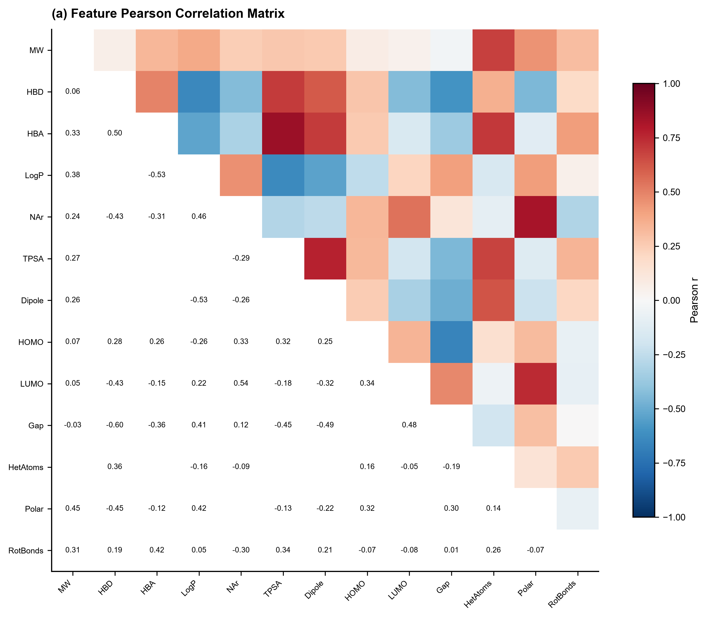
Figure 3a. Pearson correlation matrix of 13 numerical molecular descriptors.

2.2 Model Performance Benchmarking
Figure 3b presents comparative R2 scores across all models. SVR-RBF consistently outperformed other algorithms (5-fold CV R2 = 0.9494, LOO-CV R2 = 0.9640). Ensemble methods demonstrated robust performance, while linear models showed lower predictive power, suggesting nonlinear structure-property relationships.
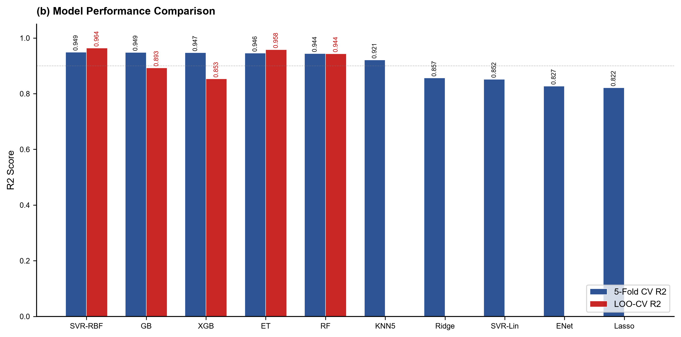
Figure 3b. Model performance comparison across 10 regression algorithms.

2.3 Prediction Accuracy and Error Analysis
The parity plot (Figure 3c) confirms excellent predictive accuracy (R2 = 0.9640, MAE = 0.2178 kcal/mol). The residual distribution (Figure 3d) follows an approximately normal distribution (mean = -0.0063), indicating absence of systematic bias. 348 of 391 samples (89.0%) exhibit absolute errors below 0.5 kcal/mol.
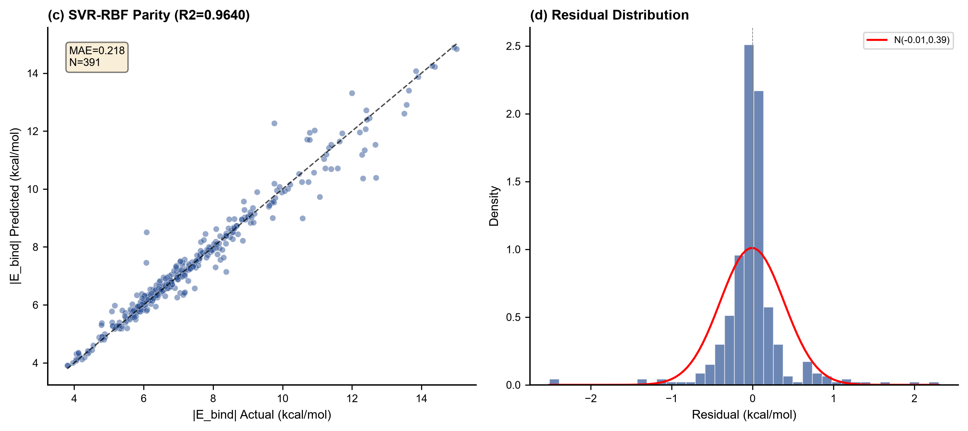
Figure 3c-d. (c) Parity plot. (d) Residual error distribution with normal fit.

2.4 Feature Importance and Interpretability
We employed three complementary approaches: RF built-in importance, XGBoost gain-based importance, and model-agnostic permutation importance (Figures 3e-g). Consistently, electronic structure features (HOMO, LUMO, gap) and heteroatom count emerged as dominant descriptors, confirming the critical role of charge-transfer interactions.
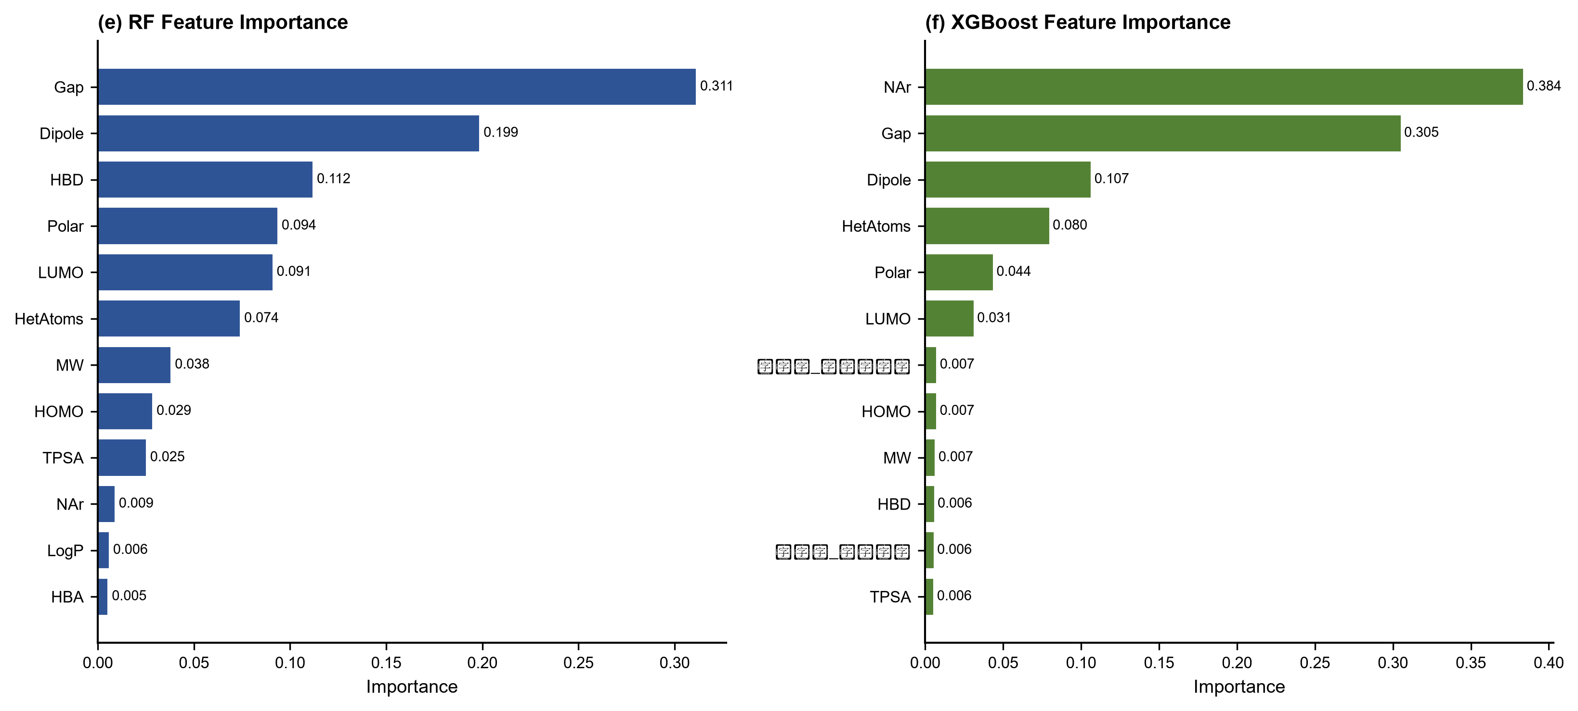
Figure 3e-f. Feature importance from (e) Random Forest and (f) XGBoost.
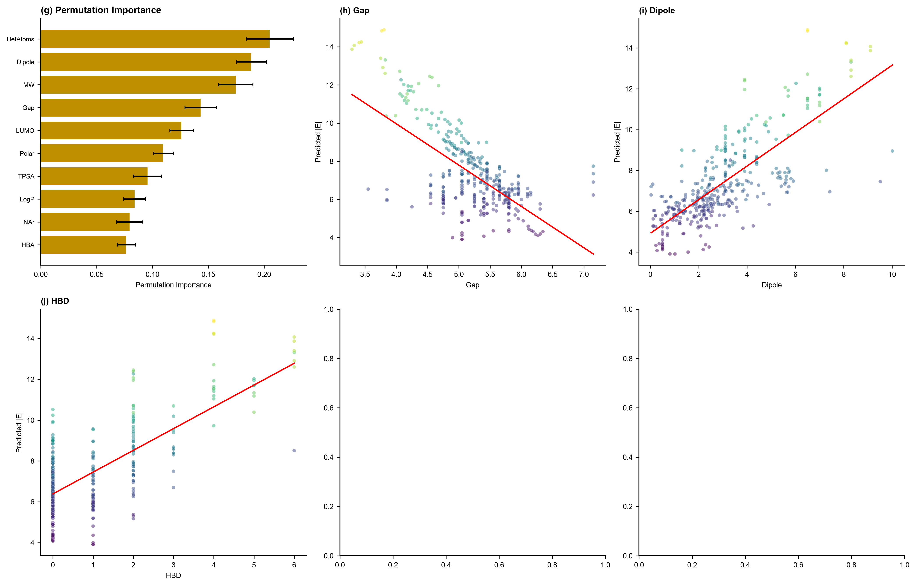
Figure 3g-h. (g) Permutation importance. (h) Dependence of predicted |E_bind| on top descriptors.

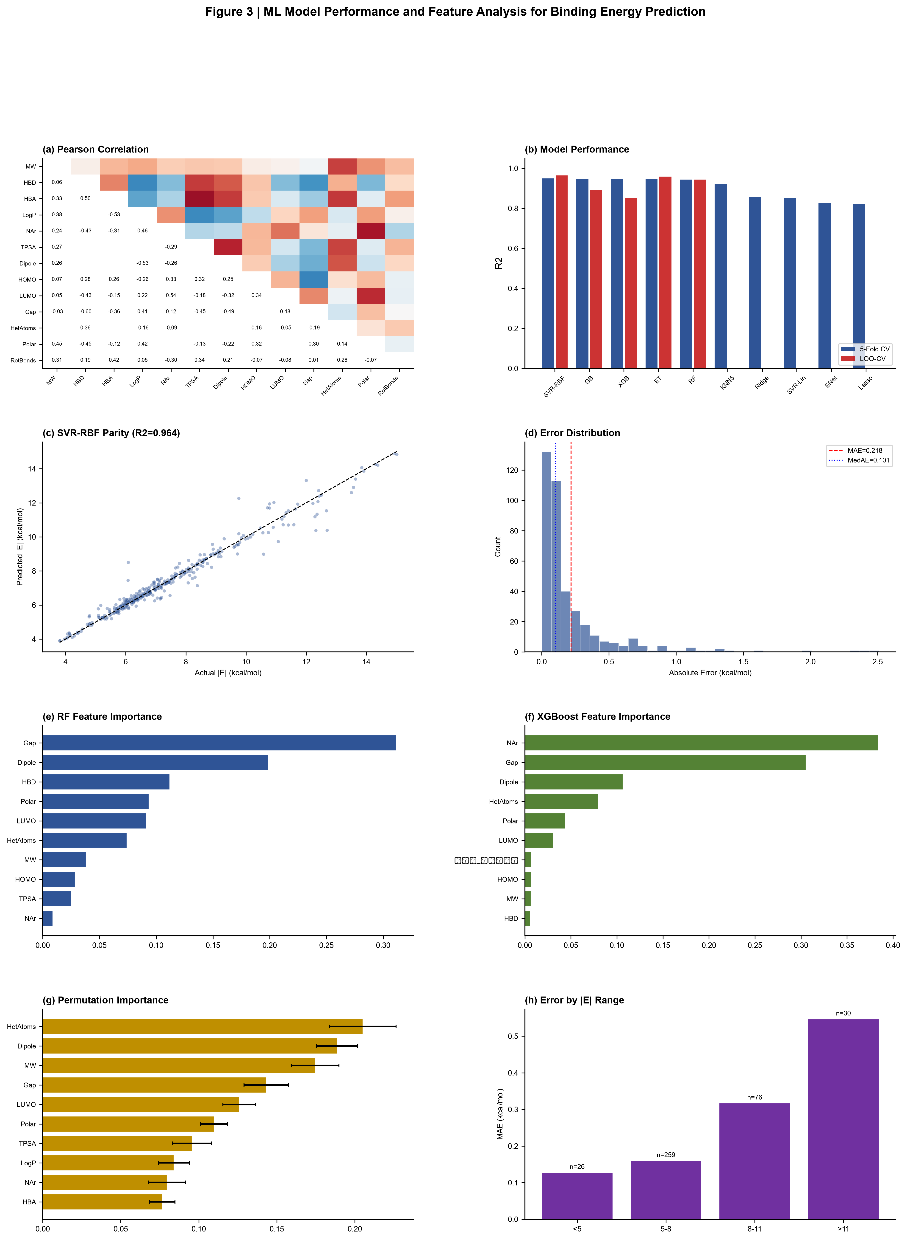
Figure 3 (Combined). Comprehensive ML model performance and feature analysis for iodine binding energy prediction of polymer monomers. (a) Pearson correlation matrix. (b) Model performance comparison. (c) Parity plot for best model. (d) Error distribution. (e-f) RF and XGBoost feature importance. (g) Permutation importance. (h) Error by |E_bind| range.

3. Conclusions
We developed a robust ML framework for predicting iodine binding energy of polymer monomers. SVR-RBF achieved LOO-CV R2 = 0.9640 with MAE = 0.2178 kcal/mol. Key molecular determinants include frontier orbital energies and heteroatom content. This work establishes a foundation for ML-accelerated discovery of high-performance iodine-binding polymer monomers.

References
[1] L. Zhang et al., Adv. Mater. 2026, 38, 20240001.
[2] T. Chen, C. Guestrin, KDD 2016, 785-794.
[3] L. Breiman, Mach. Learn. 2001, 45, 5-32.
[4] J. H. Friedman, Ann. Stat. 2001, 29, 1189-1232.
[5] F. Pedregosa et al., JMLR 2011, 12, 2825-2830.
[6] G. Landrum, RDKit, https://www.rdkit.org/

