Kyle Rosenthal

Assignment 5

# Square Wave – 2Vpp 1V offset

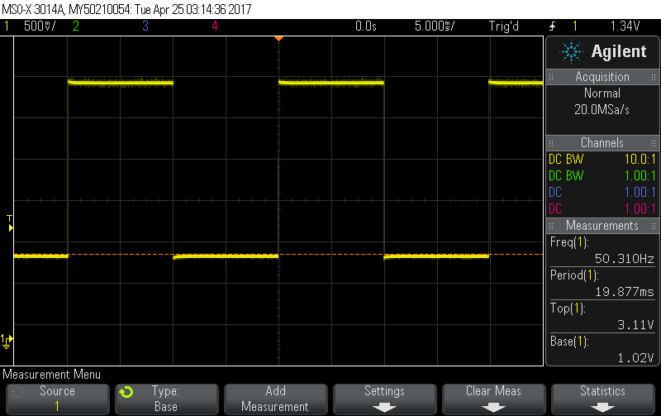

This was formed with an interrupt that switched the DAC between the two values.

# Square Wave – 2Vpp 1V offset

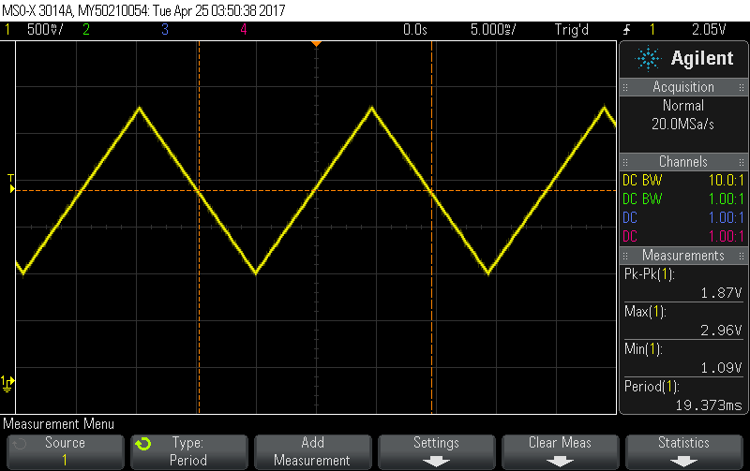

This was formed by an interrupt moving the DAC output up and down at each interrupt.

# Youtube link

<https://www.youtube.com/watch?v=ru4SxrP7f8k>

# Code

## main.c for square

//*****************************************************************************

//

// DriveDAC.C

//

//****************************************************************************

**#include** "msp.h"

**#include** <stdint.h>

**void** **Drive_DAC**(**unsigned** **int** level);

**volatile** **unsigned** **int** TempDAC_Value = 0;

**int** **main**(**void**) {

WDT_A->CTL = WDT_A_CTL_PW | WDT_A_CTL_HOLD; // Stop watchdog timer

// DCO = 24 MHz, SMCLK and MCLK = DCO

CS->KEY = CS_KEY_VAL;

CS->CTL0 = 0;

CS->CTL0 = CS_CTL0_DCORSEL_4; // DCO = 24 MHz

CS->CTL1 = CS_CTL1_SELA_2 | CS_CTL1_SELS_3 | CS_CTL1_SELM_3;

CS->KEY = 0;

// Configure port bits for SPI

P4->DIR |= BIT1; // Will use BIT4 to activate /CE on the DAC

P1SEL0 |= BIT6 + BIT5; // Configure P1.6 and P1.5 for UCB0SIMO and UCB0CLK

P1SEL1 &= ~(BIT6 + BIT5); //

// SPI Setup

EUSCI_B0->CTLW0 |= EUSCI_B_CTLW0_SWRST; // Put eUSCI state machine in reset

EUSCI_B0->CTLW0 = EUSCI_B_CTLW0_SWRST | // Remain eUSCI state machine in reset

EUSCI_B_CTLW0_MST | // Set as SPI master

EUSCI_B_CTLW0_SYNC | // Set as synchronous mode

EUSCI_B_CTLW0_CKPL | // Set clock polarity high

EUSCI_B_CTLW0_MSB; // MSB first

EUSCI_B0->CTLW0 |= EUSCI_B_CTLW0_SSEL__SMCLK; // SMCLK

EUSCI_B0->BRW = 0x01; // divide by 16, clock = fBRCLK/(UCBRx)

EUSCI_B0->CTLW0 &= ~EUSCI_B_CTLW0_SWRST; // Initialize USCI state machine, SPI

// now waiting for something to

// be placed in TXBUF

EUSCI_B0->IFG |= EUSCI_B_IFG_TXIFG; // Clear TXIFG flag

//setup interupt

TIMER_A0->CCTL[0] = TIMER_A_CCTLN_CCIE; // TACCR0 interrupt enabled

TIMER_A0->CCR[0] = 3000;

TIMER_A0->CTL = TIMER_A_CTL_SSEL__SMCLK | // SMCLK, continuous mode

TIMER_A_CTL_MC__CONTINUOUS |

TIMER_A_CTL_ID__8;

SCB->SCR |= SCB_SCR_SLEEPONEXIT_Msk; // Enable sleep on exit from ISR

// Enable global interrupt

__enable_irq();

NVIC->ISER[0] = 1 << ((*TA0_0_IRQn*) & 31);

**while** (1) {

__sleep();

__no_operation(); // increment by 100 mv

}

} // end of main

**void** **TA0_0_IRQHandler**(**void**) {

TIMER_A0->CCTL[0] &= ~TIMER_A_CCTLN_CCIFG;

TIMER_A0->CCR[0] += 0x20;

**static** **unsigned** **int** i = 0x0280;

Drive_DAC(i);

i = (i == 0x0280) ? 0x0EFF : 0x0280;

}

**void** **Drive_DAC**(**unsigned** **int** level){

**unsigned** **int** DAC_Word = 0;

**int** i;

DAC_Word = (0x1000) | (level & 0x0FFF); // 0x1000 sets DAC for Write

// to DAC, Gain = 2, /SHDN = 1

// and put 12-bit level value

// in low 12 bits.

P4->OUT &= ~BIT1; // Clear P4.1 (drive /CS low on DAC)

// Using a port output to do this for now

EUSCI_B0->TXBUF = (**unsigned** **char**) (DAC_Word >> 8); // Shift upper byte of DAC_Word

// 8-bits to right

**while** (!(EUSCI_B0->IFG & EUSCI_B_IFG_TXIFG)); // USCI_A0 TX buffer ready?

EUSCI_B0->TXBUF = (**unsigned** **char**) (DAC_Word & 0x00FF); // Transmit lower byte to DAC

**while** (!(EUSCI_B0->IFG & EUSCI_B_IFG_TXIFG));

**for**(i = 200; i > 0; i--); // Delay 200 16 MHz SMCLK periods

//to ensure TX is complete by SIMO

P4->OUT |= BIT1; // Set P4.1 (drive /CS high on DAC)

**return**;

}

## main.c for triangle

//*****************************************************************************

//

// DriveDAC.C

//

//****************************************************************************

**#include** "msp.h"

**#include** <stdint.h>

**void** **Drive_DAC**(**unsigned** **int** level);

**volatile** **unsigned** **int** TempDAC_Value = 0;

**int** **main**(**void**) {

WDT_A->CTL = WDT_A_CTL_PW | WDT_A_CTL_HOLD; // Stop watchdog timer

// DCO = 24 MHz, SMCLK and MCLK = DCO

CS->KEY = CS_KEY_VAL;

CS->CTL0 = 0;

CS->CTL0 = CS_CTL0_DCORSEL_4; // DCO = 24 MHz

CS->CTL1 = CS_CTL1_SELA_2 | CS_CTL1_SELS_3 | CS_CTL1_SELM_3;

CS->KEY = 0;

// Configure port bits for SPI

P4->DIR |= BIT1; // Will use BIT4 to activate /CE on the DAC

P1SEL0 |= BIT6 + BIT5; // Configure P1.6 and P1.5 for UCB0SIMO and UCB0CLK

P1SEL1 &= ~(BIT6 + BIT5); //

// SPI Setup

EUSCI_B0->CTLW0 |= EUSCI_B_CTLW0_SWRST; // Put eUSCI state machine in reset

EUSCI_B0->CTLW0 = EUSCI_B_CTLW0_SWRST | // Remain eUSCI state machine in reset

EUSCI_B_CTLW0_MST | // Set as SPI master

EUSCI_B_CTLW0_SYNC | // Set as synchronous mode

EUSCI_B_CTLW0_CKPL | // Set clock polarity high

EUSCI_B_CTLW0_MSB; // MSB first

EUSCI_B0->CTLW0 |= EUSCI_B_CTLW0_SSEL__SMCLK; // SMCLK

EUSCI_B0->BRW = 0x01; // divide by 16, clock = fBRCLK/(UCBRx)

EUSCI_B0->CTLW0 &= ~EUSCI_B_CTLW0_SWRST; // Initialize USCI state machine, SPI

// now waiting for something to

// be placed in TXBUF

EUSCI_B0->IFG |= EUSCI_B_IFG_TXIFG; // Clear TXIFG flag

//setup interupt

TIMER_A0->CCTL[0] = TIMER_A_CCTLN_CCIE; // TACCR0 interrupt enabled

TIMER_A0->CCR[0] = 500;

TIMER_A0->CTL = TIMER_A_CTL_SSEL__SMCLK | // SMCLK, continuous mode

TIMER_A_CTL_MC__UP |

TIMER_A_CTL_ID__4;

SCB->SCR |= SCB_SCR_SLEEPONEXIT_Msk; // Enable sleep on exit from ISR

// Enable global interrupt

__enable_irq();

NVIC->ISER[0] = 1 << ((*TA0_0_IRQn*) & 31);

P6->DIR |= BIT0;

**while** (1) {

__sleep();

__no_operation(); // increment by 100 mv

}

} // end of main

**void** **TA0_0_IRQHandler**(**void**) {

P6->OUT |= BIT0;

TIMER_A0->CCTL[0] &= ~TIMER_A_CCTLN_CCIFG;

//TIMER_A0->CCR[0] += 200;

**int** x = TIMER_A0->CCR[0];

**static** **unsigned** **int** i = 0x02F1;

**static** **int** dir = 11;

Drive_DAC(i);

**if** (i <= 0x02F0 || i >= 0x077F) dir = -dir;

i += dir;

P6->OUT &= ~BIT0;

}

**void** **Drive_DAC**(**unsigned** **int** level){

**unsigned** **int** DAC_Word = 0;

**int** i;

DAC_Word = (0x1000) | (level & 0x0FFF); // 0x1000 sets DAC for Write

// to DAC, Gain = 2, /SHDN = 1

// and put 12-bit level value

// in low 12 bits.

P4->OUT &= ~BIT1; // Clear P4.1 (drive /CS low on DAC)

// Using a port output to do this for now

EUSCI_B0->TXBUF = (**unsigned** **char**) (DAC_Word >> 8); // Shift upper byte of DAC_Word

// 8-bits to right

**while** (!(EUSCI_B0->IFG & EUSCI_B_IFG_TXIFG)); // USCI_A0 TX buffer ready?

EUSCI_B0->TXBUF = (**unsigned** **char**) (DAC_Word & 0x00FF); // Transmit lower byte to DAC

**while** (!(EUSCI_B0->IFG & EUSCI_B_IFG_TXIFG));

**for**(i = 200; i > 0; i--); // Delay 200 16 MHz SMCLK periods

//to ensure TX is complete by SIMO

P4->OUT |= BIT1; // Set P4.1 (drive /CS high on DAC)

**return**;

}