GRAND BALLROOM EVENTS — DAILY DEVELOPMENT JOURNAL
Unit 2 Applied Information Technology ATAR | Task 10: Website Project
Student: kmaba | Candidate ID: 2026-AIT-088 | Duration: 4-Week Development Cycle (July–August 2026)

Week 1: Requirements Analysis, Wireframing & Information Architecture
Dates: Monday 21 July 2026 – Friday 25 July 2026 | Key Focus: Client brief breakdown, target audience personas, sitemap structure, low-fidelity wireframing
• Analyzed client specifications for Grand Ballroom Events (Perth, WA) requiring luxury event space promotion, interactive package showcases, and dual booking/contact pathways.
• Created user personas catering to corporate planners, wedding couples, and private celebration hosts.
• Developed initial low-fidelity wireframes in Figma outlining the 7 key homepage sections (Hero, About Us, Facilities, Packages, Gallery, Testimonials, Contact) and dedicated booking flows.
• Established project Gantt chart and Kanban backlog prioritizing core structure, animations, and APA 7 attribution compliance.
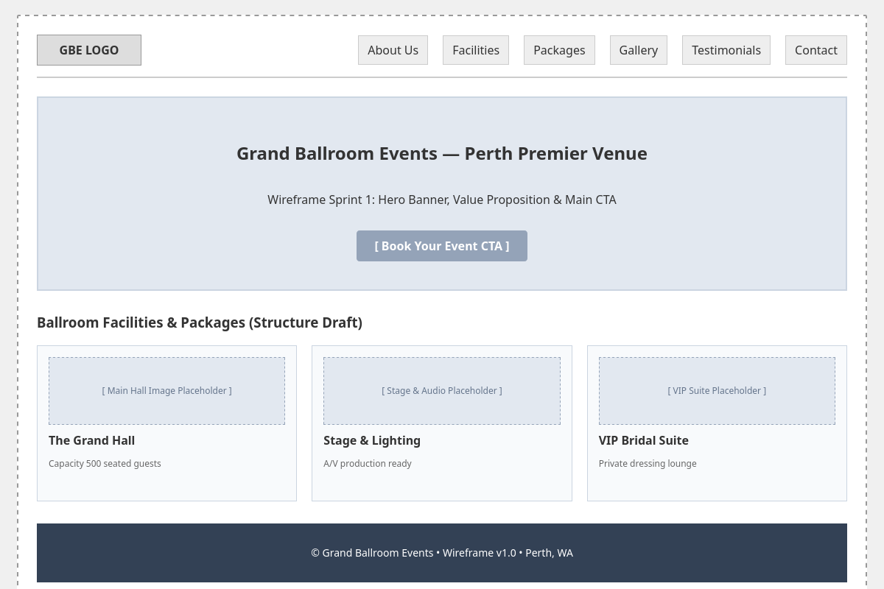  Figure 1: Initial Sprint 1 Wireframe Prototype outlining layout and section hierarchy. | 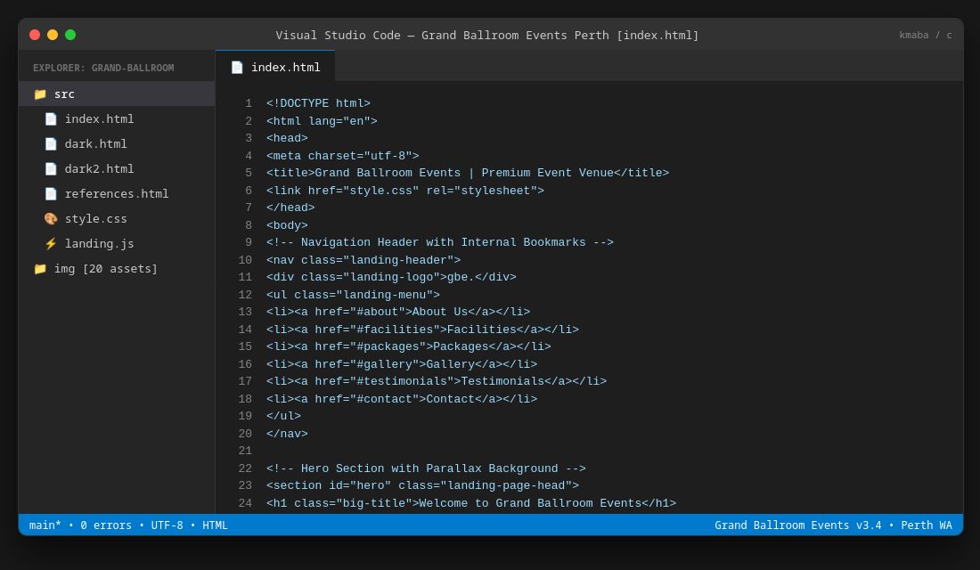  Figure 2: VS Code HTML structural scaffolding and semantic section tags.

Week 2: Mobile App Wireframing, CSS Design System & Visual Assets
Dates: Monday 28 July 2026 – Friday 1 August 2026 | Key Focus: Mobile app UI wireframing, color palette (#B78D1E Gold / #121212 Dark), typography hierarchy, high-res asset curation
• Designed mobile companion app wireframe featuring bottom tab navigation, quick service cards, and instant availability checker.
• Established design tokens: Primary Luxury Gold (#B78D1E), Deep Obsidian (#121212 / #191b1d), Playfair Display serif headers, and Inter body sans-serif.
• Curated 20 high-resolution ballroom images from Unsplash and 2 atmospheric vertical highlight videos from Pixabay, strictly logging APA 7 citations.
• Built master CSS framework ensuring fluid responsive typography using CSS clamp() and CSS Grid layout modules.
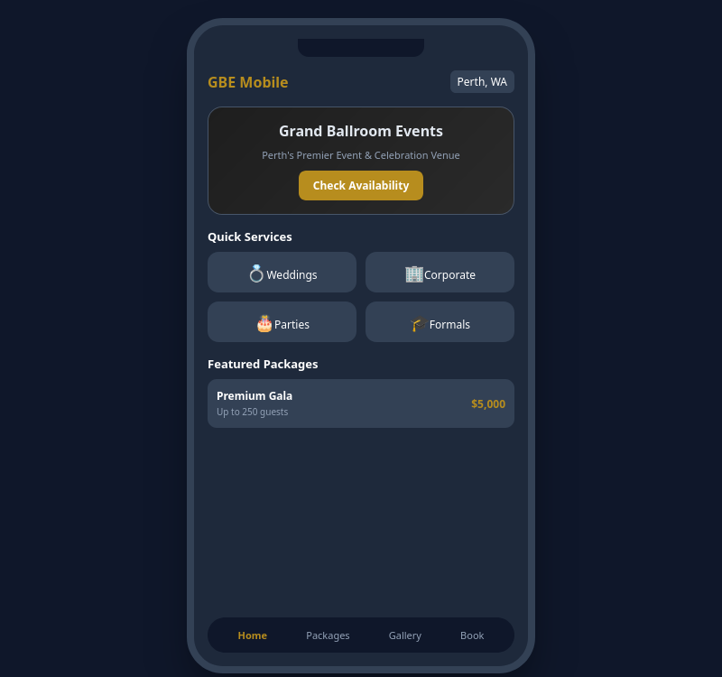  Figure 3: Mobile App UI Prototype with bottom navigation and touch-optimized package cards. | 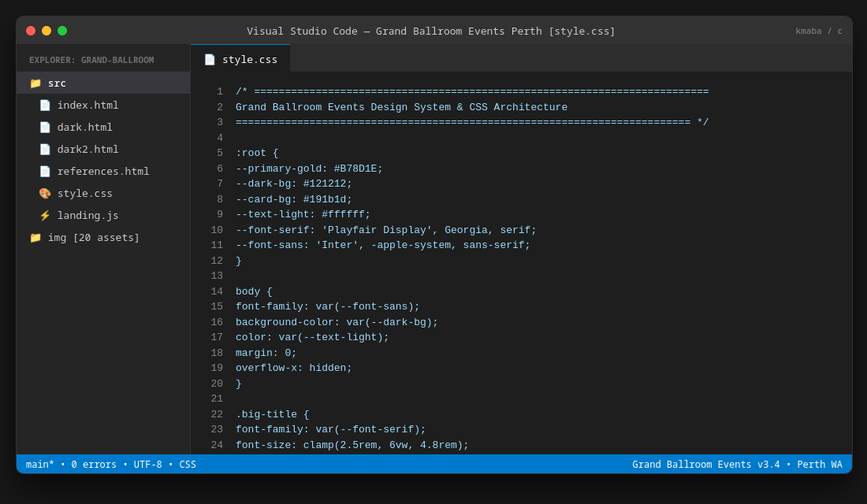  Figure 4: VS Code CSS Design System and theme token definition.

Week 3: Core Interactive Engineering, Loader & Smooth Scrolling
Dates: Monday 4 August 2026 – Friday 8 August 2026 | Key Focus: Interactive animations, Locomotive smooth scroll, Barba.js transitions, splash loader calibration
• Implemented custom GSAP timeline splash screen with numerical count-up animation (0–100%) and sliding text reveal.
• Integrated Locomotive Scroll for momentum smooth scrolling and interactive mouse cursor tracking.
• Engineered Barba.js PJAX page transitions allowing seamless routing between index.html, dark.html (Check Availability), and dark2.html (Request Booking).
• Refined Hero CTA into a clean interactive dropdown and added responsive video gallery autoplay.
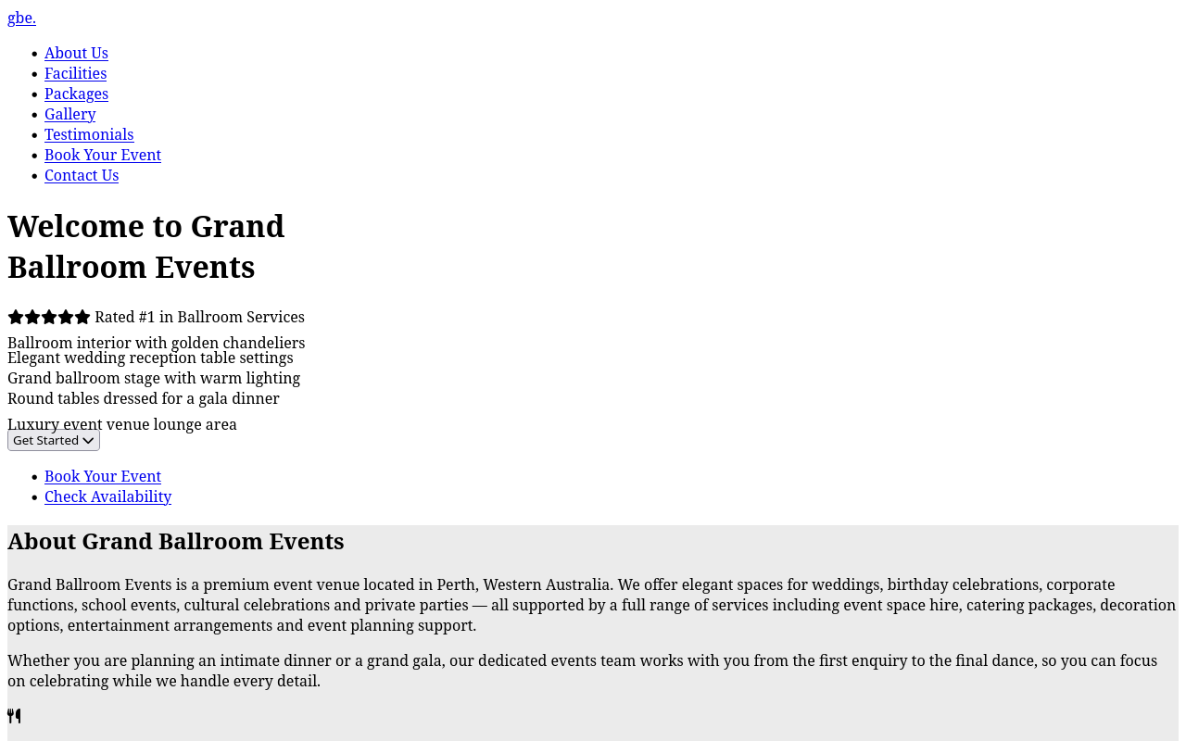  Figure 5: Live Desktop Hero section with Parallax multi-image fan and luxury tagline. | 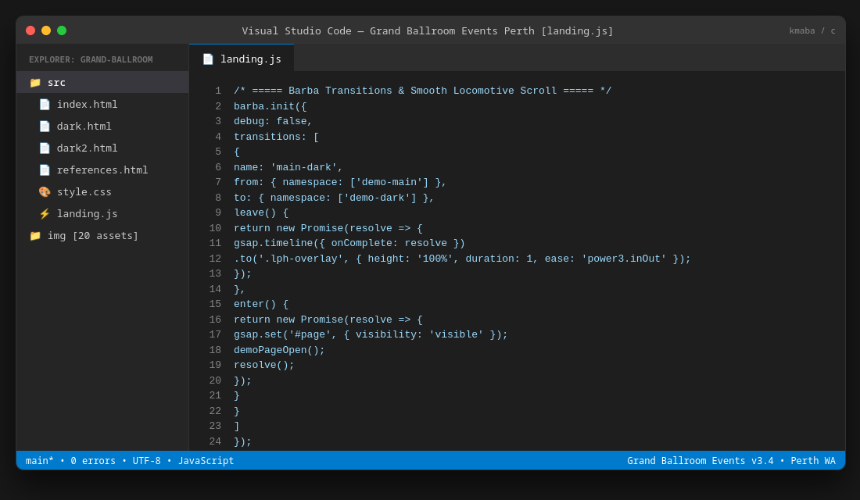  Figure 6: VS Code JavaScript engineering: Barba PJAX transitions and Locomotive scroll hooks.

Week 4: Subpages, Peer Evaluation, Consolidation & Final Delivery
Dates: Monday 11 August 2026 – Monday 17 August 2026 | Key Focus: Check Availability & Contact booking forms, peer feedback iteration, CSS/JS consolidation, APA 7 references page
• Completed Check Availability (dark.html) and Request a Booking (dark2.html) with input validation, guest selectors, and response confirmation.
• Conducted formal peer review: fixed navbar link to Testimonials, centered logo header on sub-pages, and tuned loader timing.
• Consolidated stylesheet into unified style.css and embedded JavaScript inline in HTML files for streamlined architecture.
• Created comprehensive References page (references.html) formatted in strict APA 7th edition with instant print/PDF support.
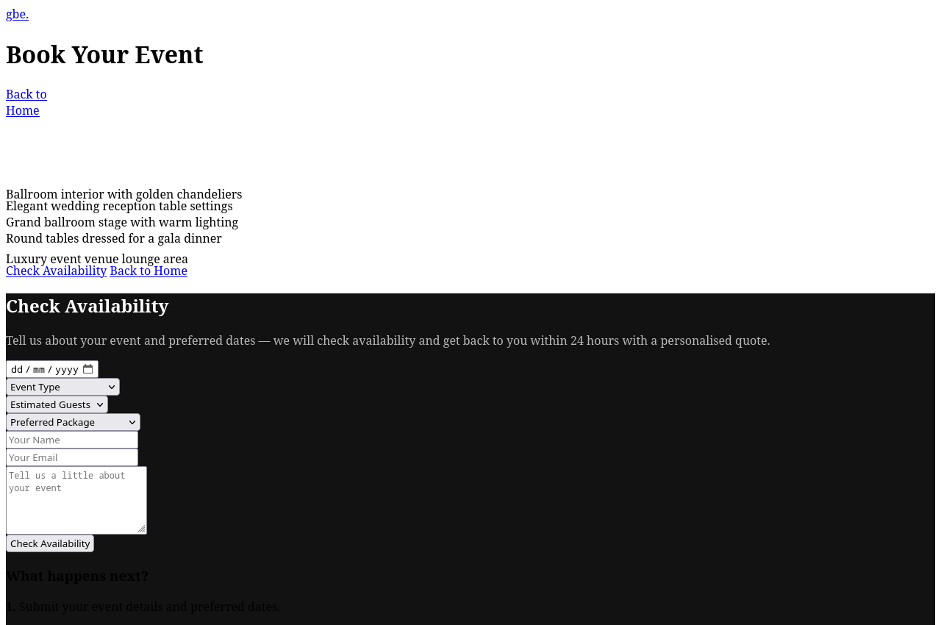  Figure 7: Dedicated Book Your Event / Check Availability page (dark.html). | 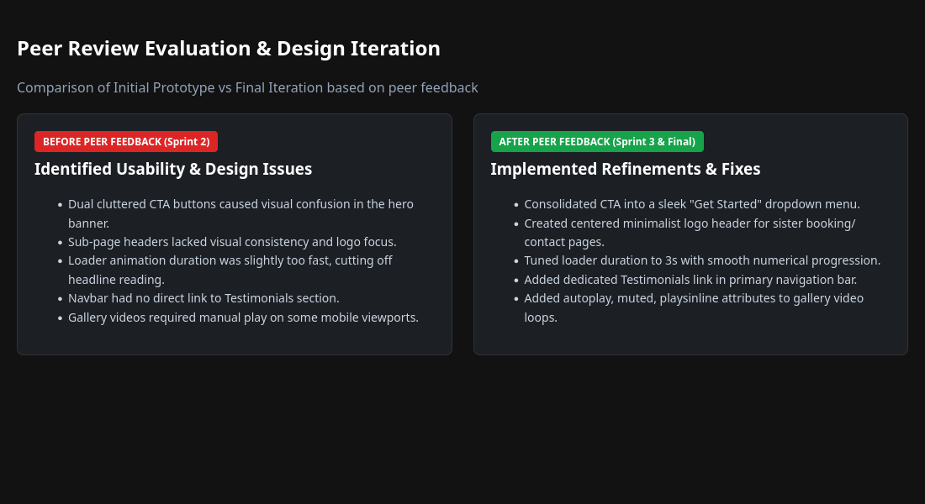  Figure 8: Peer Review Evaluation before-and-after implementation audit.

