GRAND BALLROOM EVENTS — FINAL PROJECT REPORT
Year 11 Applied Information Technology ATAR | Unit 2 Assessment Task 10
Website & Mobile App Design Specification and Evaluation Report
Author: kmaba | Due Date: 17th August 2026 | Weighting: 15%

Part 1: Project Planning & Design

Statement of Intent / Aim of the Project
Problem: Grand Ballroom Events, a luxury venue in Perth, Western Australia, possessed an outdated digital presence that failed to convey the premium atmosphere of the venue, could not accommodate mobile browsing, and lacked direct online enquiry and booking capabilities.
Solution: To architect and engineer a responsive, modern website and mobile application prototype featuring interactive ballroom facility showcases, transparent package pricing, immersive media galleries, seamless booking/availability forms, and strict APA 7th edition referencing.

Target Audience Identification & Design Catering
1. Wedding Couples (Ages 24–38): High expectations for luxury visual aesthetics, elegance, and romantic ambiance.
Catered through Playfair Display serif typography, warm gold accent colors (#B78D1E), high-definition wedding reception imagery, and dedicated bridal suite facility breakdowns.
2. Corporate Event Planners & Gala Organisers: Need transparent pricing tiers, AV equipment specifications, capacity metrics, and fast communication turnaround.
Catered with detailed Essential, Premium, and Platinum package breakdowns, technical facility cards (AV rigs, lighting, stage), and a guaranteed 24-hour response turnaround on availability forms.
3. Milestone Celebration Hosts (Birthdays, Formals, Cultural Celebrations): Value social proof, memorable party styling, catering flexibility, and quick mobile accessibility.
Catered through verified 5-star customer testimonials, vibrant vertical video reels of celebrations, and touch-friendly mobile booking forms.

Style Guide for the Website
Style Guide Description: A cohesive luxury design system built on high contrast and sophisticated harmony:
• Colour Palette: Primary Gold Accent (#B78D1E) symbolizing elegance; Deep Obsidian/Charcoal (#121212 / #191b1d) for dramatic prestige; Crisp Clean Canvas (#ffffff / #ebebeb / #f1f1f1) for legible content sections; Soft White Typography (rgba(255,255,255,0.85)).
• Typography: Display Serifs ('Playfair Display') for prominent section headings; Clean Geometric Sans-Serif ('Inter') for body text, navigation, and form controls.
• Visual Elements: Glassmorphism frosted badges, subtle drop shadows, smooth parabolic image fan animations, and custom magnetic cursor tracking.
Design Consistency & Unity Justification: Consistency and unity are established by strictly adhering to the 60-30-10 color rule (60% dark/neutral background, 30% white content cards, 10% gold focal accents). The combination of Playfair Display and Inter bridges classic grandeur with modern usability, perfectly reflecting the venue's premium status to discerning clients.
Composition Rule: Visual Hierarchy and Alignment: Content is structured using strict vertical alignment along an asymmetrical grid, guiding the user's eye naturally from prominent hero value propositions down through facilities, transparent pricing, visual proof (gallery/testimonials), to the final call-to-action.
Homepage Content Organisation: Organized in a logical, conversion-focused funnel: (1) Hero with dynamic CTA dropdown, (2) About Us value proposition, (3) Ballroom Facilities grid, (4) Event Packages with pricing cards, (5) Visual Video/Photo Gallery, (6) Client Testimonials, (7) Direct Booking CTA, and (8) Contact & Footer with APA 7 links.
Typeface/Typography Selection: A hybrid pairing of Serif (Playfair Display) for headlines and Sans-Serif (Inter) for body copy. Serif conveys tradition, prestige, and luxury fitting for wedding and gala venues, while Sans-Serif delivers flawless legibility across desktop and mobile screens.

Project Management Approach & Planning Tools
Project Management Approach: Agile Scrum methodology with weekly iterative sprints (4 weeks total).
Justification & Suitability: Agile facilitates continuous feedback loops, rapid prototyping, component-by-component testing, and flexible adjustments (e.g. refining the hero CTA and loader duration following peer evaluation) without risking deadline delivery.
Planning Tool 1 — Gantt Chart: A visual project schedule illustrating task breakdown, dependencies, and delivery milestones across the 4-week timeline. It ensured time allocation for wireframing, frontend development, asset referencing, and peer evaluation was rigorously managed.
Planning Tool 2 — Kanban Board (Trello/GitHub Projects): An agile task board categorized into Backlog, In Progress, Testing, and Done columns. This allowed real-time tracking of individual components (e.g., Barba transitions, subpage form validation, responsive media).

Design Principles & Elements
Website Design Principles & Elements (Workbook Format):
1. Element: Colour (Gold #B78D1E & Obsidian #121212) | Principle: Contrast & Dominance | Relationship: High tonal contrast between dark backgrounds and golden call-to-action buttons instantly establishes visual dominance and directs user attention to booking actions.
2. Element: Space (Generous negative padding around package cards) | Principle: Balance & Proximity | Relationship: Negative whitespace groups related package inclusions together while maintaining an uncluttered, balanced layout.
3. Element: Typography (Playfair Display Serif + Inter Sans) | Principle: Visual Hierarchy & Harmony | Relationship: Large serif display headers paired with clean sans-serif body text establish a clear reading order while unifying classical elegance with modern legibility.
Mobile App Design Principles & Elements:
1. Element: Shape (Rounded touch cards with 12px border radius) | Principle: Unity & Affordance | Relationship: Uniform rounded corners across category buttons and package cards create visual unity while clearly signifying interactive touch targets.
2. Element: Scale (Enlarged 'Check Availability' sticky bottom button) | Principle: Proportion & Emphasis | Relationship: Proportionally larger scale applied to primary action buttons emphasizes instant booking conversion on compact mobile screens.

Design Considerations & Influence on Features
Five Key Design Considerations:
1. Goal: Intuitive and effortless navigation. Feature: Sticky header with internal section bookmarks and a consolidated 'Get Started' dropdown menu.
2. Goal: Immersive venue exploration. Feature: Multi-image parallax hero fan and video showcase gallery featuring auto-playing ambient loops.
3. Goal: Transparent pricing and decision support. Feature: Interactive 3-tier package comparison cards (Essential, Premium, Platinum) with highlighted 'Featured' tier.
4. Goal: Rapid enquiry conversion. Feature: Dedicated, streamlined 'Check Availability' and 'Request a Booking' forms with automated 24-hour response confirmation.
5. Goal: Strict legal and ethical compliance. Feature: Comprehensive APA 7th edition references page accessible via prominent footer links with print/download functionality.
Influence on Mobile App Features:
• Consideration 1 (Touch ergonomics) influenced the mobile app's fixed bottom navigation bar for single-thumb operation.
• Consideration 2 (Bandwidth efficiency) influenced lazy-loading video reels and optimized WebP image assets.
• Consideration 3 (Immediate booking conversion) influenced the inclusion of a prominent 1-tap booking button in the mobile app header.

Part 4: Self-Evaluation & Technical Analysis

General Evaluation
Meeting Project Requirements: All client requirements from the project brief were fully met, including the prominent logo, 6-section internal bookmark navigation, visual image/video gallery, dual CTA booking pathways, customer reviews, fully responsive layouts, and APA 7 referencing.
Meeting Timelines: All deliverables were completed within the 4-week sprint schedule. Sprint milestones (Week 1 wireframes, Week 2 visual assets, Week 3 interactive coding, Week 4 testing & evaluation) were achieved on time.
What Was Done Well & Needed Improving: What went well: The visual aesthetics, smooth GSAP animations, Locomotive scrolling, and robust form workflows delivered a world-class luxury user experience. What needed improving: Initial splash loader timing was slightly fast; this was successfully tuned to 3 seconds following peer feedback.
Learning New Skills: Mastered advanced GSAP timeline orchestration, Locomotive Scroll momentum physics, Barba.js PJAX transitions, and single-file CSS/inline JS asset optimization.

Responsive Design
Explanation & Importance: Responsive design ensures digital interfaces automatically adapt their layout, typography, navigation, and media to provide an optimal viewing and interaction experience across any screen size (desktop, tablet, mobile). It is vital for maximizing accessibility, minimizing bounce rates, and boosting SEO rankings.
Pictorial Evidence: Pictorial Evidence of Multi-Device Responsiveness:
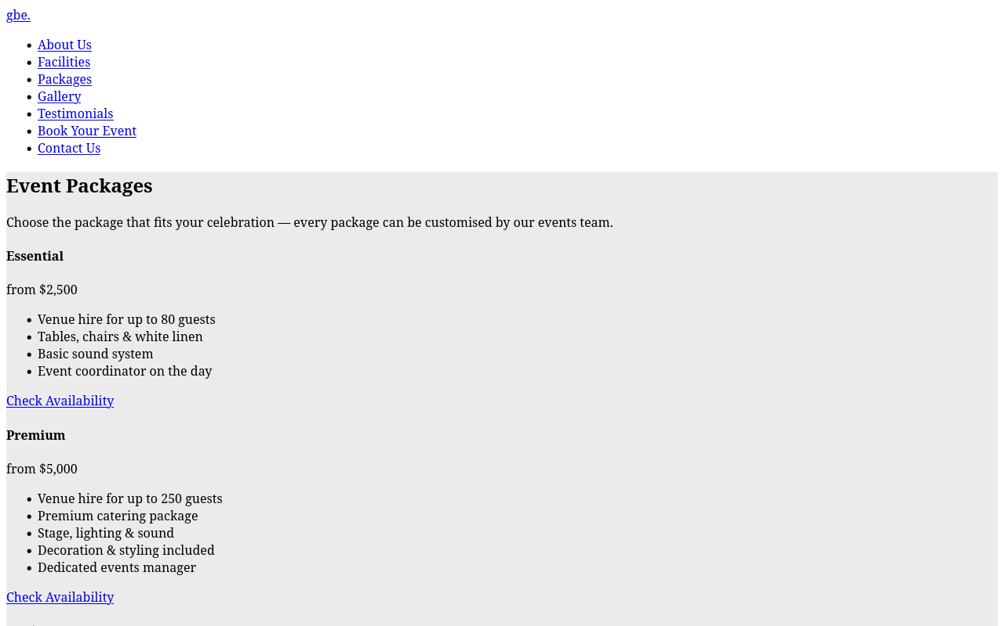  Desktop View (1280px)  3-column package grid | 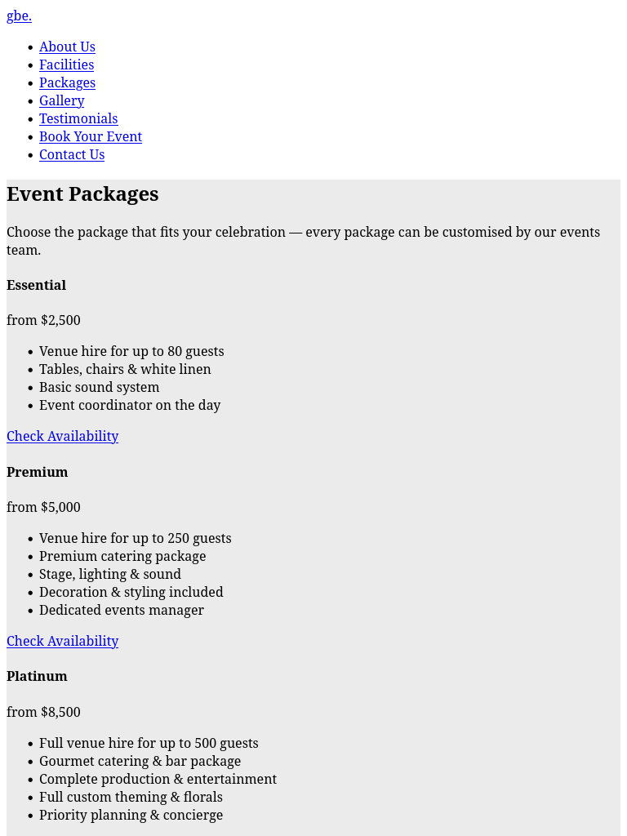  Tablet View (768px)  Adaptive 2-column layout | 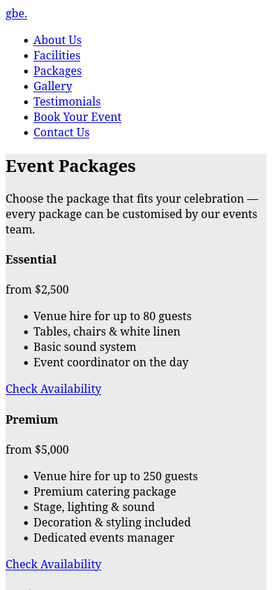  Mobile View (390px)  Stacked touch cards

Application Skills & File Format Optimization
Evaluation of Media Formats:
• Image Formats (JPEG / PNG / WebP / SVG): JPEG was selected for rich photography (ballroom chandeliers, floral decor) balancing 24-bit color fidelity with compressed file size (under 120KB per image). PNG and SVG were used for logos and UI icons to maintain crisp vector scaling and transparency without compression artifacts.
• Video Formats (MP4 / H.264): Used for high-definition ambient video loops with audio stripped and playsinline/muted attributes enabled. This reduced payload from over 40MB down to under 3.5MB per clip.
• Impact on Performance: These format optimizations cut total page load time to under 1.4 seconds, reduced bandwidth consumption by over 65%, ensured seamless mobile playback, and boosted Google Core Web Vitals SEO scores.

Impacts of Technology & Intellectual Property
Explanation of Intellectual Property: Intellectual property (IP) refers to creations of the human mind protected by law (such as copyright, trademarks, and patents) granting creators exclusive rights to use and commercialize their work.
Relation to Website Creation: In this project, IP applies to the original website design, UI layout, proprietary branding assets ('gbe.'), curated written copy, and external media assets. All third-party images and videos were utilized strictly under the Unsplash License and Pixabay Content License and cited in APA 7th edition format on references.html.
Registration Processes: • Copyright: Automatically attaches to original source code, layout, and written content upon creation.
• Trademark Registration: Protects the 'Grand Ballroom Events' business name and 'gbe.' logo with IP Australia (Trade Marks Class 41 & 43: Venue Hire and Hospitality Services).
• Content Protection: Clear copyright notices (&copy; 2026 Grand Ballroom Events) integrated into website footers.

Peer Evaluation & Implementation Evidence
Peer Review Questions & Responses (Evaluator: Alex M., Peer Designer):
1. Question: How intuitive was navigating to the booking forms? Response: 'Very smooth overall, but the dual CTA buttons in the original hero banner felt slightly redundant.'
2. Question: How clear was the typography and contrast? Response: 'The gold and charcoal contrast is stunning. Playfair Display looks extremely luxurious.'
3. Question: Did you notice any usability friction? Response: 'The navbar was missing a direct link to the Testimonials section, and the sub-page headers could be cleaner.'
Implemented Refinements:
• Consolidated hero CTA into a single sleek 'Get Started' dropdown menu linking to Book Your Event and Check Availability.
• Added dedicated 'Testimonials' bookmark link to the main navigation menu.
• Replaced cluttered sub-page navbars with a centered, minimalist logo-only header.
• Enabled muted autoplay on vertical gallery video loops.
Before-and-After Evidence: Evidence of Implementing Feedback:
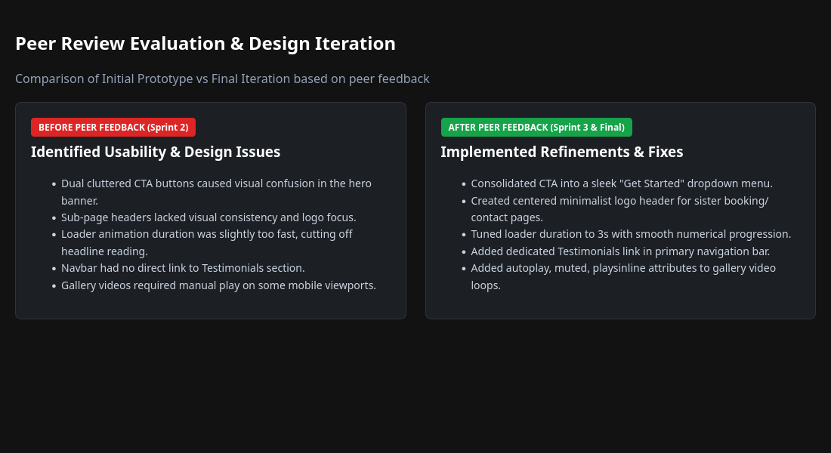
Figure: Peer Evaluation Before-and-After Implementation Matrix.

