Kimberly mackey

02/19/2021

Cit220

Hands on one

1.Create downloads folder and calling it.

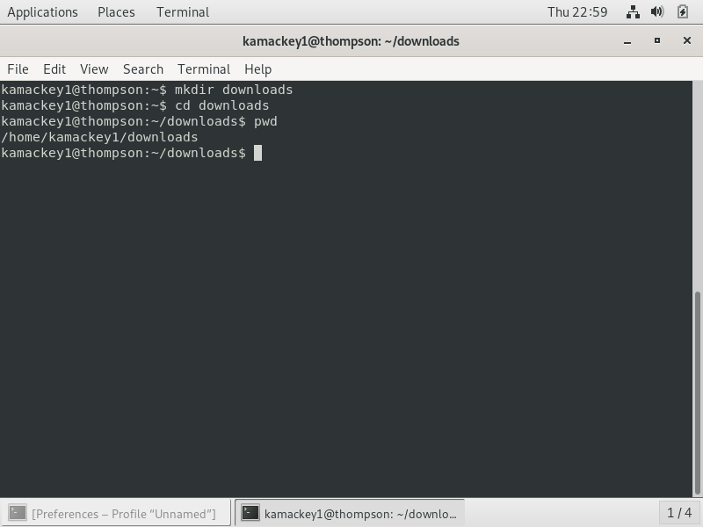

2.unzip DCVMStools file and call file.

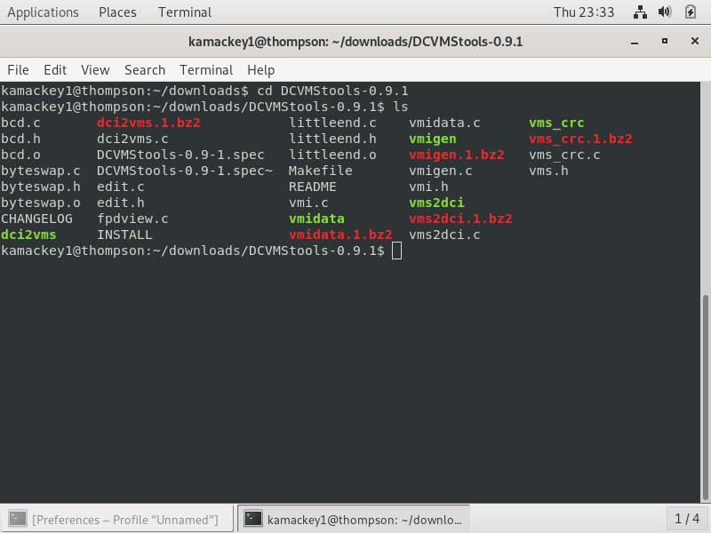

Listing all files ending with .c

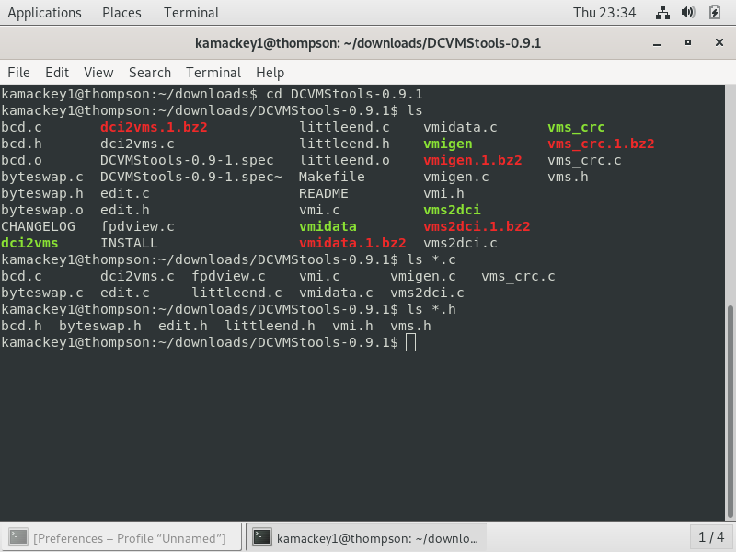

Listing all files and sized and changed README to README.txt also

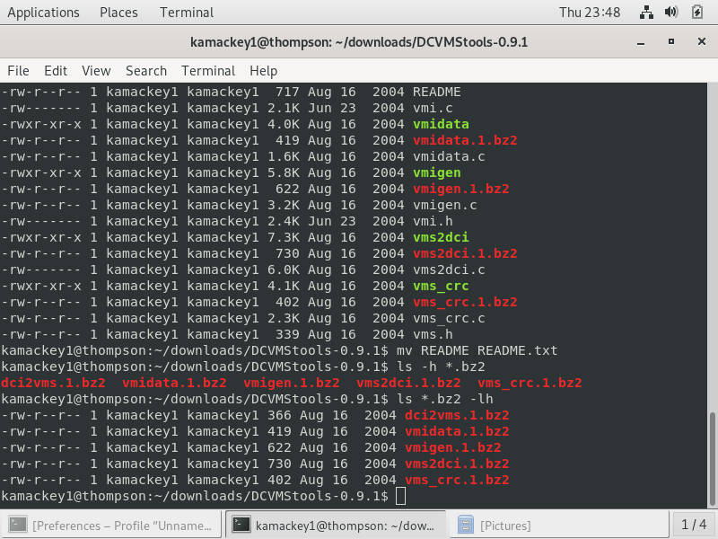

Copying all .h and .c files into the new backup/ directory

