Kimberly mackey

Unix Permissions Hands-On

Cit220

02/27/2021

2) Run the command

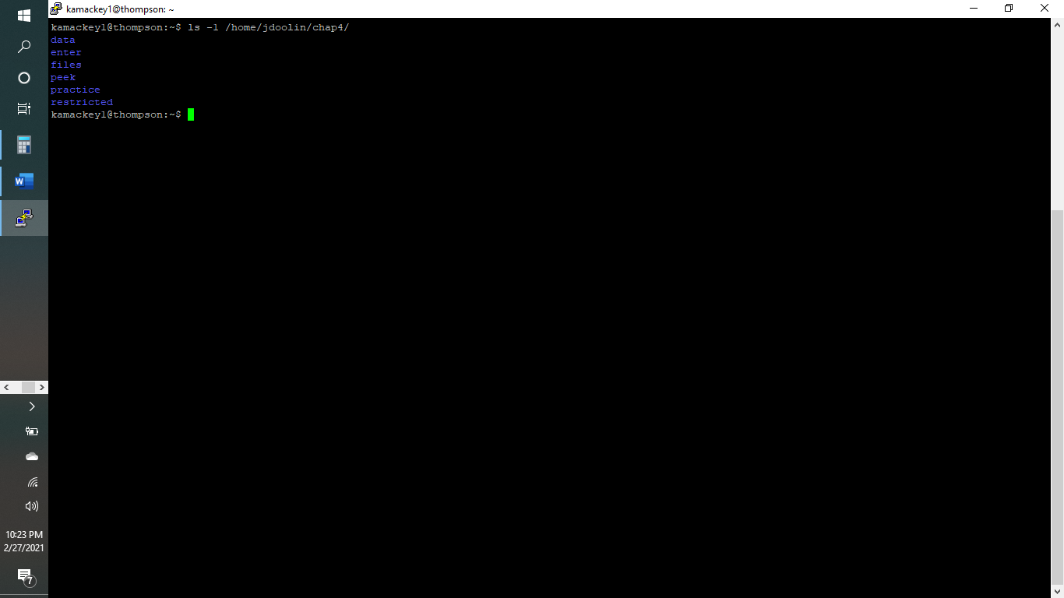

3) Run the commands:

describe why you saw the behavior that you did.

I can read the file names of the directory but cannot read any info about the files and cannot execute or write since the file isn’t in a group I am in.

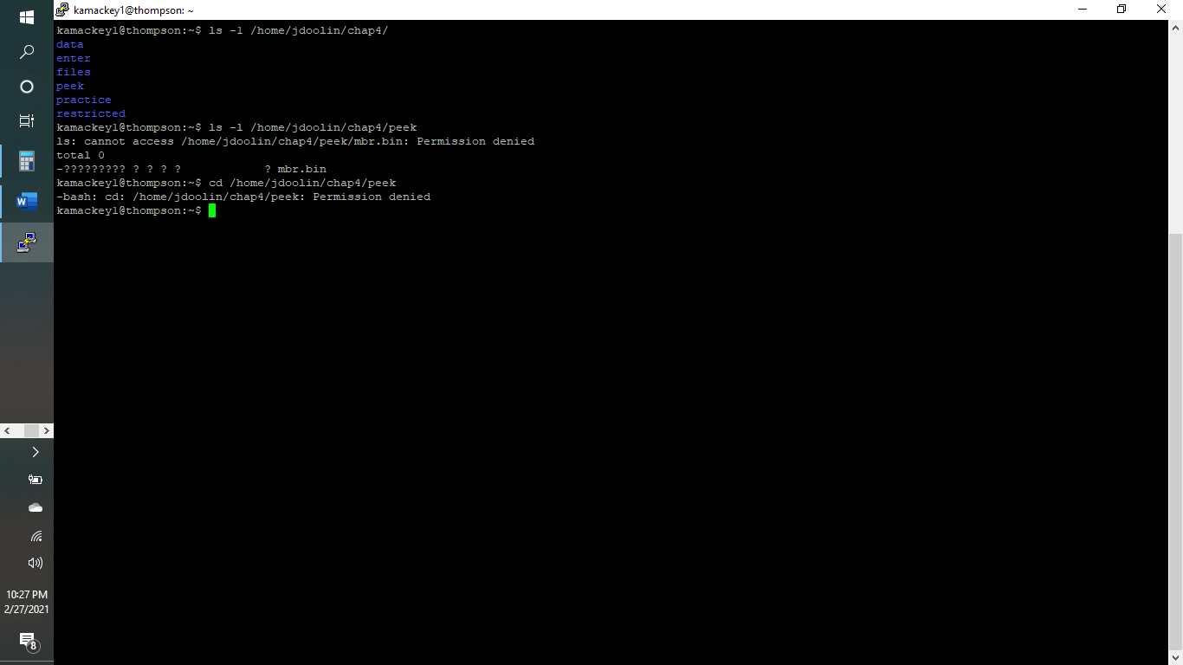

4) Run the command:

below the screenshot, describe why you saw the behavior that you did.

I do not have permission to read, write or execute the file at all.

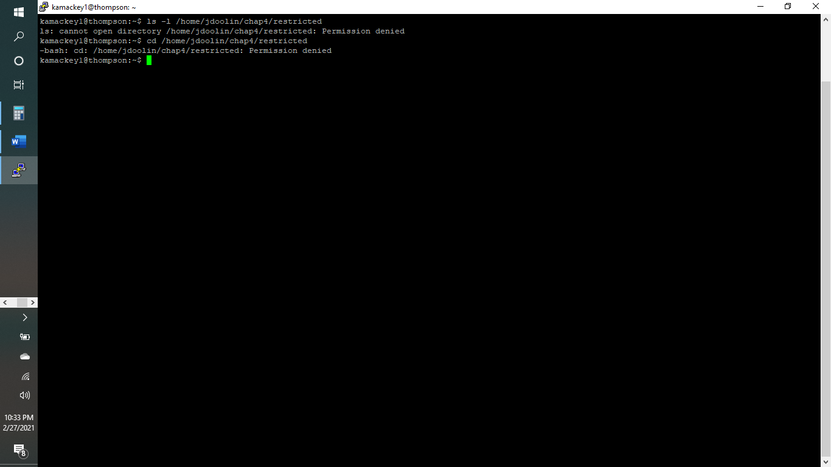

5.) Run the command:

below the screenshot, describe why you saw the behavior that you did.

I have permission to read and execute but not write.

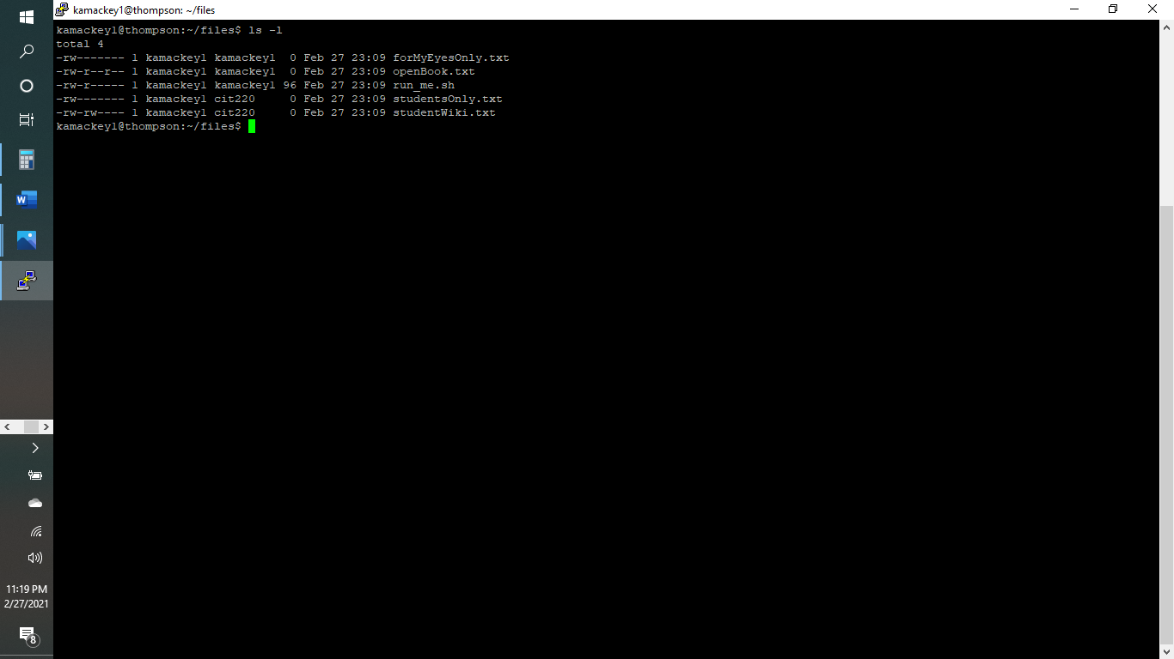

6) Try to copy the directory /home/jdoolin/chap4/data to your home directory

7) That should have failed. Why?

I am not a member of the group that the file is in.

14) Run the file "run_me.sh" by typing the following

What happened?

Permission was denied

16) Run the following command:

