WEB ASSIGNMENT

Q1-

|  |
| --- |
| const mongoose = require('mongoose');  async function main(){ await mongoose.connect('mongodb://127.0.0.1:27017/test3');  } main()  .then(()=>{console.log("Connected Succesfully");})  .catch((err)=>{console.error(err);});  const userSchema = new mongoose.Schema({ name:String, Roll_no:String, age:Number,  });  const User = mongoose.model("User",userSchema); // Making the model or we can say making the collection and giving the template to the collection.  const user1=new User({ // Inserting one by one or making the document for the collection User.  name: "Nitesh saini", Roll_no: "22cs2015", age: 20  }); |
| const user2=new User({ // Inserting or making the document for the collection User.  name: "Jyotirmoy konwar", Roll_no: "22cs2016", age: 20  }); user1.save(); user2.save(); |

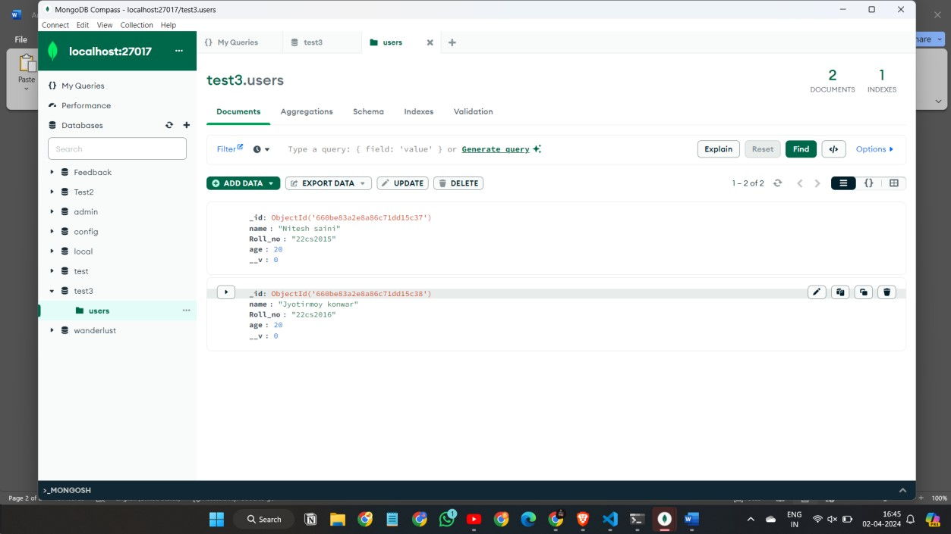

Q-2

Step -1

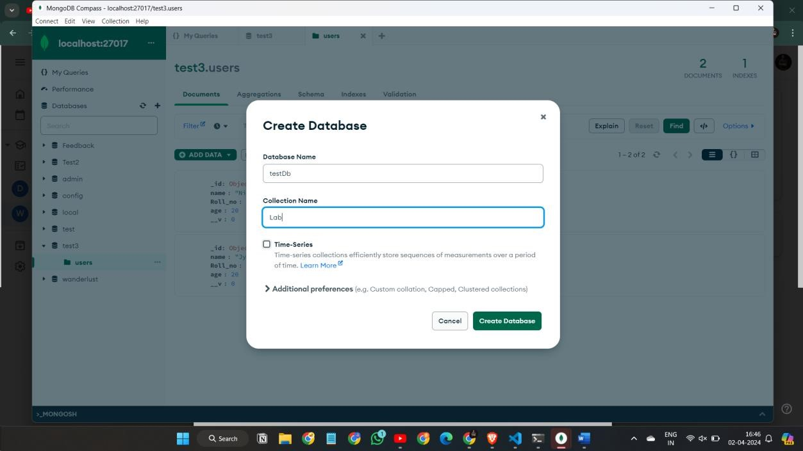

Step-2

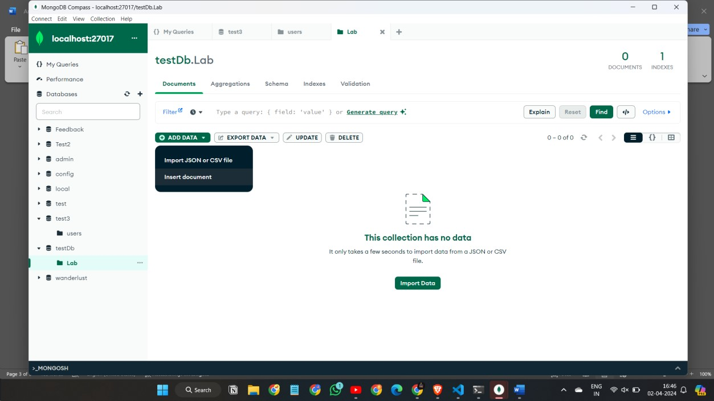

Step-3

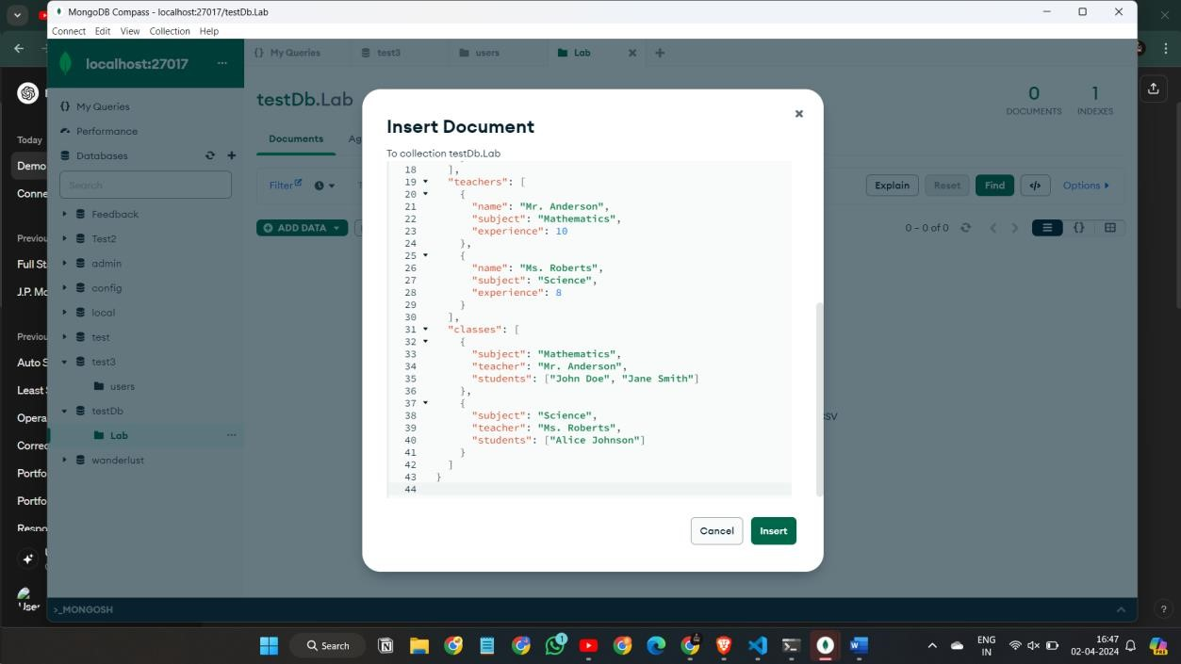

Step-4

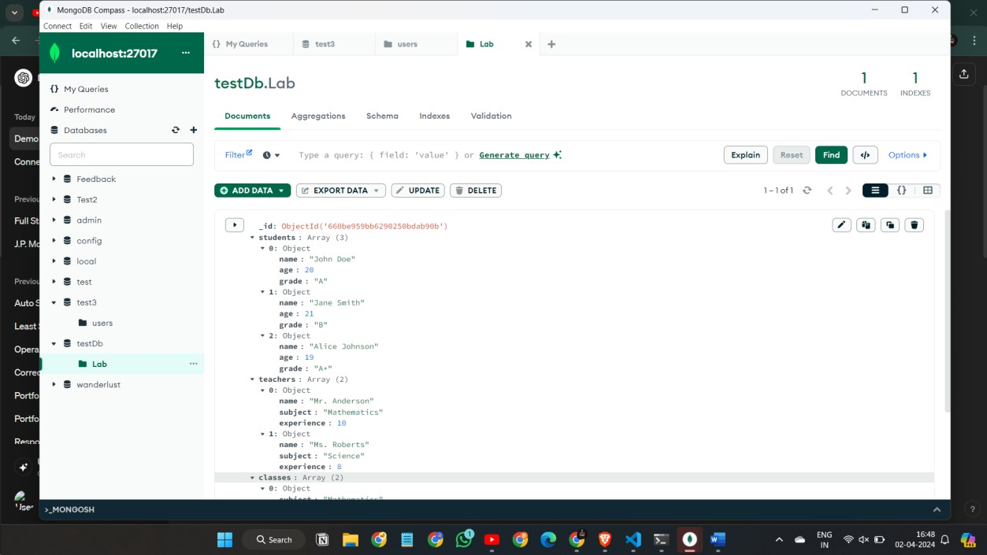

Q-3

Step-1

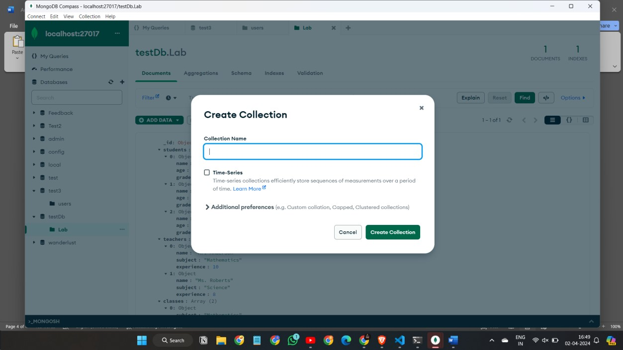

Step-2

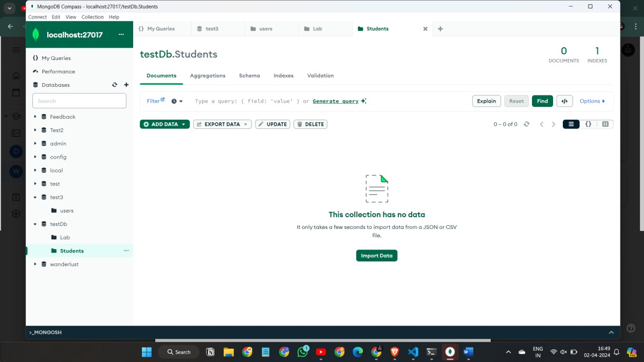

Step-3

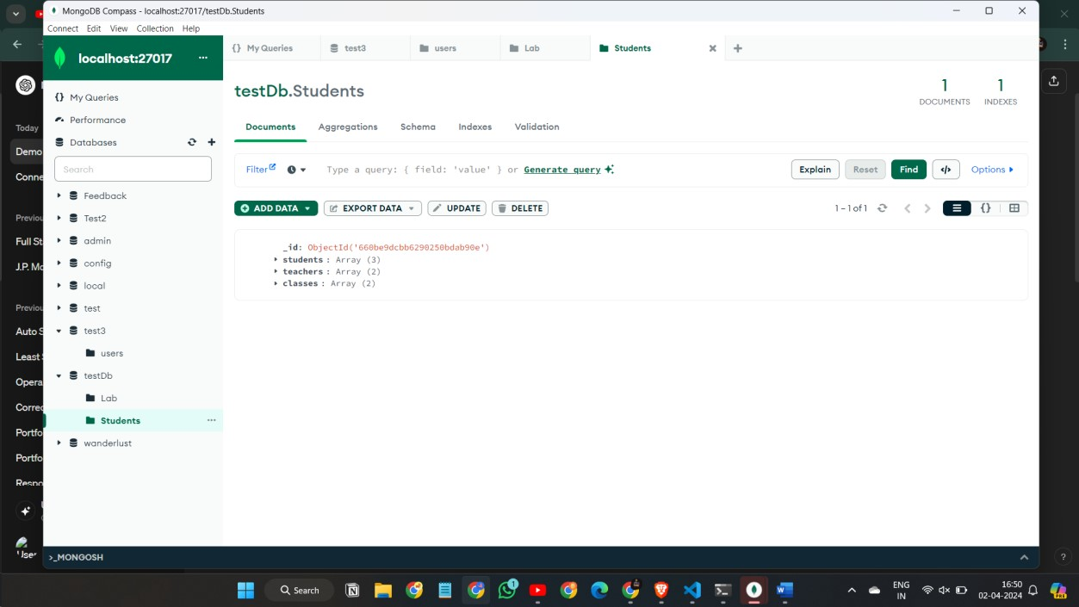

Q-4

Step-1

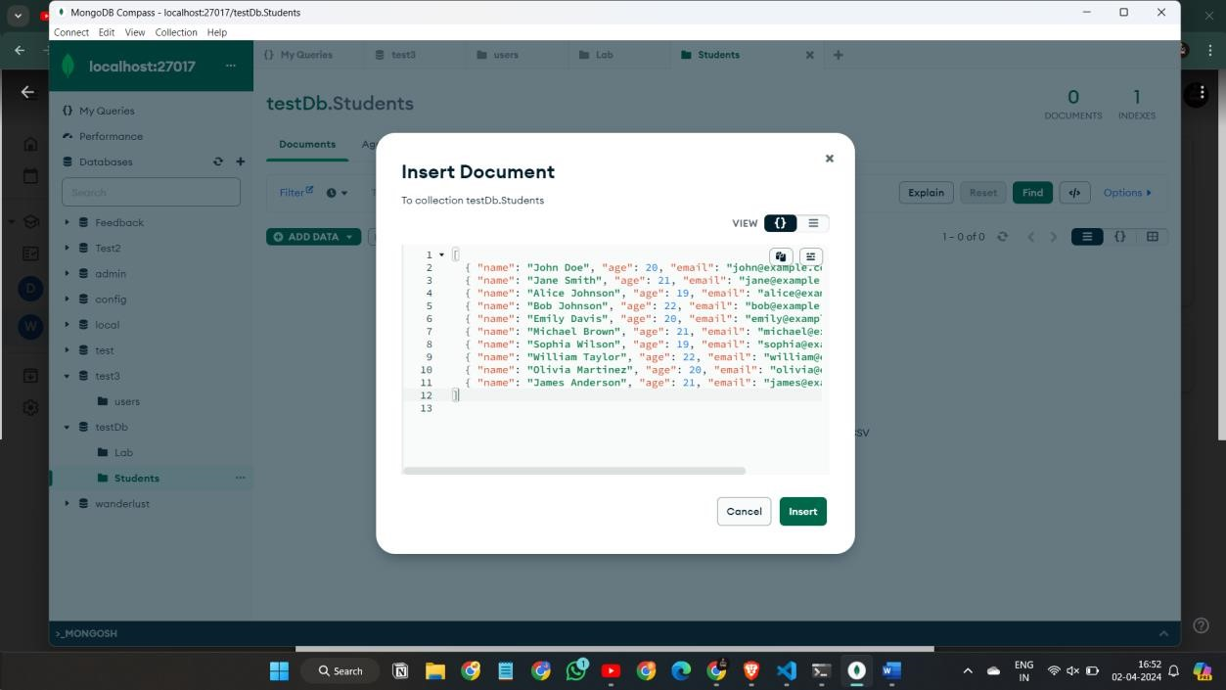

Q-5

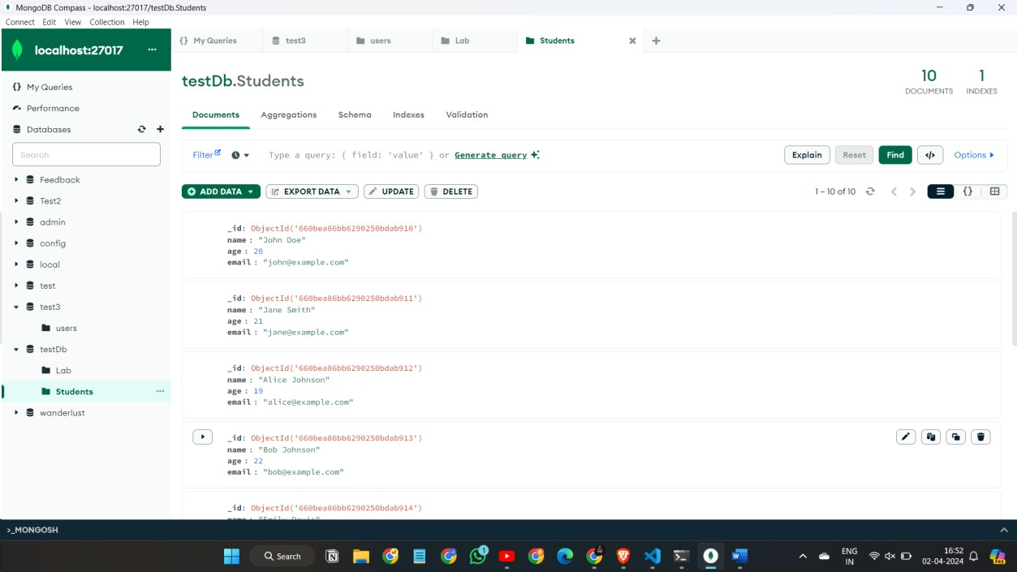

Q-6

Step-1

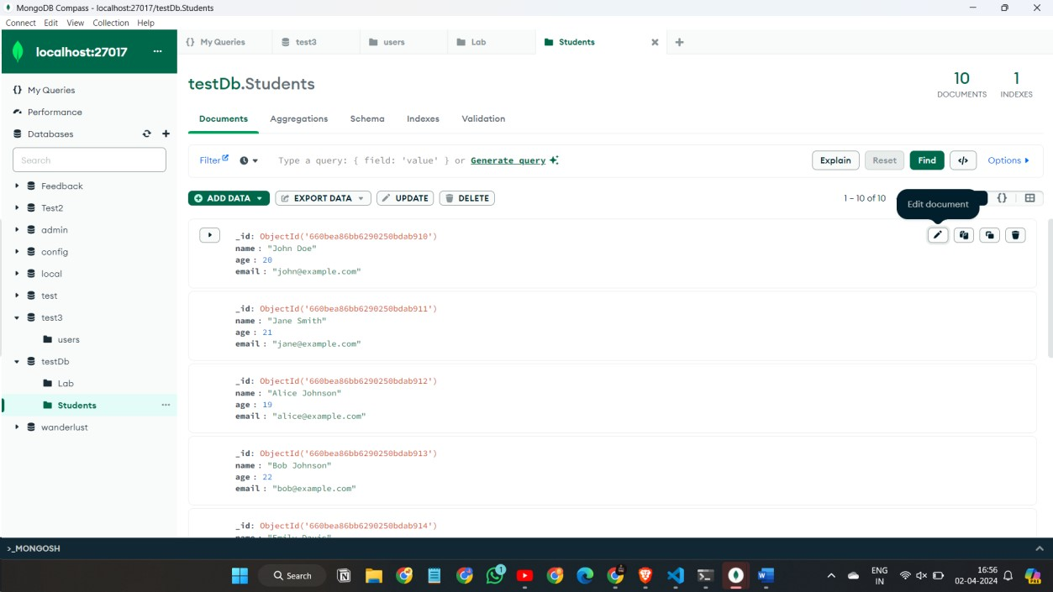

Step-2

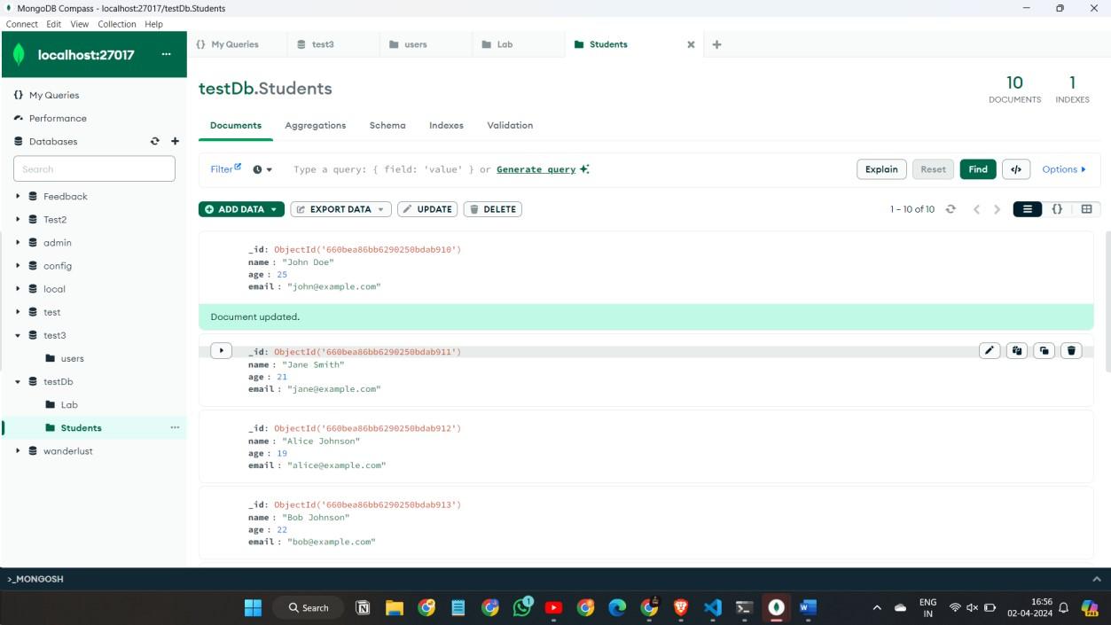

Q-7

Step-1

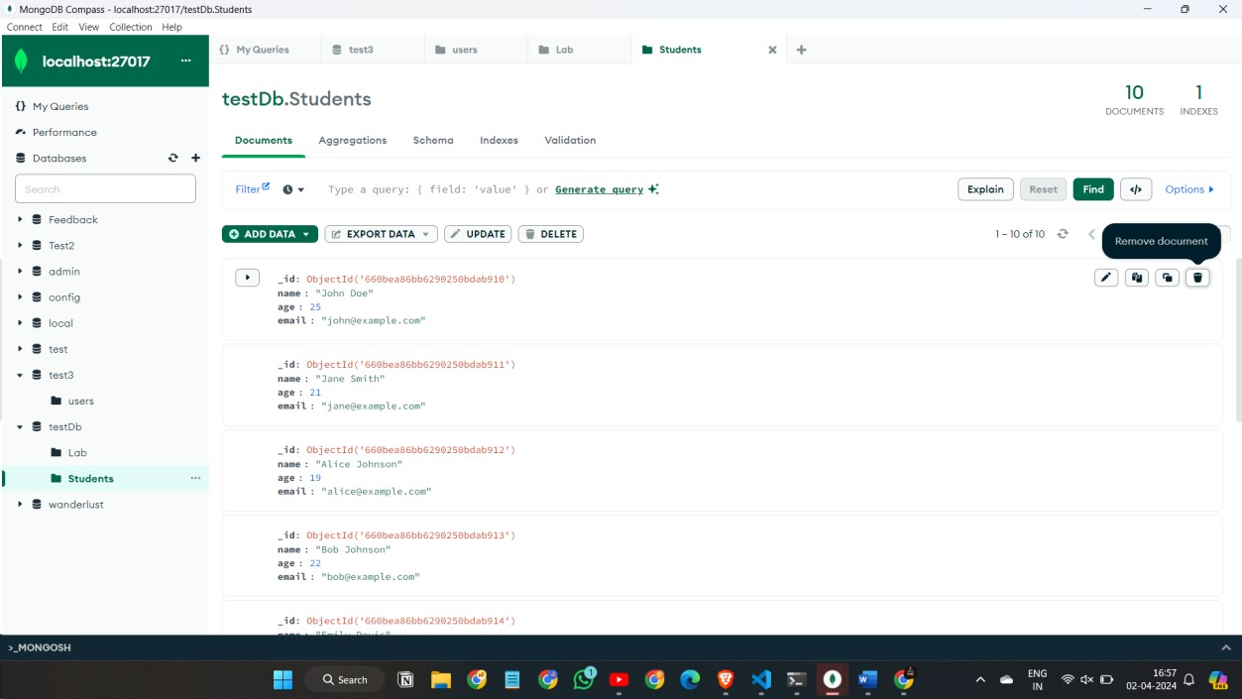

Step-2

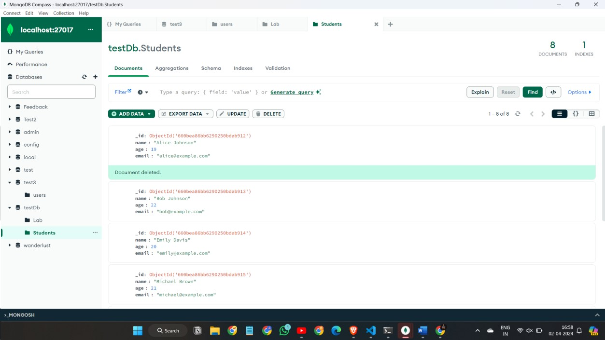

Q-8

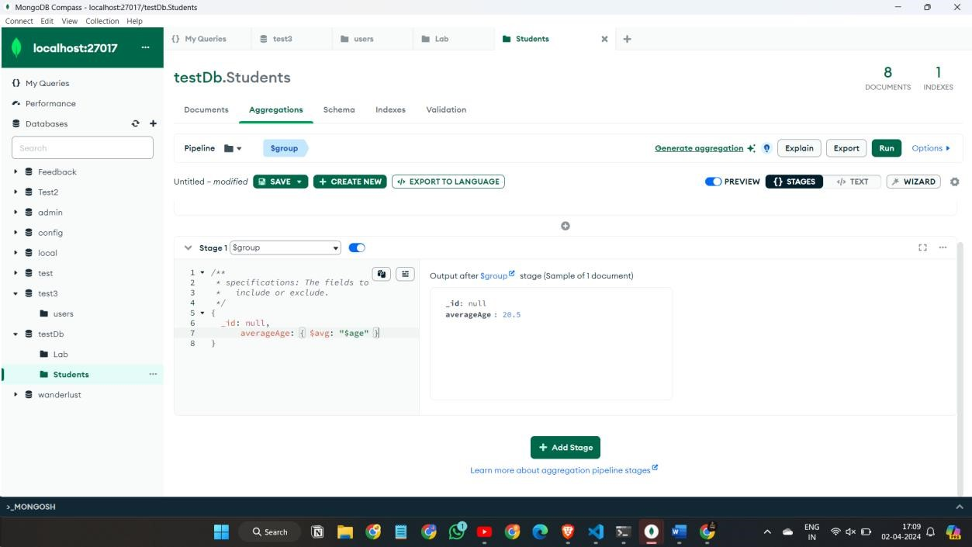

Q-9

Step-1

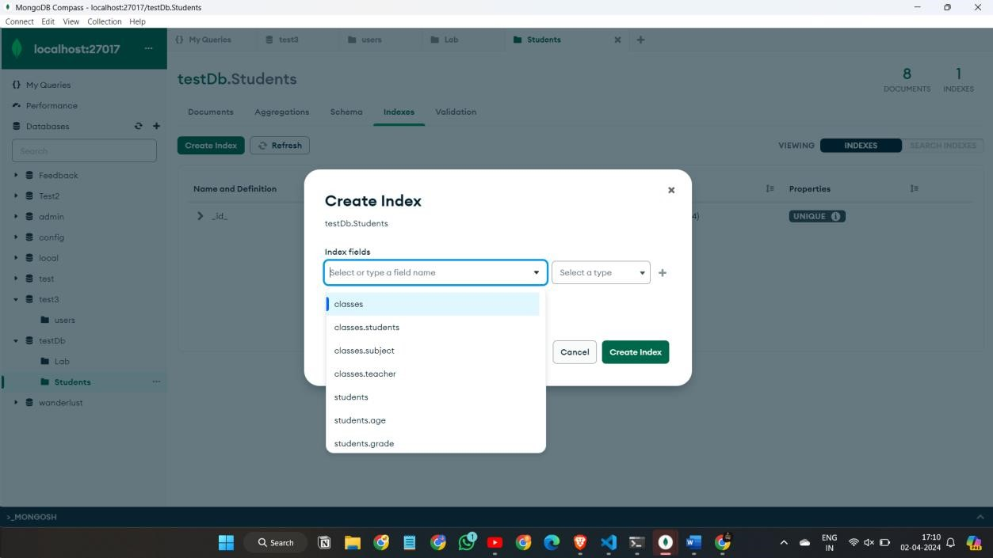

Step-2

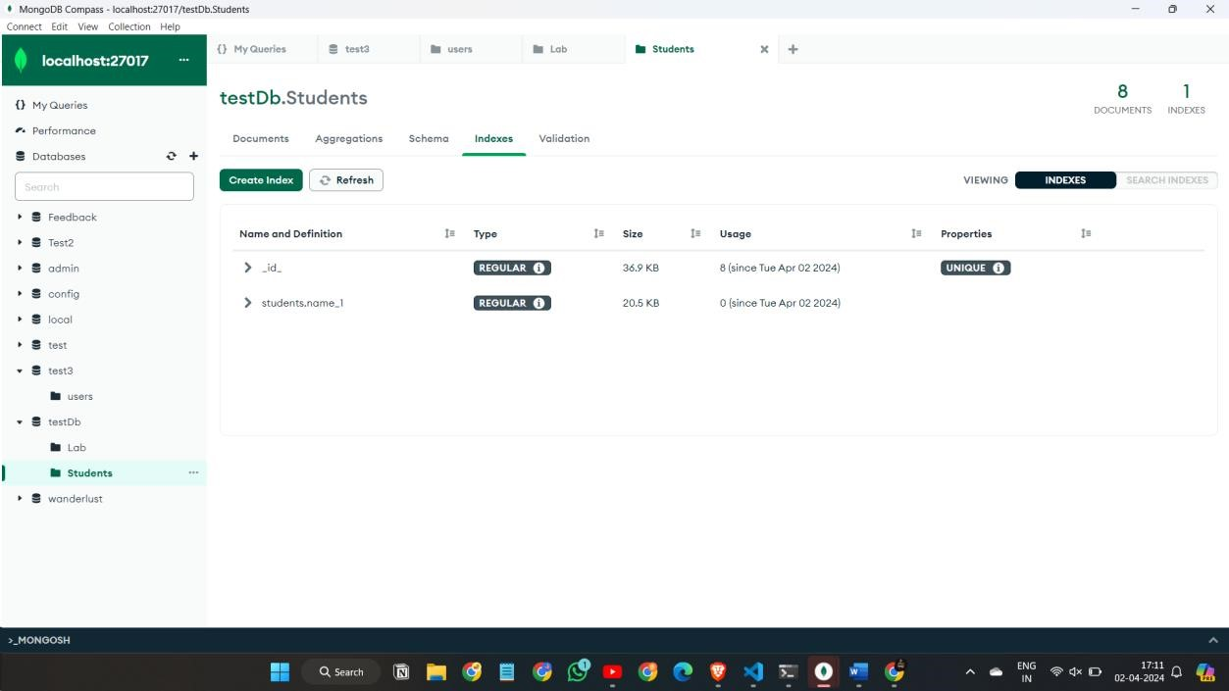

Q-10

Step-1

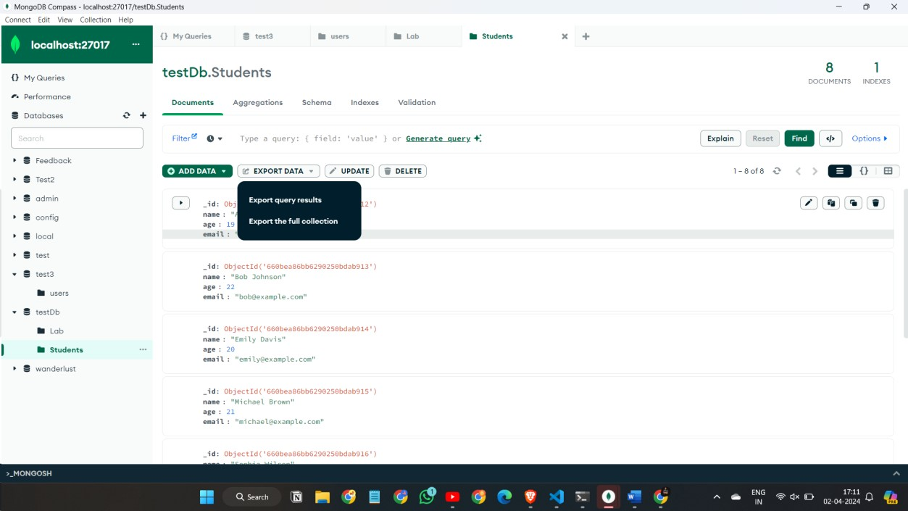

Step-2

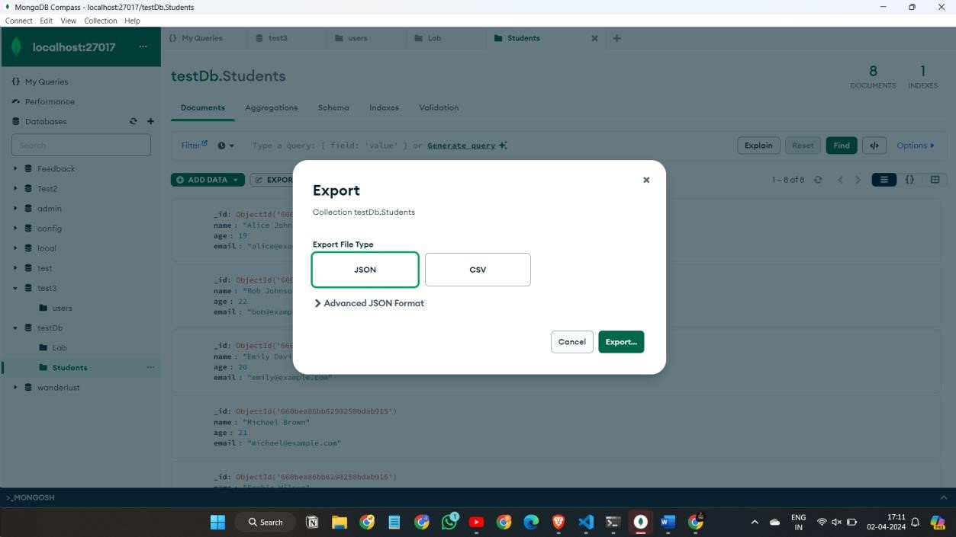

Step-3

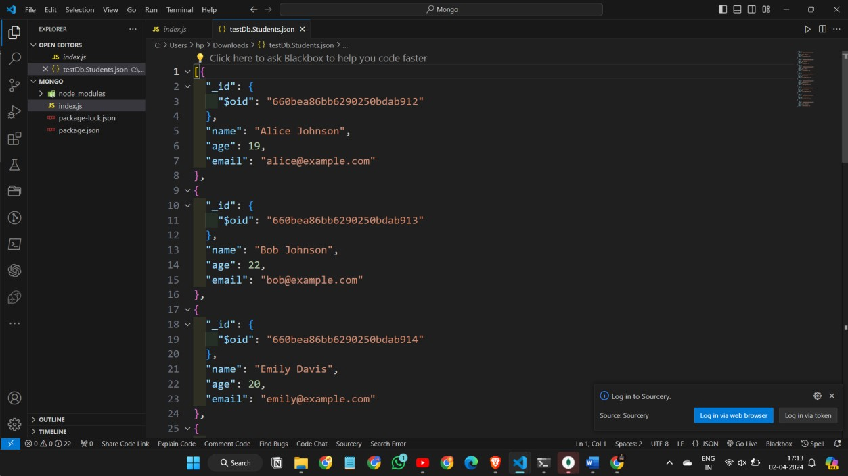

Q-13

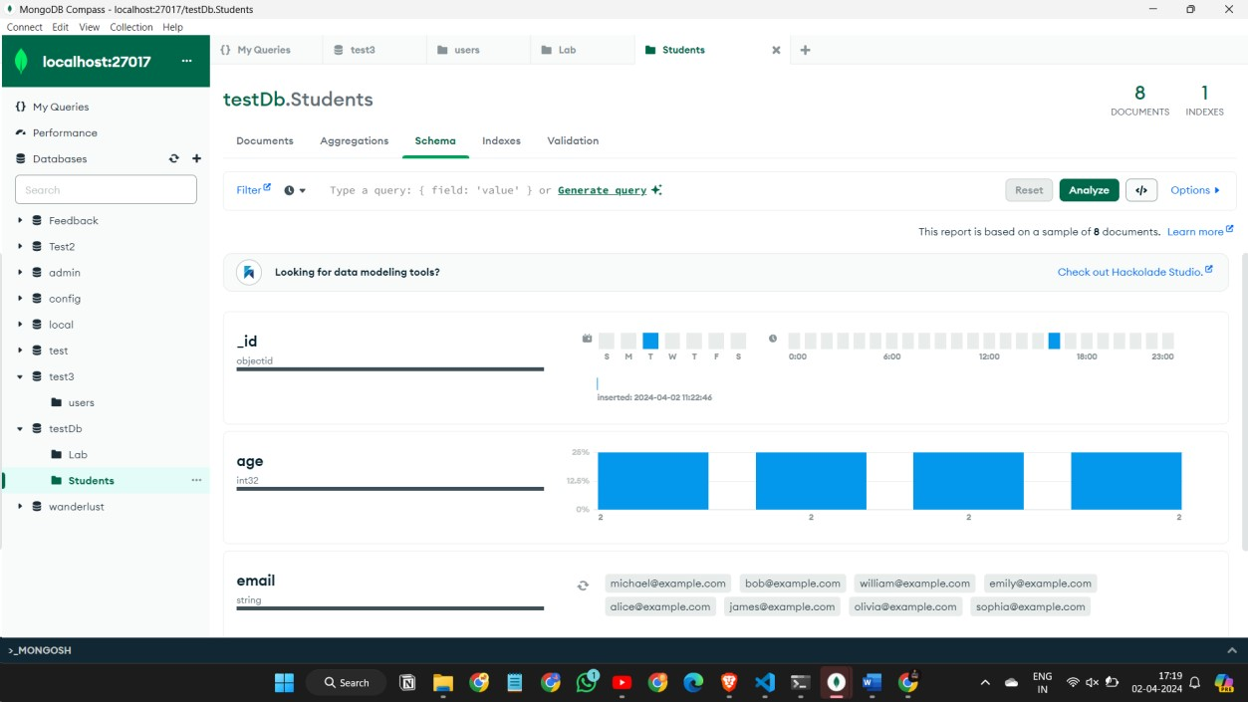

Q-14

